TASK 3
Machine Learning
Model Exploration
Train and test your own AI model using Google's Teachable Machine, with no coding
A complete step-by-step guide, with diagrams, a testing sheet and a report template
Image · Audio · Pose
Please note: The pictures of the Teachable Machine screens in this guide are simplified illustrations drawn to explain each step. The boxes marked "YOUR SCREENSHOT" are where you paste real screenshots from your own project, because the task asks you to capture the actual process and results.

What's inside: 1 Introduction · 2 Choosing a platform · 3 Before you start · 4 Key ideas in simple words · 5 Planning the project · 6 Step-by-step guide · 7 Audio and Pose projects · 8 Testing and results · 9 Experiments · 10 Tips and troubleshooting · 11 What the model really learned · 12 Responsible use · 13 Real-world uses · 14 My project report (template) · 15 Glossary · 16 Self-check · 17 Conclusion

1. Introduction
In the earlier tasks we learned what Machine Learning is and how systems such as movie recommenders, spam filters and face unlock learn from examples. In this task we move from reading about Machine Learning to doing it. We will train a real model ourselves, using a free tool that needs no programming, and then test how well it works.

1.1 Objective
The objective is to gain basic hands-on experience with how a Machine Learning model is trained and tested. By the end of this task you will have:
- Chosen a beginner-friendly Machine Learning platform.
- Created a simple model that can recognise images, sounds or poses.
- Trained the model on examples that you collected yourself.
- Tested the model on new input, and recorded and explained the results.
- Captured screenshots of the process and the results.

1.2 What is Teachable Machine?
Teachable Machine is a free, web-based tool from Google that lets anyone train a Machine Learning model right inside the browser. You do not write code. Instead you show the computer examples using your webcam, microphone or uploaded files, press a button to train, and then test the model immediately.
In simple words: You teach the computer the same way you would teach a child: show it examples, tell it what each one is called, and then check whether it can name new things correctly.

1.3 Why a hands-on task matters
Reading that "a model learns from examples" is very different from watching it happen. When you train a model yourself, ideas such as training data, labels, testing, accuracy and overfitting stop being vocabulary and become things you can see. You will notice, for example, that a model trained with only a few photos makes more mistakes than one trained with many varied photos, exactly as the theory says.

2. Choosing a Beginner-Friendly Platform
Several tools let beginners explore Machine Learning without advanced coding. The table compares some well-known options.
Platform | What you can do | Needs coding? | Best for
Teachable Machine (Google) | Train image, sound and pose models in the browser, test them live, and export them | No | Quick, visual first project
Machine Learning for Kids | Train simple models and use them inside Scratch projects | Block coding (Scratch) | Games and school projects
Orange Data Mining | Drag-and-drop workflows to analyse data and train models on tables of data | No (visual) | Learning about data and algorithms
Create ML (Apple) | Train image, sound and text models on a Mac | No | Apple device users

2.1 Why Teachable Machine was chosen
- Free and runs in a web browser: nothing to install, and you can try it without signing in.
- Three project types: image, audio and pose, matching the task.
- Instant feedback: you can test the model live as soon as training ends.
- Fast training: simple models train in about a minute.
- Shows the idea clearly: classes, samples, training and testing are all visible on one screen.
- Exportable: the model can be shared with a link or used in other projects later.

3. Before You Start

3.1 What you need
Item | Details
A computer or laptop | With a working webcam (for image and pose projects) and a microphone (for audio projects).
A web browser | Google Chrome is recommended because Teachable Machine works best in it.
Internet connection | Needed to open the website and load the tool.
Objects to teach | Two or three simple objects, for example a pen and a mug. Choose things that look clearly different.
A quiet, well-lit place | Good lighting and a plain area make the first model more accurate. (For audio, a quiet room.)
Screenshot tool | Windows: Snipping Tool or Win + Shift + S. Mac: Shift + Command + 4. Phone: the screenshot buttons.
Optional: Google account | Only needed if you want to save the project to Google Drive.
Time | About 30 to 45 minutes for the first full attempt.

3.2 Privacy note
Teachable Machine trains your model inside your web browser, and your webcam pictures stay on your computer unless you choose to save the project to Google Drive or upload the model to create a shareable link. Even so, it is wise to train only on objects, your own hands or your own face, and to avoid recording other people without their permission.

3.3 Quick checklist
- Chrome is open and the webcam is allowed to be used by the website.
- The objects are within reach and the lighting is good.
- The screenshot tool is ready.
- A notebook or this document is open for recording results.

4. Key Ideas in Simple Words
Term | Meaning | In our project
Class | A category you want the model to recognise | "Pen", "Mug" and "Nothing"
Sample | One example given to a class (one photo or one sound clip) | One photo of the pen
Training | The model studies all samples and learns the differences between the classes | Pressing the Train Model button
Model | The learned result that can recognise new input | The trained Pen / Mug / Nothing recogniser
Prediction | The model's answer for new input | "This looks like a pen"
Confidence | How sure the model is, shown as a percentage | 96% Pen
Testing | Checking the model on input it did not see during training | Showing the pen from a new angle

4.1 How does it learn so fast? (transfer learning)
Training a large image-recognition network from nothing needs millions of pictures and hours of computing. Teachable Machine takes a shortcut called transfer learning. It starts with a network that has already learned to see basic things such as edges, shapes and textures. Your samples are then used to adjust only the final part of the network so that it separates your classes. Because the hard part has already been learned, a few dozen samples per class and a minute of training are enough for a simple project.
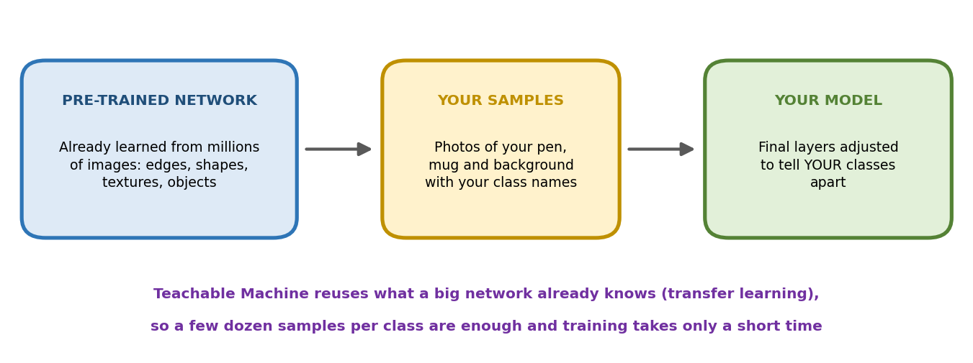
Figure 1: Transfer learning: a ready-made network is adapted to your own classes using your samples

4.2 Which type of Machine Learning is this?
Because every sample is labelled with a class name that you provide, this is supervised learning, and more specifically classification: the model places each new input into one of your classes. It is the same kind of learning used by a spam filter, only with pictures, sounds or poses instead of emails.

5. Planning the Project

5.1 Our example project: Pen or Mug?
To keep the first model simple, we will build an image classifier that looks through the webcam and decides whether it is seeing a pen, a mug, or nothing.
Class | What to show the camera | Why it is included
Pen | A pen held in different positions, distances and angles | The first object to recognise
Mug | A mug or cup held in different positions | The second object, clearly different in shape
Nothing | The empty background, and you without any object | Teaches the model what "no object" looks like, so it does not guess wildly

Remember: Always add a "Nothing" (background) class. Without it, the model must always pick Pen or Mug, even when nothing is in front of the camera, and it will often be confidently wrong.

5.2 You can choose a different idea
Type | Idea | Classes | Input
Image | Hand gestures | Thumbs up, Peace sign, Open palm, Nothing | Webcam
Image | Fruit recogniser | Apple, Banana, Orange, Nothing | Webcam or photos
Image | Mask or no mask (own face) | Mask, No mask | Webcam
Audio | Sound commands | Clap, Snap, Whistle, Background noise | Microphone
Audio | Short spoken words | Yes, No, Stop, Background noise | Microphone
Pose | Exercise moves | Hands up, Hands on hips, Standing | Webcam
Pose | Yoga or dance poses | Tree pose, Warrior pose, Standing | Webcam

The steps in the next chapter are written for an Image project. Audio and Pose projects follow almost the same steps, and Chapter 7 explains the differences.
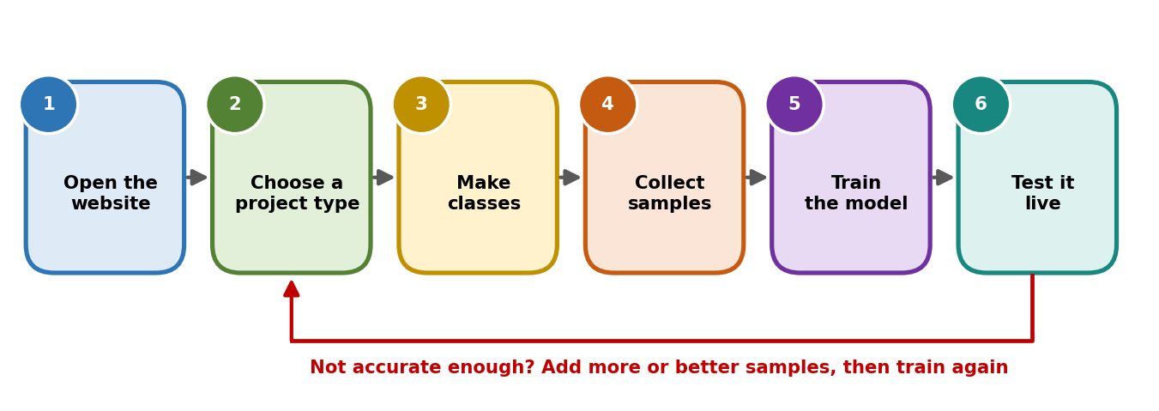
Figure 2: The overall steps of the project

6. Step-by-Step Guide (Image Project)

Step 1: Open Teachable Machine
- Open Google Chrome.
- Search for "Teachable Machine" or type teachablemachine.withgoogle.com in the address bar.
- Click the "Get Started" button on the home page.
What you should see: a page asking what kind of project you want to create.
YOUR SCREENSHOT 1
The Teachable Machine home page (before clicking Get Started)
(Paste your own screenshot here and delete this box)

Step 2: Choose the project type
- Click "Image Project".
- If asked, choose "Standard image model". This is the normal option for computers and phones. (The embedded model is for tiny microcontroller boards.)
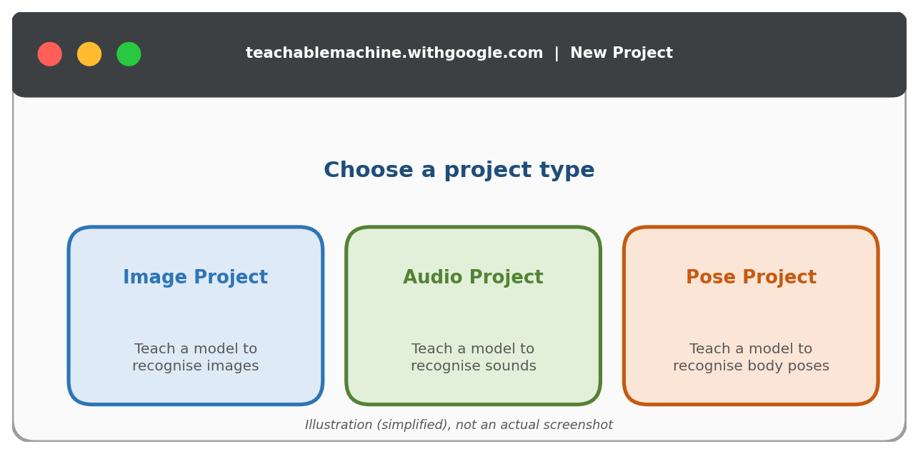
Figure 3: Choosing a project type (illustration)
YOUR SCREENSHOT 2
The project type screen, and your chosen Image Project opened
(Paste your own screenshot here and delete this box)

Step 3: Create and name your classes
- You will see two boxes called "Class 1" and "Class 2".
- Click the pencil icon next to the name and rename Class 1 to "Pen" and Class 2 to "Mug".
- Click "Add a class" to make a third class and rename it "Nothing".
Use short, clear names, because they will appear as the model's answers.

Step 4: Collect samples for each class
Samples are the examples the model learns from. The more varied they are, the better the model will work.
- In the "Pen" class, click "Webcam" and allow the browser to use your camera when asked.
- Hold the pen in front of the camera. Click and hold the "Hold to Record" button. The tool takes many pictures per second while you hold it.
- While recording, slowly move and turn the pen: closer, farther, left, right, tilted, held in different hands, and with different backgrounds behind it.
- Aim for around 50 to 100 samples per class. You can see the number grow next to the class name.
- Repeat for the "Mug" class, using the mug.
- For the "Nothing" class, record the empty background and yourself without any object, again with some movement.
Instead of the webcam you can also click "Upload" and add image files from your computer.
Do | Avoid
Use similar numbers of samples in every class | Having 100 pen photos but only 10 mug photos
Change angle, distance and lighting | Recording every sample from exactly the same position
Vary the background a little | Always showing the object against one identical wall
Keep the object clearly in view | Covering most of the object with your hand

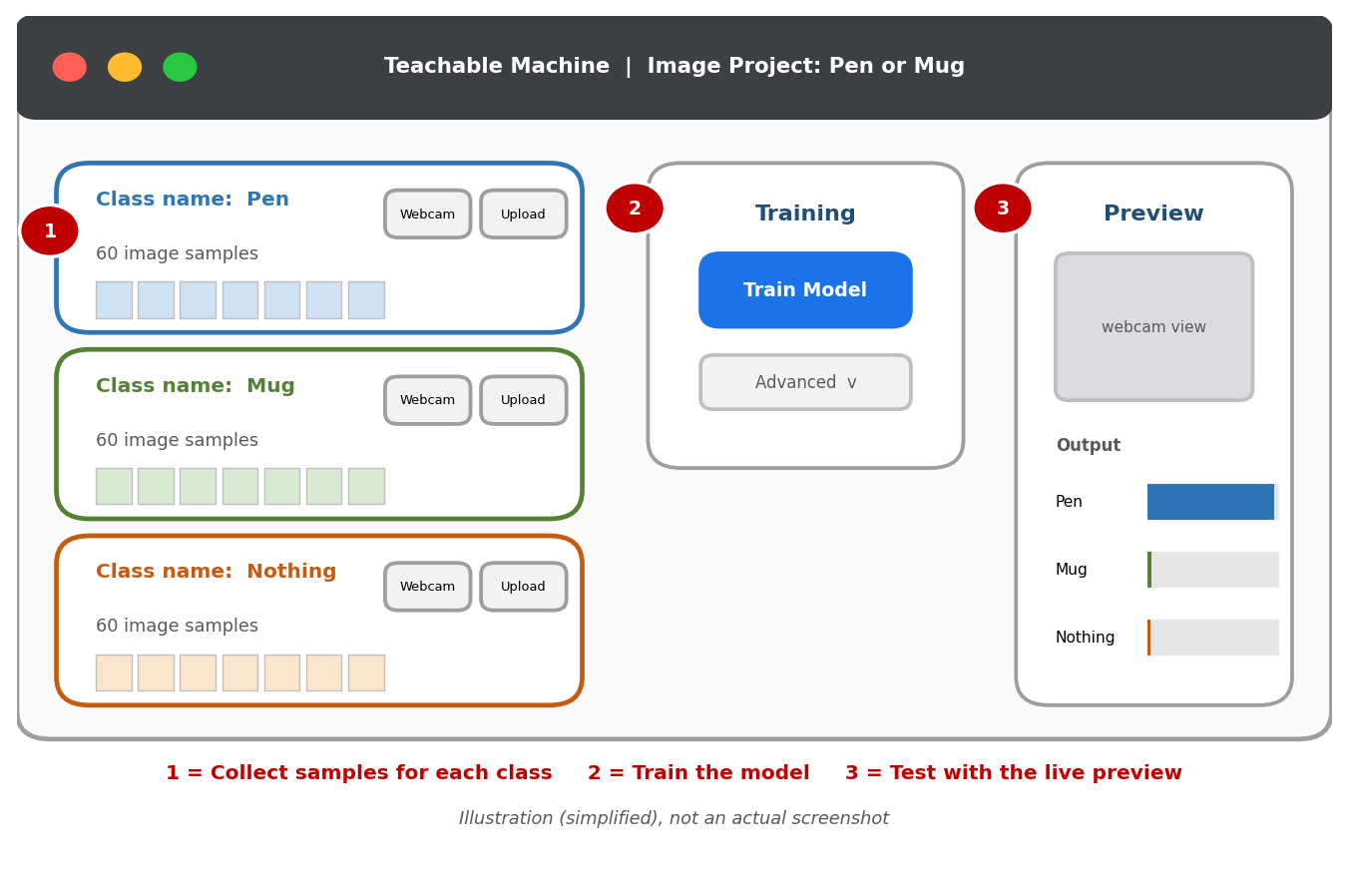
Figure 4: The workspace with three classes, the Training box and the Preview box (illustration)
YOUR SCREENSHOT 3
Your three classes, each showing its collected samples
(Paste your own screenshot here and delete this box)

Step 5: Train the model
- Click the "Train Model" button in the middle box.
- Wait while the progress shows that the model is training. Keep this browser tab open and visible, because switching away can slow or pause training.
- When training finishes, the Preview box on the right becomes active and the model is ready.
You can click "Advanced" to see three settings. The defaults are fine for a first model, but understanding them is useful:
Setting | Simple meaning | Default
Epochs | How many times the model goes through all your samples. More rounds can mean better learning, but takes longer. Too many can cause memorising. | 50
Batch size | How many samples the model looks at together before making an adjustment. | 16
Learning rate | How big each adjustment is. Too large can be unstable; too small learns slowly. | 0.001

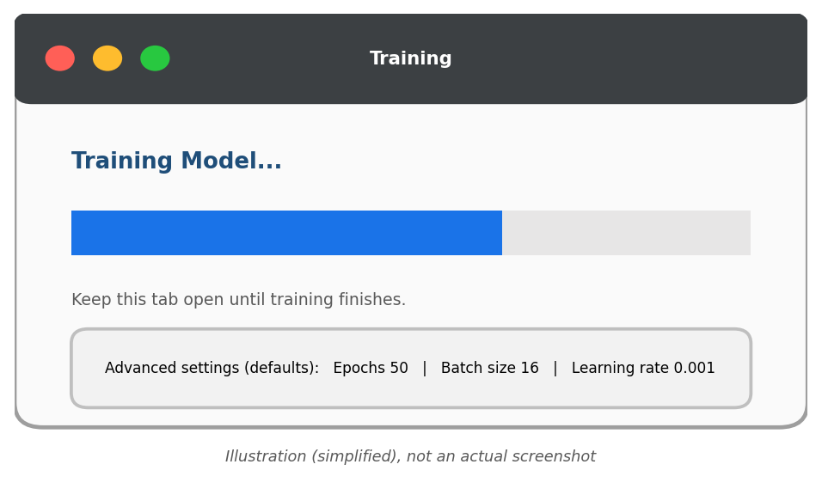
Figure 5: The training stage and the Advanced settings (illustration)
YOUR SCREENSHOT 4
The model training (or the finished training screen), with Advanced settings if you opened them
(Paste your own screenshot here and delete this box)

Step 6: Test the model in the Preview
- In the Preview box, make sure "Webcam" input is switched on.
- Hold up the pen. Watch the bars in the "Output" section. Each class has a bar showing how confident the model is.
- Now try the mug, then remove everything to see if "Nothing" lights up.
- Test harder situations: a different angle, a different distance, a dim room, the object partly hidden, or a similar object.
- You can also click "File" instead of webcam to test with an image saved on your computer.
- Write down each test and result in the testing sheet in Chapter 8.
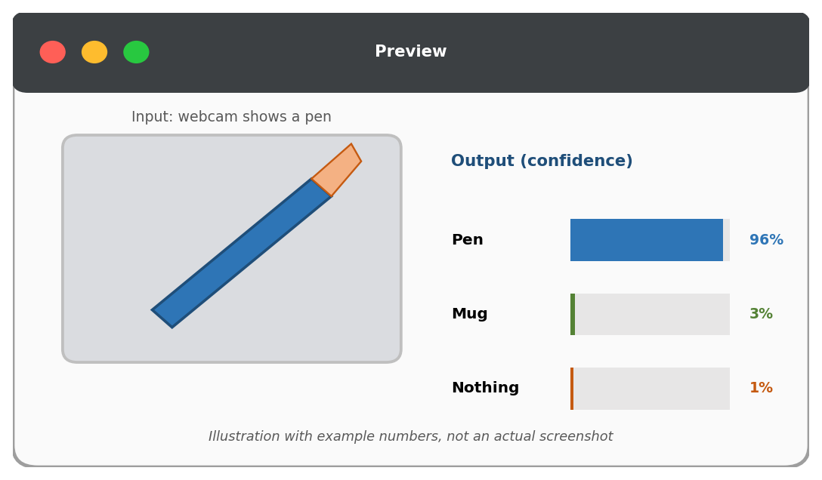
Figure 6: Reading the Preview output (illustration with example numbers)
YOUR SCREENSHOT 5
The Preview showing the model recognising the Pen (with the confidence bar)
(Paste your own screenshot here and delete this box)

YOUR SCREENSHOT 6
The Preview showing the model recognising the Mug
(Paste your own screenshot here and delete this box)

YOUR SCREENSHOT 7
The Preview showing Nothing, or a mistake you found (good for your observations)
(Paste your own screenshot here and delete this box)

Step 7: Improve the model
If the model makes mistakes, you do not need to start again. Improve the examples and retrain.
- Find out what went wrong. For example, the model says "Pen" when it sees the mug held at a certain angle.
- Record more samples of the class that was confused, especially in the situation that failed.
- Click "Train Model" again and test the same situation.
- Compare the new result with the old one and note the improvement.

Step 8: Save or export the model (optional)
- Click "Export Model" above the Preview box.
- Choose a tab such as TensorFlow.js and click "Upload my model" to get a shareable link. Anyone with the link can try your model. You can also download the model files for other tools.
- To keep the project itself, use the project menu to save it to Google Drive or download it as a file.
YOUR SCREENSHOT 8
The Export Model window showing the shareable link (optional)
(Paste your own screenshot here and delete this box)

7. Audio and Pose Projects
The same idea works for sounds and body poses. The main differences are shown below.

7.1 Audio project (recognising sounds)
- On the project type screen choose "Audio Project".
- The first class is for "Background Noise". Record the normal quiet sound of your room. This class is essential, so the model knows what "no sound command" is.
- Create classes such as "Clap", "Snap" and "Whistle" and record several short clips for each using the microphone. The tool shows the minimum number of clips it needs on screen.
- Click "Train Model" and wait for it to finish.
- In the Preview, make the sounds and watch the bars react live.
Tip: sound models are sensitive to background noise, so test in the same kind of place where you recorded the samples.

7.2 Pose project (recognising body positions)
- Choose "Pose Project" and allow the webcam.
- Create classes such as "Hands up", "Hands on hips" and "Standing".
- For each class, record yourself holding that pose, moving slightly, from a steady distance. The tool finds the key points of your body (such as shoulders, elbows and wrists) and learns the shape they make.
- Train, then test by striking each pose in front of the camera.
Tip: stand far enough from the camera so that your whole upper body is visible, and keep the same distance when testing.

7.3 Comparing the three project types
 | Image | Audio | Pose
Input | Pictures (webcam or files) | Sounds (microphone) | Body positions (webcam)
Special class | "Nothing" or background is recommended | "Background Noise" is required | "Standing" or neutral pose is helpful
Best conditions | Good light, clear view | Quiet room, same place | Whole body visible, steady distance
Example use | Sorting objects, gestures | Voice or sound commands | Exercise and dance apps

8. Testing and Results
Testing is how we find out whether the model has really learned. A good test uses input the model has not seen in training, covers easy and difficult situations, and is recorded carefully so that the results can be explained.

8.1 How to test properly
- Test each class several times, at least five tries per class.
- Include normal cases (object in the middle, good light) and difficult cases (dim light, angled, partly hidden, different background).
- Use a few new photos from a file that were not used in training, if possible.
- Record what you showed, the model's answer and its confidence.

8.2 How to read the confidence bars
What you see | What it usually means
One bar very high (above about 90%) | The model is very sure. Check that it is also correct.
Two bars close together | The model is confused between those two classes. They may look alike, or need more samples.
Bars jumping around | Not enough varied samples, or the object is partly out of view.
Wrong class at high confidence | The model learned something misleading, such as the background or lighting instead of the object.

8.3 Testing sheet (fill this in during your tests)
Example of how to fill the sheet (illustration only, not real results):
Test | What I showed | Conditions | Model said | Confidence | Correct?
Ex. | Pen | Bright light, centre | Pen | 95% | Yes
Ex. | Mug | Dim light, tilted | Pen | 58% | No

Your own testing sheet:
Test | What I showed | Conditions | Model said | Confidence | Correct?
1
2
3
4
5
6
7
8
9
10
11
12

8.4 Calculating accuracy
Accuracy is the share of tests the model got right.
Formula: Accuracy (%) = (number of correct answers / total number of tests) x 100. For example, if the model is right in 17 of 20 tests, accuracy = 17 / 20 x 100 = 85%.

My result | Number | Notes
Total tests done
Correct answers
Accuracy
Hardest situation for the model

YOUR SCREENSHOT 9
Your most useful test result (a success, or an interesting mistake with the confidence bars visible)
(Paste your own screenshot here and delete this box)

9. Experiments to Understand Machine Learning Better
A great way to learn is to change one thing at a time and watch what happens. Try at least two of these experiments and record what you notice.
Experiment | What to do | What you will learn
Few vs many samples | Train once with only 5 samples per class and test. Then train with 60 or more and test the same situations. | How the amount of training data affects accuracy.
Same vs varied samples | Record samples only from one angle and one background, then test from another angle. | Why variety matters and what overfitting looks like.
Remove the Nothing class | Delete the background class and retrain. Show an empty scene. | Why a background class prevents confident wrong answers.
Change the settings | Under Advanced, try fewer and more epochs and compare. | How training length changes the result.
Add a confusing object | Show a pen-like object such as a marker or a pencil. | The limits of what the model was taught.
Change the lighting | Test in bright, dim and coloured light. | How sensitive models are to conditions.

9.1 My experiment notes
Experiment | What I changed | What happened

10. Tips and Troubleshooting

10.1 Tips for a better model
- Collect at least 50 samples per class, with similar numbers in each.
- Add variety: angle, distance, lighting, background and hand position.
- Always include a background ("Nothing") class.
- Make classes clearly different from one another.
- Test with situations that are different from your training samples.
- Retrain after adding samples. The model only learns what you give it.

10.2 Troubleshooting
Problem | What to try
The webcam does not turn on | Click Allow when the browser asks. Check the camera permission in the address bar. Close other apps using the camera.
Training seems stuck | Keep the tab open and visible. Wait a little longer, or refresh and retry with fewer samples.
The model is always wrong | Check the class names, add more varied samples and retrain.
It confuses two classes | Add more samples of each, especially from angles where it fails.
It says an object is present when nothing is there | Add more "Nothing" samples with different backgrounds.
Results change when lighting changes | Collect samples in different lighting.
The audio model reacts to room noise | Record more Background Noise and test in the same quiet place.

11. What the Model Really Learned
It is tempting to think the model "understands" a pen. In reality it learned a pattern of pixels that tends to appear in the pen samples. That is why it can be fooled by things you did not intend.
- If all your pen photos were taken against a white wall and your mug photos against a dark door, the model may learn "white background = pen" instead of learning the pen's shape.
- If your samples all come from one angle, a new angle may confuse it. This is a small version of overfitting.
- The confidence number is the model's estimate, not a guarantee. A model can be very confident and still wrong.

11.1 Connection to what we studied earlier
Idea from earlier tasks | In this project
Supervised learning | Your class names are the labels, and you supplied them.
Training data and test data | Samples are training data. Anything new you show in the Preview is test data.
Features | The network automatically finds features such as edges and shapes in the pictures.
Overfitting | Samples that are too similar make the model fail on new angles and backgrounds.
Feedback and improvement | You add samples where it failed, retrain, and test again.
Deep learning | The model is a neural network, adapted using transfer learning.

12. Responsible Use
- Privacy: do not record other people's faces or voices without their clear permission, and avoid sharing project links that contain personal images.
- Fairness: if you train on faces or voices, a model trained on just a few people will work poorly for others. Variety in the data matters.
- Honesty about results: report your real test results, including mistakes. Mistakes are valuable learning, not failures.
- Limits: a small classroom model is for learning. It is not accurate or safe enough for important decisions such as security or health.

13. Where Are Such Models Used in Real Life?
Model type | Real-life use | Same idea as your project
Image | Sorting fruit on a conveyor, spotting crop disease from leaf photos, reading road signs | Classes are shown many labelled pictures
Audio | Smart speaker wake words, detecting machine faults from sound, bird-call recognition | Classes are sound types with a background class
Pose | Fitness and yoga coaching apps, sports training, gesture control for games | Body key points are used to tell poses apart

Professional systems use the same learning cycle, but with millions of samples, careful testing and much stronger computers.

14. My Project Report (Template)
Fill this page with your own details. Together with your screenshots, it forms your submission.
Item | My details
Platform used | Teachable Machine (Google)
Project type (Image / Audio / Pose)
Project title
Date
Classes created
Number of samples per class
Training settings (epochs, batch size, learning rate)
Number of tests done
Accuracy (correct / total x 100)
What worked well
Where the model made mistakes
What I did to improve it
What I learned about Machine Learning

14.1 Screenshot checklist
No. | Screenshot | Done?
1 | Teachable Machine home page
2 | Project type screen and Image Project opened
3 | Classes with collected samples
4 | Training in progress or finished
5 | Preview recognising the first class
6 | Preview recognising the second class
7 | Preview showing Nothing, or a mistake
8 | Export Model window (optional)
9 | Best test result

14.2 Conclusion in my own words
YOUR SCREENSHOT 10
Space to write 4 to 5 sentences in your own words about what you learned
(Paste your own screenshot here and delete this box)

15. Glossary
Term | Meaning
Accuracy | The percentage of tests the model gets right.
Batch size | How many samples are processed together in one training step.
Class | A category the model is trained to recognise.
Classification | Sorting input into one of several classes.
Confidence | How sure the model is about its answer, shown as a percentage.
Epoch | One complete pass of the model through all training samples.
Export | Saving or sharing a trained model so it can be used elsewhere.
Label | The name given to a sample, such as Pen.
Learning rate | How big each adjustment to the model is during training.
Model | The learned patterns that can recognise new input.
Overfitting | Memorising the training samples so well that new input is handled badly.
Preview | The Teachable Machine box where you test the trained model live.
Sample | One example (a photo, sound clip or pose) given to a class.
Training | Letting the model learn patterns from the samples.
Transfer learning | Re-using a network that already learned general features and adapting it to a new task.

16. Self-Check Questions
- What is Teachable Machine, and why is it suitable for beginners?
- What is a class, and what is a sample?
- Why do we add a "Nothing" or "Background" class?
- What happens when you press the Train Model button?
- What is transfer learning, and why does it let us train with so few samples?
- Which type of Machine Learning is this project (supervised, unsupervised or reinforcement)? Why?
- Why should samples be collected from different angles and lighting?
- What do the confidence bars in the Preview show?
- If the model gets 16 of 20 tests right, what is its accuracy?
- Name two ways to improve a model that makes mistakes.

Answers
1. A free, web-based Google tool that trains image, sound and pose models in the browser without coding. It is beginner-friendly because it is visual and gives instant feedback.
2. A class is a category the model should recognise (such as Pen). A sample is one example added to a class (one photo or sound clip).
3. So the model learns what "no object" looks like and does not wrongly choose one of the objects when nothing is present.
4. The model studies all the samples and adjusts itself to separate the classes. When it finishes, it can be tested in the Preview.
5. Re-using a network that already knows general features and adapting only its final part to your classes. Since the hard learning is already done, a small number of samples is enough.
6. Supervised learning (classification), because every sample has a label that you supplied.
7. So the model learns the object itself and not one specific view, which helps it work on new situations and avoids overfitting.
8. How confident the model is that the input belongs to each class.
9. 16 / 20 x 100 = 80%.
10. Add more varied samples where it fails (especially for confused classes), and retrain. Also check class balance and add a background class.

17. Conclusion
In this task we explored Teachable Machine, a free and beginner-friendly platform, and followed the full life of a simple Machine Learning model. We chose classes, collected our own samples, trained the model with a single button and tested it live. Along the way we saw the ideas from earlier tasks in action: supervised learning from labelled examples, the importance of varied training data, testing on unseen input, overfitting, and improving through feedback.
The most important lesson is that a model is only as good as the examples it learns from. A few varied, well-labelled samples, a background class and honest testing matter more than any technical setting. The same lesson applies to the systems behind movie recommendations, spam filters and face unlock, only on a much larger scale.
Key takeaways: 1. You can train a real ML model without writing code. 2. Good, varied samples make good models. 3. Always test on new input and record results honestly. 4. If the model makes mistakes, add better samples and retrain.

