**PROJECT REPORT**

ON

SOCIAL MEDIA WEBSITE & ITS DATABASE MANAGEMENT SYSTEM

IN FULFILMENT FOR THE REQUIREMENT OF SECOND YEAR DBMS PROJECT

## Btech Computer Science and Engineering

SUBMITTED BY

BTech TY – A03 – 2020BCS005

MAHESHWARI SURWASE

### UNDER GUIDENCE OF

Miss. Swapnaja Moralwar

AND

Dr. Jaishri Waghmare

( HOD of CSE Department )



# Department of Computer Science & Engineering

SHRI GURU GOBIND SINGHJI INSTITUTE OF ENGINEERING AND TECHNOLOGY VISHNUPURI NANDED

- 431606 (M.S) INDIA ACADEMIC YEAR: 2021-2022

**Abstract**

Social media websites are the primary means of communication in the twenty-first century, and they are required to manage massive volumes of data using their databases. The database component of social media websites is implemented in this project. How do they classify, manage, and store information? .Social Media Website Database Management System The database utilised by social media websites needs to be error-free, secure, dependable, and quick so that users can communicate with their companions without bothering about their user information. As this project only concentrates on the database component, it uses a MySQL Server based database with PHP as a backend and all other frontend components are built using Bootstrap (for CSS and JS). The aim is to create a social networking platform that can categorise, store, and manipulate data for all individuals who are also connected.

**INDEX**

|  |  |  |
| --- | --- | --- |
| 1 | INTRODUCTION | 4 - 5 |
| 1.1 | Basic Information about Project | 4 |
| 1.2 | Flow Of Modules | 5 |
| 2 | **DATABASE SECTION** | 6 – 8 |
| 2.1 | Er Diagram | 6 |
| 2.2 | Relational Tables | 7 |
| 3 | **TECHNOLOGY STACK** | 9 - 12 |
| 4 | **FEATURES** | 13 |
| 5 | **SCREENSHORTS** | 14 - 18 |
| 6 | **REFERENCES** | 19 |

1. **INTRODUCTION**

In our modern world where the internet is necessary, everyone relies on various online resources for news. Along with the increase in the use of social media platforms like Facebook, Twitter, etc. news spread rapidly among millions of users within a very short span of time.

The Social Media Websites are the Boom of the Era. People interact on daily basis on these platforms and many aspects of the society are related to it. Making a Social Media Platform where users can interact with each other in efficient and easy way is the goal of the project. The Database part has to be really strong and robust so that the site can be accessed by multiple users simultaneously and all data is stored and manipulated properly.

* 1. Basic Information of Project

Instagram Project comprises of many modules working together.

The Website should authenticate user every time so a login module is developed and when he is in a session and the sessions should remember the user credentials (AJAX). The User can update his information using Edit profile module, He can Post using the post module and consequently like and comment using the same module. The Massaging part is handled by Massaging module and the notifications are handled by notifications module. At last, he followers and block list are attained by follow module.

This can be explained by the flow chart of the modules.

* Login or Sign_Up module
* User Module

User module further consist of :

* Post Module
* Follow Module
* Edit Info Module
* Notifications Module
  1. Flow of the Modules

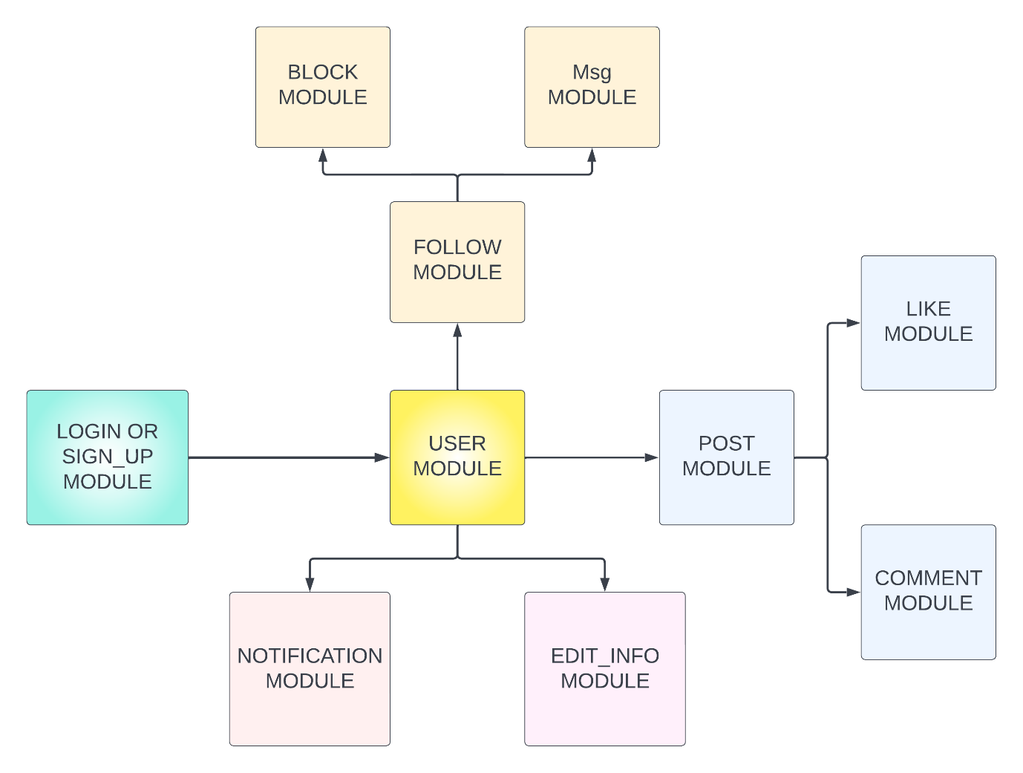

1. **DATABASE SECTION**
   1. Er Diagram

Er Diagram for Social Media Website Database Management system is as follows.

* Yellow Rectangles – Entity’s
* White Diamonds ­– ­Relationships

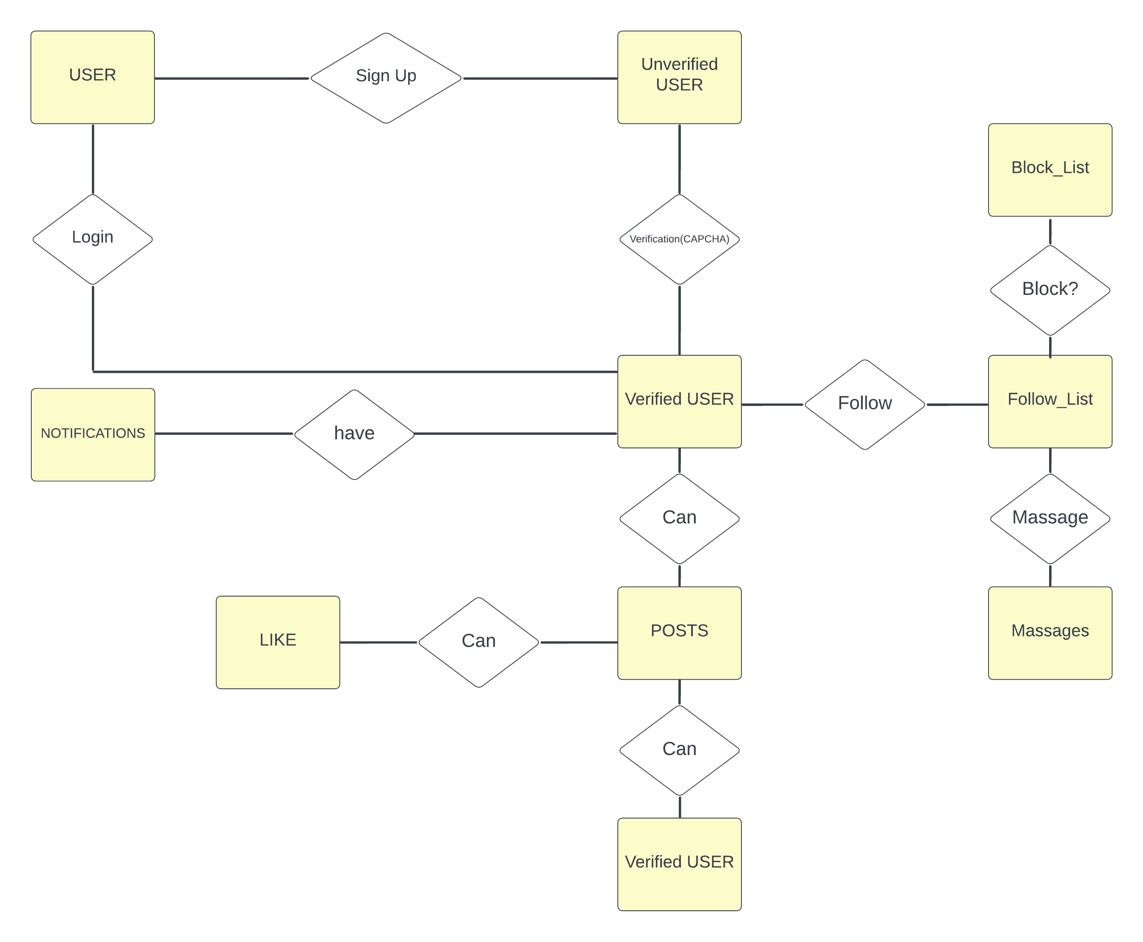

* 1. Relational Tables in Database.

In the database Er Diagram Represents the relational diagram how different schemas interact with each other to form a robust database.

The Entity Tables are enlisted here with their different attributes.

|  |
| --- |
| User |
| * User-id * First name * Last name * Email * User_name * Gender * Password * ProPick |

|  |
| --- |
| Notifications |
| * Notification-i * To_user_id * From_user_id * Massage_sys * read_status * Post_id |

|  |
| --- |
| Post |
| * Post-id * User_id * Post_text * Created at * image |

|  |
| --- |
| Massages |
| * Massage-id * From_user_id * To_user_id * msg * read_status * sent at |

|  |
| --- |
| Comments |
| * comment-id * User-id * Post-id * comment * created at |

|  |
| --- |
| Likes |
| * like-id * User-id * Post-id |

|  |
| --- |
| Follow_list |
| * ID * User_id * Follower_id |

|  |
| --- |
| Block_list |
| * ID * User_id * Blocked_id |

Database in xampp :

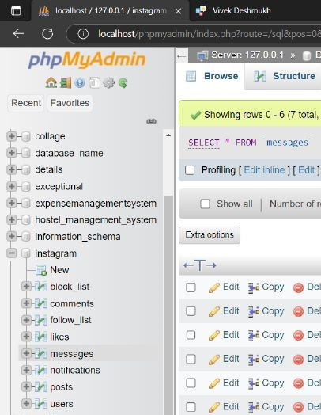

1. **Technology Stack**

The Project can be made using various technology stacks but the MySQL was compulsory to be used. As it is a website, we used technologies related to web.

The Technologies are :

* HTML5
* CSS3
* Bootstrap
* PHP
* MySQL
* Ajax

Applications Used are :

* Xampp
* Vs-code

Technologies Explained :

HTML5:



Html 5 is the latest version of Hypertext Markup Language which is the code behind the scenes that describes the structure and architecture of the website.

We have added many elements of php code to the html the document type is not specified as index.html its index.php . But html is used in it.

CSS3 :



CSS3 ( Cascading Style Sheets ) has been used in with html to create a formatted content that looks nice on the webpage. Navbar, login page and the user section styling are done using CSS 3 individually.

Bootstrap 5:



Bootstrap 5 is a free opensource front-end development framework used for creating websites and web apps. Designed to enable responsive development it has collection of template code for everything that is used in web dev.

Here we have used dropdowns , Modals and JS transitions in order to make website more live and playful.

PHP :



Hypertext Pre-processor (PHP) is a general-purpose scripting language that is especially suited to web development. Fast, flexible and Powerful tool for browser side scripting. The Php is used in the html template to instantly feed in the information according to the user by interacting with our MySQL database.

AJAX :

AJAX stands for **A**synchronous **Ja**vaScript and **X**ML. AJAX is a new technique for creating better, faster, and more interactive web applications with the help of HTML, CSS, and Bootstrap. Here we communicate with our Apache Tomcat server by xampp using AJAX in order to send the request , get the request and simultaneously maintain the user session.

MySQL :



MySQL, the most popular Open-Source SQL database management system, is developed, distributed, and supported by Oracle Corporation.

Database in MySQL are relational mean that the data is stored in form of tables that are interrelated. Also, the SQL queries that at used to feed in or fetch out the data are executed using PHP in the browser side.

Applications Used :

Xampp :



Xampp is the free and open-source cross-platform web server package developed by Apache. It consists of Apache HTTP server , MariaDB as SQL database and interpreters and scripts written in PHP.

It is a small tool that makes a website to run on local server while interacting with the SQL database via MariaDB.

* Apache HTTP server
* MariaDB MySQL Database

VS-code :



Visual Studio Code, also commonly referred to as VS Code is an open-source editor made by Microsoft with Electron Framework for all the machines out here. It is an IDE Interactive Development Environment that helps along the way to develop various applications effectively.

It is free, very popular and developers love to use vs-code.

1. **Features of the application.**

This project has mainly two features that have been added in to make the website more secure.

1. Verification Code :

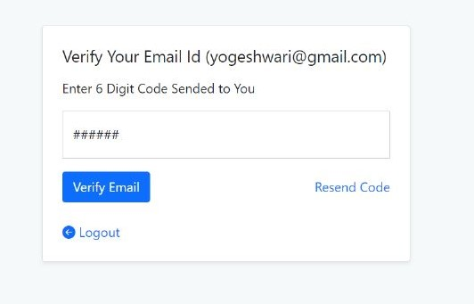

While the user is using signup function to create an account on website the email is verified by sending a verification code to the email account of the registering user and the User is verified. This stops from users creating multiple fake accounts and also it adds to safety.

Currently Verification code is set to : 111111

1. Captcha for login :

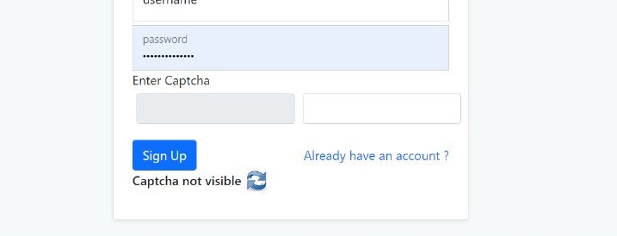

While it is important for us to have only verified accounts there is one more point to be worried about BOTS. The web bots go on creating accounts that is not sustainable. To avoid this and to add a bit more to safety we added captcha feature so that site will be bot secured.

1. **Screenshots**
2. Login and Signup Page :

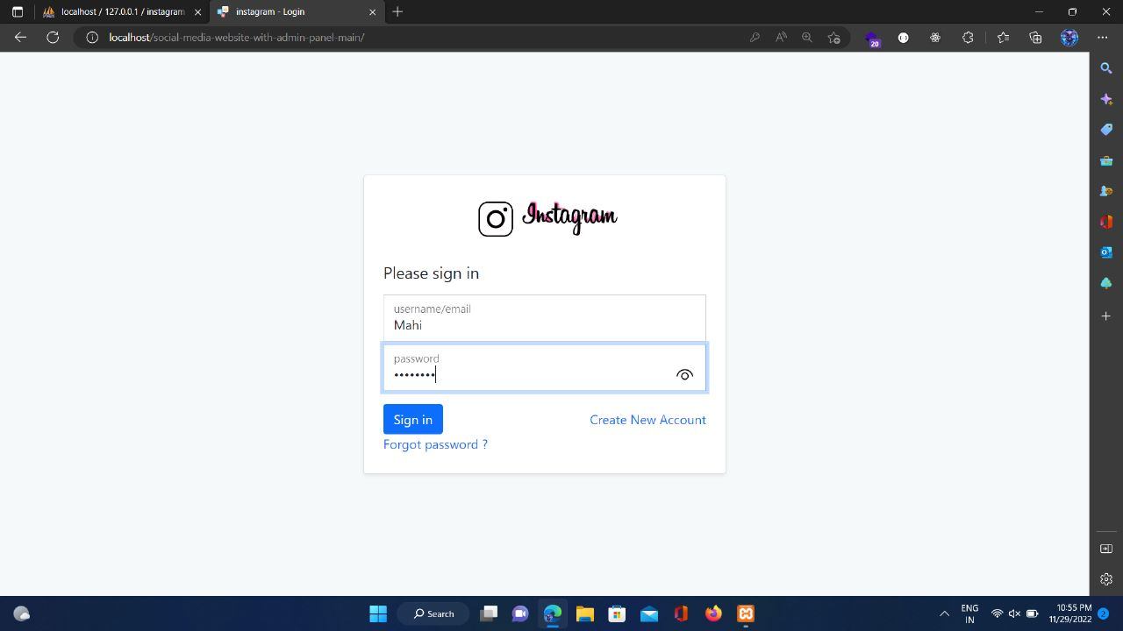

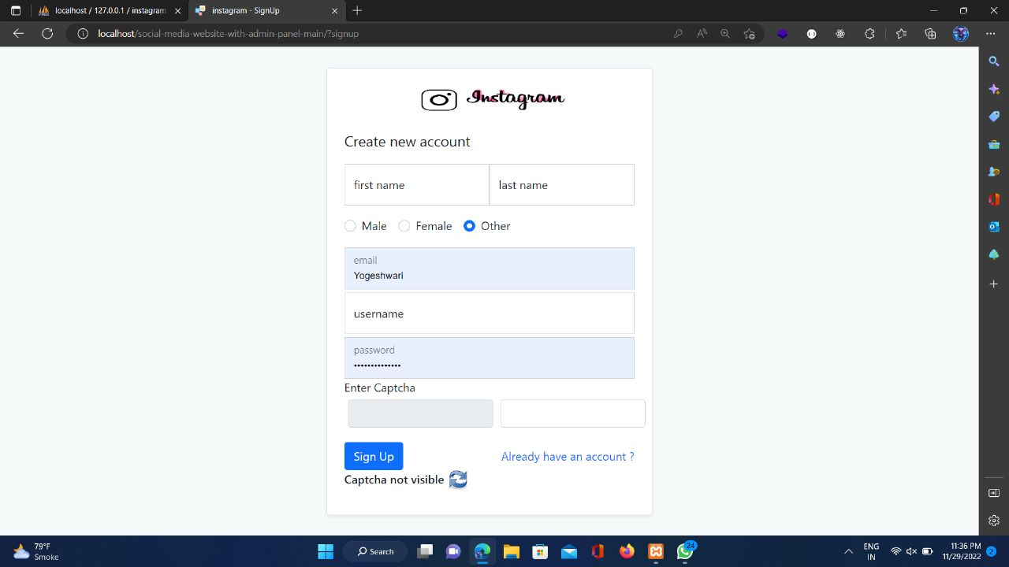

1. Main User Page :

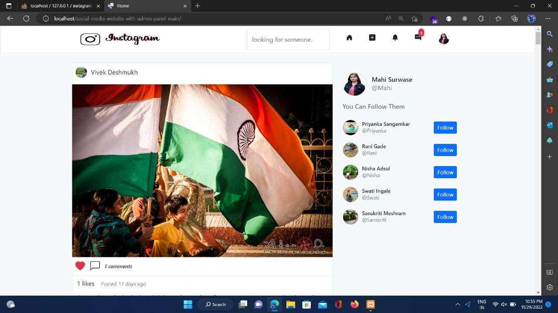

1. Notifications :

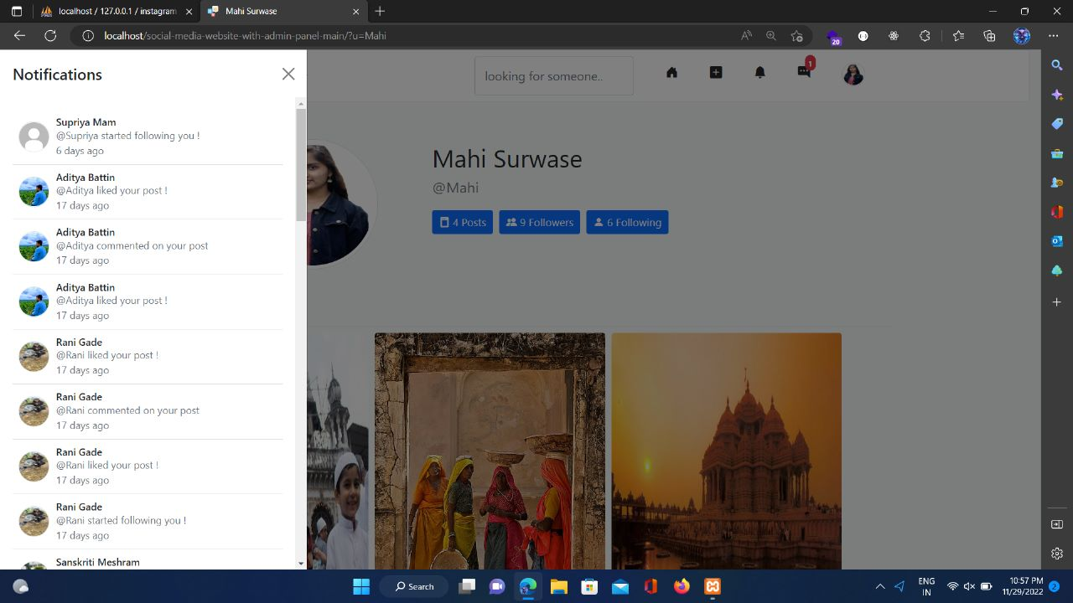

1. Massages :

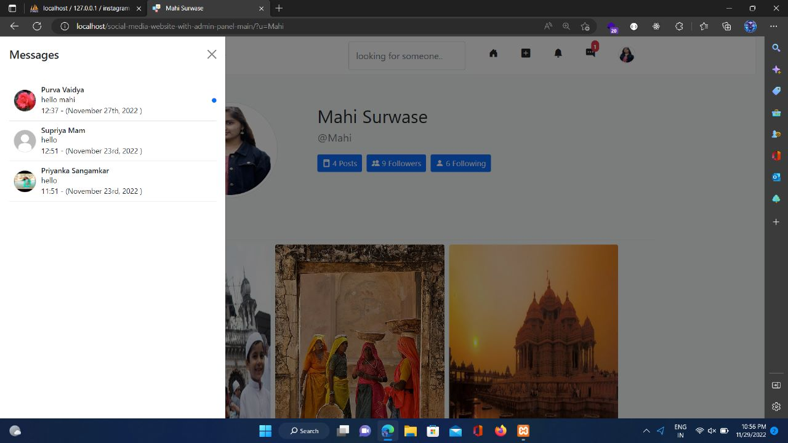

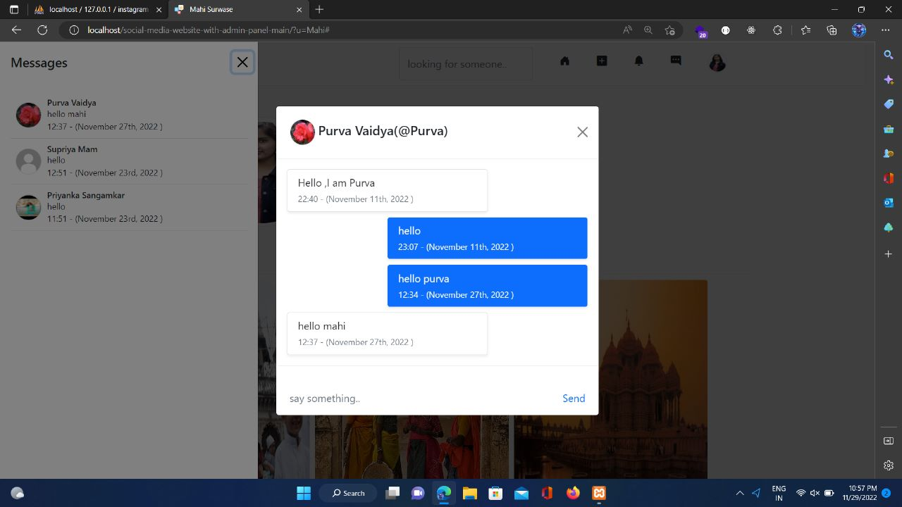

1. Follow :

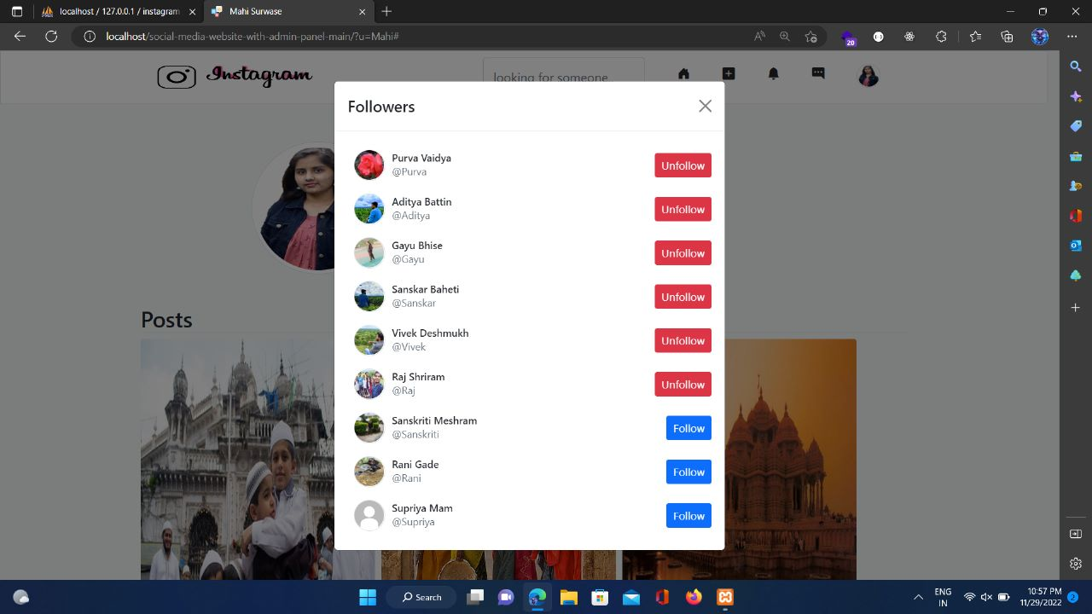

1. Edit Info Page :

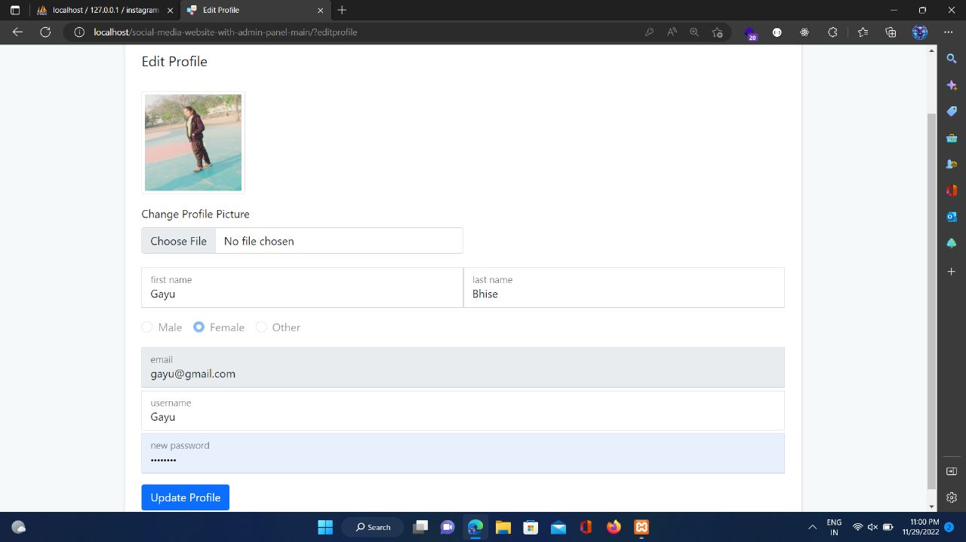

1. Post :

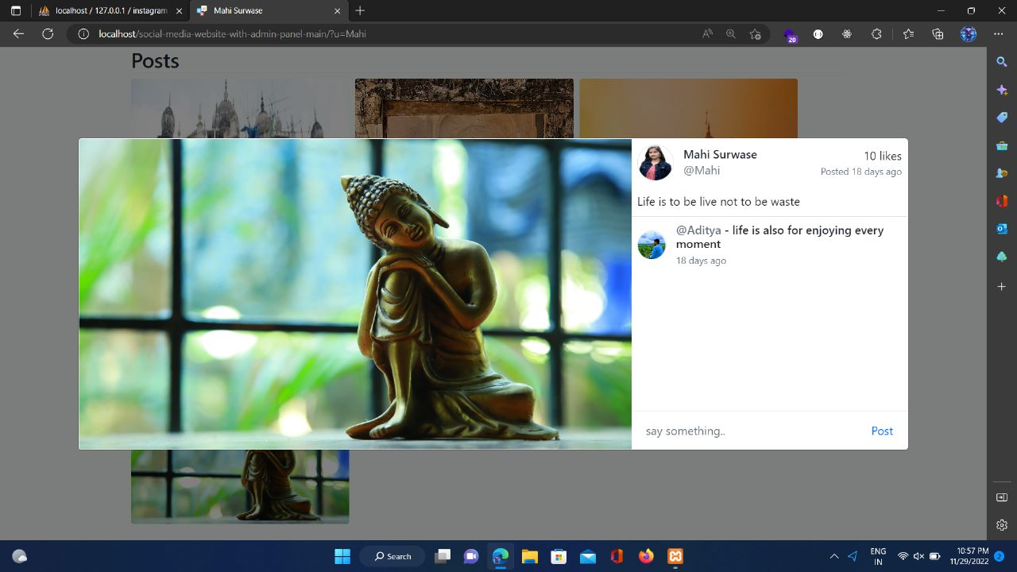

1. **References :**

Technology Stack References :

1. PHP w3cschools Tutorials : <https://www.w3schools.com/php/>
2. Ajax w3cschools Tutorials: <https://www.w3schools.com/jquery/jquery_ref_ajax.asp>
3. MySQL Documentation : <https://dev.mysql.com/doc/>
4. Xampp Java Point :

[https://www.javatpoint.com/creating-mysql-database-with-xampp](%20https:/www.javatpoint.com/creating-mysql-database-with-xampp)

Captcha Add on GitHub and YouTube Links :

* GitHub : <https://github.com/yawarazeem/loginPage_withCaptcha/blob/master/captcha.html>
* YouTube : <https://www.youtube.com/watch?v=wSyu6sANHTQ>

Project Reference and Idea form :

YouTube Social Media Website Project: <https://www.youtube.com/playlist?list=PLrL9i_Ka3T0eSt00jw7BOpbsRqbuVOuj2>

Final Project GitHub Link :

GitHub Social Media Website : <https://github.com/MaheshwariSurwase/social-media-website-with-admin-panel-main>