**BI Implementation Report**

The growth of any organisations has various tasks such as cost-effective supply chain of Walmart such as raw materials and delivery process through **Supply chain Management,** migration of Walmart Customers and maintenance of their relationships through **Customer Relationship Management,** using **Power BI** tool business analysis can be done and can overcome the challenges

**Supply Chain Management**

Supply chain management is a complete process from raw material to finest product in customer’s hands. In this generation online market is very competitive and this process would help in fastening up deliverables. If this process goes fine and efficient the organisation can opt for budget cut-off to optimise complexities and SCM covers the material services and deliveries.

**Fig 1**

In Walmart sales decides the business and that makes organisation to meet customers’ expectation .If they delay supply service, definitely it will cost organisation very high in loss ,in Fig1 we can see a basic process which can be more improved to focus the major areas such as support team and emergencies alerts. Any company should also focus on support during the overall supply chain management process.

**Customer Relationship Management:**

CRM is mainly used in many organisation to maintain the relationship between organisation and customers. We will see the CRM implementation going forward.

Step 1: **Finding Leads**: Walmart is well reputed organization in market so many stakeholders will approach to get in touch with the organization that will be stored as leads in CRM.

We can see there are many leads listed down in the screenshot.

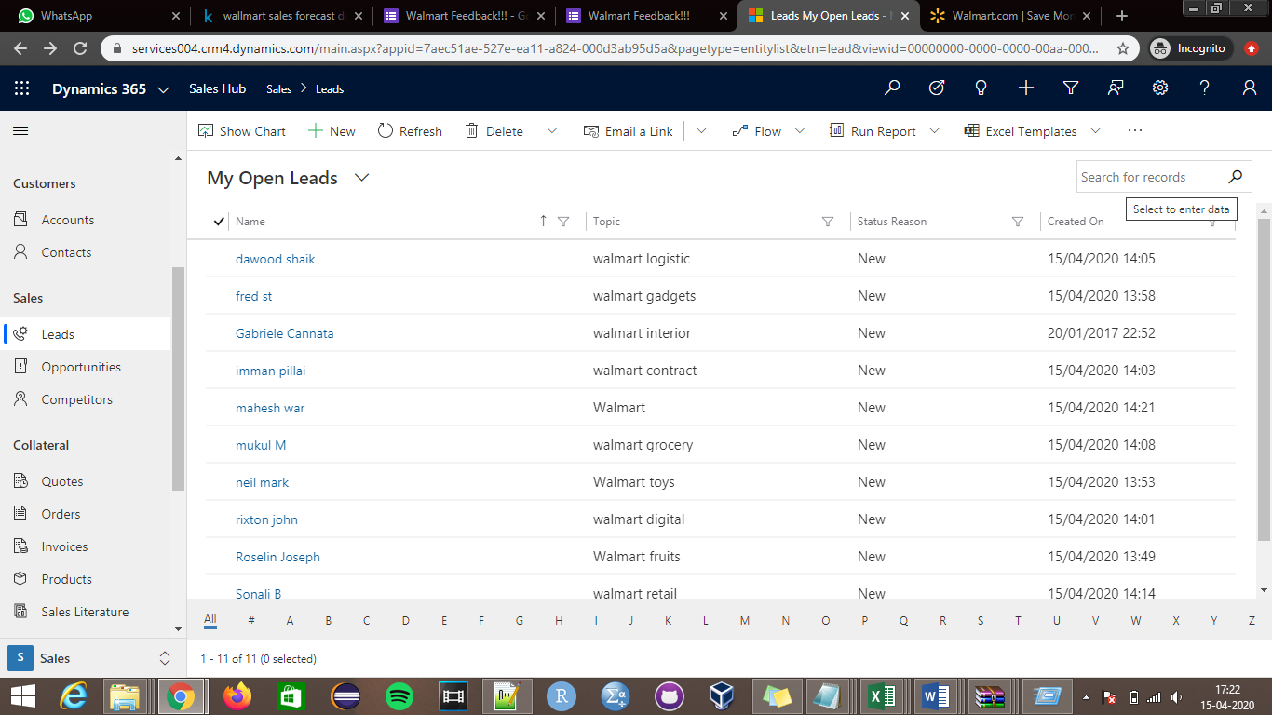

Step 2: **Qualify a Lead**: If the organization considers the particular stakeholder to be in then we can opt for qualifying that particular stakeholder and that profile will reflect in opportunities once the profile is qualified.

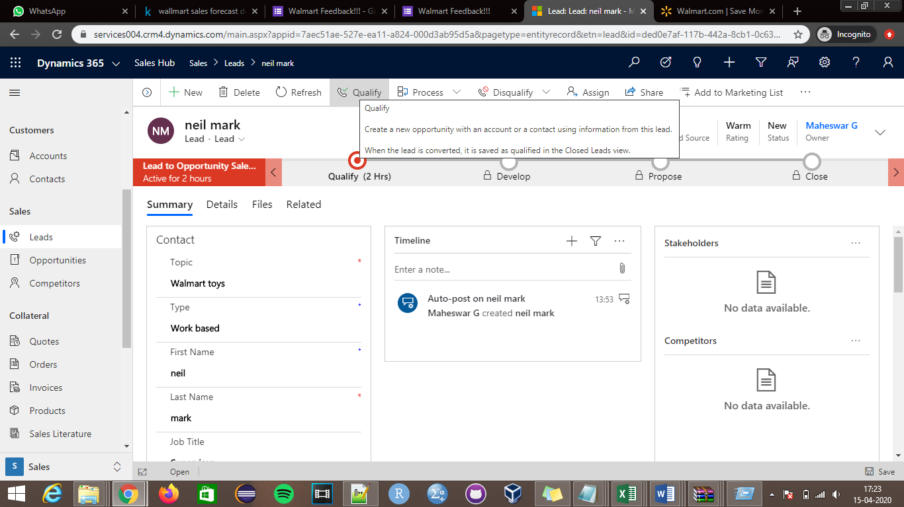

Step 3: **Disqualify a Lead**: If the organization want to take any particular profile off, this can be done by opting disqualify and we can select the reasons for disqualifying as mentioned in below screenshot.

We can revoke the profile if required going forward in future by opting reactivating feature.

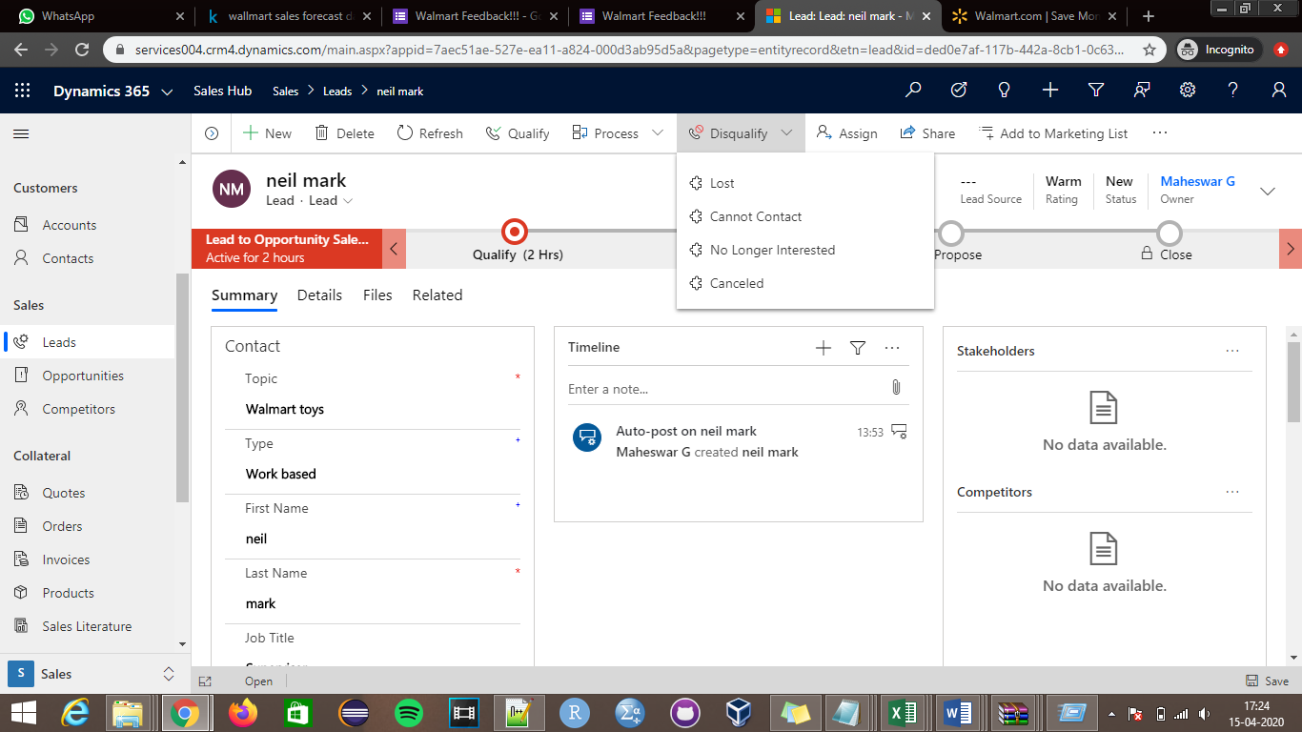

Step 4: **Opportunities Details**: we can append budget and many more fields for the particular deal.

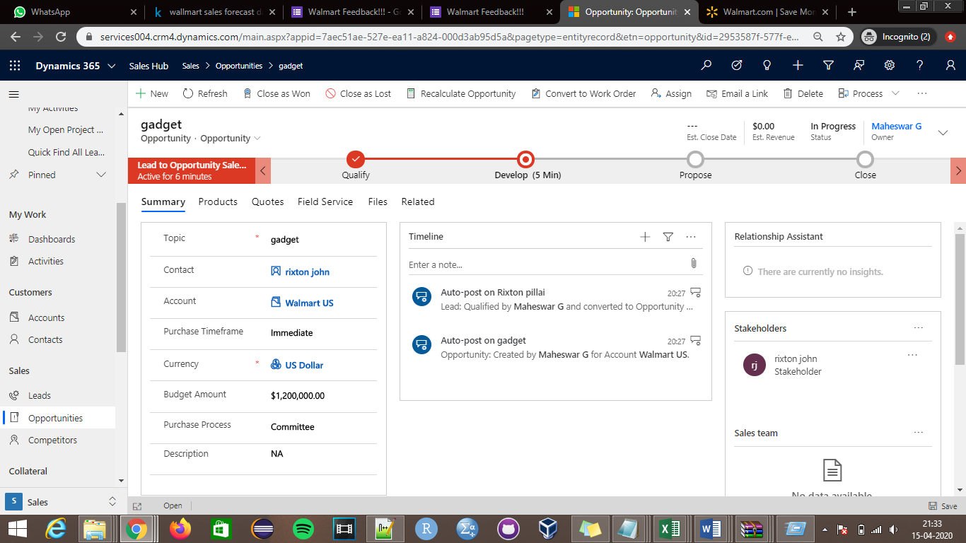

Step 5: **Creating Quotes and orders**: If any profile requests for quotation the organization can send the quotes with all the offers and demand requirements. To enable this quote to the profile we can activate this quotes once filled with requirements by clicking on activate.

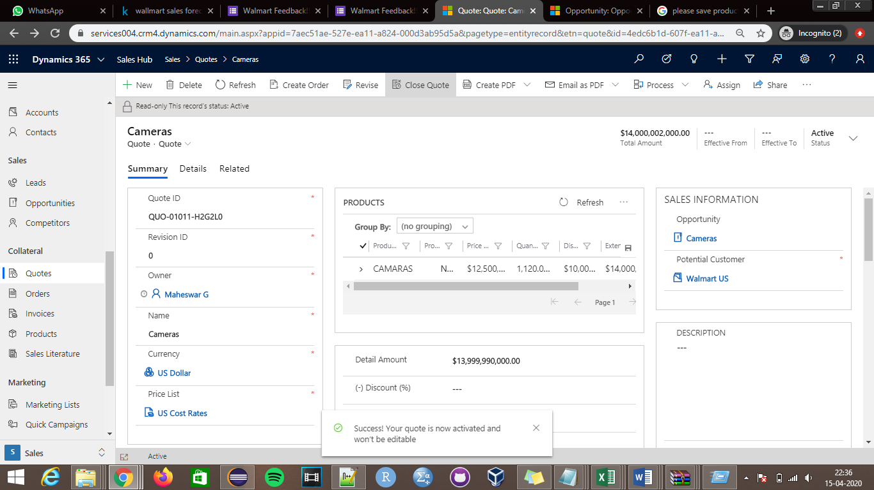

Step 6: **Create Order**: using the activated quote we can create order if the stakeholder is good to go by clicking the create order. Bill will be generated for stakeholder and can send this invoice.

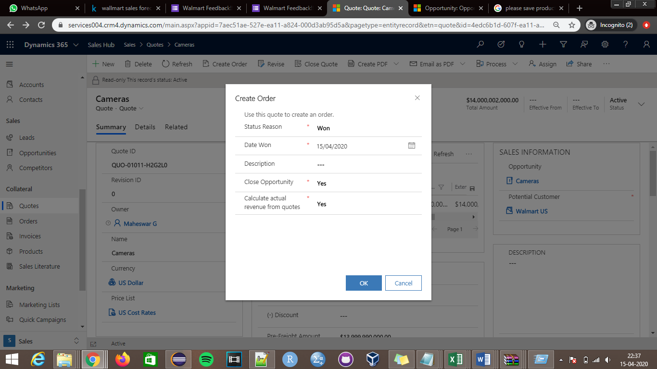

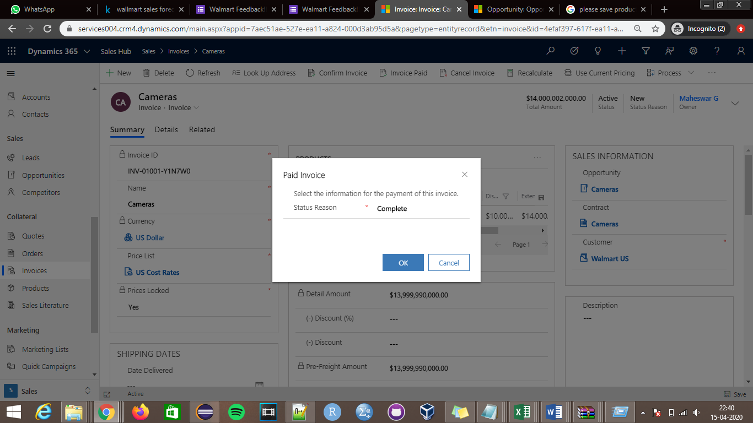

Step 7: **Verify Data**: We can cross verify the CRM for all open and closed opportunities as shown in the below screenshot.

**Closed opportunities**

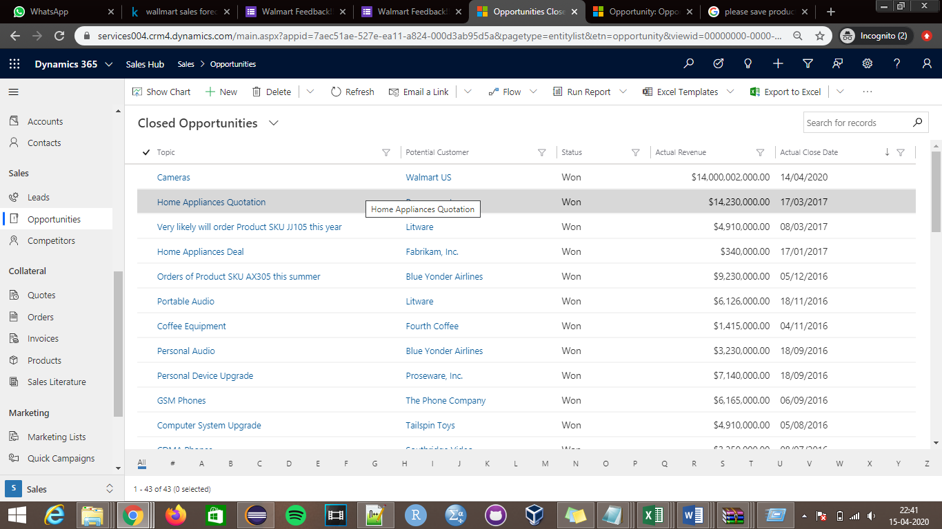

**Sales Activity Dashboard**: All the performed activities will be reflected dashboard ,we have performed couple of activities on few profiles which is reflected in the dashboard, we can see them in below screenshot.

