**USING JAVASCRIPT METHODS**

**ALERT() :**

<html>

<body>

<p>alert box.</p>

<button onclick="myFunction()">click</button>

<script>

function myFunction() {

alert("Hi! I am an alert box!");

}

</script>

</body>

</html>

**OUTPUT :**

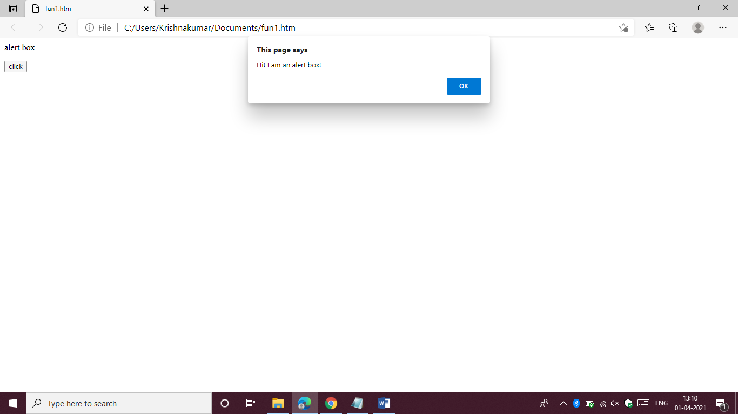**EVAL ():**

<html>

<body>

<p>click button.</p>

<button onclick="myFunction()">press</button>

<p id="demo"></p>

<script>

function myFunction() {

var x = 28;

var y = 13;

var a = eval("x * y") + "<br>";

var b = eval("2 + 2") + "<br>";

var c = eval("x + 17") + "<br>";

var res = a + b + c;

document.getElementById("demo").innerHTML = res;

}

</script>

</body>

</html>

**OUTPUT :**

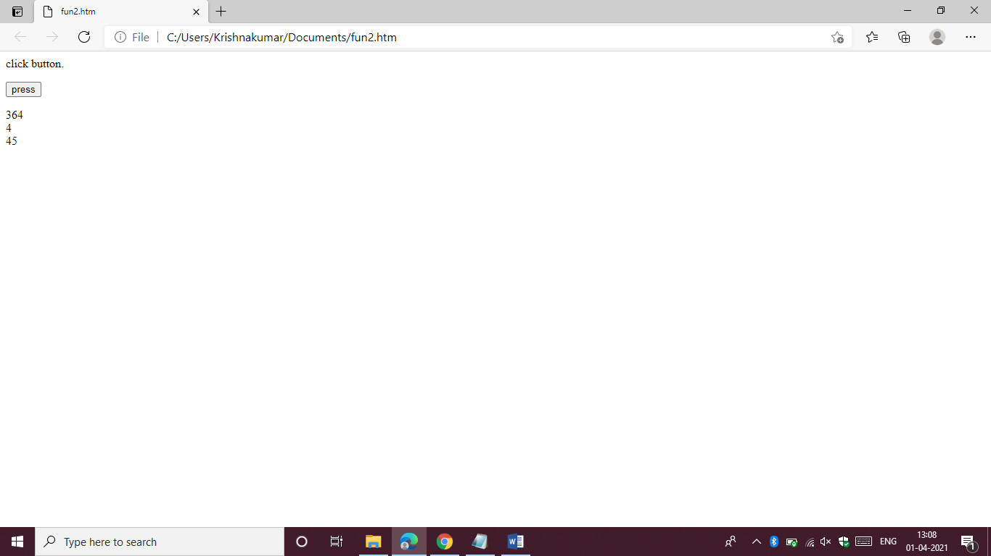

**PARSEINT () :**

<html>

<body>

<p>parse different strings.</p>

<button onclick="myFunction()">go on</button>

<p id="in"></p>

<script>

function myFunction() {

var a = parseInt("10") + "<br>";

var b = parseInt("10.00") + "<br>";

var c = parseInt("20.33") + "<br>";

var d = parseInt("13.00") + "<br>";

var e = parseInt(" 28.13 ") + "<br>";

var f = parseInt("29 years") + "<br>";

var g = parseInt("riya was 13") + "<br>";

var n = a + b + c + "<br>"+d + e + f + g ;

document.getElementById("in").innerHTML = n;

}

</script>

</body>

</html>

**OUTPUT :**

