Bank Customer Financial Insights & Analysis

1. Project Overview and Objective

This project involves cleaning, transforming, and analysing raw bank customer data using Excel and Power Query, and creating an interactive Power BI dashboard to derive meaningful business insights about customer demographics, income patterns, loan behaviour, and account status.

The main objective is to demonstrate data pre-processing techniques using Excel and Power Query, and build an interactive Power BI dashboard visualization to help bank management make informed decisions.

2. Data Sources

- Source: Internally generated synthetic bank customer dataset
- Domain: Banking / Finance / Customer Analytics
- Records: 500 customers
- Cities Covered: Trichy, Salem, Chennai, Coimbatore, Madurai

3. Problem Statement

- To analyse bank customer income patterns and loan behaviour across different age groups and income categories.
- To study account balance distribution across cities and account types for better financial planning.
- To evaluate customer activity status (Active vs Inactive) and gender distribution.
- To understand the correlation between monthly income and account balance for customer segmentation.

4. Attribute (Column / Features) Details

Attribute Name | Data Type | Description
Customer_ID | String (Text) | Unique identifier for each customer
Name | String (Text) | Full name (First + Last Name combined)
City | Categorical | Customer city — Trichy, Salem, Chennai, Coimbatore, Madurai
Age | Numeric (Integer) | Customer age in years
Age Group | Categorical | Derived column — Young / Middle Age / Senior
Gender | Categorical | Male / Female
Account Balance | Numeric (Decimal) | Current account balance in INR
Loan Amount | Numeric (Decimal) | Outstanding loan amount in INR
Monthly Income | Numeric (Decimal) | Monthly income of the customer in INR
Income Category | Categorical | Derived column — Low / Medium / High Income
Account Type | Categorical | Current / Savings / Salary
Status | Categorical | Active / Inactive customer status

5. Tools & Technologies

- Excel: Data cleaning, missing value handling, Find & Replace standardization, CONCATENATE formula, and Pivot Tables.
- Power Query: Data transformation, conditional columns (Age Group, Income Category), and data type fixing.
- Power BI: Data modelling, DAX calculations, visualization, and interactive dashboard creation.

6. Data Pre-Processing (Excel / Power Query)

Tasks Performed:

- Duplicate Check: Verified all 500 records — No duplicate values found.

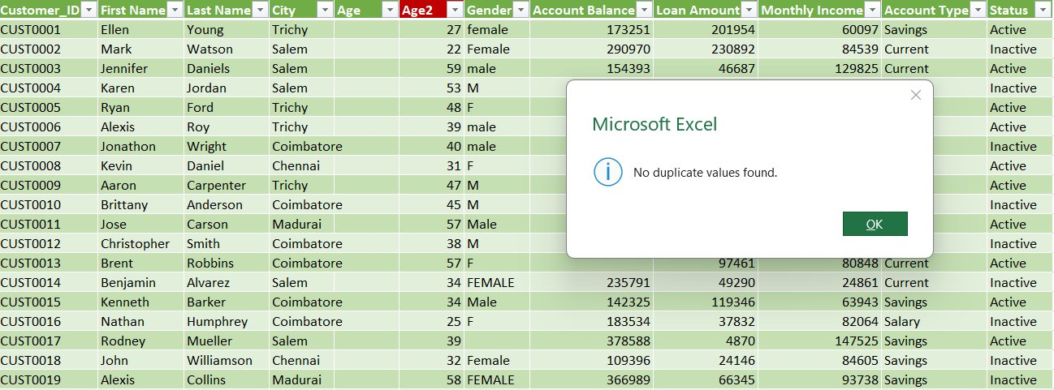
Figure 1: Raw Dataset — No Duplicate Values Found

- Gender Standardization: Used Find & Replace to fix inconsistent values — 'male' to 'Male' (327 replacements) and 'female' to 'Female' (171 replacements).

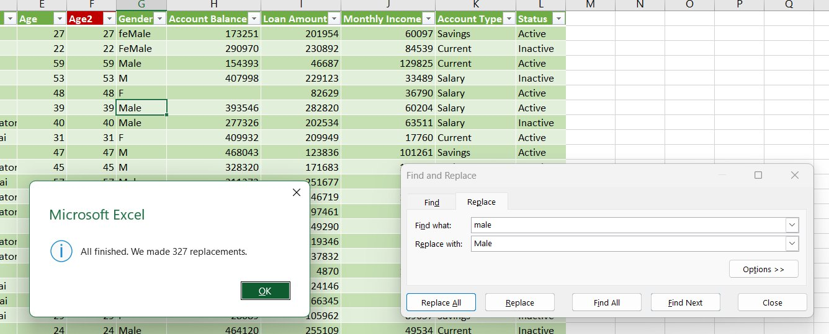
Figure 2: Find & Replace — male to Male (327 replacements)

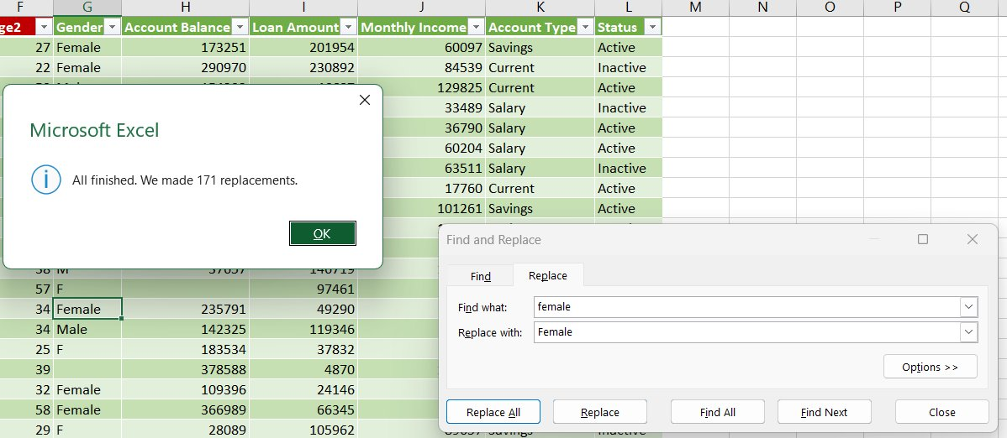
Figure 3: Find & Replace — female to Female (171 replacements)

- Name Column Creation: Combined First Name and Last Name using CONCATENATE formula to create a single Name column.

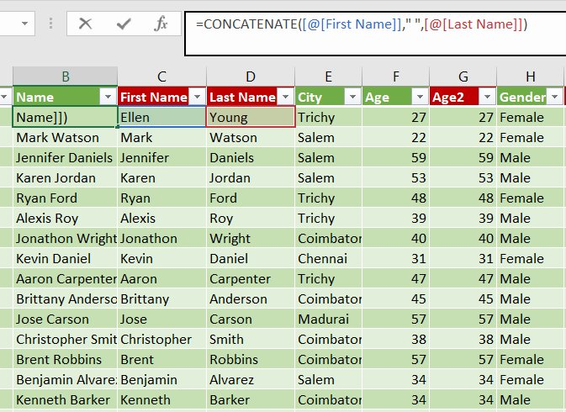
Figure 4: CONCATENATE Formula for Name Column

- Missing Value Handling: Used IF + AVERAGE formula to fill blank Account Balance cells and IF + AVERAGEIF for Loan Amount based on category average.

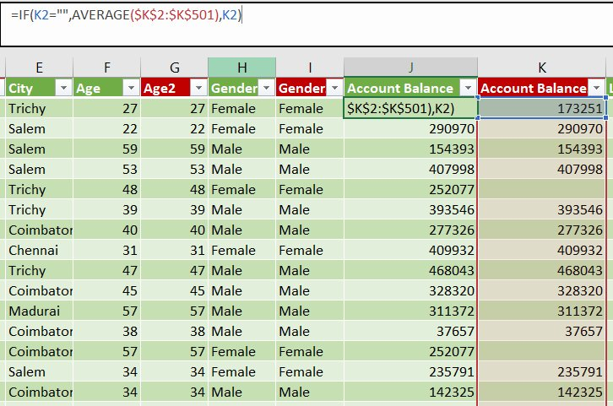
Figure 5: IF + AVERAGE Formula for Missing Account Balance

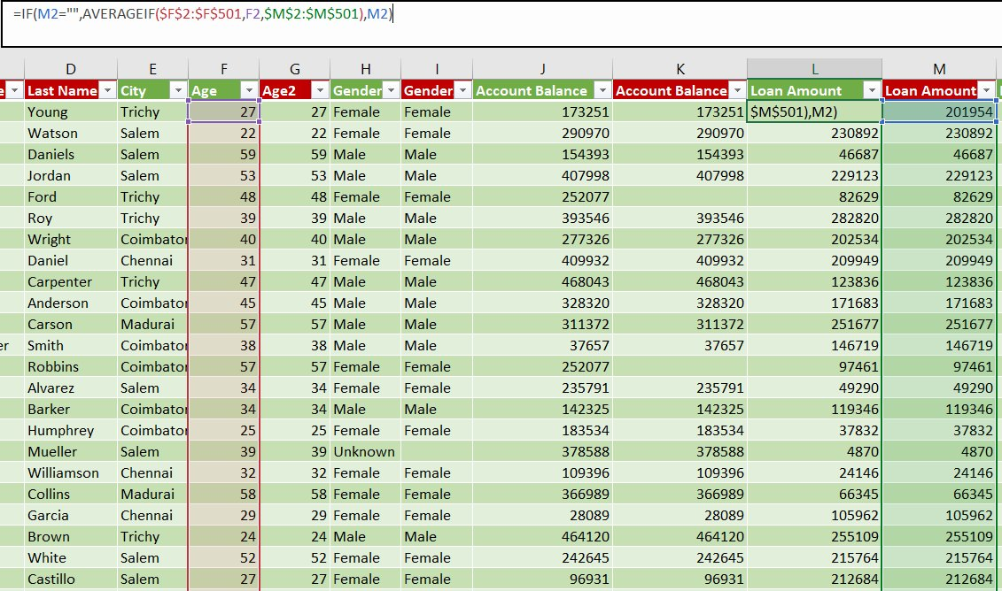
Figure 6: AVERAGEIF Formula for Missing Loan Amount

- Pivot Tables: Generated Pivot Tables for data summarisation — City-wise Account Balance, Account Type-wise Customer Count, Gender-wise Loan Amount, and Account Type-wise Monthly Income.

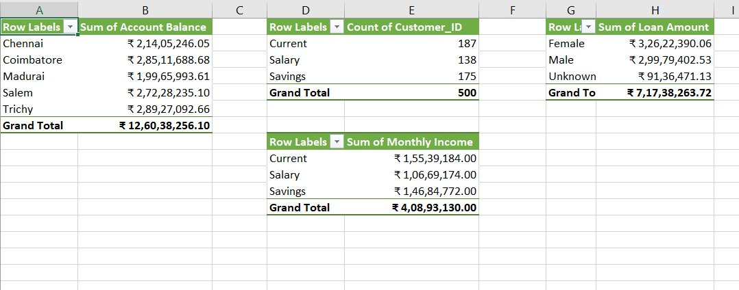
Figure 7: Pivot Tables Summary

- Power Query — Income Category Column: Added Conditional Column: Low Income (<=50K), Medium Income (<=100K), High Income (>100K).

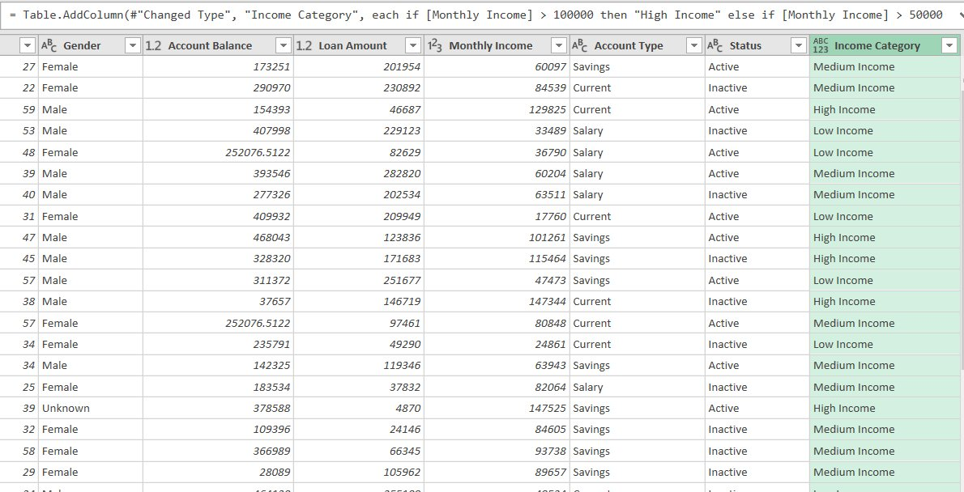
Figure 8: Income Category Conditional Column in Power Query

- Power Query — Age Group Column: Added Conditional Column: Young (Age<=30), Middle Age (Age<=50), Senior (Age>50).

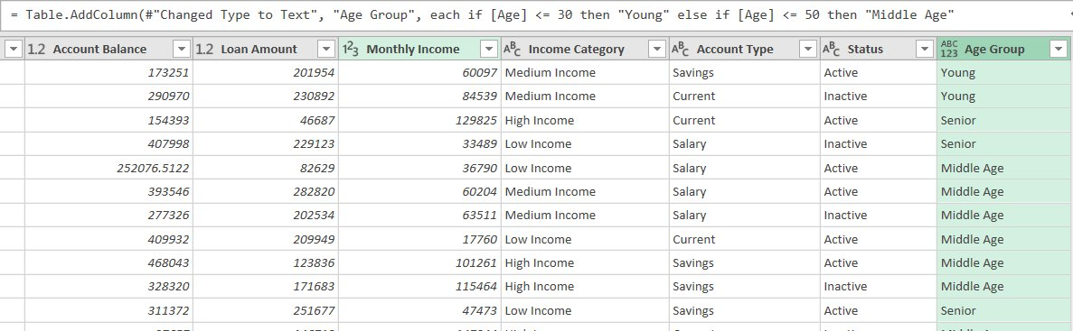
Figure 9: Age Group Conditional Column in Power Query

7. Data Modelling and DAX (Power BI)

- Data Model: Single flat table (Transformation) loaded from Excel via Power Query. Data types set for all columns — Whole Number for Age, Decimal for financial columns, Text for categorical columns.

Calculated Columns & DAX Measures:

Figure 10: Total Customers — COUNT DAX Measure

Figure 11: Average Loan Amount — AVERAGE DAX Measure

Figure 12: Average Monthly Income — AVERAGE DAX Measure

Figure 13: Active Customers — CALCULATE + COUNT DAX Measure

Measure Name | DAX Formula | Purpose
Total Customers | COUNT(Transformation[Customer_ID]) | Total number of customers
Average Loan Amount | AVERAGE(Transformation[Loan Amount]) | Average loan across all customers
Average Monthly Income | AVERAGE(Transformation[Monthly Income]) | Average monthly income
Active Customers | CALCULATE(COUNT(Transformation[Customer_ID]), Transformation[Status]="Active") | Count of active customers only

8. Analysis and Visualizations (Power BI)

Dashboard Features:

- Multiple Visualizations: Cards (KPI), Pie Chart, Bar Chart, Clustered Column Chart, Donut Chart, Map Chart, Funnel Chart, Scatter Chart, Line Chart, KPI Visual — all communicating key insights.
- Interactive Layout: 4 Slicers (Gender, Age Group, Income Category, Status) for dynamic filtering across all visuals.
- Titles & Labels: Clear titles added to every visual. Data labels and legends enabled for all charts.

# | Visual Type | Title | Insight
1 | Card x4 | Active Customers, Avg Loan, Avg Income, Total Customers | Quick KPI overview
2 | Pie Chart | Gender Distribution | Male vs Female ratio
3 | Bar Chart | Age Group vs Loan Amount | Loan pattern by age group
4 | Clustered Column | Income Category vs Account Balance | Income impact on savings
5 | Donut Chart | Account Type Distribution | Current vs Savings vs Salary split
6 | Map Chart | City wise Customer Count | Geographic customer spread
7 | Funnel Chart | Income Category wise Customer Count | Income distribution funnel
8 | Scatter Chart | Monthly Income vs Account Balance | Income-Balance correlation
9 | Line Chart | Age vs Account Balance | Balance trend across age
10 | KPI Visual | Account Balance vs Loan Amount | Balance vs loan comparison
11 | Slicers x4 | Gender, Age Group, Income Category, Status | Interactive filtering

SCREENSHOT OF DASHBOARD / REPORT

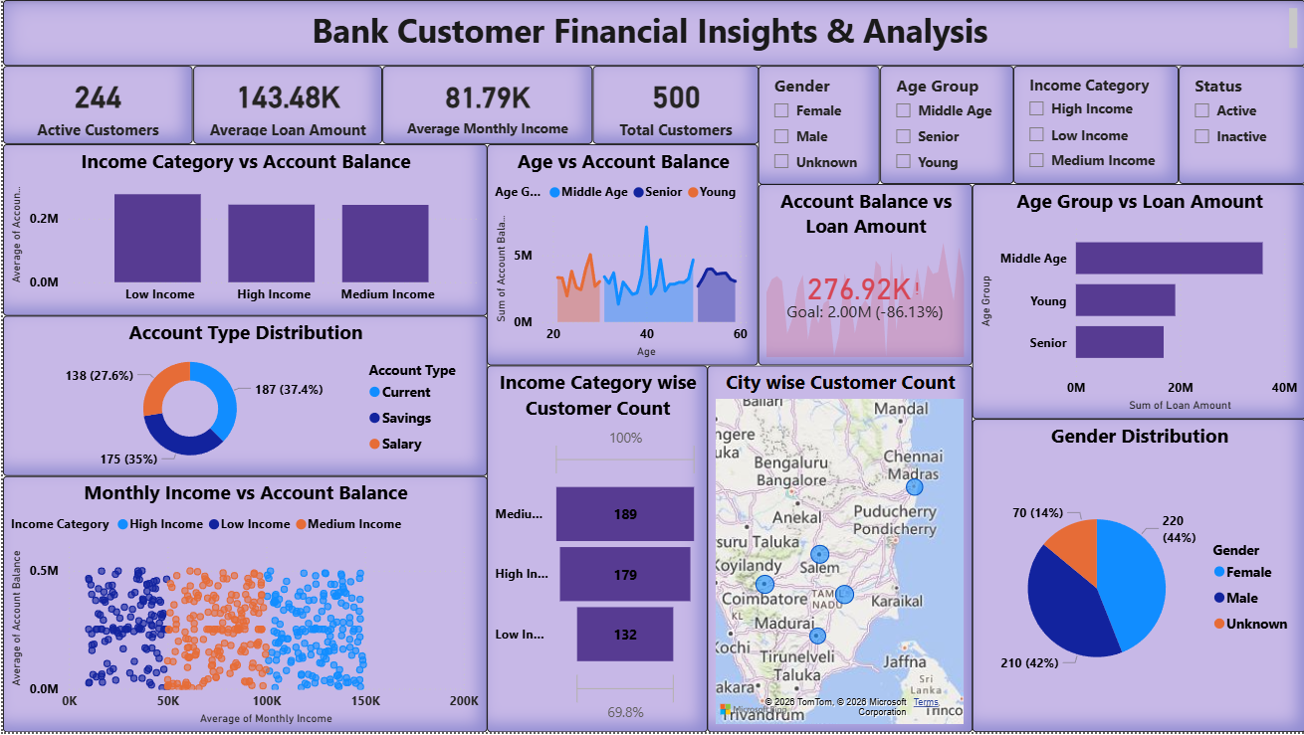
Figure 14: Final Power BI Dashboard — Bank Customer Financial Insights & Analysis

9. Insights & Conclusions

Key Findings:

- Descriptive: 500 total customers across 5 cities. 244 Active (48.8%) and 256 Inactive customers. Savings is the most popular account type (37.4%), followed by Current (35%) and Salary (27.6%).
- Diagnosis: Middle Age customers carry the highest average loan amount compared to Young and Senior groups. High Income customers maintain significantly higher account balances, indicating stronger saving habits.
- Predictive: Positive correlation observed between Monthly Income and Account Balance in the Scatter Chart — customers with higher income are likely to accumulate higher balances over time.
- Prescriptive: Bank should target Middle Age and High Income customers with premium savings products. Inactive customers (51.2%) should be engaged through personalized retention campaigns.

10. Conclusions

The integration of Excel, Power Query, and Power BI proved effective for end-to-end data analysis — from raw data cleaning to interactive visual reporting. The project successfully demonstrates data preprocessing, transformation, DAX measure creation, and dashboard design skills. The final dashboard provides actionable insights for bank management to understand customer financial behaviour and make data-driven decisions.

