**Identifying a suitable location for opening a Restaurant**

Maheswari

July 16, 2020

**1. Introduction :**

In this project we will try to find out the **suitable location for opening a Restaurant** in Chennai. This report will be targeted to the persons who are interested in opening Restaurants.

Chennai is the capital of the state Tamil Nadu and one of the biggest metropolitan cities in India. Around 10 million people live in Chennai.

Chennai is one of the important hub for IT Industry and many other business opportunities are available as it plays a pivotal role in the trading routes that crossed the Bay of Bengal. Therefore, finding out the **location which is crowded with IT companies** would help in finding the area which is having **greater people movement**.

**2. Data Analysis:**

We need to know

(i) the locations which are crowded with IT companies

(ii) need to find the center location of the locations having IT companies

(iii) no.of Andhra restaurants available in the location

**2.1 Data Sources:**

**List of IT companies** in Chennai have been taken from the below site and stored the required information in a Dataframe.

<https://en.wikipedia.org/wiki/List_of_tech_parks_in_Chennai>

**For location informaton, Used FourSquare data.**

**2.2 Data Cleanup:**

(a) There were few companies for which location information was empty, removed them from the list as it would not be useful for our analysis

(b) There were few companies which were having the street name, but location information was not available, removed it from the list

(c) Location column had full address and phone number, as these information are not requied for our analysis and this would error out while finding out the lattitude and longtitude, have removed them from the unnecessary information from the location column

(d) There was one record which was not having Company name, removed it from the list as we are not sure if it is an IT company

**3. Methodology:**

First step in our process would be **identifying the locations which are having IT companies.** For this we have used the data from <https://en.wikipedia.org/wiki/List_of_tech_parks_in_Chennai>. Locations having IT companies have been plotted in a map.

The next step is to identify the **center location of the identified locations**. In our case we identified **Thiruvanmiyur** as the center locaiton.

Then, we need to **identify types of restaurants** existing in Thiruvanmiyur.

**4. Analysis:**

By plotting the locations having IT companies in map, we could identify the center location.

We see that Thirumanmiyur is the center location of the IT companies.

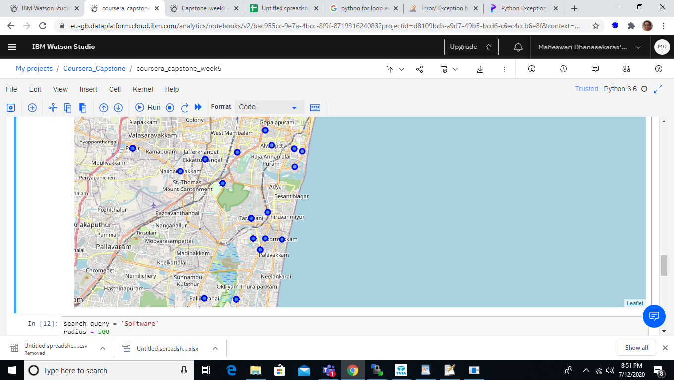

Further, we need **to analyze Thiruvanmiyur location**. Need to check the type of restaurants available in that place. Now, using the foursquare app, we are getting the list of restaurants which exists **within 5KM radius from Thiruvanmiyur.**

Indian Restaurants, vegeterian Restaurant and Asian Restaurans are available in this location.

**Number of Andhra Restaurant in this area is only one.**

There fore, we suggest **opening an Andhra Restaurant in Thiruvanmiyur would help succeeding in the business.**

**5. Conclusion:**

In this project, I have analyzed the area which is having IT companies, by which we identified the locations having greater people movement. Then we identified the center location of these neighborhoods. The number of Andhra restaurants is very less in this in this location. Hence, we suggest opening an Andhra restaurant in Thiruvanmiyur.