🛒 Retail / E-commerce Sales Analysis

📌 Project Overview
This project analyzes retail sales data from the Sample Superstore Dataset using Python and Tableau.
The main objective is to understand sales performance, profit trends, customer behavior, and regional business performance to support better business decisions.

🚀 Technologies Used
- Python
- Pandas
- NumPy
- Matplotlib
- Seaborn
- Tableau
- Jupyter Notebook

📂 Dataset
Dataset Used: Sample Superstore Dataset
The dataset contains:
- Order ID
- Order Date
- Ship Date
- Ship Mode
- Customer ID
- Customer Name
- Segment
- Country
- City
- State
- Region
- Product ID
- Category
- Sub-Category
- Product Name
- Sales
- Quantity
- Discount
- Profit

📊 Steps Performed
1️⃣ Data Collection
- Collected Superstore sales dataset
- Imported dataset into Jupyter Notebook
2️⃣ Data Understanding
- Checked rows and columns
- Explored data structure
- Identified features and data types
3️⃣ Data Cleaning
- Checked missing values
- Removed duplicate records
- Standardized column names
- Verified data consistency
4️⃣ Exploratory Data Analysis (EDA)
- Sales analysis
- Profit analysis
- Regional analysis
- Category & Sub-category analysis
- Customer segment analysis
- Discount impact analysis
5️⃣ Data Visualization
Created:
- Bar Charts
- Pie Charts
- Histograms
- Line Charts
- Boxplots
- Heatmaps
- Sales Trend Graphs
6️⃣ Tableau Dashboard
Created an interactive dashboard containing:
- KPI Cards (Sales, Profit, Quantity)
- Region-wise Sales Analysis
- Category-wise Sales Comparison
- Monthly Revenue Trend
- Profit Analysis
- Segment-wise Performance
- Top Selling Products

📈 Key Insights
- Technology category generated high sales revenue.
- Some products had high sales but low profit due to discounts.
- Western region showed strong sales performance.
- Discounts negatively affected profit in some categories.
- Consumer segment contributed major sales.
- Certain sub-categories showed consistent losses.

🏫 Business Recommendations
Reduce unnecessary discounts on low-profit products.
Focus on high-performing categories and regions.
Improve inventory for best-selling products.
Optimize pricing strategies.
Monitor low-performing sub-categories.
Use dashboard insights for better business planning.

📊 Dashboard Preview
This Tableau dashboard provides a clear overview of Retail / E-commerce Sales Analysis by visualizing category-wise sales and performance metrics.
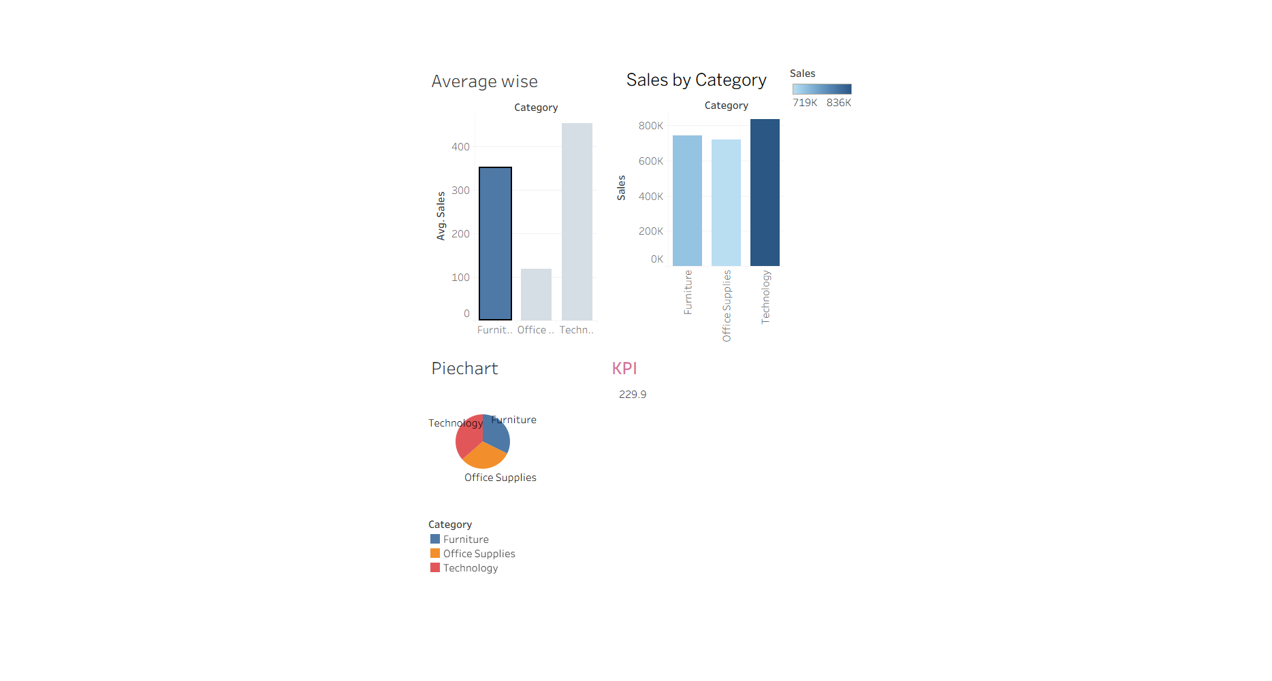
- Average Sales by Category – Comparison of average sales across Furniture, Office Supplies, and Technology.
- Sales by Category – Total sales distribution among major product categories.
- Pie Chart Analysis – Percentage contribution of each category to overall sales.
- KPI Card – Displays key performance indicator (Average Sales ≈ 229.9).
- Category Comparison – Helps identify top-performing product categories.

🎯 Conclusion
- This dashboard helps analyze sales trends, category performance, and business KPIs using Tableau.
- It supports better decision-making by identifying profitable categories and improving sales strategy.

👩‍💻 Author
Maheswari

