MAHESWARI S-764701

MILESTONE-2 MIDDLEWARE BATCH-2

STOCK MARKET CHARTING

Github link:

https://github.com/Maheswari12345/StockExchange_milestone_2

Addcompany page using hibernate,html,css,springmvc:

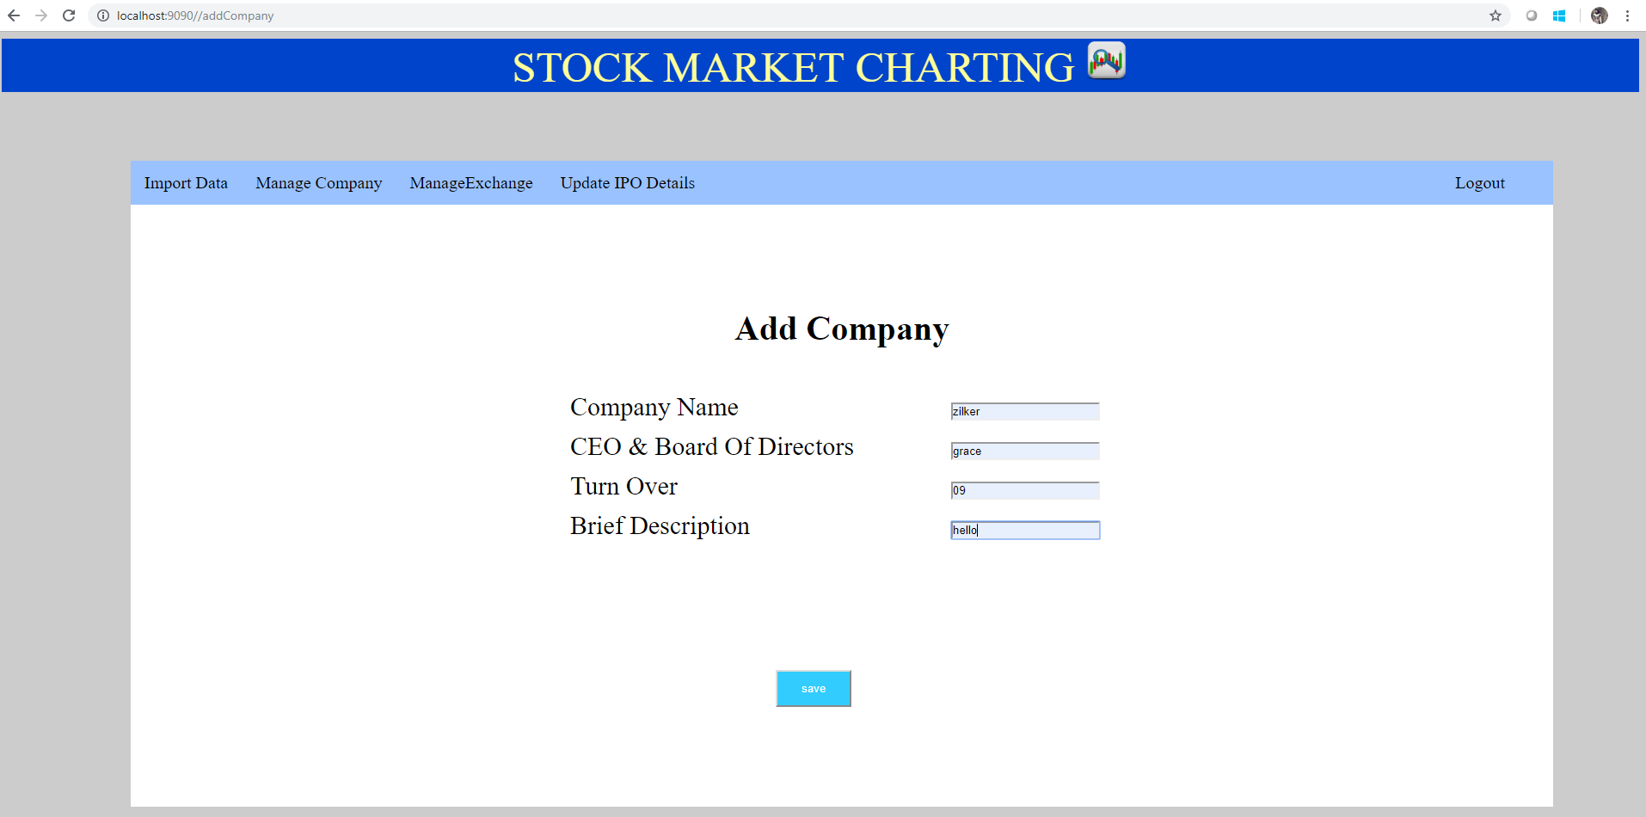

ListCompanyList page using hibernate,html,css,springmvc

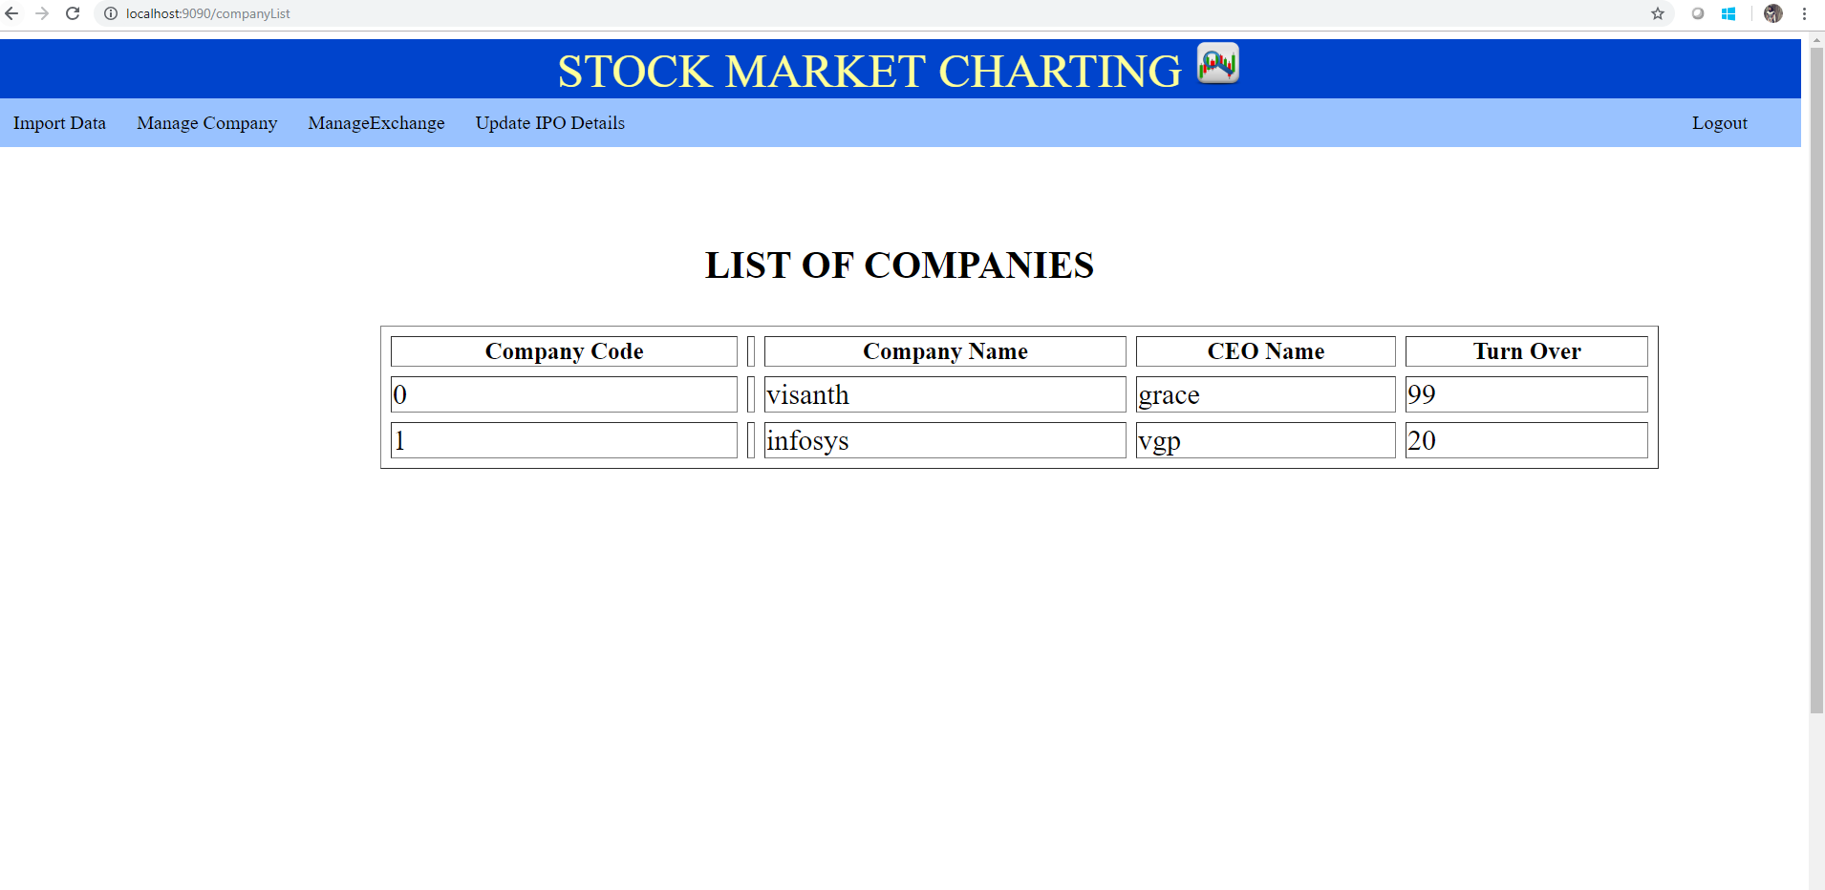

Userregistration using hibernate,springmvc,html,css

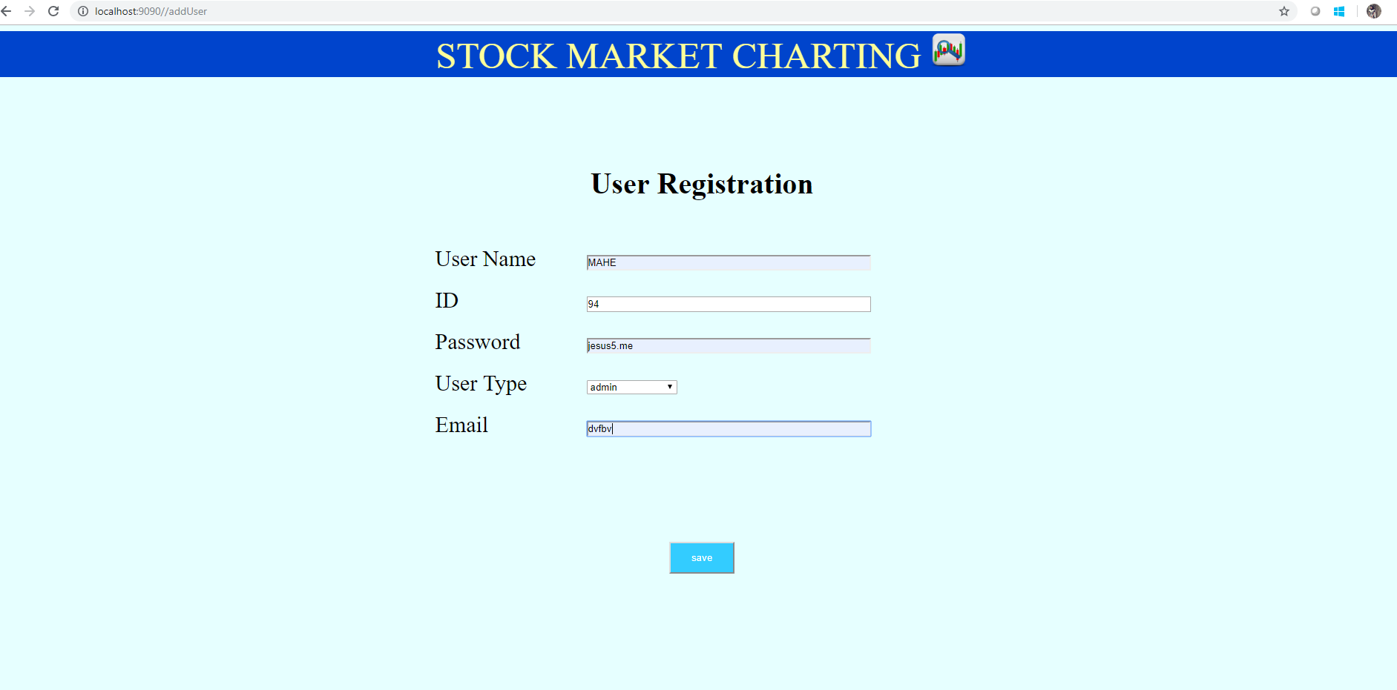

addStockExchange using hibernate,springmvc,html,css

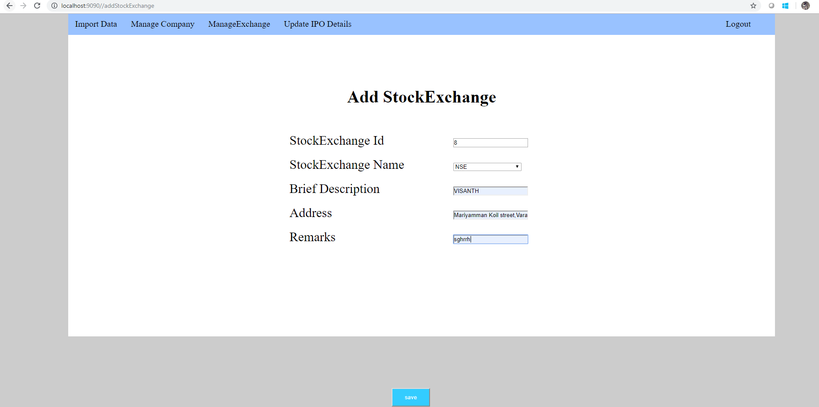

Liststockexchange using hibernate,springmvc,html,css:

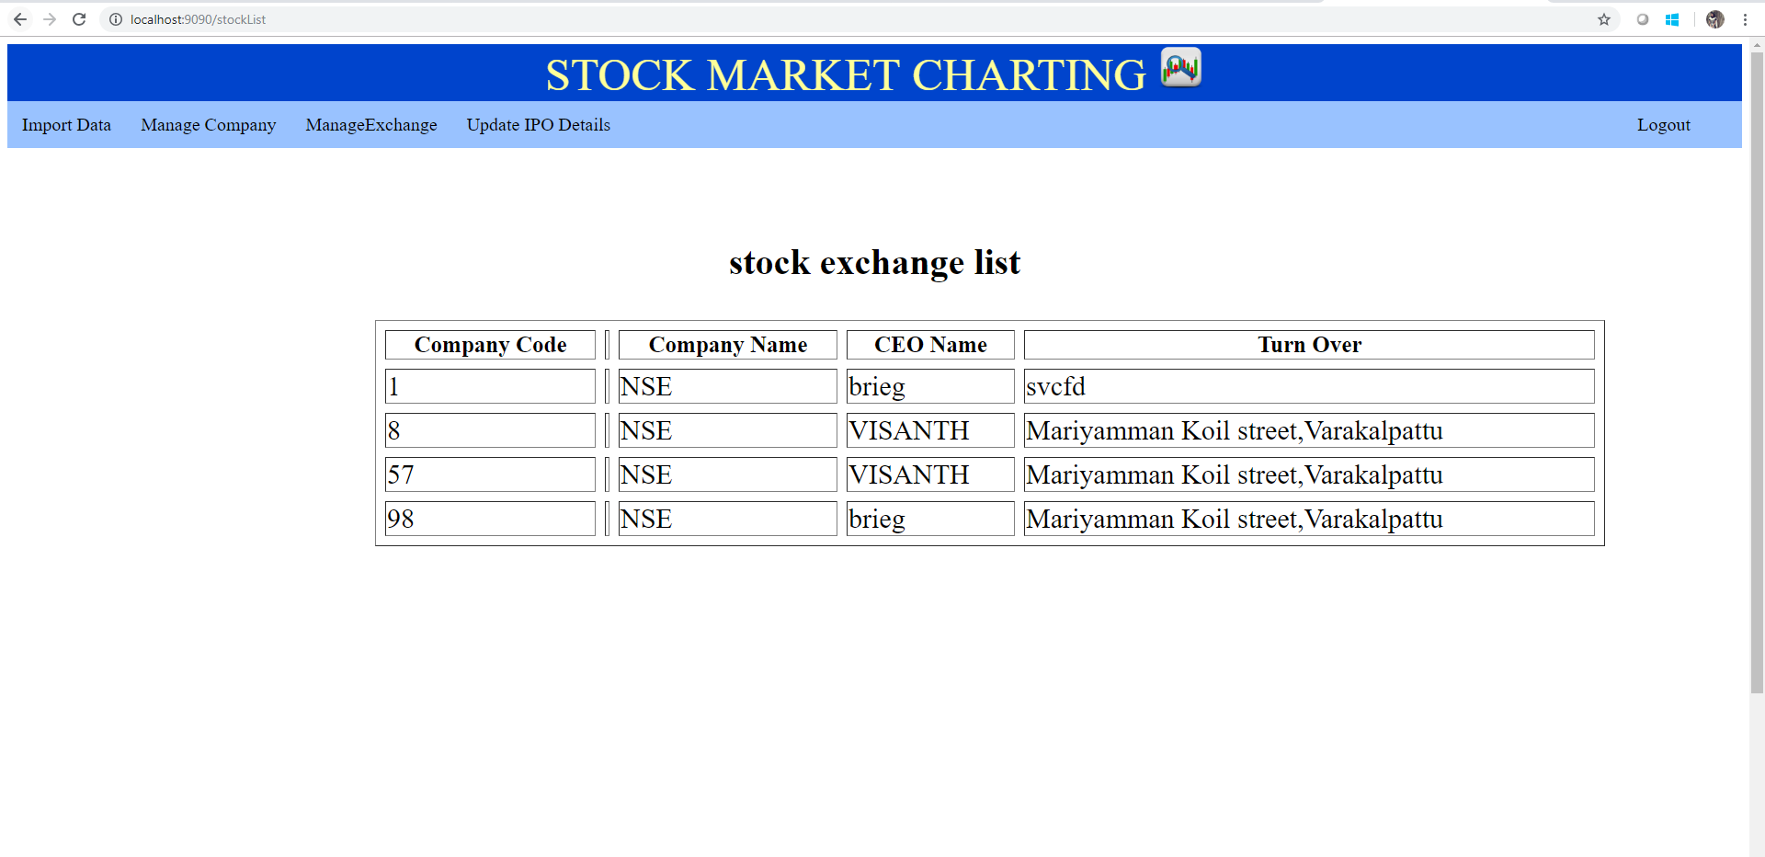

addipo planned using hibernate,springmvc,html,css:

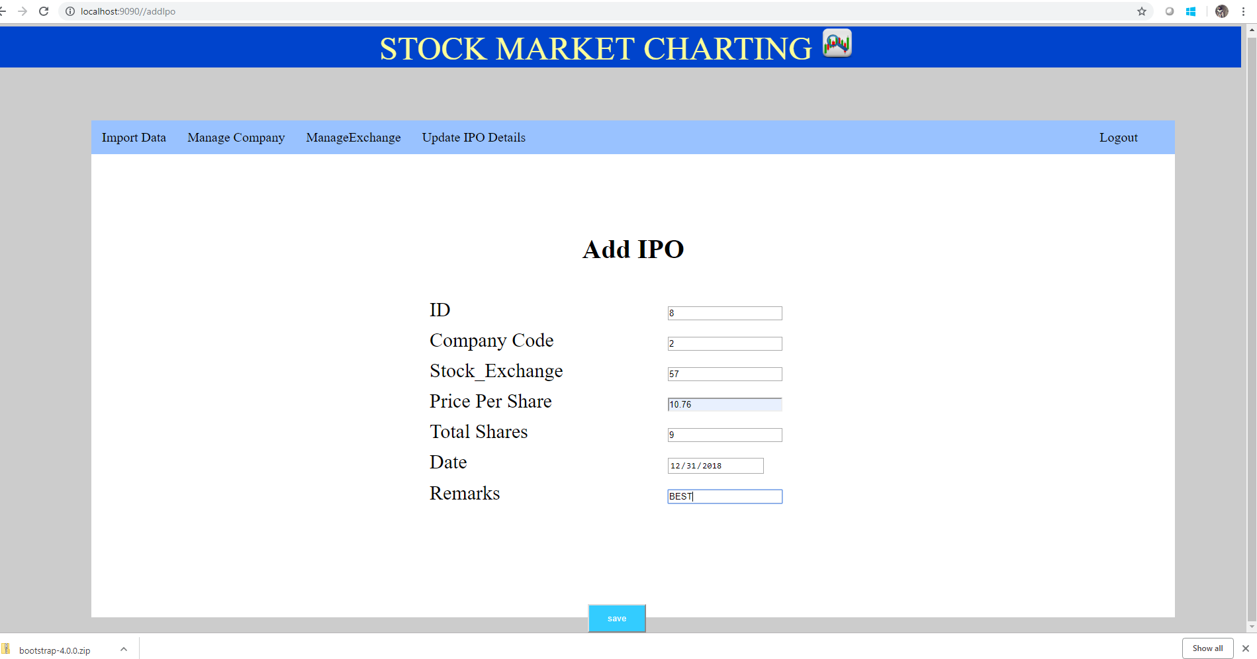

listipo using hibernate,springmvc,html,css:

