MILESTONE:1

MIDDLEWARE BATCH

EMP_ID:764701

EMP_NAME: Maheswari S

PROJECT NAME: Stock Market Charting

SCHEMA DIAGRAM FOR STOCK EXCHANGE:

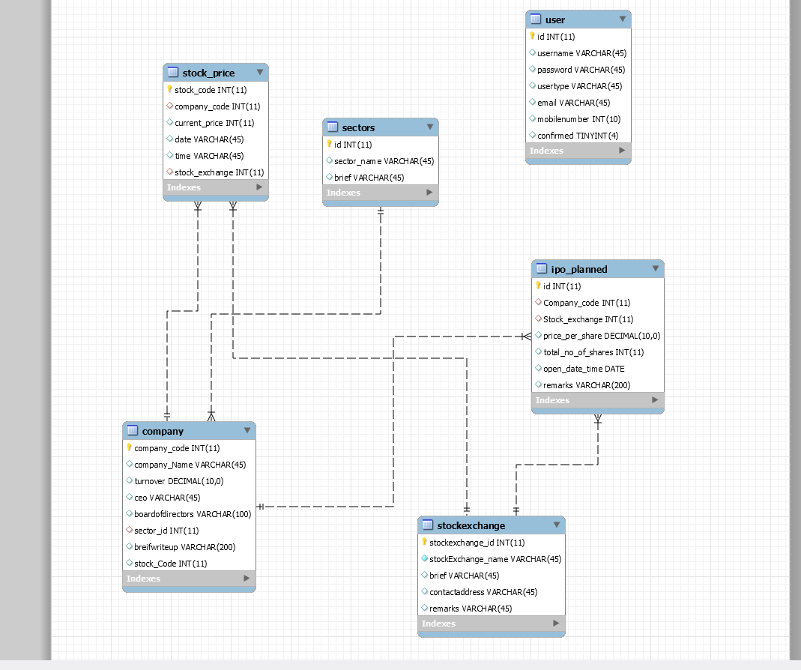

HTML PAGES:­­­­

INDEX PAGE:

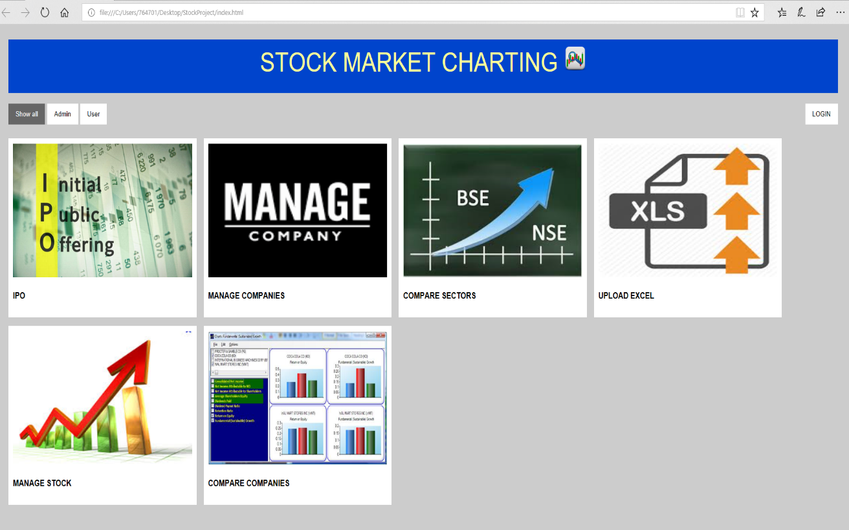

ABOUTEXCELUPLOAD:

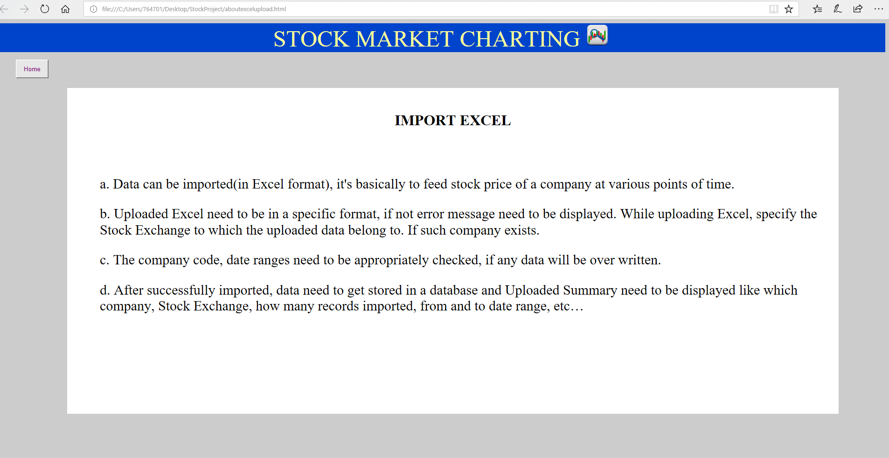

ABOUTMANAGE COMPANY

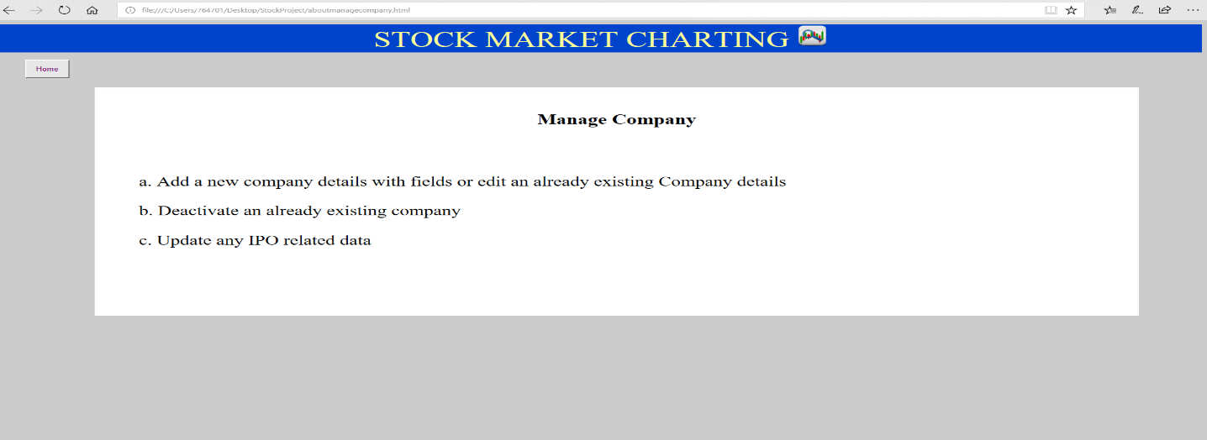

ABOUT MANAGE EXCHANGE:

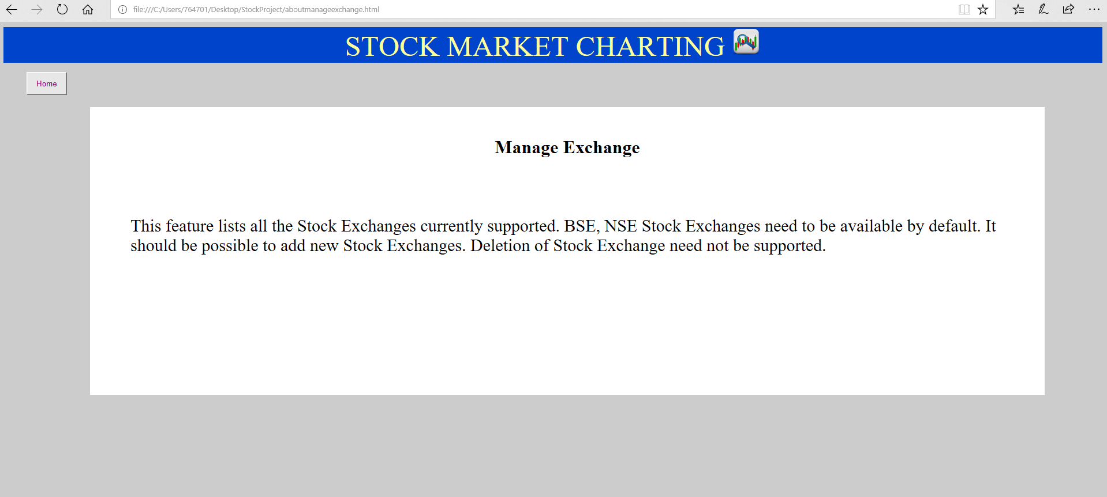

ADMIN LANDING:

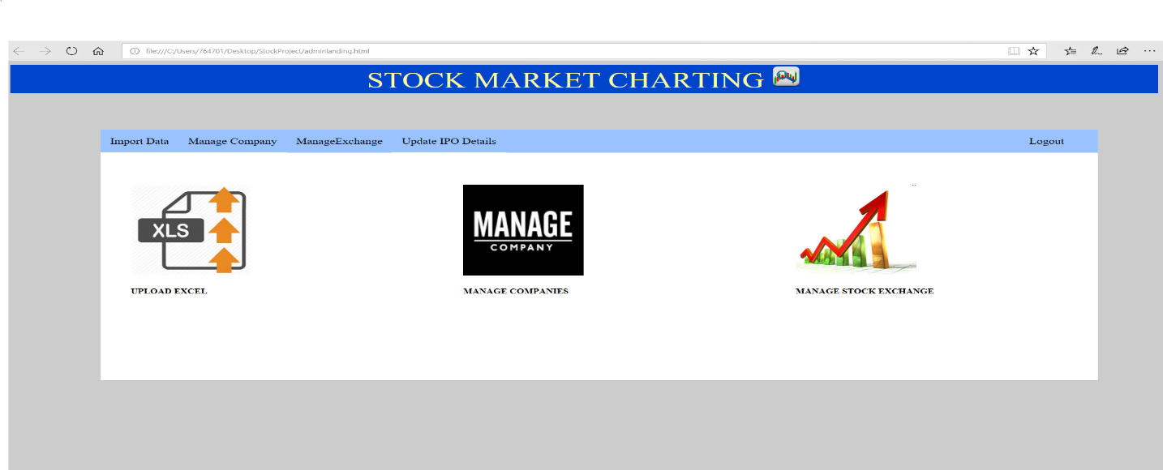

EXCEL UPLOAD:

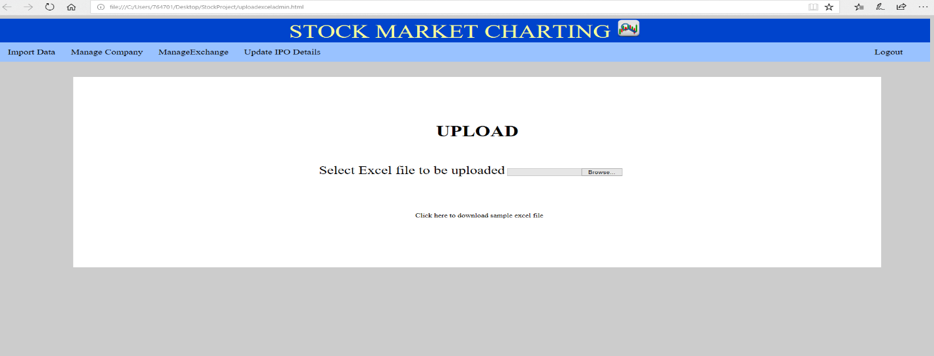

EXCEL UPLOAD SUMMARY:

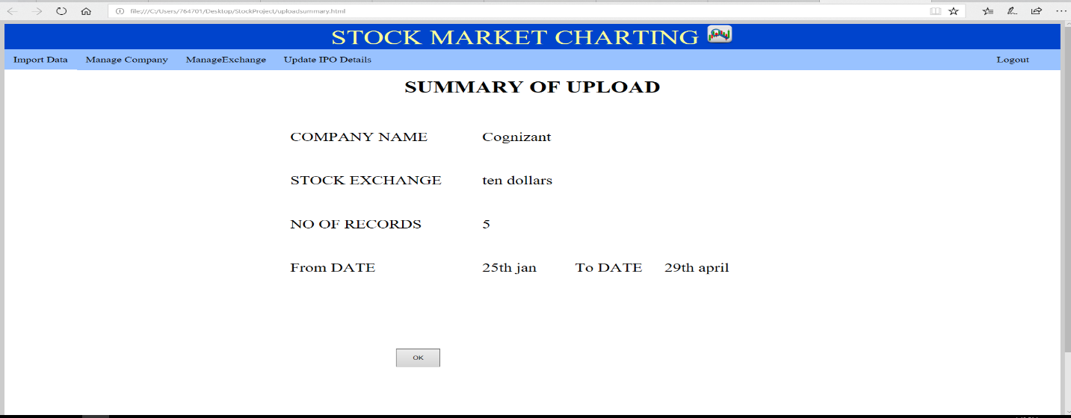

ADD COMPANY:

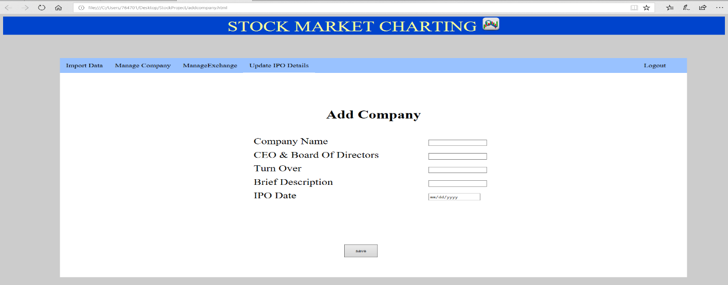

MANAGE COMPANIES:

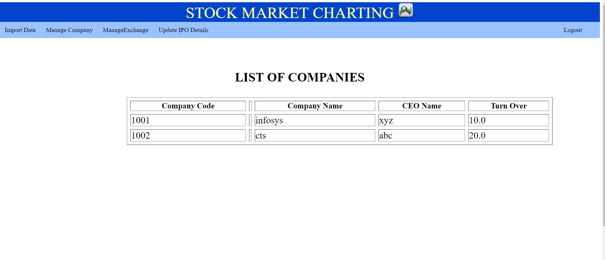

USER LANDING:

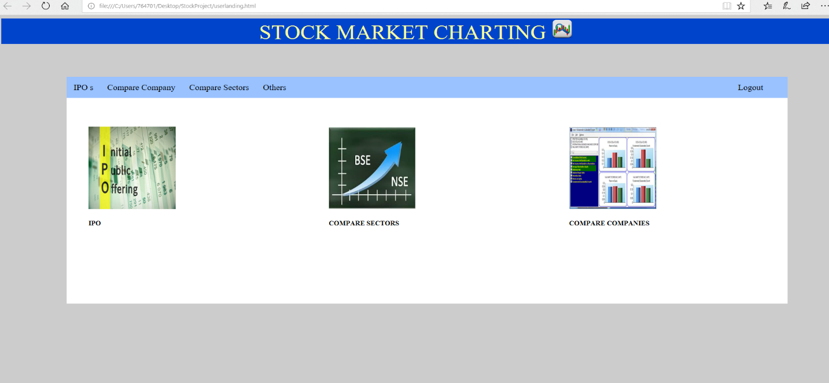

GENERATING COMPARISON CHART:

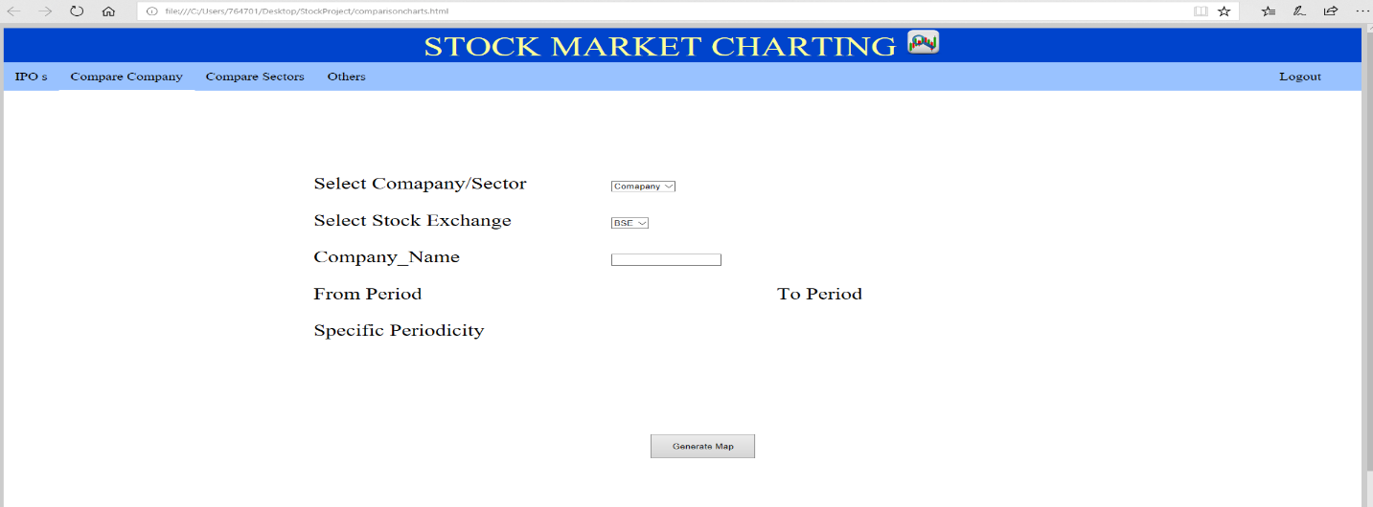

GITHUB LINK FOR COMPANY VIEW:

<https://github.com/Maheswari12345/stockExchange_companyView>

RESULT FOR COMPANY LIST:

