**WEBSITE TRAFFIC ANALYSIS**

**PHASE 2: INNOVATION**

1. **Data Collection and Processing**: Collect and process extensive data on user behavior including page views, click-through rates, time spent on pages, bounce rates, referral sources, and more.
2. **Machine Learning Models**: Train machine learning models using this data to understand patterns and correlations in user behavior. Deep learning models, such as recurrent neural networks (RNNs) or transformers, can be employed for this task.
3. **Real-time Analysis**: Implement a real-time analysis component that continuously processes incoming data to update user behavior predictions. This allows for immediate insights and adaptability.
4. **User Segmentation**: Categorize users into segments based on their predicted behavior. For instance, "likely to convert," "likely to bounce," etc.
5. **Personalization Recommendations**: Utilize these predictions to dynamically personalize content, offers, and suggestions for each user segment.
6. **A/B Testing Optimization**: Integrate with A/B testing tools to automatically optimize experiments based on predicted user behavior. For example, if a user is predicted to be less likely to convert, they might see a different variation of a page.
7. **Dynamic Content Generation**: Use predictions to dynamically generate content that is more likely to engage each user segment. This could include personalized product recommendations, tailored messaging, or curated content lists.
8. **Alerts and Notifications**: Send alerts or notifications when certain user behaviors deviate significantly from predictions. This could help businesses react quickly to potential issues or opportunities.
9. **Feedback Loop**: Implement a feedback loop where the predictions are continuously refined based on actual user behavior, ensuring that the system becomes more accurate over time.
10. **Privacy Considerations**: Ensure compliance with privacy regulations by anonymizing and aggregating data, and providing clear opt-out options for users who don't want their behavior to be analyzed.

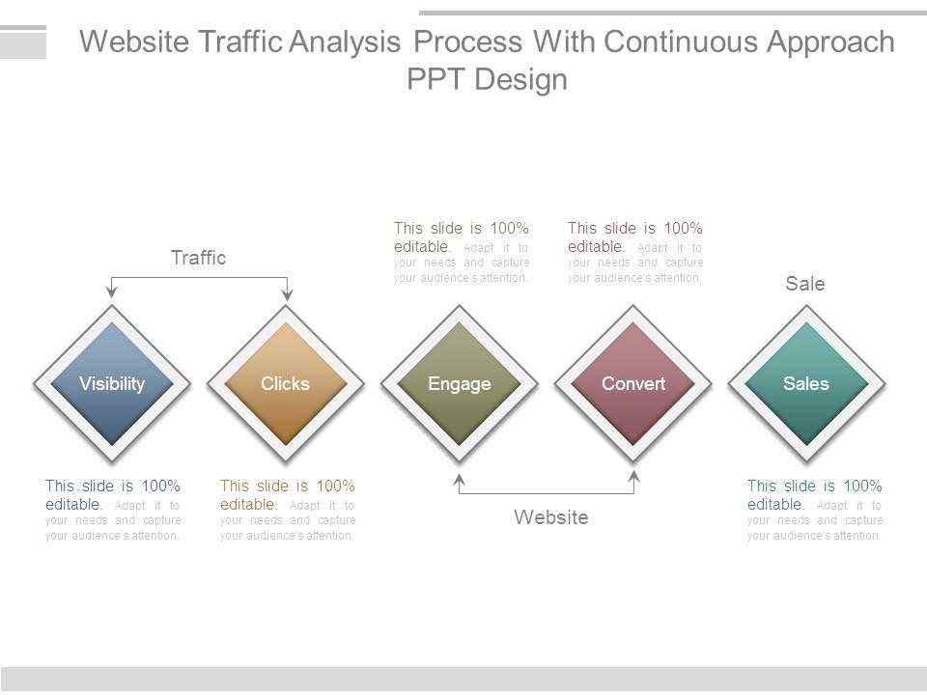**Website Traffic Analysis**

|  |  |
| --- | --- |
| def main(): |  |
|  | analytics = initialize_analyticsreporting() | |  |
|  |  | |  |
|  | global dfanalytics | |  |
|  | dfanalytics = [] | |  |
|  |  | |  |
|  | rows = [] | |  |
|  | rows = handle_report(analytics,'0',rows) | |  |
|  |  | |  |
|  | dfanalytics = pd.DataFrame(list(rows)) | |  |
|  |  | |  |
|  |  | |  |
|  | main() | |  |
|  |  | |  |
|  | print(dfanalytics) | |  |

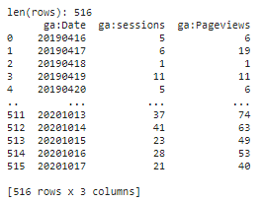

|  |  |
| --- | --- |
|  | dfanalytics.plot() |

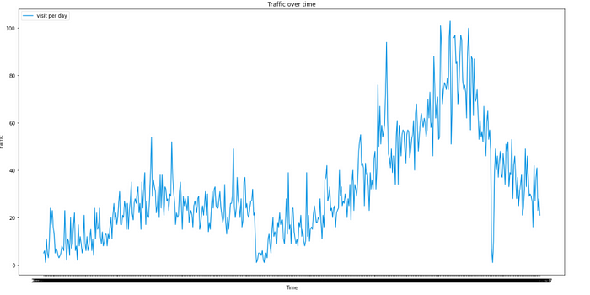

|  |  |
| --- | --- |
|  | forecast = model.predict(future) |
|  | model.plot(forecast) |

