Name:-D.Maheswari

Rollno:- 23p35a1203

1. Take a screenshot of wireless adapter model of your laptop and paste here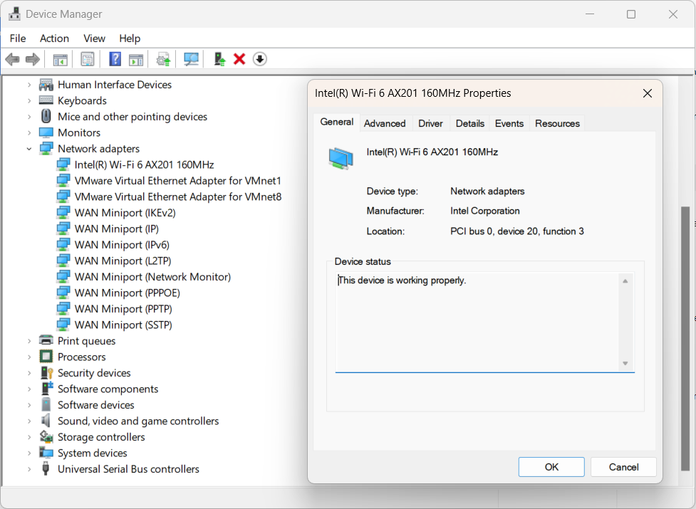
2. Take a screenshot of partitions information in your laptop and paste here

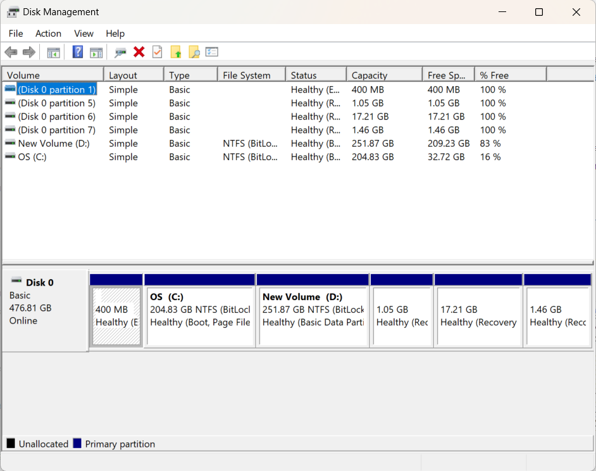

3.Post the screen shot of display chip type

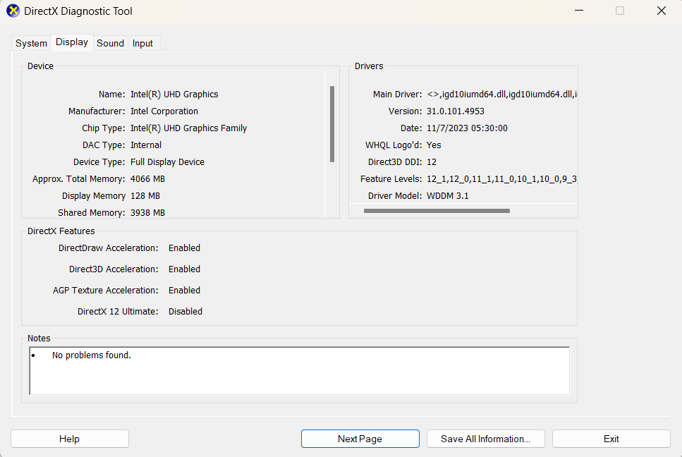

4.Post the screenshot of BIOS version

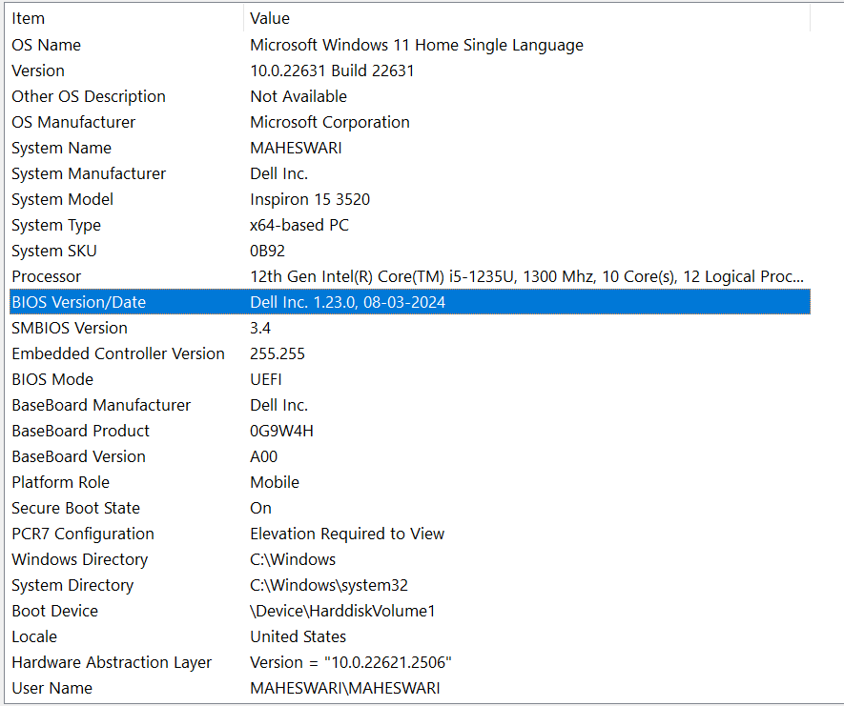

5. Take a screenshot of processor information and post here

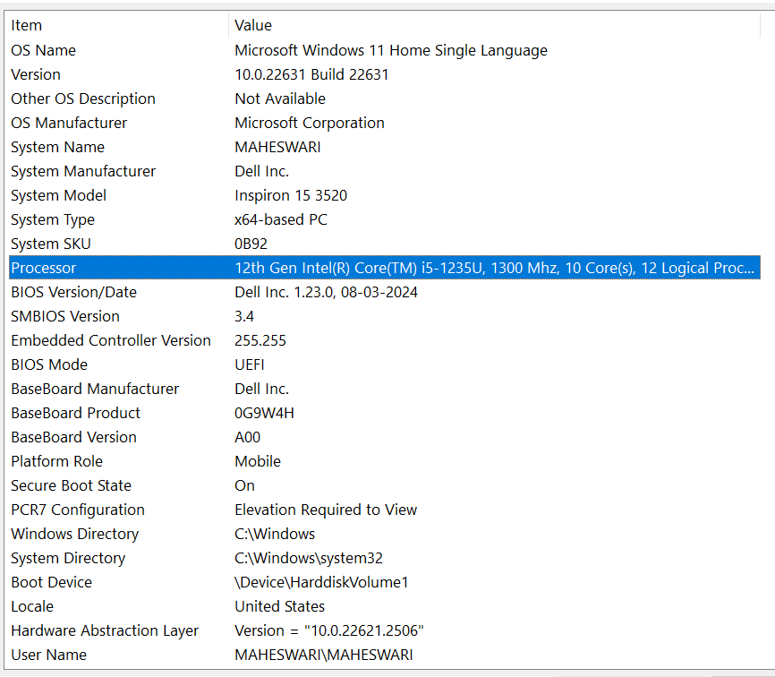

6. Locate Total Virtual Memory and post the screen shot here

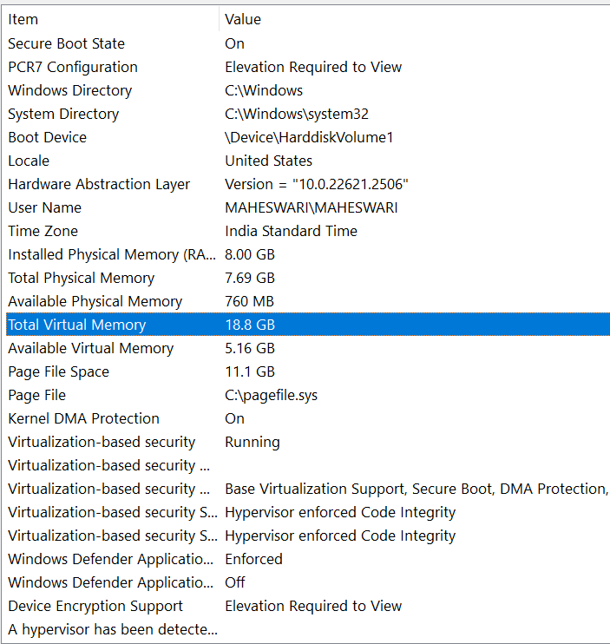

7. Locate and post the screen shot of CPU threads currently running in background

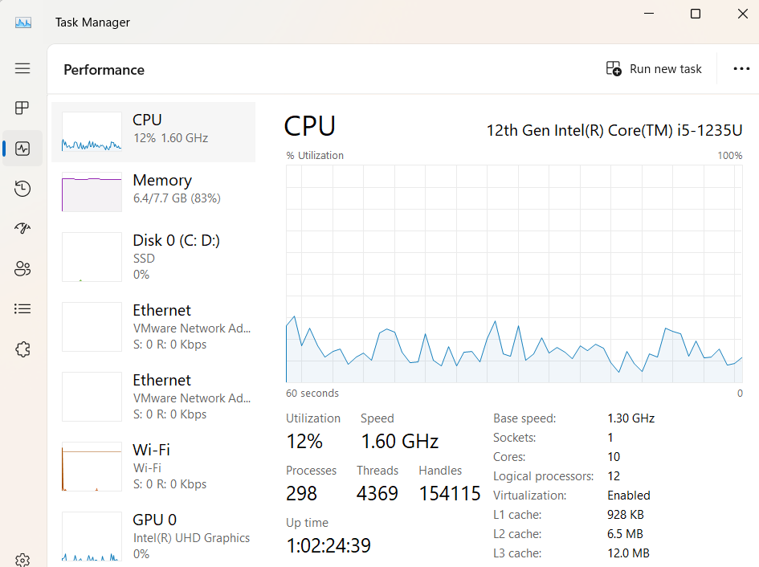

8. Post the screen shot of System Type

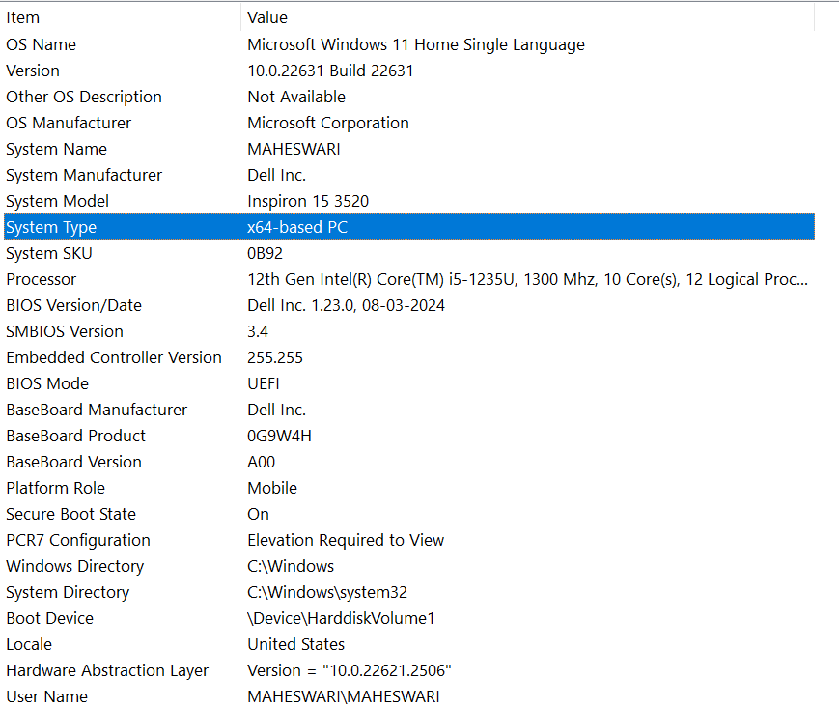

9. Post the screen shot of memory usage of Google Chrome running in your laptop

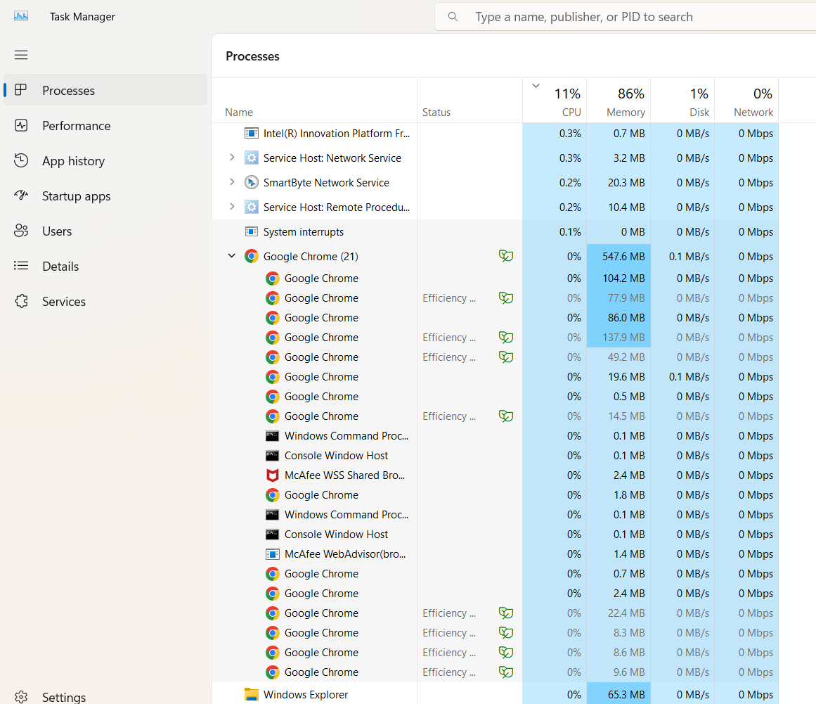

10. Take a screenshot of CPU usage of Microsoft word application running in laptop

