Exercise 1: Inventory Management System
Scenario:
You are developing an inventory management system for a warehouse. Efficient data storage and retrieval are crucial.
Product.java
package com.cognizant.InventoryManagementSystem;
public class Product {
int productId;
String productName;
int quantity;
double price;
public Product(int productId, String productName, int quantity, double price) {
this.productId = productId;
this.productName = productName;
this.quantity = quantity;
this.price = price;
}
@Override
public String toString() {
return productId + " " + productName + " " + quantity + " " + price;
}
}
package com.cognizant.InventoryManagementSystem;
public class Product {
int productId;
String productName;
int quantity;
double price;
public Product(int productId, String productName, int quantity, double price) {
this.productId = productId;
this.productName = productName;
this.quantity = quantity;
this.price = price;
}
@Override
public String toString() {
return productId + " " + productName + " " + quantity + " " + price;
}
}

Inventory.java
package com.cognizant.InventoryManagementSystem;
import java.util.HashMap;
public class Inventory {
HashMap<Integer, Product> products = new HashMap<>();
public void addProduct(Product product) {
products.put(product.productId, product);
System.out.println("Product Added");
}
public void updateProduct(int id, int quantity, double price) {
Product product = products.get(id);
if (product != null) {
product.quantity = quantity;
product.price = price;
System.out.println("Product Updated");
} else {
System.out.println("Product Not Found");
}
}
public void deleteProduct(int id) {
if (products.remove(id) != null) {
System.out.println("Product Deleted");
} else {
System.out.println("Product Not Found");
}
}
public void displayProducts() {
for (Product product : products.values()) {
System.out.println(product);
}
}
}

Main.java
package com.cognizant.InventoryManagementSystem;
public class Main {
public static void main(String[] args) {
Inventory inventory = new Inventory();
inventory.addProduct(new Product(101, "Laptop", 10, 55000));
inventory.addProduct(new Product(102, "Mouse", 50, 500));
inventory.addProduct(new Product(103, "Keyboard", 20, 1200));
System.out.println("\nInventory:");
inventory.displayProducts();
System.out.println("\nUpdating Product 102");
inventory.updateProduct(102, 75, 450);
System.out.println("\nInventory:");
inventory.displayProducts();
System.out.println("\nDeleting Product 101");
inventory.deleteProduct(101);
System.out.println("\nInventory:");
inventory.displayProducts();
}
}
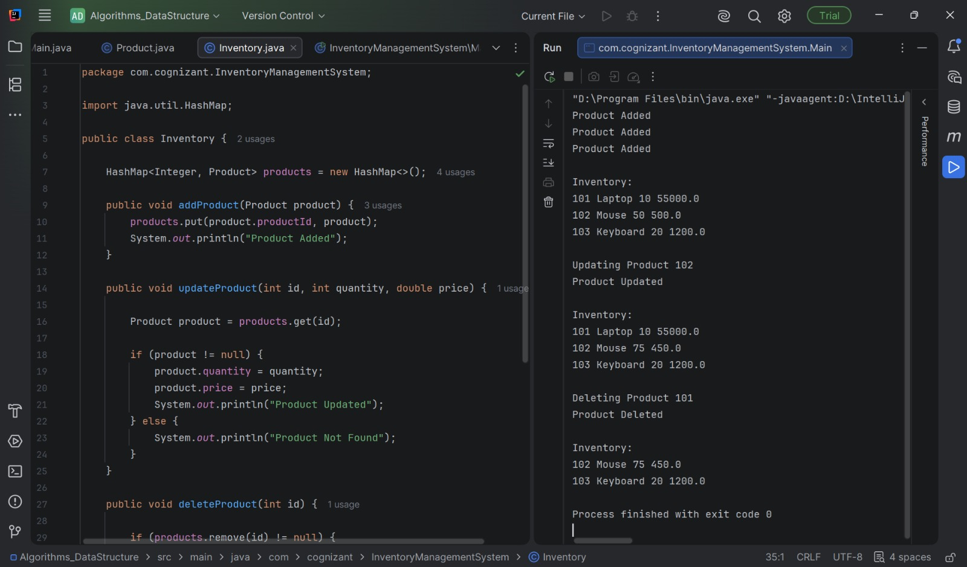
Exercise 2: E-commerce Platform Search Function
Scenario:
You are working on the search functionality of an e-commerce platform. The search needs to be optimized for fast performance

Product.java
package com.cognizant.EcommercePlatformSearch;
public class Product {
int productId;
String productName;
String category;
public Product(int productId, String productName, String category) {
this.productId = productId;
this.productName = productName;
this.category = category;
}
@Override
public String toString() {
return productId + " " + productName + " " + category;
}
}

Search.java
package com.cognizant.EcommercePlatformSearch;
public class Search {
public static Product linearSearch(Product[] products, String name) {
for (Product product : products) {
if (product.productName.equalsIgnoreCase(name)) {
return product;
}
}
return null;
}
public static Product binarySearch(Product[] products, String name) {
int low = 0;
int high = products.length - 1;
while (low <= high) {
int mid = (low + high) / 2;
int result = products[mid].productName.compareToIgnoreCase(name);
if (result == 0)
return products[mid];
else if (result < 0)
low = mid + 1;
else
high = mid - 1;
}
return null;
}
}

Main.java
package com.cognizant.EcommercePlatformSearch;
public class Main {
public static void main(String[] args) {
Product[] products = {
new Product(101, "Keyboard", "Electronics"),
new Product(102, "Laptop", "Electronics"),
new Product(103, "Mouse", "Electronics"),
new Product(104, "Phone", "Mobiles"),
new Product(105, "Watch", "Accessories")
};
Product p1 = Search.linearSearch(products, "Mouse");
if (p1 != null)
System.out.println("Linear Search: " + p1);
else
System.out.println("Product Not Found");
Product p2 = Search.binarySearch(products, "Mouse");
if (p2 != null)
System.out.println("Binary Search: " + p2);
else
System.out.println("Product Not Found");
}
}

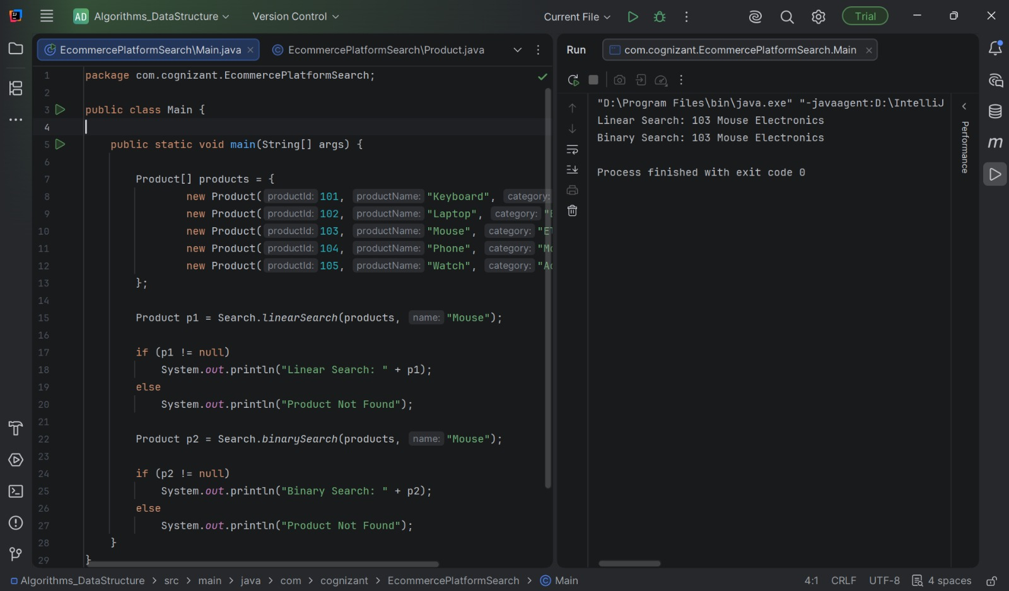

Exercise 3: Sorting Customer Orders
Scenario:
You are tasked with sorting customer orders by their total price on an e-commerce platform. This helps in prioritizing high-value orders.

Order.java
package com.cognizant.SortingCustomersOrders;
public class Order {
int orderId;
String customerName;
double totalPrice;
public Order(int orderId, String customerName, double totalPrice) {
this.orderId = orderId;
this.customerName = customerName;
this.totalPrice = totalPrice;
}
@Override
public String toString() {
return orderId + " " + customerName + " " + totalPrice;
}
}

Sort.java

package com.cognizant.SortingCustomersOrders;
public class Sort {
public static void bubbleSort(Order[] orders) {
int n = orders.length;
for (int i = 0; i < n - 1; i++) {
for (int j = 0; j < n - i - 1; j++) {
if (orders[j].totalPrice > orders[j + 1].totalPrice) {
Order temp = orders[j];
orders[j] = orders[j + 1];
orders[j + 1] = temp;
}
}
}
}
public static void quickSort(Order[] orders, int low, int high) {
if (low < high) {
int pivot = partition(orders, low, high);
quickSort(orders, low, pivot - 1);
quickSort(orders, pivot + 1, high);
}
}
private static int partition(Order[] orders, int low, int high) {
double pivot = orders[high].totalPrice;
int i = low - 1;
for (int j = low; j < high; j++) {
if (orders[j].totalPrice <= pivot) {
i++;
Order temp = orders[i];
orders[i] = orders[j];
orders[j] = temp;
}
}
Order temp = orders[i + 1];
orders[i + 1] = orders[high];
orders[high] = temp;
return i + 1;
}
}

Main.java
package com.cognizant.SortingCustomersOrders;
public class Main {
public static void main(String[] args) {
Order[] orders = {
new Order(101, "Alice", 2500),
new Order(102, "Bob", 1000),
new Order(103, "Charlie", 5000),
new Order(104, "David", 3000)
};
System.out.println("Before Sorting:");
for (Order order : orders)
System.out.println(order);
Sort.quickSort(orders, 0, orders.length - 1);
System.out.println("\nAfter Quick Sort:");
for (Order order : orders)
System.out.println(order);
}
}



Exercise 4: Employee Management System
Scenario:
You are developing an employee management system for a company. Efficiently managing employee records is crucial.

Employee.java

package com.cognizant.EmployeeManagementSystem;
public class Employee {
int employeeId;
String name;
String position;
long salary;
Employee(int employeeId, String name, String position, long salary){
this.employeeId = employeeId;
this.name = name;
this.position = position;
this.salary = salary;
}
@Override
public String toString(){
return "Employee Id: "+employeeId+"\nName: "+name+"\nPosition: "+position+"\nSalary: "+salary+"\n\n";
}
}

EmployeeOperations.java
package com.cognizant.EmployeeManagementSystem;
public class EmployeeOperations {
Employee[] employees;
int length;
int size;
EmployeeOperations(int n){
this.employees = new Employee[n];
this.length =0;
this.size=n;
}
void addEmployee(Employee newEmployee){
if(length<size){
employees[length] = newEmployee;
length++;
}
else{
System.out.println("Can't add anymore employees system is fulll!!!");
}
}
void traverse(){
for(int i=0;i<length;i++){
System.out.println(employees[i]);
}
}
void search(int targetEmployeeId){
boolean isFound = false;
int index = -1;
for(int i=0;i<length;i++){
if(employees[i].employeeId == targetEmployeeId){
isFound = true;
index = i;
break;
}
}
if(isFound){
System.out.println("Employee found: ");
System.out.println(employees[index]);
}
else{
System.out.println("Employee not found!!");
}
}
void deleteEmployee(int targetEmployeeId) {
int index = -1;
for (int i = 0; i < length; i++) {
if (employees[i].employeeId == targetEmployeeId) {
index = i;
break;
}
}
if (index == -1) {
System.out.println("Employee not found!!");
return;
}
for (int i = index; i < length - 1; i++) {
employees[i] = employees[i + 1];
}
employees[length - 1] = null;
length--;
System.out.println("Employee deleted successfully.");
}
}

Main.java

package com.cognizant.EmployeeManagementSystem;
public class Main {
public static void main(String[] args) {
EmployeeOperations empOps = new EmployeeOperations(5);
empOps.addEmployee(new Employee(101, "Alice", "Manager", 75000));
empOps.addEmployee(new Employee(102, "Bob", "Developer", 60000));
empOps.addEmployee(new Employee(103, "Charlie", "Tester", 50000));
System.out.println("Employees:");
empOps.traverse();
System.out.println("Searching Employee 102:");
empOps.search(102);
System.out.println("Deleting Employee 102:");
empOps.deleteEmployee(102);
System.out.println("Employees after deletion:");
empOps.traverse();
System.out.println("Searching Employee 102 again:");
empOps.search(102);
}
}
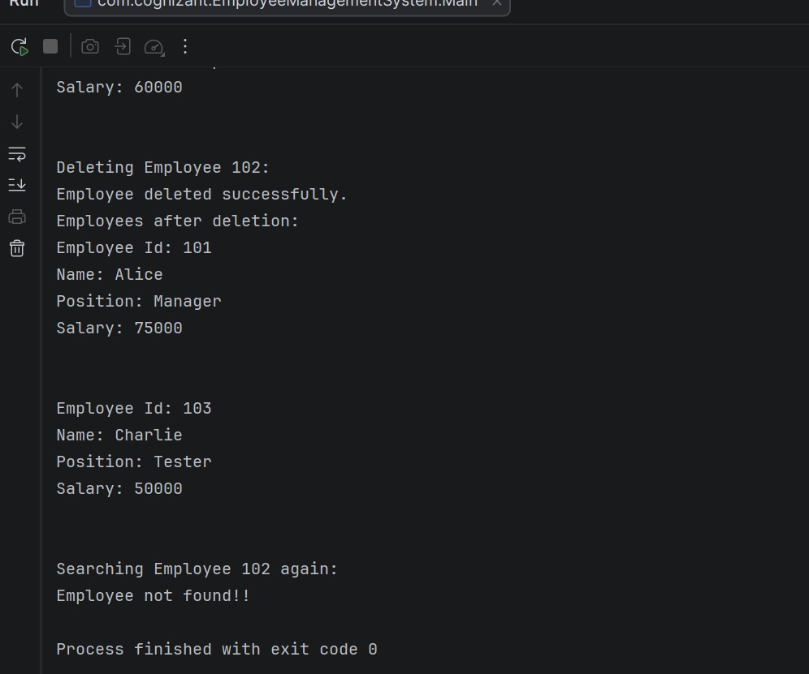

Exercise 5: Task Management System
Scenario:
You are developing a task management system where tasks need to be added, deleted, and traversed efficiently.
Task.java
package com.cognizant.TaskManagementSystem;
public class Task {
int taskId;
String taskName;
String status;
Task(int taskId, String taskName, String status){
this.taskId = taskId;
this.taskName = taskName;
this.status = status;
}
@Override
public String toString() {
return taskId + " " + taskName + " " + status;
}
}

Node.java
package com.cognizant.TaskManagementSystem;
public class Node {
Task task;
Node next;
Node(Task task){
this.task = task;
this.next = null;
}
}

TaskLinkedList.java
package com.cognizant.TaskManagementSystem;
public class TaskLinkedList {
Node head;
void addTask(Task task){
Node newNode = new Node(task);
if(head==null){
head = newNode;
return ;
}
Node temp = head;
while(temp.next!=null){
temp = temp.next;
}
temp.next = newNode;
}
void search(int taskId){
Node temp = head;
Task searchTask = null;
if(head == null){
System.out.println("List is emptyyy.....");
return ;
}
while(temp!=null){
if(temp.task.taskId == taskId){
searchTask = temp.task;
break;
}
temp = temp.next;
}
if(searchTask!=null){
System.out.println("Task Found!!");
System.out.println(searchTask);
}
else{
System.out.println("Task not found!!!");
}
}
public void traverse() {
if (head == null) {
System.out.println("No Tasks");
return;
}
Node temp = head;
while (temp != null) {
System.out.println(temp.task);
temp = temp.next;
}
}
public void delete(int taskId) {
if (head == null) {
return;
}
if (head.task.taskId == taskId) {
head = head.next;
System.out.println("Task Deleted");
return;
}
Node temp = head;
while (temp.next != null &&
temp.next.task.taskId != taskId) {
temp = temp.next;
}
if (temp.next == null) {
System.out.println("Task Not Found");
return;
}
temp.next = temp.next.next;
System.out.println("Task Deleted");
}
}

Main.java
package com.cognizant.TaskManagementSystem;
public class Main {
public static void main(String[] args) {
TaskLinkedList tasks = new TaskLinkedList();
tasks.addTask(new Task(1, "Design UI", "Pending"));
tasks.addTask(new Task(2, "Develop Backend", "In Progress"));
tasks.addTask(new Task(3, "Testing", "Pending"));
System.out.println("Tasks:");
tasks.traverse();
System.out.println("\nSearching Task 2");
tasks.search(2);
System.out.println("\nDeleting Task 2");
tasks.delete(2);
System.out.println("\nTasks After Deletion");
tasks.traverse();
}
}

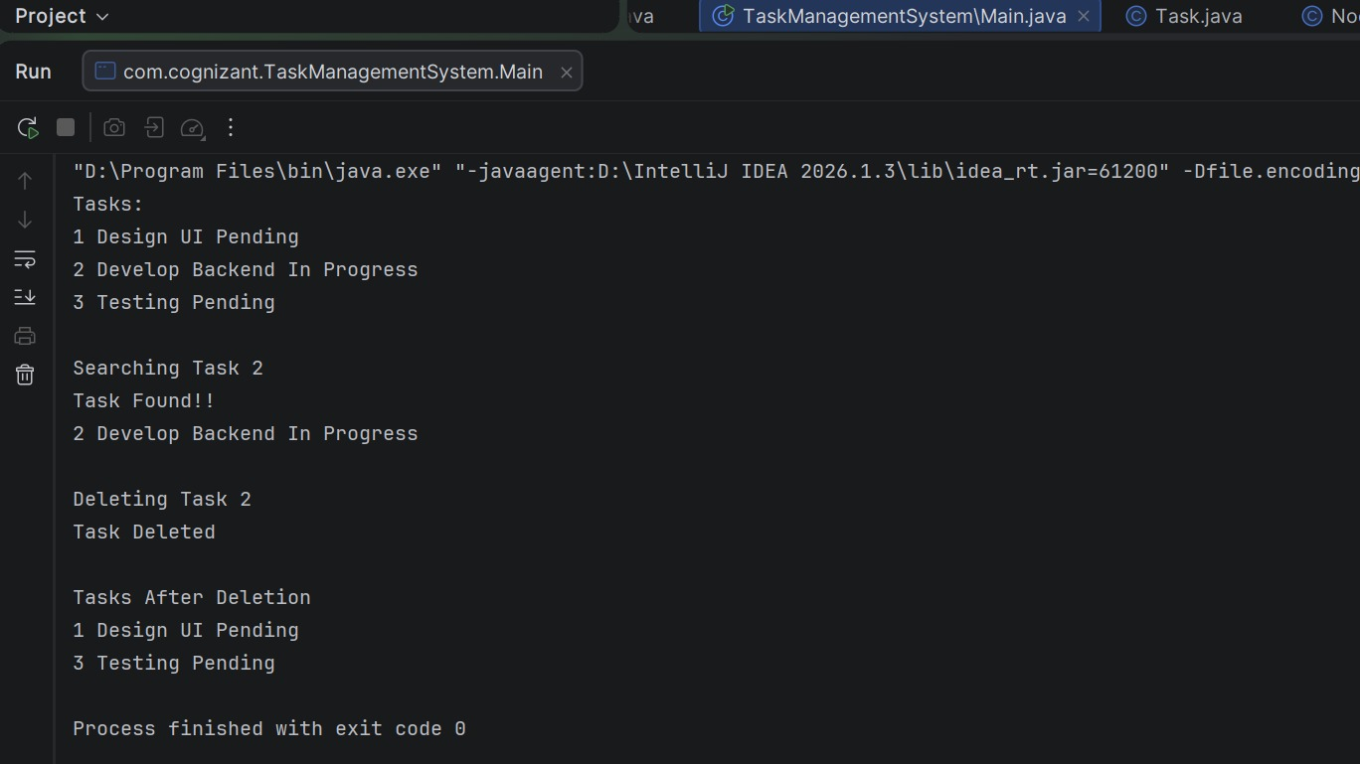

Exercise 6: Library Management System
Scenario:
You are developing a library management system where users can search for books by title or author.

Book.java
package com.cognizant.LibraryManagementSystem;
public class Book {
int bookId;
String title;
String author;
public Book(int bookId,String title,String author){
this.bookId = bookId;
this.title = title;
this.author = author;
}
@Override
public String toString(){
return this.bookId + " "+ this.title +" "+ this.author;
}
}

Search.java
package com.cognizant.LibraryManagementSystem;
public class Search {
public static Book linearSearch(Book[] books, int bookId){
for(int i=0;i<books.length;i++)
if(books[i].bookId == bookId)
return books[i];
return null;
}
public static Book binarySearch(Book[] books, int bookId){
int l=0,h=books.length-1;
while(l<=h){
int mid = l + (h-l)/2;
if(books[mid].bookId == bookId)
return books[mid];
else if(books[mid].bookId > bookId)
h = mid-1;
else
l = mid+1;
}
return null;
}
}

Main.java
package com.cognizant.LibraryManagementSystem;
public class Main {
public static void main(String[] args){
Book[] books = {
new Book(101, "C++", "Bjarne"),
new Book(102, "Java", "James Gosling"),
new Book(103, "MongoDB", "Mongo Inc"),
new Book(104, "Python", "Guido"),
new Book(105, "React", "Facebook")
};
Book linear = Search.linearSearch(books, 103);
if (linear != null)
System.out.println("Linear Search Found:");
else
System.out.println("Book Not Found");
System.out.println(linear);
Book binary = Search.binarySearch(books, 103);
if (binary != null)
System.out.println("\nBinary Search Found:");
else
System.out.println("Book Not Found");
System.out.println(binary);
}
}
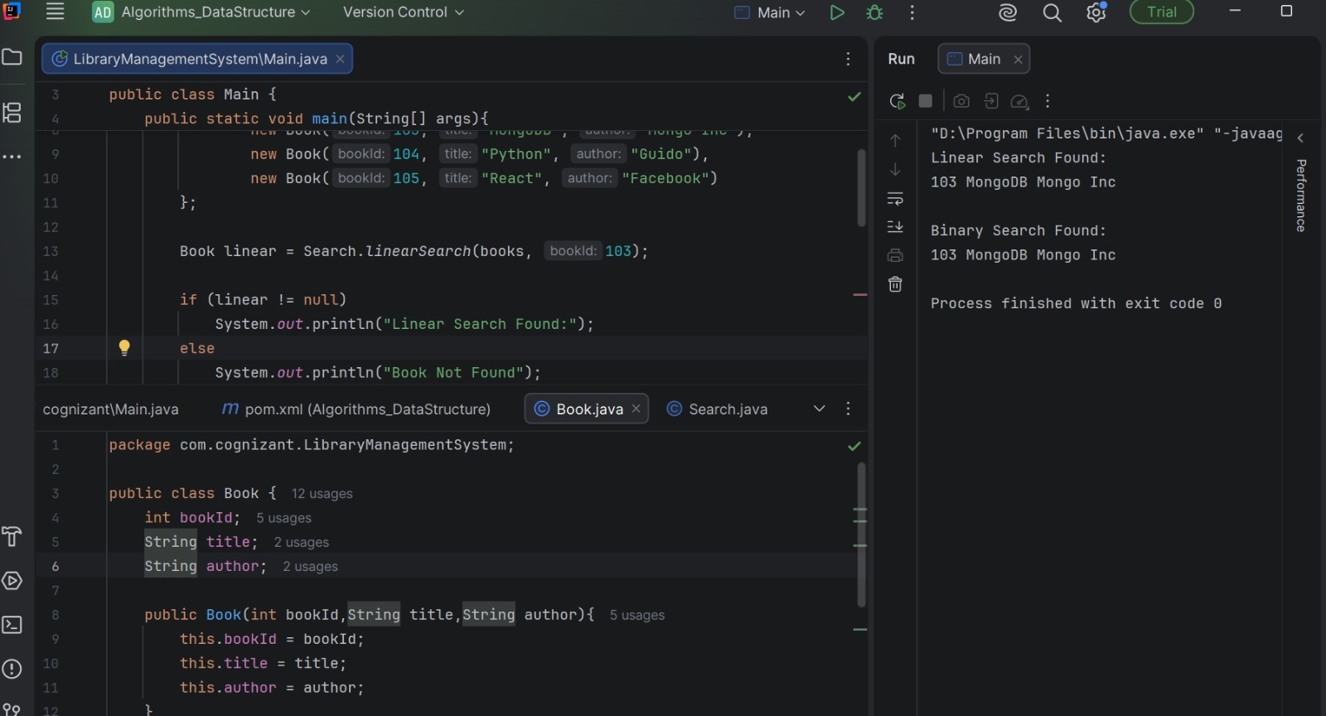

Exercise 7: Financial Forecasting
Scenario:
You are developing a financial forecasting tool that predicts future values based on past data.

FinancialForecast.java

package com.cognizant.FinancialForecasting;
public class FinancialForecast {
public static double futureValue(double presentValue, double growthRate, int years) {
if (years == 0) {
return presentValue;
}
return futureValue(presentValue, growthRate, years - 1) * (1 + growthRate);
}
}

Main.java
package com.cognizant.FinancialForecasting;
public class Main {
public static void main(String[] args) {
double presentValue = 10000;
double growthRate = 0.10; // 10%
int years = 5;
double result = FinancialForecast.futureValue(
presentValue,
growthRate,
years
);
System.out.println("Future Value = " + result);
}
}

