Disk analyzers’ report
1- Disk usage analyzer (baobab)

-The application is launched with the terminal command: baobab
-No inputs are required at terminal launching
-After this, the GUI starts through which you can choose the directory to scan
-There is also a “scan folder” option which allows you to select a particular folder to scan not an entire directory

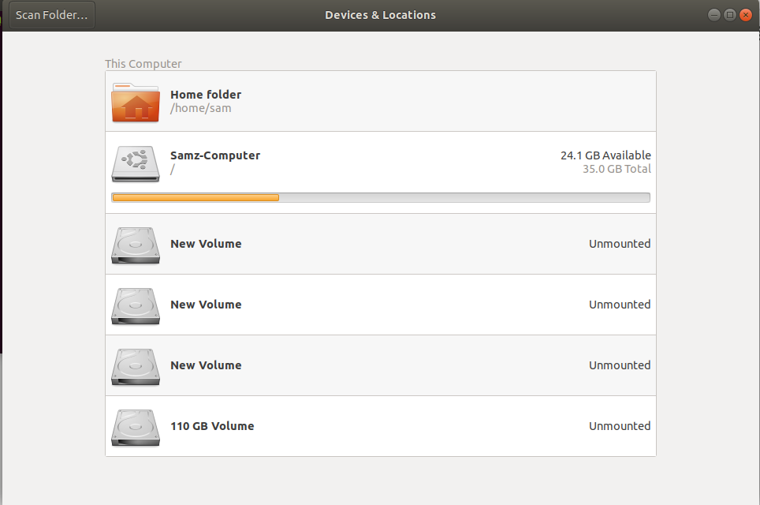
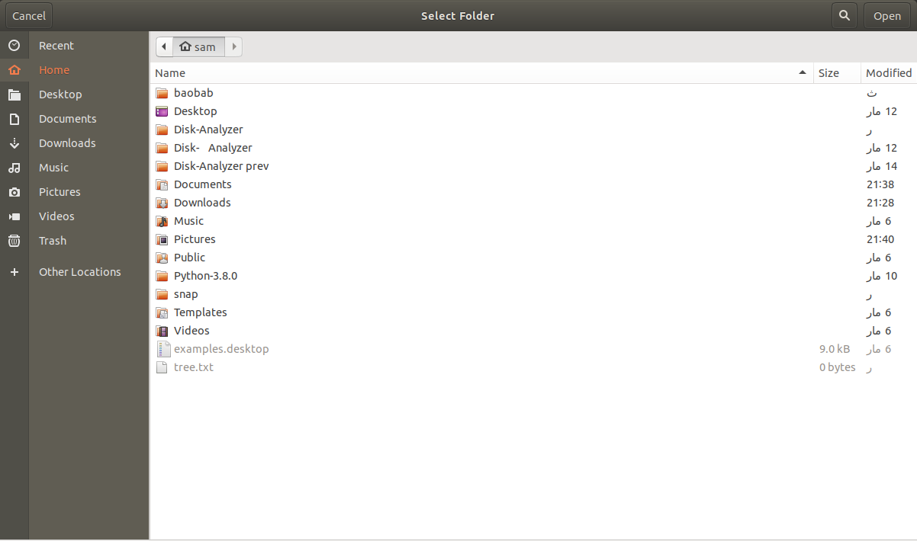

-On selecting a folder or directory, the analysis starts and is displayed in the form of a list (main) and either a pie chart or a treemap chart.
-Upon clicking on a specific part of the chart, it replaces the shown chart with a new one of the analysis of the clicked part if it was a directory.
-The application shows the total size of the selected directory in the middle of the pie-chart, once the middle part is clicked on, pointers appear labeling each part of the chart
-For the list, it shows the name, size, number of contents, and date modified for each entry. It also displays the color for this entry on the chart
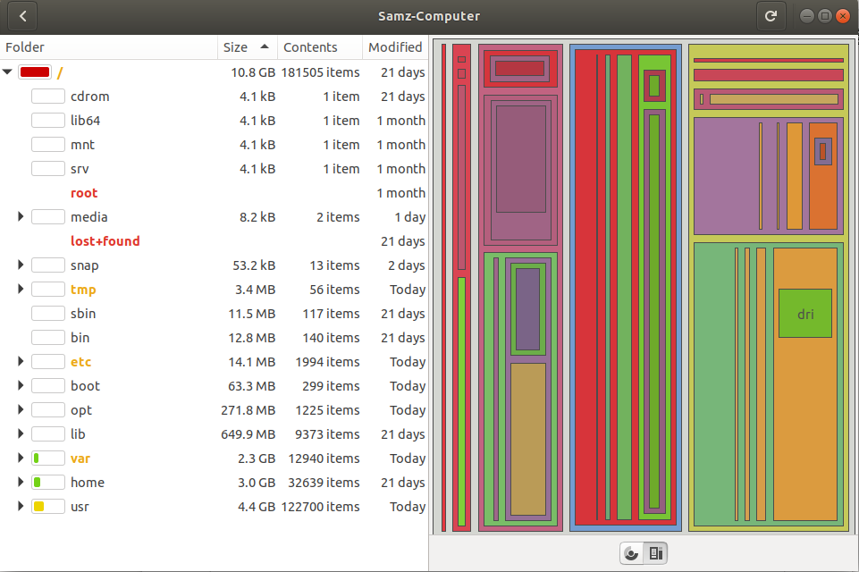

*treemap view

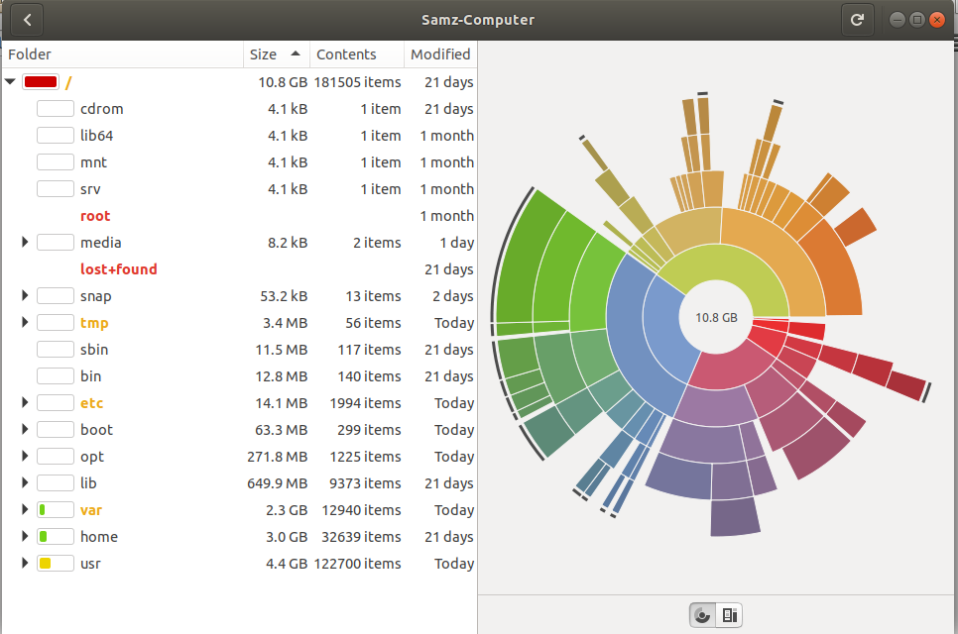
*Pie chart view

-One perk for this software is that it can capture changes that happen to the home directory constantly
-Another perk is that it can do this analysis on remote file systems using protocols such as ssh, ftp, smb, HTTP, and https.

2-QdirStat

- This package is mainly User interface, you run it through the command: qdirstat and everything else is done through the UI
- Once it runs, it directly opens a window where you can chose the directory to scan

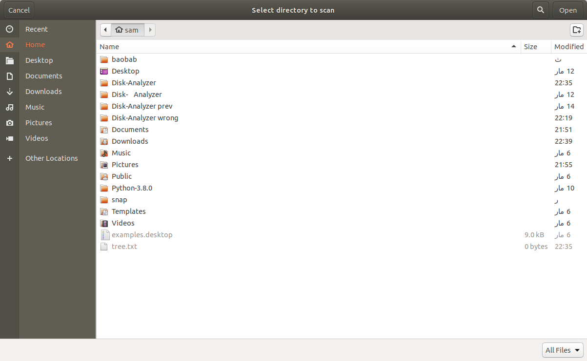
- once a directory is chosen, analysis is done and results are displayed in the GUI in the form of a list and a rectangular treemap
- the treemap can be hidden, viewed as a side panel, or at the bottom
- there’s a tool bar in the GUI offering multiple options such as:
  - Clean up
  - compression
  - deletion
  - removing junk files
  - expanding the tree to 1 up to 9 levels
- moving the cursor along the treemap the name of each displayed directory is written in the bottom left side bar
- the list displayed can be contracted or expanded, selecting a certain entry corresponds to outlining that entry in the treemap display
- there is also a zoom in/out option for the treemap
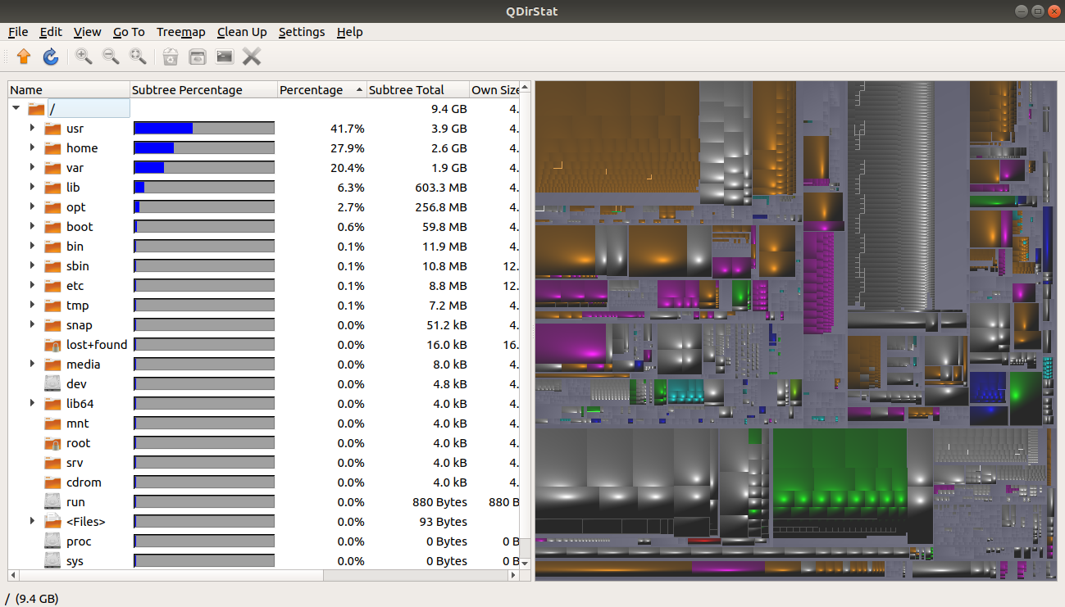

3- NCDU
This package is only console based application without a Graphical User Interface (GUI). It depends on the terminal to run and it. It scan the system very fast and automatically just right after running it in the command line. After running it the following output appears on the terminal total disk usage, number of items, apparent size and the size of each directory.

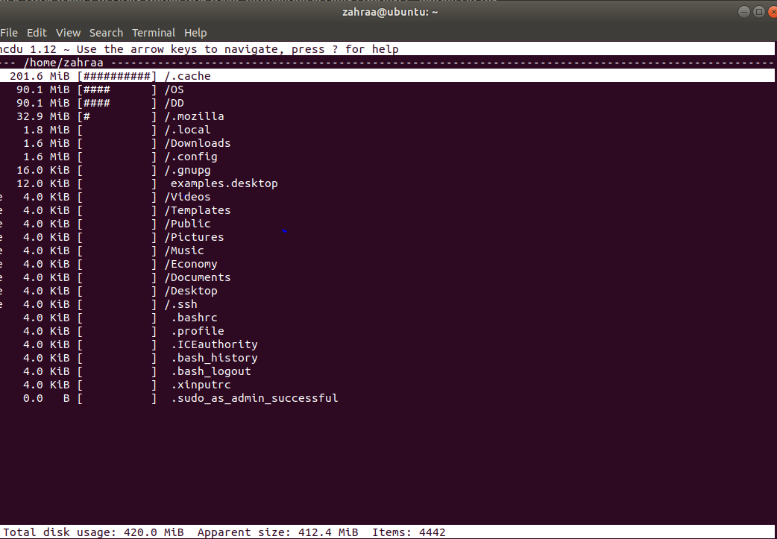
Notes on NCDU:
- It lacks the user interface.
- It shows only the total size of each directory and a detailed analysis of each directory, by pressing ENTER on the directory and then navigate through its files
- This program is dynamic and has lots of options, for example it allows user to delete folder and recalculate the size again.

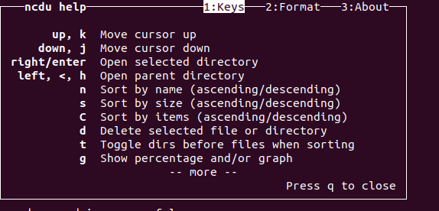

- Show detailed info a bout the selected directory
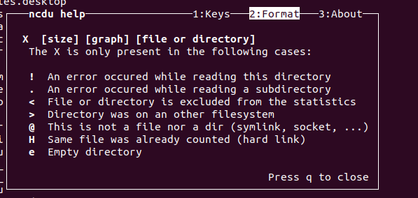

- Allow to delete files/ directories
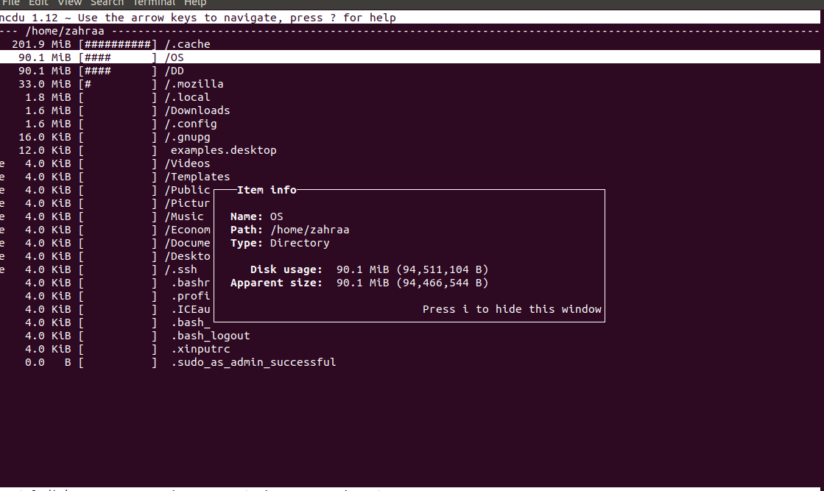
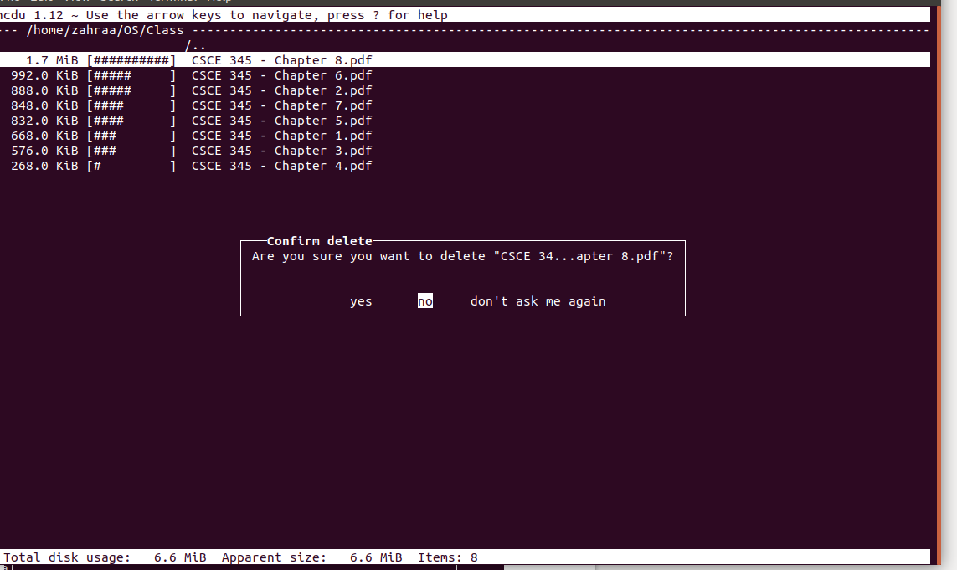
- Overall it is a flexible , fast and easy program; however, it would be moe user friendly if it has a reliable GUI

4- XDISKUSAGE
This package is launched using the command: xdiskusage
after that a GUI appeas, then we choose which directory we want to analysis and also there is option to analysis the whole root /

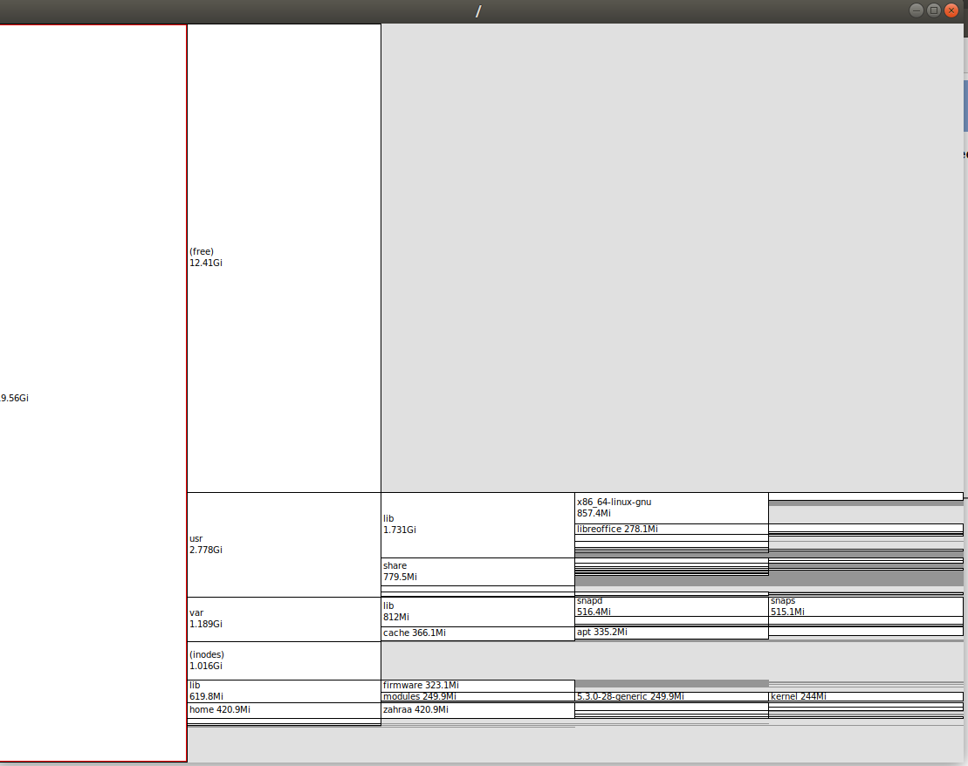
Notes on XDUSAGE:
- This package primary display the name of the directory and the used space for each directory.
- The navigation through directories, folders, and files is so easy and dynamic just click on it and it will be represented alone in a new window it is like a zoom in and out feature.
- Double clicking on an item allows io expand and show its subitems and by double clicking again it minimize.
- It shows the path of each selected item to be copied and used in any other program easily
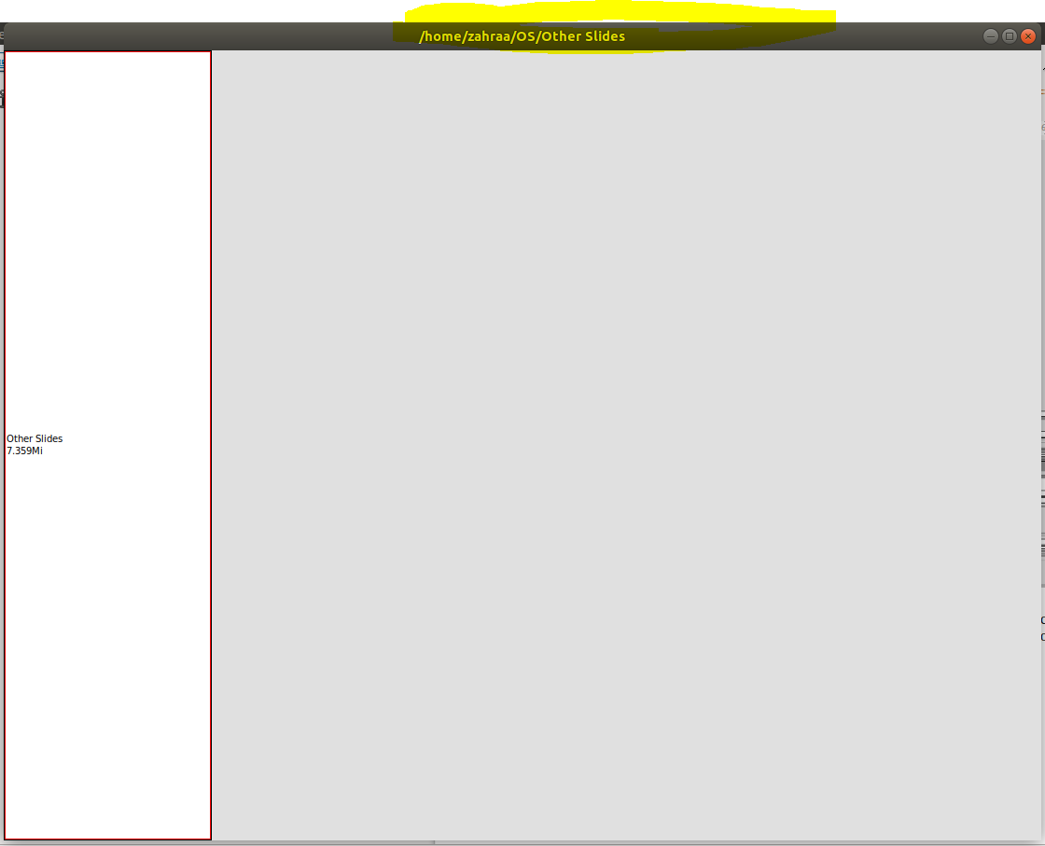

7- DUC
This application offers six different features:
  - List the files in the given directory. Command: duc ls <path is optional>
  - Dump the data in a XML format to be used later. Command: duc xml <path is optional>
  - Generate an illustrative graph showing the disk partitions and their analysis: duc graph
  - Use DUC with an online server. Command: duc cgi
  - Launch a graphical user interface version of DUC. Command: duc gui <path is optional>
  - Launch an user interface version of DUC inside the terminal, similar the one of Ncurses analyzer. Command: duc ui <path is optional>
Notes on the GUI:
- The GUI shows a pie-chart of the analyzed space
- upon clicking on a specific part of it, it replaces the shown pie-chart with a new one of the analysis of the clicked part if it was a directory.
- The application shows the total size of the selected directory in the middle of the pie-chart, as well as, the size of each file or directory on the pie-chart parts themselves
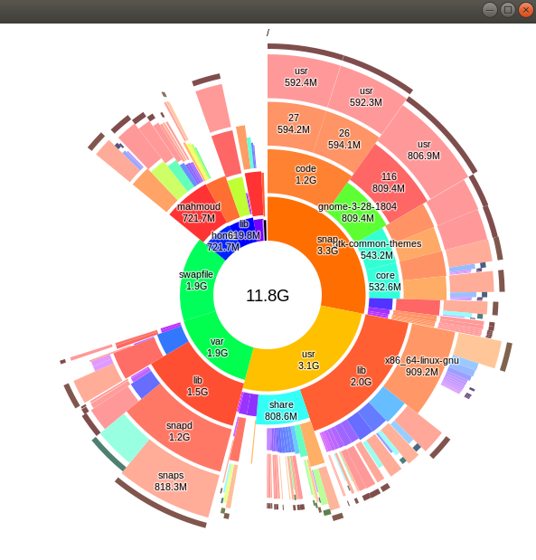

Notes of the UI mode:
- Running the UI mode results in an Ncurses like analysis with the tree structure of the directory analysis.
- Selecting one of the directories and pressing Enter, would expand this directory and show the size of it as well as the sizes of it sub-directories and files.
- The size of the directory as well as the number of files and directories in it are shown at the bottom of the terminal.
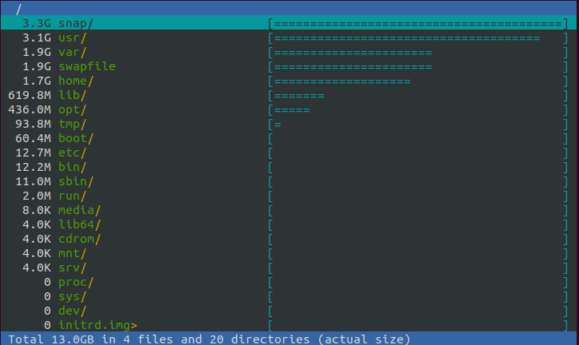

8- DuTree
This package is only a console based application with no user interface available. Based on the passed command line argument, it outputs one of the following:
- A report of the files’ sizes in a hierarchical colored format. Command: dutree <path is optional>
- A summary of the disk usage for the given current directory or the specified directory. Command: dutree -s <path is optional>
- A summary of the actual disk usage instead of the file size. Command: dutree -u <path is optional>
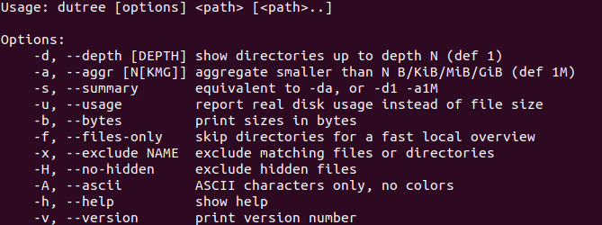
In addition a few other additional utilites such as printing the hierarchy with ASCII characters only and no colors, show the size in bytes, exclude the hidden files. The complete list of commands to be used with dutree is shown below:
Notes on DuTree:
- The lack of a user interface makes it difficult to see the hierarchy of large directories such as “/” for an example
- it would be more suitable to redirect the output of this command to and external text file to see the data later on. Command: dutree / > data.txt
9- GDMap
This package is launched with the command: gdmap
It does not take any command line arguments since we choose the path via the GUI.
Once the GUI is opened we have a blank screen and an option to choose the path we want to analyze.
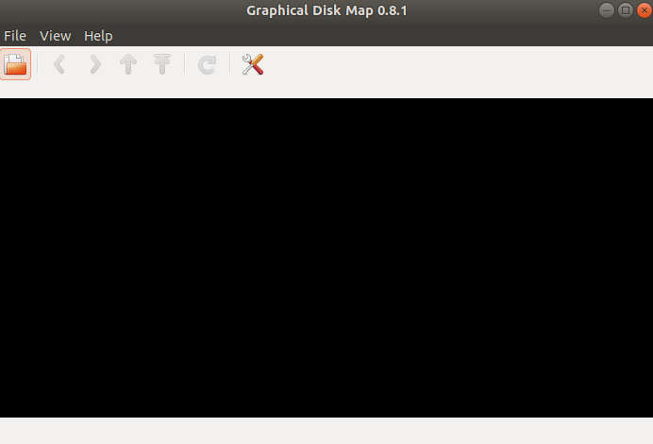
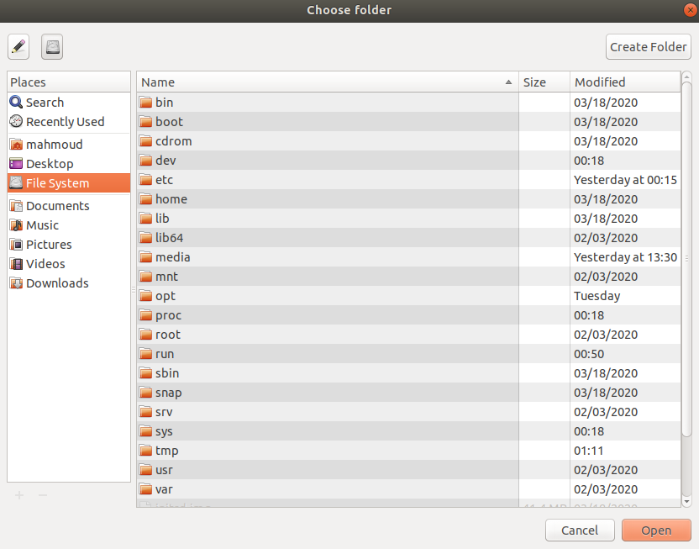

Afterwards, the application starts the analysis and outputs it in one of two forms:
- Shows the partitioning of directories in a square cushioned up tree view:
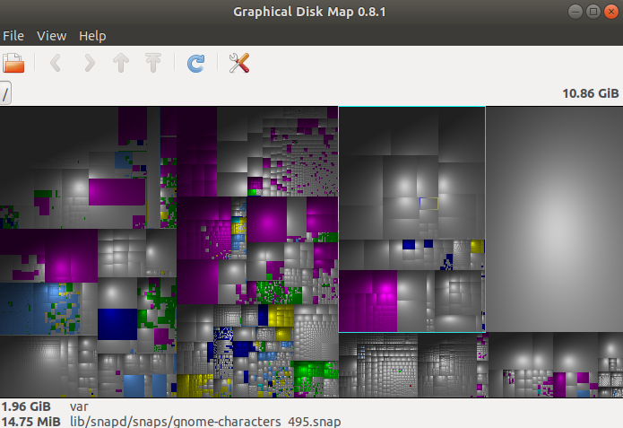

- Shows the partitioning of directories in a square mashed up tree view:
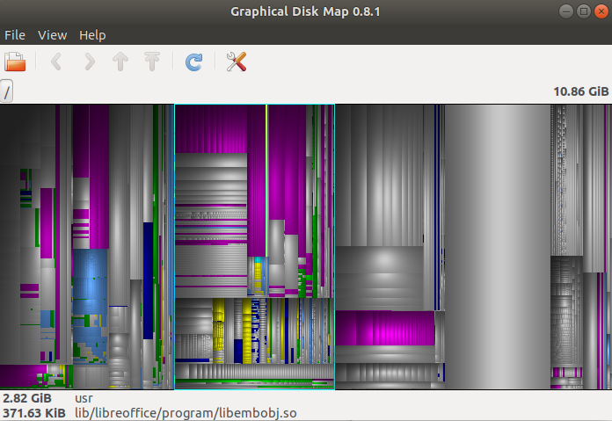
Notes on the GUI:
- The way the directories and files are arranged in the GUI is difficult to navigate and makes the GUI confusing.

10- CrossStateDir
The application has a very interactive GUI which starts by giving several options to choose where to start the scan from
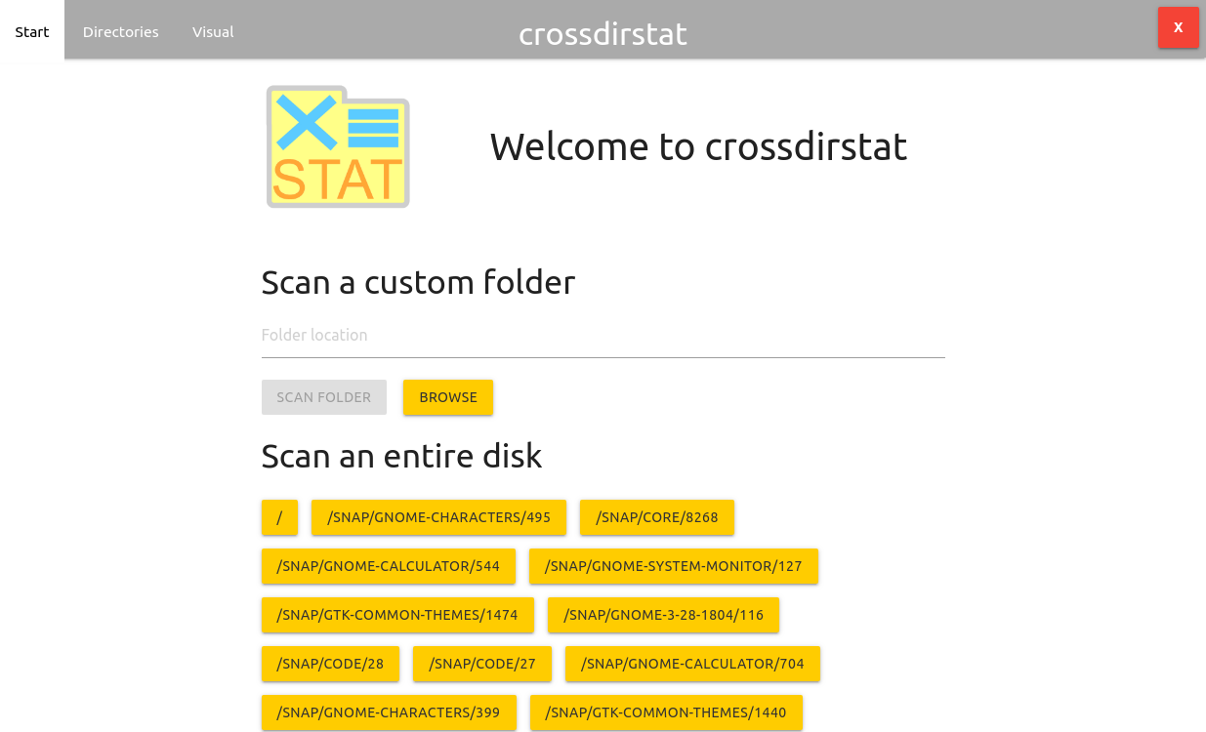
After selecting the directory to scan, it shows the progress over four phase
- scanning the directory
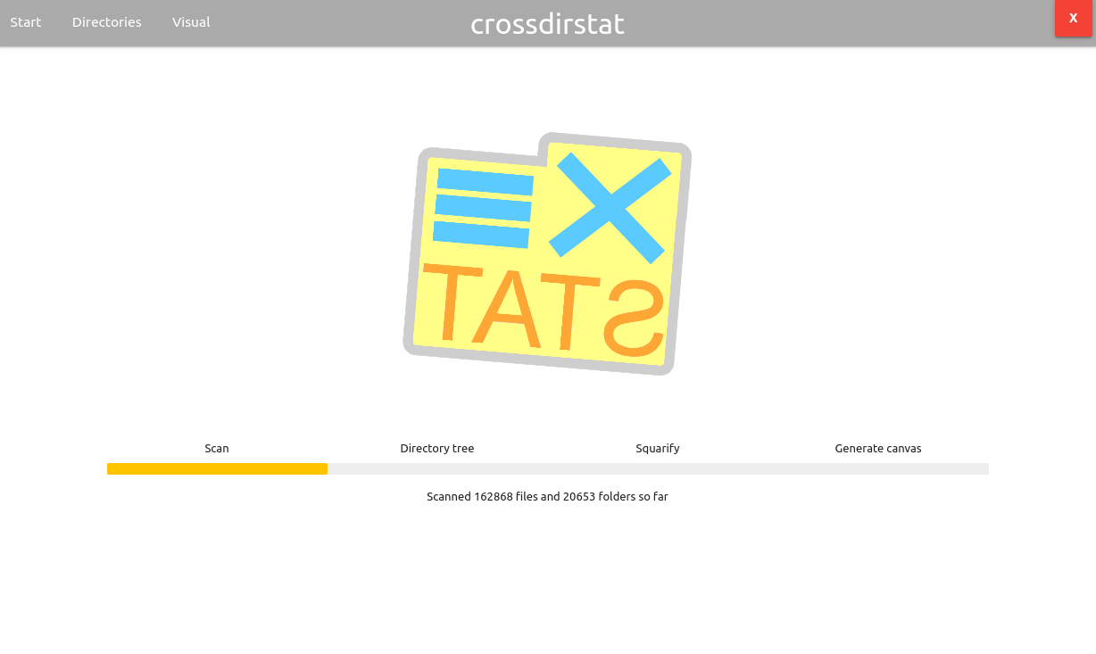
- calculating the directory size
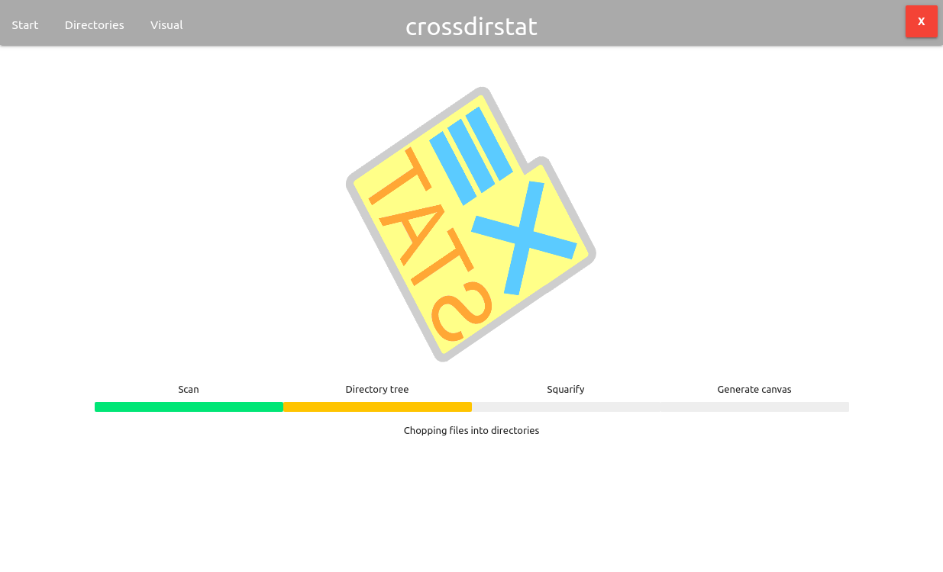
- creating squares out the scanned tree
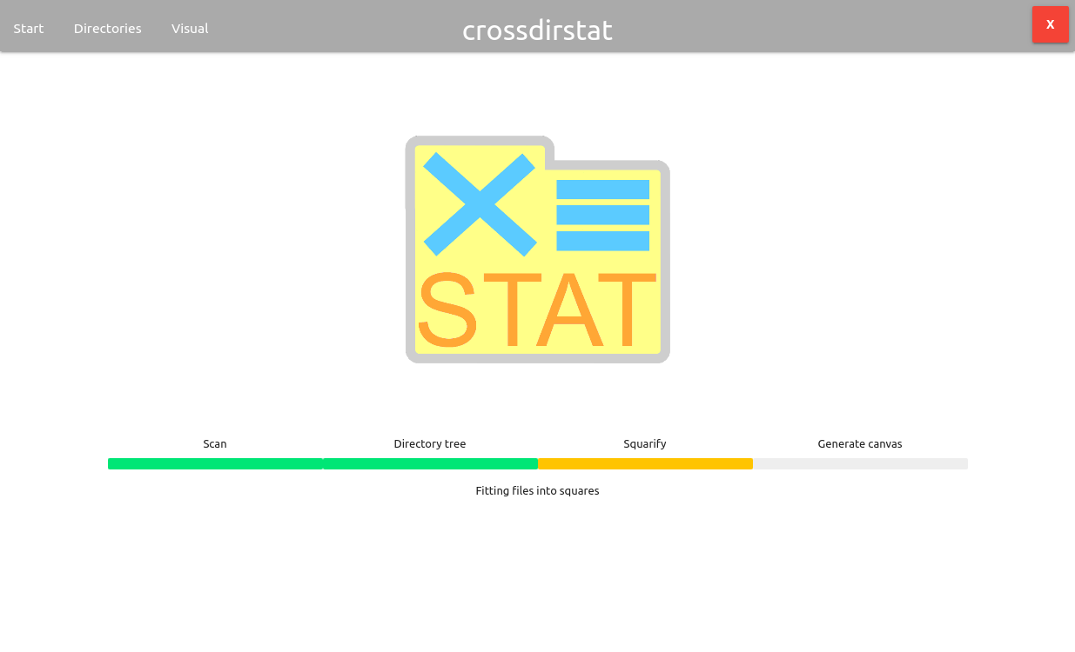
- converting these trees into canvas

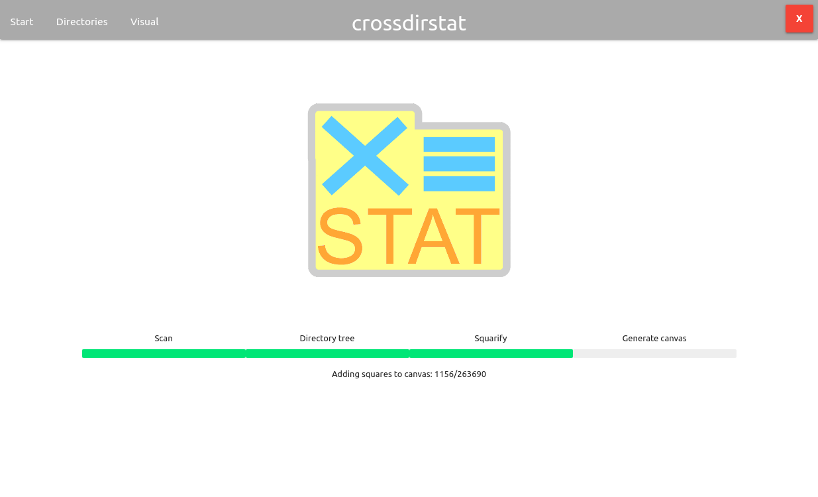
The final output has two forms. The first is a tree file structue
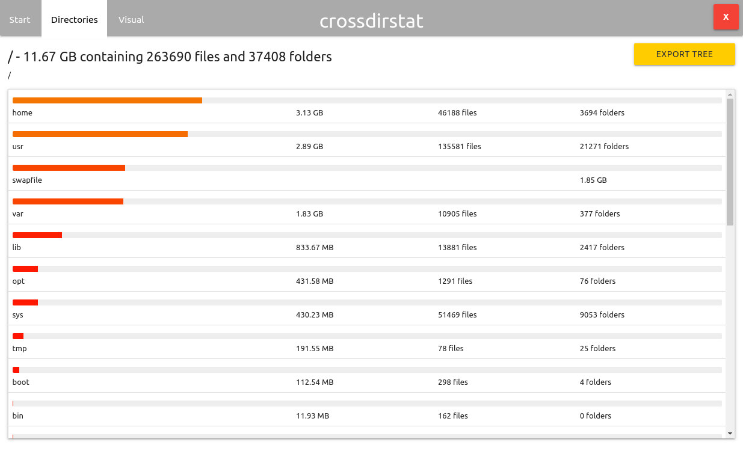
The second is supposed to be a visual representation of the disk. However, the application crashes each time we tried to use this option.

Notes on the application:
- The application took over 9 minutes to show the output of scanning the root. While this may depend on the machine on which the application is used, this is still slower than most of the other disk analyzers.

Project analysis

Running the project
- Open a terminal in the same directory of the project files
- Use the command: sudo python3 __main__.py
- Enter the path from which you want to start the analysis and click “Start Analysis”
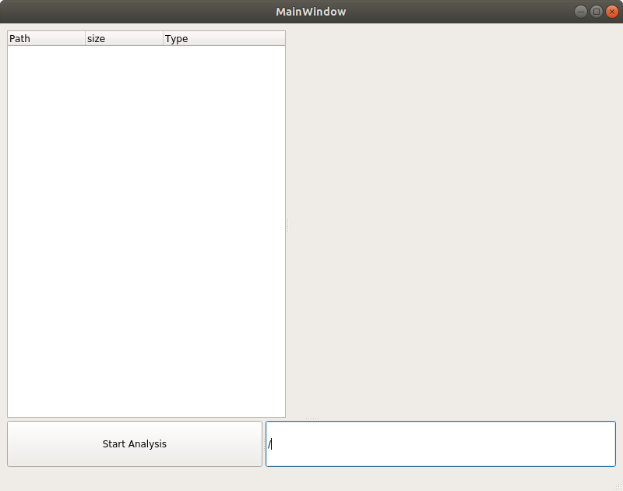
Our reference in this project was “Advanced Programming in the Unix Environment” by W. Richard Stevens suggested to us by Dr. Amr El-kadi
- Specific system calls
  - opendir(const char *name): used to open the directory specified by the parameter name. Returns a DIR struct.
  - readdir(DIR *dirp): used to read the different type of files in the passed dirp directory. Returns a dirent struct.
  - lstat(const char *pathname, struct stat *statbuf): used to get the files status data such as the mode, and size in bytes. The information is returned in the statbuf which is a stat struct passed by reference.
- Unix Macros
  - S_ISLNK(statbuf.st_mode): takes as input the st_mode member of the stat struct. Returns 1 if the file was a symbolic link and 0 otherwise.
  - S_ISREG(statbuf.st_mode): takes as input the st_mode member of the stat struct. Returns 1 if the file was a regular file and 0 otherwise.
  - S_ISDIR(statbuf.st_mode): takes as input the st_mode member of the stat struct. Returns 1 if the file was a directory file and 0 otherwise.
- UNIX pre-defined values used:
  - DT_DIR: this value was compared against the d_type of the dirent struct returned from readdir to check whether this file was a directory or otherwise.
  - PATH_MAX: this value was used as a size for the name string since according to the book, this is the greatest possible length of a path.
- Traversal algorithm:
The algorithm used to traverse the disk was a depth first traversal based on the following pseudo code:
  - open the directory specified by passed path
  - while there are files in the opened directory that we haven’t read:
    - read this file
    - check whether it’s file or a directory
    - if it’s a file, check that it’s not a symbolic link. If it’s not, add its size to the total size and put it in the tree structure.
    - If it’s a directory, check that it’s not a symbolic link. If it’s not, get its size by going to step 1 again but with the read directory path. Then add the returned size to the total size and put it in the tree.
  - Return the total calculated size to the previous call to get the total size of the directory.
- Data structures:
  - Vector: a simple implementation of the c++ vector library is developed in C in order to make it easier to have a dynamic sized array that expands according to the number of elements added to it.
  - General Tree: an implementation of the general tree data structure, which can have any number of children, is used to store the directories hierarchy. The tree had 3 members: the name of the entry, the size of the entry, and a vector of pointers to the children entries of this directory
- Functions:
  - directorySize(char * path, struct list *prev): does the disk traversal of the give path and stores any new directories or files found in the children vector of the prev.
  - print_tree(struct list *ptr): recursively print the data in the ptr struct and its children
  - calculateSize( unsigned long long size): used to convert the number of bytes to a string containing the first float digit along with the unit in TB, GB, MB, KB,B.
- Output file:
the output file is a simple .txt file in a certain format which contains the path, size, and number of children for each directory. This file is read in front-end, parsed, and stored again into a tree-like data structure that contains this information.

