Software Requirements Specification

for

Student Feedback Review & Automated Question Generate System

Table of Contents

Table of Contents 2

1. Introduction 3

1.1 Purpose 3

1.2 Motivation 3

1.3 Target Audience 3

1.4 Project Scope 3

1.5 Acronyms 4

1.6 References 4

2. External Interface Requirements 5

2.1 Project Perspective 5

2.2 System Interface 6

2.3 System Interface for all actors 7

2.4 Hardware Interfaces 8

2.5 Software Interfaces 9

2.6 Communications Interfaces 9

3. Design and Implementation Constraints 9

3.1 Language 9

3.2 Server-Side Technology 10

4. Requirement Specification 11

4.1 Functional Requirement 11

4.2 Data Requirement 13

4.3 Performance Requirement 13

4.4 Maintainability and Supportability 14

4.5 Security Requirements 14

4.6 Usability and Human Integrity Requirements 14

4.7 Look and Feel Requirements 15

4.8 Style Requirements 15

4.9 Legal Requirements 15

5. Requirement Engineering Process 16

5.1 Requirement Elicitation Techniques 16

6. System Features 16

6.1 ER -diagram 18

6.2 Use-case Diagram 19

6.3 Database Schema 20

7. Other Requirements 21

Appendix A: Glossary 21

Appendix B: Analysis Models 21

Appendix C: To Be Determined List 21

# Introduction

## Purpose

At the conclusion of each semester, higher education institutions now routinely ask students to rate their classes and their instructors. The main goal of collecting student feedback is to evaluate and enhance the quality of instruction. Review assignments for students may be offered each month. The feedback enables teachers to improve their methods of instruction and better comprehend the viewpoint of their students. The Student Comments Review section assists in extracting themes from student reviews and in producing a summary of feedback. a sophisticated mechanism for creating university exams. It is designed to enable colleges to quickly produce question papers that cover the majority of a subject's chapters with varying degrees of difficulty. A collection of questions and their corresponding answers are input here by the administrator for choice selection. Additionally, the system lets the administrator specify the weight and intricacy of each of these questions. Following this, the questions and their weight and age are kept in a database. The administrator now just needs to choose the difficulty level when it is time to generate the question papers. In this selection, the algorithm generates questions at random so that their weighted average equals 70 marks, and the instructor selects the questions depending on their level of difficulty. The system automatically generates paper and creates a doc file in accordance with the chosen paper format as soon as the admin selects the kind of paper difficulty (Easy, medium, difficult). The questions are also added for various difficulty levels. After being converted to a pdf format, this exam paper.

## Motivation

* + It is easy to maintain.
  + It is user-friendly.
  + The system helps students to submit reviews by selecting teachers and classes
  + Wide portion coverage and efficient question paper generation.
  + No chance of paper leaks.
  + No need of transporting papers through police/security vans to all colleges.
  + The system provides an unbiased result.
  + Thus, the system excludes human efforts and saves time and resources.

## Target Audience

* Faculty chairman/ director
* Teacher
* Student

## Project Scope

The Student Feedback System will give the Administrator the ability to keep a record of the data submitted by the students, which will be helpful for the faculties and the college in their continual attempts to improve the caliber of education. The student's views will be treated in confidence. The evolution will be computed using the combined scores from all students' replies. The application also offers many options for editing information, viewing statistics, and making comments on components related to feedback. The study's objective was to create a method for course feedback over the Internet that would benefit both professors and students. The system comprises creating and analyzing course evaluation pages, giving feedback, and providing a summary. The automated question creation portion is the most crucial since it minimizes data entry mistakes as much as possible. Additionally, when inputting inaccurate data, an error notice is displayed. The user doesn't require any special training to utilize this system.

## Acronyms

|  |  |
| --- | --- |
| SRS | SOFTWARE REQUIREMENT SPECIFICATION |
| SFS | STUDENT FEEDBACK SYSTEM |
| WEB-BASED | ABLE TO BE RUN OVER THE WEB, WITHOUT ANY |
| SQL | STRUCTURED QUERY LANGUAGE |
| BCA | BACHELOR OF COMPUTER APPLICATION |
| B-TECH | BACHELOR OF TECHNOLOGY |
| AQGS | AUTOMATED QUESTION GENERATE SYSTEM |
| MCA | MASTER OF COMPUTER APPLICATION |

## References

1. Website link

<http://www.w3schools.com/aspnet/default.asp>

<http://www.w3schools.com/ado/default.asp>

<http://www.w3schools.com/aspnet/aspnet>

2. Diagrams

Adobe Illustrator 2020

draw.io

3. Online Communication

<https://www.messenger.com/>

<https://meet.google.com/>

4. Coding problem solutions

[www.stackoverflow.com](http://www.stackoverflow.com)

5. Conceptual Learning

Learn with Sumit (JavaScript)

Training with Live Project (Php)

W3Schools

Tech2 etc

MND web docs

Learn Hunter

Laravel documentation

6. Image

<https://www.pngwing.com/>

<https://www.freepik.com/>

<https://undraw.co/illustrations>

<https://thenounproject.com/>

# External Interface Requirements

## Project Perspective

The Student Feedback System is designed to take the role of the paper-based manual methodology of recording feedback. One contact between the students and the student will replace the paper records.

Feedback Mechanism. The Student Feedback System is designed to completely implement the functionality stated in this Software Requirements Specification document. The system will be created in a way that gives students and administrators alike an intuitive user interface. Automated Question generation part, reduce the time costing and complexity.

## System Interface

A web server that is connected to the institution's whole system is necessary for this application. The software product will be a windows-based, autonomous, self-contained program. 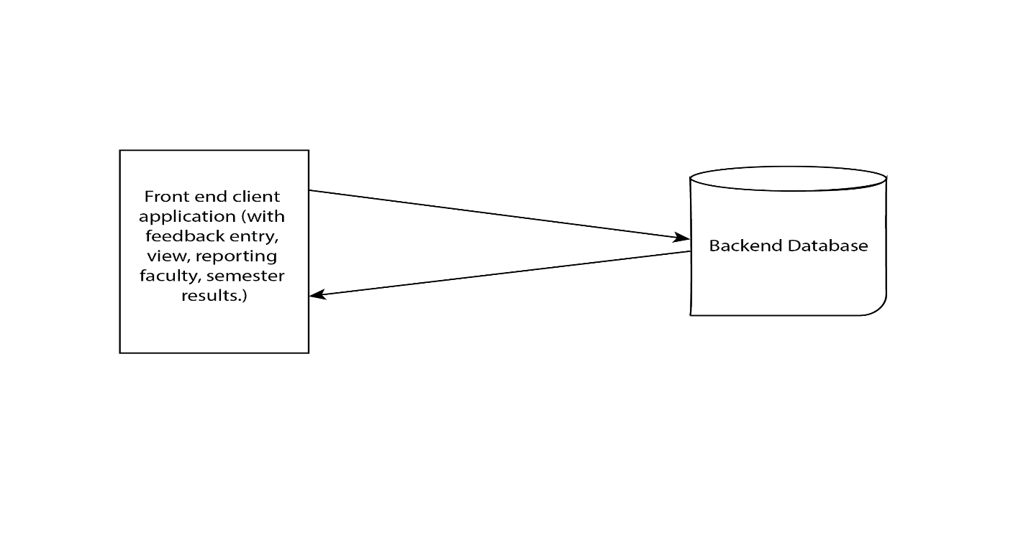

## System Interface for all actors

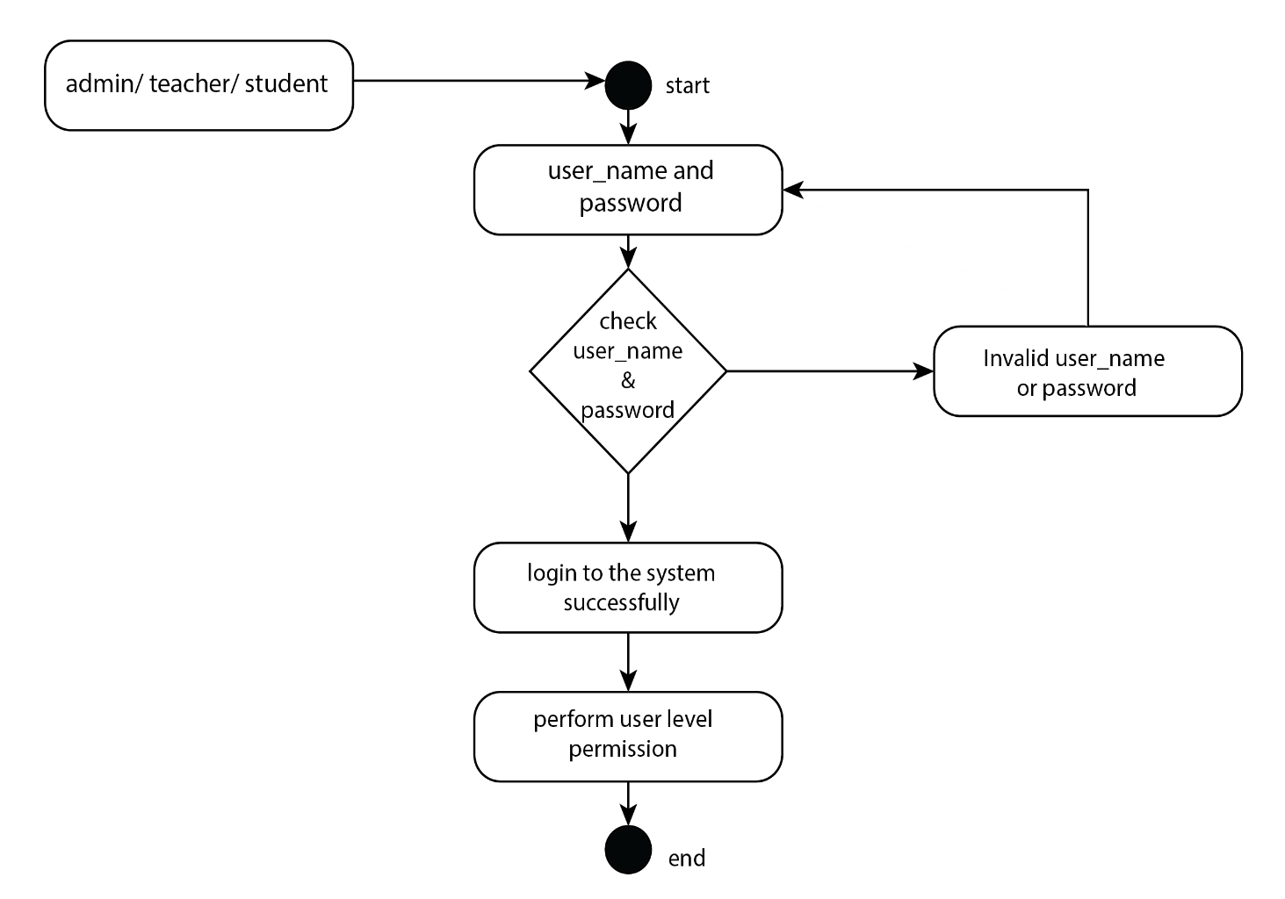

Fig-01

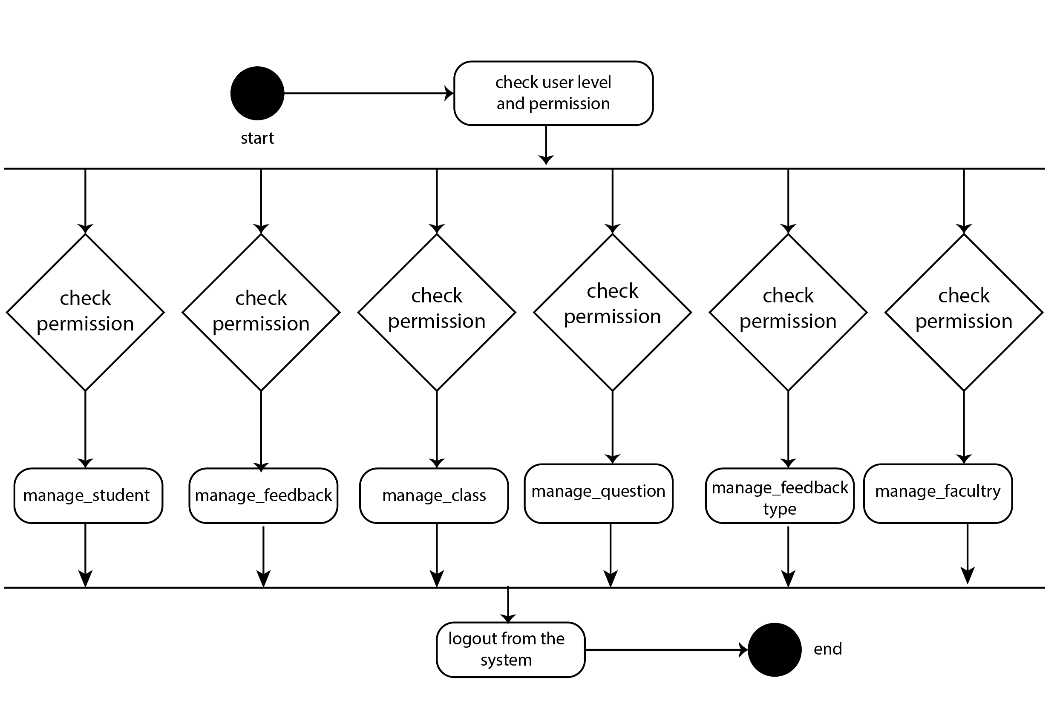

Fig-02

## Hardware Interfaces

1. **Laptop or PC**

* Windows 7 or higher
* I3 processor system or higher
* 4 GB RAM or higher
* 100 GB ROM or higher

## Software Interfaces

1. **Laptop or PC**

* Php/ Laravel
* Visual Studio
* XAMP Server

## Communications Interfaces

* The security of a user must be consistent through the use of passwords.
* The Student Feedback System will communicate to the database directly

# Design and Implementation Constraints

We employed design and implementation constraints to guarantee the project's success. It may also be used to describe a tool that lets developers and testers to observe and interact with an application's user interface (UI) components.

## Language

The visual arrangement of the components of a website or technical product that a user could interact with is known as user interface design, or UI Design. In other terms, it is a website's visual design. On the other hand, the back end refers to the code that makes it possible for a computer program or application to execute but cannot be seen by a user. The majority of data and operational logic are stored and accessed in a computer system's back end. Usually, one or more programming languages are used in the code.

### HTML

The coding that organizes a web page's content is called HTML (Hypertext Markup Language). HTML is the exact name of the code used to arrange the content of a web page (Hypertext Markup Language). You can instruct a web page to identify a paragraph, list, heading, link, picture, multimedia player, form, or any other of the numerous other components that are presently supported, or even a brand-new element that you create, using the aid of HTML. It is the extensively used programming language for formatting web pages. The majority of users are small and medium-sized organizations since they don't truly need a lot of functionality on their websites. The decision to use HTML to create the structure of my web pages was made since it is cost-effective, compatible with all browsers on the client's computer, and straightforward to use and comprehend.

### CSS

A stylesheet language called CSS is used to specify how an HTML or XML page is presented. In addition to voice, paper, screens, and other media, CSS also specifies how objects should be shown in other media. All major browsers support CSS, one of the core languages of the open web, which is established by the W3C (World Wide Web Consortium) specification.

### Bootstrap (Front-end framework)

A front-end web framework for creating websites and online apps, Bootstrap is open-source and free. Along with HTML and CSS-based design templates for navigation, buttons, forms, and other interface components, it also provides optional JavaScript extensions. Unlike many web frameworks, it exclusively covers front-end development. The application's style would be created using CSS and Bootstrap. For the following reasons, Bootstrap is crucial to the application:

* **Easy to use:** Anyone can begin using Bootstrap with just a basic Knowledge of HTML and CSS.
* **Responsive features:** The responsive CSS in Bootstrap adapts to mobile devices, tablets, and desktops.
* **Mobile-first approach:** The fundamental Bootstrap framework provides mobile-first styling.
* **Browser compatibility:** All current browsers are compatible with Bootstrap (Chrome, Firefox, Internet Explorer, Safari, and Opera).

### JavaScript

Making interactive web pages is possible with JavaScript, a text-based computer language used both on the client-side and server-side. While HTML and CSS are the languages that give web sites their structure and appearance, JavaScript adds interactive aspects to internet pages that keep people interested.

Every JavaScript object has a built-in attribute called the prototype. The prototype chain, which forms because the prototype is an item in and of itself, will have a prototype of its own. The chain ends when we reach a prototype that has null for its own prototype.

### PHP

A powerful tool for creating dynamic and interactive Web sites, PHP is a server programming language. It was one of the first server-side languages that HTML could use, making it easier to add functionality without referencing other files. PHP's ability to be user-friendly for beginners while still providing numerous complex capabilities for experienced programmers is one of its finest qualities. In this project I am using the Laravel framework.

## Server-Side Technology

Server-side development describes the operations carried out in the background of an application. The key subjects addressed include databases, scripting, website architecture, backend logic, APIs, and servers.

### Database Server

An open-source relational database management system is called MySQL (RDBMS). Data is organized into one or more tables in a relational database so that they may be related to one another. The SQL language is used by programmers to control user access to relational databases as well as to build, modify, and retrieve data from such databases.

# Requirement Specification

## Functional Requirement

Functional requirements are those that serve as examples for the system's internal operation, its description, and an explanation of each subsystem. It comprises of the task that the system should complete, the associated processes, the data that the system should store, and the user interfaces.

### User registration and login

|  |  |  |  |
| --- | --- | --- | --- |
| **FR-1** | User (Student, teacher) | | |
| **Description** | User should register his/her account for the first time and be able to login to  the account which was registered once. Already registered users will not face  this stage. At first the registration request is checked by the librarian and then it is finally approved by the director or IIT, NSTU. | | |
| **Stakeholders** | User (student, teacher) System | **Priority** | High |

### Submit Feedback

|  |  |  |  |
| --- | --- | --- | --- |
| **FR-2** | Student | | |
| **Description** | After login successfully, student can easily express their feeling using student feedback form. When selecting teacher and subject is completed then they can easily submit their feedback. | | |
| **Stakeholders** | User(student) | **Priority** | High |

### Active Feedback Option

|  |  |  |  |
| --- | --- | --- | --- |
| **FR-3** | Admin | | |
| **Description** | When admin is free then he/ she can easily enable the feedback option. | | |
| **Stakeholders** | User(admin) | **Priority** | High |

### Approve all registration request

|  |  |  |  |
| --- | --- | --- | --- |
| **FR-4** | Admin | | |
| **Description** | Admin can only person who can approve all the request in a particular faculty | | |
| **Stakeholders** | User (Admin, student, teacher) | **Priority** | High |

### Question Generate

|  |  |  |  |
| --- | --- | --- | --- |
| **FR-5** | Teacher and admin is directly involved in this part | | |
| **Description** | Teacher can upload various question with difficulties. When teacher create a question they can easily select how many question have needed and how many sub-part is needed in each question. After select all the part system automatically create a question paper. | | |
| **Stakeholders** | Teacher, admin | **Priority** | High |

### Report Generate of Feedback

|  |  |  |  |
| --- | --- | --- | --- |
| **FR-6** | The system will generate a report with all the feedback comment | | |
| **Description** | Sometimes, it is required to see a report of which teacher is needed to improve their teaching ability and it also needed for knowing who is excellent and for the faculty improvement. | | |
| **Stakeholders** | System | **Priority** | High |

### Send Email

|  |  |  |  |
| --- | --- | --- | --- |
| **FR-7** | The system will send an email with all required information as a response for some specific operations. | | |
| **Description** | Operations like sending registration request, updating passwords needs to be notified by an email. It increases user satisfaction and leaves a footprint for any critical operation. | | |
| **Stakeholders** | System | **Priority** | High |

## Data Requirement

### Searching Teacher and Subject

|  |  |  |  |
| --- | --- | --- | --- |
| **DR-1** | Searching teacher using the his/her name and select a particular subject | | |
| **Description** | If any particular teacher and subject have then easily can find out. | | |
| **Stakeholders** | Teacher, Student | **Priority** | High |

## Performance Requirement

It is important that maintain the performance of the system. To ensure the best performance of the system we must maintain the following steps:

### Speed and Latency Requirements

|  |  |  |  |
| --- | --- | --- | --- |
| **PR-1** | Faster searching for Teacher and subject. | | |
| **Description** | When any authentic user of our system wants to search of a teacher then the user can feel the fast searching. | | |
| **Stakeholders** | Student, teacher, admin | **Priority** | High |

### Safety Critical Requirements

For our project there is no safety critical requirements.

## Maintainability and Supportability

The term "maintenance" describes how simple it is to fix, enhance, and comprehend software code. After the user has received the product, the software maintenance phase of the software development cycle begins.

### Maintenance Requirements

|  |  |  |  |
| --- | --- | --- | --- |
| **MR-1** | Develop maintainable code | | |
| **Description** | Maintainability must be ensured so that it can be modified later and will be readable. | | |
| **Stakeholders** | Developers (Team Twins) | **Priority** | High |

### Supportability Requirements

This system satisfies the supportability requirements for testability, maintainability, compatibility, configurability, serviceability, and install ability.

## Security Requirements

Information security is far more crucial for a system to gain user’s trust. Here are some security requirements are given below:

### Access Requirements

The system will apply some authorization approaches when granting access to information to make sure the right user is using the right data.

### Integrity Requirements

Integrity requirements relate to a security system that ensures an expectation of data quality. It also ensures that no data on the system will ever be exposed to malicious modification or accidental deletion.

## Usability and Human Integrity Requirements

Usability in software engineering refers to how well a piece of software may be used by a specific target audience to accomplish goals. A user-friendly environment will be provided by the system.

### Ease of Use Requirements

Our system will be easier to use by any type of stakeholder and they don’t need any training to use the system.

### Accessibility Requirements

The system provides authorization / authentication to get access to it. Numerous modules are used in this system.

|  |  |  |  |
| --- | --- | --- | --- |
| **SR-1** | Safeguards are provided by the system. | | |
| **Description** | The system is designed in a way that allows all modules to access a mechanism that provides security services. | | |
| **Stakeholders** | Developers (Team Twins) | **Priority** | High |

## Look and Feel Requirements

The system's appearance is mostly covered by the look and feel standards. In software design, the "look" of a graphical user interface relates to components such colors, forms, layouts, and fonts. The behavior of dynamic components like buttons, boxes, and menus is frequently referred to as "the feel" ("The Feel").

### Appearance Requirements

|  |  |  |  |
| --- | --- | --- | --- |
| **AR-1** | Text color and font | | |
| **Description** | Our system has to be different and attractive from another existing student feedback system and automated question generate system. | | |
| **Stakeholders** | Developers (Team Twins), User | **Priority** | Medium |

## Style Requirements

There are no style requirements in our system.

## Legal Requirements

Legal obligations frequently include reference to the terms and conditions or privacy policy of an entity. The terms and conditions of our application prohibit the use of our data for commercial reasons by any third-party program or human.

# Requirement Engineering Process

Requirements engineering (RE), which takes into consideration client needs or wishes, is used to develop software requirements. The requirements engineering process includes the steps of requirements elicitation, needs modeling, requirements analysis, requirements assurance & validation, and requirements management.

## Requirement Elicitation Techniques

The act of looking into and identifying system needs for users, clients, and other stakeholders is known as requirements elicitation, often referred to as "requirement collecting." You can elicit requirements by contacting individuals directly or by doing research, analysis, and testing.

### Hold Interviews

We engage in dialogues that may be held either by ourselves or in small groups. Since we just meet with participants to go over a few important program requirements, they are a helpful way to access services without having to spend a lot of time with participants. Negotiations may be used to set up workshops where program participants can get together to resolve any issues or disagreements and obtain specific requests from them. Most of the time, we conduct our interviews in accordance with a preset set of criteria.

### Perform Document Analysis

The usage of existing documentation can help to explain how systems are used or what I should do with them. Documents include textual information about already-existing programs, administrative processes, necessary specifications, and market research on rivals. Textual analysis is once again helpful. Consult the Software Requirements Specification to determine which features should be eliminated and which performances should be retained. In our earlier investigational research, we identified a number of problems with the present system.

* Existing system cannot integrate the automated question generate part.
* Very time-consuming to find a teacher and select a subject.
* Authenticate student can easily submit their feedback

### Distribute Questionnaires

The survey is an effective instrument for assessing user satisfaction with priorities, preferences, and shifts in attitudes, ideas, and styles. Our goal was to limit the number of questions on our lists. The reaction may be weary or indignant. A basic explanation for each question was provided, along with groupings of the topics to help the responder focus. The fact that the survey results were acquired in the expected way was the main advantage of them. Many others offered informational summaries.

# System Features

* **ADMIN:**
* **Login:** The admin can log in to the system using their username and password.
* **Manage Class:** They can view, add, update or delete Class from the system.
* **Manage Subjects:** The admin can view, add, update or delete subjects which is been taught.
* **Manage students:** They can also view, add, update or delete student details in the system and they can assign classes to students.
* **Manage Questions for Students:** They can manage questions for students by viewing, adding, updating or deleting them.
* **View Student Feedback**
* **View Students:** The admin can view the feedback of all students.
* **Filter:** Admin can apply a filter to sort by class or by name.
* **Feedback list:** They can view a list of feedback questions wise & average ratings.
* **TEACHER:**
* **Login:** The student can log in to the system using a username and password.
* **Change Password:** They can change their old password to the new one.
* **Question Insertion**: They may insert questions as per weight age, difficulty, subject and chapter in the system.
* **Difficulty Choosing:** They may then choose the paper difficulty level.
* **STUDENT:**
* **Login:** The student can log in to the system using a username and password.
* **Change Password:** They can change their old password to the new one.
* **Submit Review**
* **Select Teacher:** The student can submit reviews and select a teacher as per the class assigned.
* **Mark Answers**: They can mark answers to the questions to submit the review.

## ER -diagram

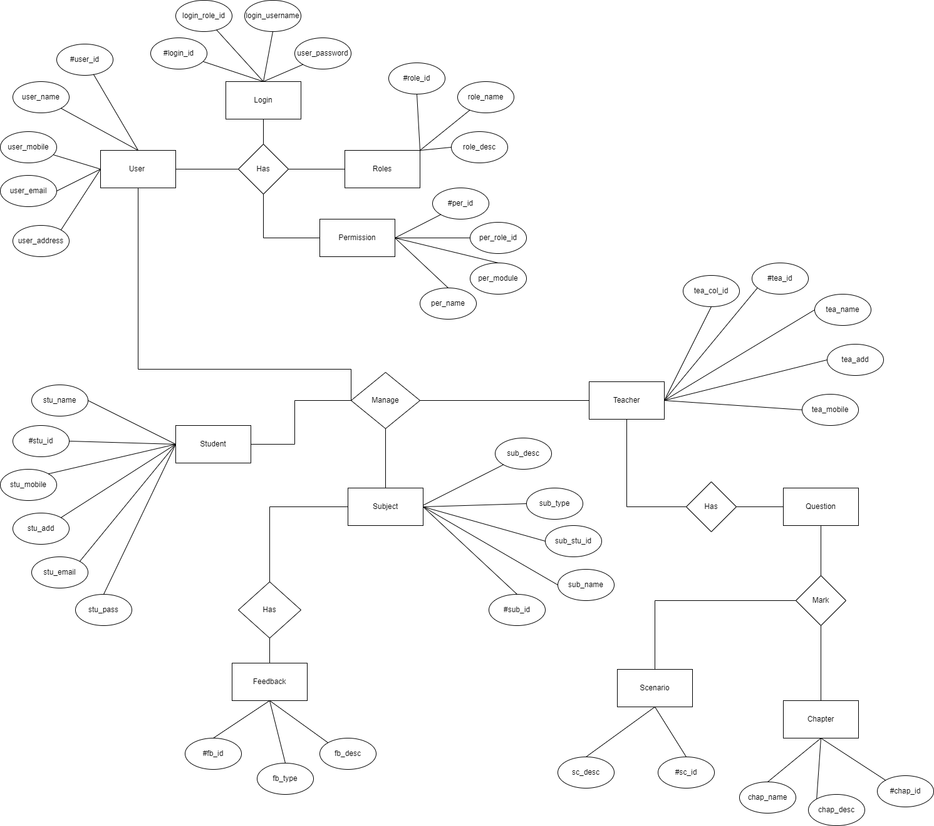

## Use-case Diagram

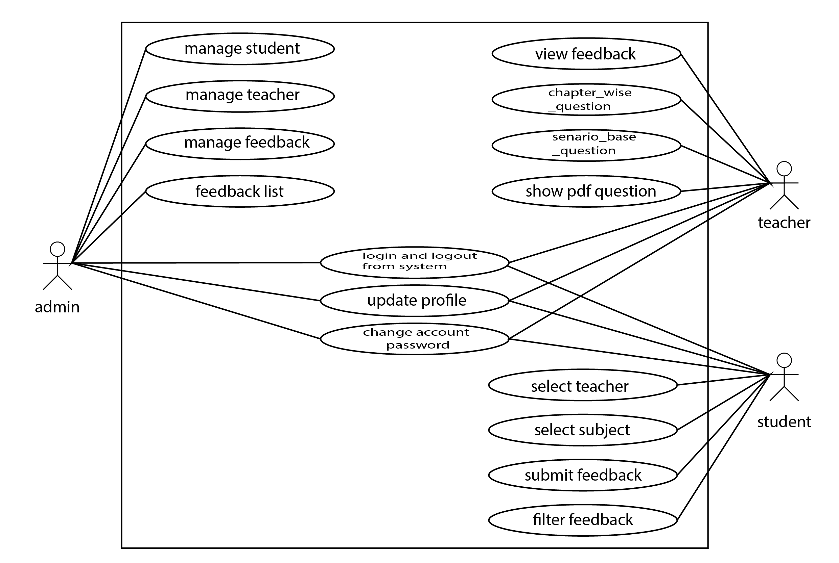

## Database Schema

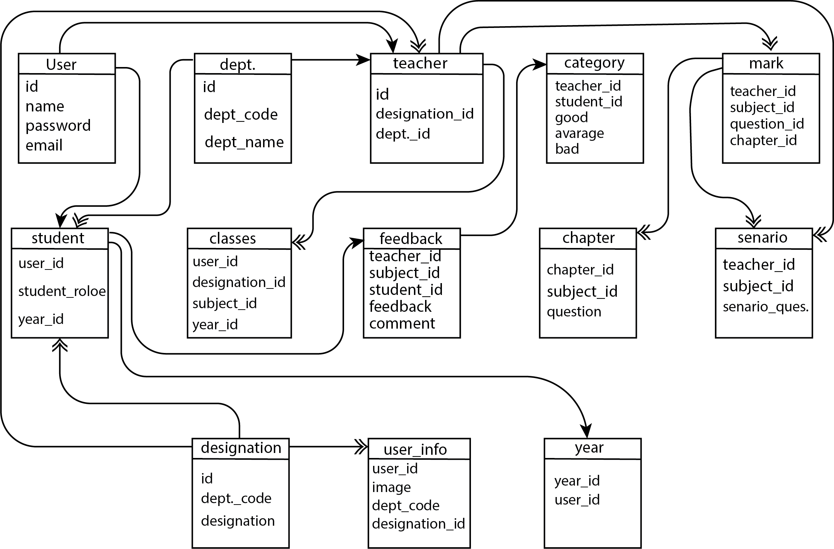

# Other Requirements

<Define any other requirements not covered elsewhere in the SRS. This might include database requirements, internationalization requirements, legal requirements, reuse objectives for the project, and so on. Add any new sections that are pertinent to the project.>

Appendix A: Glossary

<Define all the terms necessary to properly interpret the SRS, including acronyms and abbreviations. You may wish to build a separate glossary that spans multiple projects or the entire organization, and just include terms specific to a single project in each SRS.>

Appendix B: Analysis Models

<Optionally, include any pertinent analysis models, such as data flow diagrams, class diagrams, state-transition diagrams, or entity-relationship diagrams.>

Appendix C: To Be Determined List

<Collect a numbered list of the TBD (to be determined) references that remain in the SRS so they can be tracked to closure.>