Twisting:



Figure: Twisting it’s not good for health

Stooping:

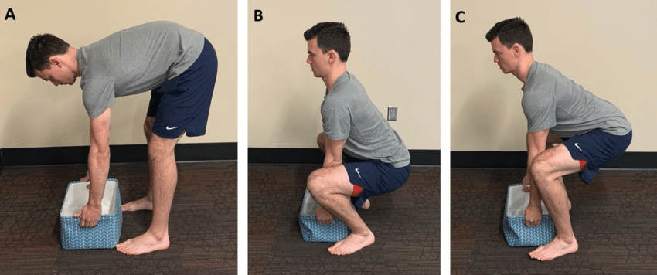

**(A) Stoop lift, (B) squat lift, (C) semi-squat lift.**

the stoop lift involves bending forward at the waist with the knees relatively straight, resulting in significant forward bending of the spine (trunk flexion). It's often described as "lifting with your back.

**Quantitative Description:** Approximately 4$\sim 90^\circ$ of trunk flexion and 5$<45^\circ$ of knee flexion when lifting from the floor.

**Is it good**? ; it’s good for save energy than squat lifting. Common use for light, repetitive lift .

**Suggested Use:** May be preferable for **light, frequent lifts** or for individuals with knee issues, as it places less stress on the knees

**Squat Lift:**

The squat lift involves bending the knees deeply while keeping the back as straight as possible (an upright, neutral spine). It's commonly advised as "lifting with your legs."

**Quantitative Description:** Approximately 11$\sim 135^\circ$ of knee flexion and 12$<30^\circ$ of trunk flexion when lifting from the floor.

**Is it good?** It engages the strong leg muscles.

**Suggested:** It’s used for Heavy and bulky objects.

**The semi-squat lift.:** he semi-squat lift is a compromise between the stoop and squat lifts. It involves bending both the knees and the back moderately

**Quantitative Description:** Approximately $\sim 90^\circ$ of knee flexion and $\sim 45^\circ$ of trunk flexion.

**Suggested Use:** Many health professionals recommend the semi-squat for general daily lifting as it balances muscle activity and reduces the extremes of spinal loading

Bending:

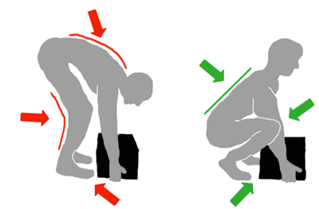

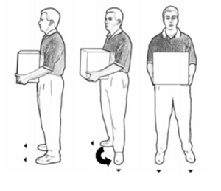

Pivot Technique

How many branch of Kmart of WA

36

Introduction:

Hello everyone, my name is **Mahfujur Rahman**. I’m currently studying in **Murdoch**, and I came to Australia last year.

Back in my home country, I worked in both the **retail and warehouse industries**. I started my career in the **manual section**, then moved to the **sorting area**, and was later **promoted to team leader**. Also, I worked same type job in Australia. These roles helped me build strong skills in teamwork, organization, and managing warehouse operations efficiently.

After coming to Australia, I achieved my **forklift license**, which has help me to handle warehouse equipment safely and effectively.

A few of my friends already work here at **Kmart Distribution Centre**, and I’ve heard that the **job responsibilities match well with my previous experience**. I understand that **work safety is a very high priority here**, and I always make sure to follow safety procedures carefully.

I’m also very excited to work in such a **large-scale operation** with a wide range of products — it’s a great opportunity to **gain more knowledge and experience** in modern warehouse systems.

I really enjoy **teamwork**, as it helps me learn from others and contribute my own skills. Working in a **multicultural environment** like Kmart is also a great way to connect with people from different backgrounds and grow both personally and professionally.

Overall, I’m very motivated to be part of the Kmart team, contribute my experience, maintain safety standards, and continue learning every day.