

Course Assignment Report

|  |  |  |  |  |  |  |
| --- | --- | --- | --- | --- | --- | --- |
|  | | **Only for course Teacher** | |  | | |
|  | | **Needs**  **Improvement** | **Developing** | **Sufficient** | **Above Average** | **Total Mark** |
| **Allocate mark & Percentage** | | **25%** | **50%** | **75%** | **100%** | **5** |
| **Content Quality** | **2** |  |  |  |  |  |
| **Clarity** | **1** |  |  |  |  |  |
| **Spelling & Grammar** | **1** |  |  |  |  |  |
| **Organization and Formatting** | **1** |  |  |  |  |  |
|  | |  | | **Total obtained mark** | |  |
| **Comments** |  |  | |  | | |

**Semester: Fall 24**

**Student Name: Md. Mahfuzur Rahman**

**Student ID: 0242310005341235**

**Batch: 40th Section: C**

**Course Code: SE221 Course Name: Object Oriented Design**

**Course Teacher Name: Akash Ghosh**

**Designation: Lecturer**

**Submission Date: 13/12/24**

# USE CASE DIAGRAM

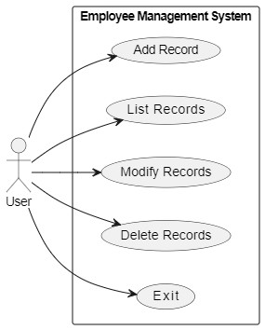

# CLASS DIAGRAM

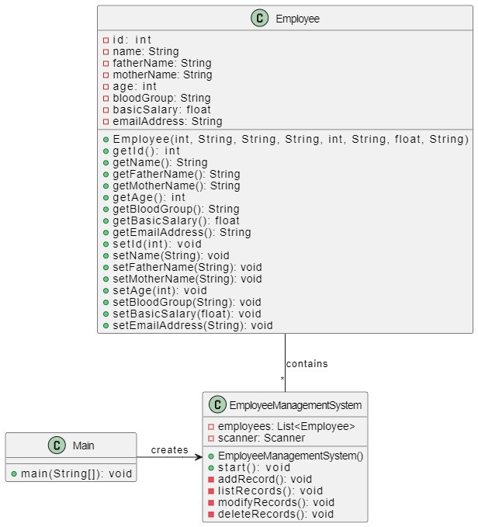

# ACTIVITY DIAGRAM

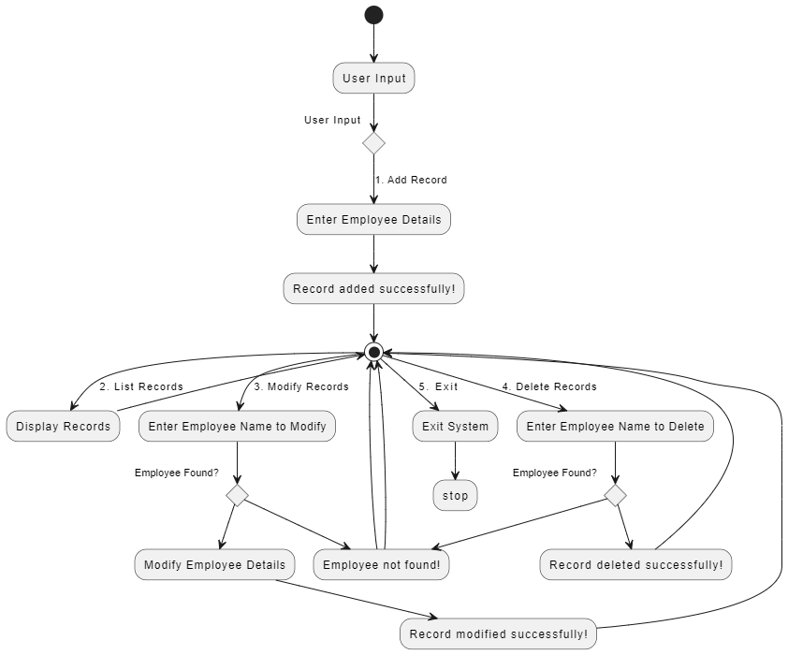

# THE END