
Form1

Semester Project Proposal Form

Department of Batch:

FYP Title
SpeakSafe: Confidential Concern Reporting and Case Management for Campuses and Workplaces

Domain
Human-Computer Interaction (Usable Security), Information Security, Full-Stack Web Application Development

Nature of FYP New Project Industrial Collaboration Funded Project

Extension of Existing Project Other Department / Academic Institution
Problem Statement
Students and employees who face harassment, discrimination, academic misconduct, fraud or safety issues often do not report them. They fear being identified or facing retaliation, are unsure whether the issue "counts", or do not trust how the report will be handled. Many institutions still take such reports by email, paper forms or in person, which exposes the reporter's identity, gives no safe way to follow up anonymously, and leaves no record of who viewed or acted on a case.
Existing whistleblowing platforms are either commercial and costly, or designed for journalists rather than for distressed, non-technical users. The problem is therefore both a usability problem and a security problem.

Objectives
- Design and build a working web system (frontend, backend and database) that lets users report concerns anonymously, confidentially or by name, and follow up on their case without creating an account.
- Apply user-centred design (user research, personas, prototyping and heuristic evaluation) so that a first-time, stressed user can submit a report without help, and apply ergonomic design to reduce physical strain, mental workload and stress.
- Ensure that only the committee members chosen for a case can read it, using end-to-end encryption, MFA, per-case access control and a tamper-evident audit log.
- Make the security understandable: at least 80% of test participants correctly identify who can and cannot read their report.
- Evaluate the system through a usability study (target mean SUS score above 68, the commonly cited average) and security testing against OWASP Top 10 risks.

Proposed Solution
SpeakSafe will be a web-based system that supports the full reporting journey, from "not sure" to "resolved", with security and usability designed together (usable security).
The proposed system will include:
- Know Your Options: plain-language guidance on what can be reported and what happens next.
- Private journal: record incidents privately over time (encrypted in the browser) and turn entries into a report later.
- Report wizard: anonymous, confidential or named reporting; evidence upload with hidden metadata removed; a "Who will see this?" preview where the reporter can exclude a committee member.
- Receipt card: a case ID and 5-word passphrase to check status and message the committee without an account.
- Committee dashboard: assigned cases only, case workflow, recusal, MFA login and two-person approval to close a case.
- Admin console: user and role management, tamper-evident audit log and privacy-preserving statistics. The admin will not be able to read reports.
- Quick-exit button on every reporter page and Urdu support for reporter pages.
- Ergonomic, comfortable interface: light, dark and eye-care display modes; thumb-friendly mobile layout; one question per screen; approximate dates ("about a week ago"); autosave and progress indicators.
- Handler support: case summary cards, blurred evidence by default, reply templates, "waiting too long" alerts, workload-aware assignment, undo and keyboard shortcuts.

Scope of the Project
In scope:
- Full-stack web application: React frontend, Node.js/Express backend and PostgreSQL database.
- Three user roles: reporter (no account needed), committee member (handler) and administrator.
- Thirteen pages covering the reporter journey, case handling and administration.
- End-to-end encryption of reports, journal entries and messages in the browser; excluded handlers never receive a decryption key.
- Secure authentication: Argon2id password hashing, TOTP-based MFA, secure sessions, and role-based and per-case access control.
- Tamper-evident (hash-chained) audit log recording every case view and action.
- Protection against OWASP Top 10 risks, report spam (proof-of-work CAPTCHA, rate limiting) and malicious file uploads.
- English and Urdu (right-to-left) interface for reporter pages; WCAG 2.2 AA accessibility in all display modes.
- Ergonomic features: three display modes (light, dark, eye care), mobile-first layout, reduced memory and stress load for reporters, and workload and wellbeing features for handlers.
- User research, usability study and security testing of the working system.
Out of scope:
- Native mobile apps (the web application will be fully responsive on phones).
- Email/SMS notifications, integration with external authorities, and live deployment at a real institution.
- Handling real incidents: all research and testing will use invented scenarios only.
- Preventing identification through writing style or very small groups (documented as a known limitation).

Development / Research Methodology
The project will follow a Secure Software Development Lifecycle (aligned with OWASP guidance and the NIST SSDF) combined with user-centred design:
- Planning and requirements: interviews with students and working professionals using hypothetical scenarios; personas, user stories, security requirements and a STRIDE threat model.
- Design: user flows, wireframes, Figma prototype and heuristic evaluation, applying physical, cognitive and organisational ergonomics; encryption, access-control and database design.
- Implementation: weekly iterations, secure coding practices and dependency scanning.
- Testing: comparative usability study of two "Who will see this?" designs (comprehension, trust, SUS, task success) and security testing (OWASP ZAP, Burp Suite, brute-force, metadata and tamper tests).
- Deployment and maintenance: HTTPS hosting, secrets management, patching, key-rotation and data-retention plan.

Resources Involved
- Hardware: personal laptop; smartphones for mobile and accessibility testing.
- Software (free/open source): React, Vite, TypeScript, Tailwind CSS, Node.js, Express, PostgreSQL, Prisma, libsodium, Figma, Git/GitHub, VS Code.
- Testing tools: OWASP ZAP, Burp Suite Community Edition, Semgrep, npm audit; axe DevTools, Lighthouse and NVDA screen reader for accessibility.
- Hosting: free tiers of Render (application) and Neon (database).
- People: 8-10 participants (students and working professionals) for interviews and usability testing; course instructors.
- Estimated cost: none (free tools and free hosting tiers).

Final Outcome / Deliverables
- Working, deployed SpeakSafe web application (frontend, backend and database) with source code on GitHub.
- HCI documentation: research findings, personas, user flows, wireframes, Figma prototype, heuristic evaluation and usability study report (SUS, comprehension and trust results).
- Security documentation: security requirements, STRIDE threat model, data-flow diagram, encryption design, traceability matrix and security test report.
- Accessibility audit report (WCAG 2.2 AA).
- Final report, presentation and live demonstration.

Learning Outcome
- Applying user-centred design and usability evaluation methods to a sensitive, real-world problem.
- Designing security features that users can understand and trust (usable security).
- Applying ergonomic principles to reduce physical strain, mental workload and stress for different user groups.
- Implementing end-to-end encryption, MFA, access control and audit logging in a full-stack application.
- Threat modelling and testing a web application against OWASP Top 10 risks.
- Handling sensitive data ethically and communicating system limitations honestly.

Existing Systems and Gap Analysis
Existing approach | Mainly used by | Strengths | Gap that SpeakSafe addresses
Email, paper forms or in-person reporting | Many local universities and workplaces | Simple; no setup needed | Reporter identity exposed; no anonymous follow-up; no record of who viewed or acted on a case
GlobaLeaks (open source) | NGOs, media and public bodies | Free; strong anonymity features | General-purpose whistleblowing tool; needs technical setup; not designed around hesitant reporters or committee workflows
SecureDrop (open source) | News organisations | Very strong security | Built for sources contacting journalists; requires Tor Browser and technical knowledge
NAVEX EthicsPoint (commercial) | Large companies | Hotline, web reporting and case management | Paid licence; corporate-compliance focus; not affordable for most local institutions
Callisto | Survivors of sexual misconduct, mainly in the US | Private record first, report later | Narrow focus and region; not a case-management system for local committees
SpeakSafe (proposed) | Local campuses and workplaces | Free; designed for hesitant, non-technical users | Combines a private journal, guided reporting, reporter-controlled visibility, committee workflow with recusal and two-person approval, and Urdu support

Target Users and Stakeholders
User / stakeholder | Needs | Main concern
Reporter (student or employee) | Report safely, follow up on the case, understand what happens next | Being identified; retaliation; not being believed
Committee member (handler) | See assigned cases, ask questions, record decisions | Workload; fairness; conflicts of interest
Administrator | Manage users, roles and categories; check system integrity | Must not be able to access case content
Institution | An accountable, transparent process; awareness of patterns | Reputation; meeting legal and policy duties
Planned personas | Anxious student reporting on a phone; professional worried about retaliation; busy committee member | To be finalised after interviews

Usable Security Approach (Where HCI and Security Meet)
Security feature | Usability risk | Design response
5-word passphrase instead of an account | Users may lose it, and it cannot be recovered | Downloadable receipt card; user re-types 2 words before leaving; clear warning in plain language
End-to-end encryption and reporter exclusion | Protection is invisible, so users may not trust it | "Who will see this?" visual preview showing excluded members crossed out
Metadata stripping of uploads | Users do not know photos can reveal location | Plain-language notice at upload explaining what is removed
Mandatory MFA for handlers | Setup friction for staff | Guided first-login setup with QR code and recovery codes
Session timeout for handlers | Losing unsaved work | Warning with an "extend" button; reporters have no timeout and their draft stays in the open tab
Audit log of every case view | Can feel like surveillance | Shown to reporters as reassurance: "Viewed by the committee on [date]"
Quick exit | Someone may be watching the screen | One-click exit button on every reporter page

Ergonomic Design
Ergonomic area | Design feature | Benefit
Physical | Thumb-friendly mobile layout with main buttons at the bottom; touch targets of at least 44 x 44 px | Easier one-handed use on phones, fewer mis-taps under stress
Physical | Light, dark and eye-care (warm, reduced-glare) display modes; works at 200% zoom and with voice dictation | Visual comfort in different lighting; discreet use at night; support for low vision and typing difficulty
Physical | Keyboard shortcuts for handlers | Less mouse movement during long review sessions
Cognitive | One question per screen, progress bar and time estimate ("about 5 minutes") | Lower mental load and anxiety for reporters
Cognitive | Approximate date options ("about a week ago"); autosave indicator; passphrase shown as large word chips with a copy button | Supports fragmented memory under stress; less fear of losing work; fewer copying errors
Cognitive | Case summary card and 5-second undo for handler actions | Faster orientation in a case; mistakes are easy to correct (all actions still logged)
Organisational | Evidence images blurred until the handler chooses to view them | Reduces repeated exposure to distressing material; protects privacy on screen
Organisational | Reply templates, "waiting too long" alerts and workload-aware case assignment | Consistent, timely responses to reporters; fair workload; respects exclusion and recusal rules
The eye-care mode is offered as a comfort and reduced-glare option. All three modes will be checked against WCAG 2.2 AA contrast requirements.

Preliminary Threat Model (STRIDE)
Threat | Example in SpeakSafe | Planned control
Spoofing | Attacker guesses a case ID and passphrase | High-entropy passphrase, Argon2id hashing, rate limiting and ALTCHA proof-of-work
Tampering | Handler or attacker edits a report or log | Immutable reports with SHA-256 fingerprint; add-only notes; hash-chained audit log
Repudiation | Handler denies opening a case | Every view and action logged; log cannot be updated or deleted by the app's database role
Information disclosure | Reporter identified through IP logs, file metadata or a database leak | No IP logging on reporter routes; metadata stripping; end-to-end encryption
Denial of service | Spam of fake reports or oversized uploads | Proof-of-work CAPTCHA, rate limiting, upload size and type limits
Elevation of privilege | Handler opens a case not assigned to them; admin reads reports | Per-case access control and encryption keys; admin has no decryption key; two-person approval to close cases

Proposed System Architecture
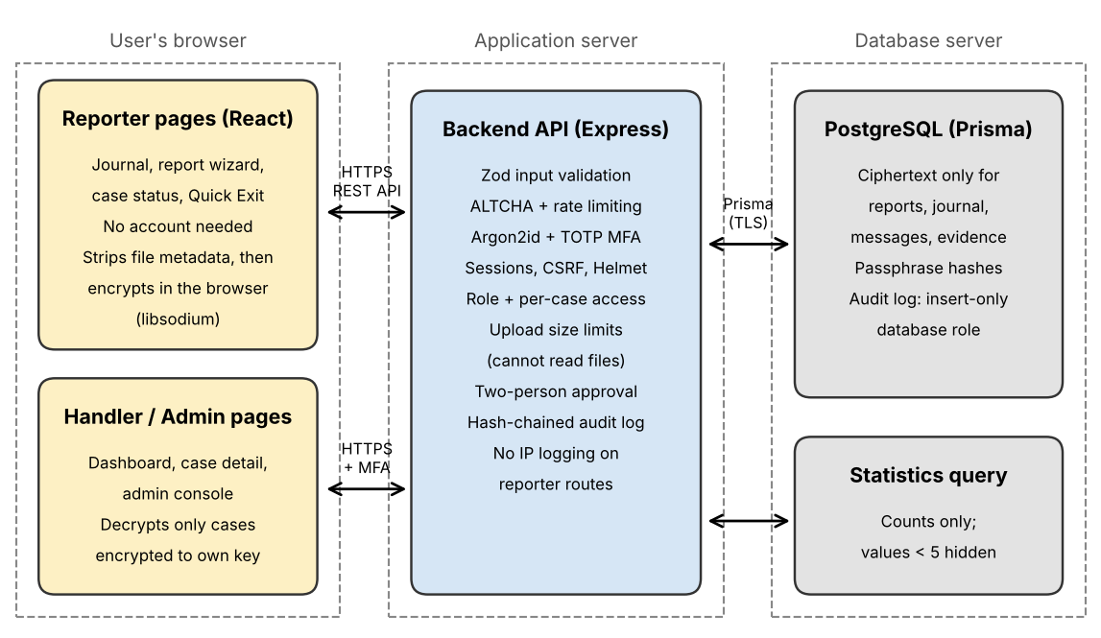
Figure 1: Proposed SpeakSafe architecture. Reports will be encrypted in the browser, so the server and database will store only ciphertext.

Evaluation Plan and Success Criteria
Area | Method | Success criterion
Task success | Task-based testing with 8-10 participants (think-aloud) | At least 90% complete "submit a report" and "check my case" without help
Satisfaction | System Usability Scale (SUS) | Mean SUS score above 68
Understanding of security | Comprehension questions (e.g., "Can the admin read your report?") | At least 80% correct answers
Design comparison | A/B test of two "Who will see this?" designs | Report which design gives better comprehension and trust
Accessibility | axe DevTools, Lighthouse, keyboard-only and NVDA screen reader checks in light, dark and eye-care modes | No critical WCAG 2.2 AA issues remaining; all modes meet AA contrast
Security | OWASP ZAP scan; Burp Suite access-control and IDOR tests; brute-force tests | No unresolved high-risk findings; all access-control tests pass
Data protection | Inspect database contents and uploaded files | No readable report content in the database; no metadata left in files

Ethical Considerations
- Participants will use invented scenarios only and will never be asked about real experiences.
- Participation is voluntary, with informed consent; participants may stop at any time.
- No identifying information will be kept in study records; participants will be labelled P1, P2 and so on.
- Instructor approval will be obtained before any user testing.
- The system will not be used to collect real reports during the project.

Risks and Mitigation
Risk | Impact | Mitigation
End-to-end encryption takes longer than planned | Schedule delay | Use the well-tested libsodium library; build encryption early (Week 2); documented fallback to server-side encryption
Reporter loses passphrase | Cannot access case | Receipt card, re-type check and optional contact email (with a clear anonymity warning)
Limited time as a solo developer | Features incomplete | 6 weeks of development plus a 2-week buffer; fixed priority order (core features first, then extra features); no new features after Week 4
Difficulty recruiting participants | Weak usability evidence | Recruit students and working professionals early; allow remote sessions
Free hosting limits or platform logging | Demo issues; privacy gap | Document hosting logs honestly; keep a local demo as backup
Limits of anonymity (writing style, small groups) | Reporter could be guessed | Documented as a known limitation; warning shown to reporters; statistics hide counts below 5

Industrial Support (if any) __________________________-________________________________

FYP Team members:
S. No. | Name of the Student | IU Regn No | CGPA | Signature
1
2
3

Details of Supervisor / Industrial Advisor:

 | Name | Designation &  Department | Contact No. | Signature
Supervisor
Co-Supervisor
(if any)
Industrial Advisor
(if any)

Project Schedule
S.no | Weeks | Milestones | Deliverables
1 | Week 1 | Problem definition, user interviews, personas, requirements, STRIDE threat model; project setup with theme system (light, dark, eye care) and translation files | Proposal, requirements document, personas, threat model
2 | Week 2 | User flows, wireframes, Figma prototype, heuristic evaluation; encryption and database design; report wizard (one question per screen, approximate dates, autosave) and receipt card | Prototype, design document, first working pages
3 | Week 3 | Committee login with MFA, dashboard with waiting alerts, case detail with summary card and blurred evidence, recusal, reporter exclusion, workload-aware assignment | Working case-handling module
4 | Week 4 | Private journal, messaging with reply templates, evidence upload, audit log, quick exit, two-person approval, undo, keyboard shortcuts | Feature-complete system
5 | Week 5 | Comparative usability study (A/B) with SUS; security testing with OWASP ZAP and Burp Suite; statistics page | Usability report, security test report
6 | Week 6 | Urdu and RTL support, accessibility audit of all display modes, fixes, deployment | Deployed, complete system
7 | Week 7-8 (buffer) | Second usability round, bug fixes, report finalisation, demo rehearsal, instructor feedback | Final reports, presentation, live demo

Gant Chart
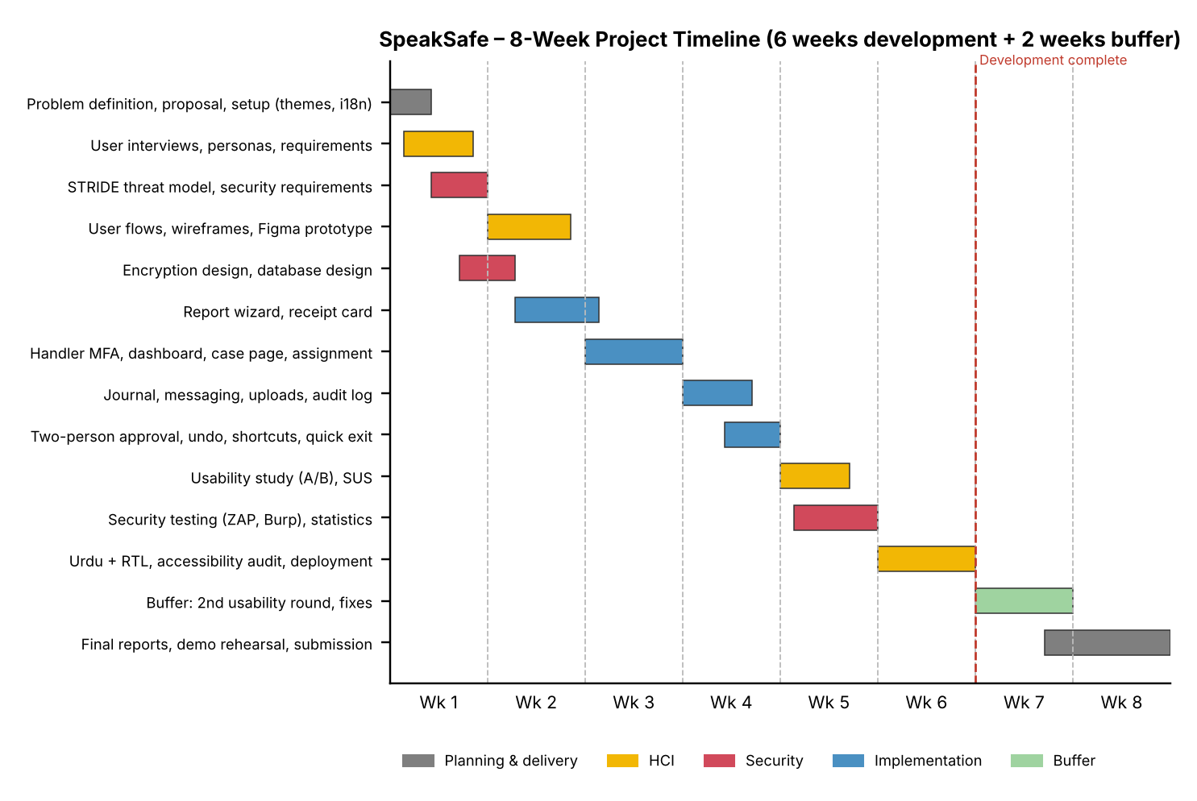

FYP to Sustainable Development Goals (SGDs) Mapping:
SGDs | Mapping | Description
SDG 01. No poverty
SDG 02. Zero hunger
SDG 03. Good health and well-being
SDG 04. Quality  education | ✓ | Supports target 4.a (safe, non-violent learning environments) by giving students a safe way to report harassment and misconduct on campus.
SDG 05. Gender equality | ✓ | Supports target 5.2 (eliminating violence against women and girls) by lowering the barriers to reporting harassment.
SDG 06. Clean water and sanitation
SDG 07. Affordable and clean energy
SDG 08. Decent work  and economic growth | ✓ | Supports target 8.8 (safe and secure working environments) by giving employees a confidential reporting channel.
SDG 09. Industry,
innovation, and infrastructure
SDG 10. Reduced
inequalities
SDG 11. Sustainable
cities and communities
SDG 12. Responsible consumption and production
SDG 13. Climate action
SDG 14. Life below water
SDG 15. Life on land
SDG 16. Peace, justice and strong institutions | ✓ | Supports target 16.6 (accountable and transparent institutions) through audit logs, recusal and two-person approval.
SDG 17. Partnerships for the goals

FYP to Complex Computing Problem (CCP) Mapping:

CCP Attribute | WP1 and some or all of WP2 to WP7: | FYPD to CCP Mapping  How it is addressed in FYPD
Depth of knowledge required | WP1: one or more of ACM Knowledge Ara | Depth of knowledge required: HCI (user research, usability evaluation, accessibility), applied cryptography (end-to-end encryption, key management), secure web development and research ethics.
Range of conflicting requirements | WP2: wide-ranging or Conflicting technical, engineering/computing and other issues | Range of conflicting requirements: Anonymity against accountability and abuse prevention; strong security (non-recoverable passphrases, session timeouts) against ease of use for distressed users; transparency to reporters against privacy of handlers.
Depth of analysis required | WP3: no obvious solution | Depth of analysis required: No established design makes end-to-end encrypted, anonymous reporting understandable to non-technical users. The visibility model and the way it is explained must be designed and validated through user testing.
Familiarity of issues | WP4: Involve infrequently encountered issues | Familiarity of issues: Usable security for anonymous reporting is rarely attempted for local campuses and workplaces, and reporting processes differ widely between institutions.
Extent of applicable codes | WP5: outside problems encompassed by standards and codes of practice | Extent of applicable codes: General guidance (OWASP Top 10/ASVS, WCAG 2.2, NIST SSDF) applies, but no standard covers usable anonymous reporting systems. User studies must follow research ethics and data protection practices.
Extent of stake-holder involvement and conflicting requirements | WP6: diverse groups of stakeholders with widely varying needs | Reporters (students and employees), committee members, administrators and the institution, each with different needs for privacy, accountability, workload and trust.
Interdependence | WP7: many component parts or sub-problems | Client-side encryption, key management, reporter journey, case workflow, access control, audit log, Urdu localisation and evaluation all depend on each other.

For office use only:
- Proposal  Approved | - Not Approved | - Returned for Clarification / Modification
Comments
(if any):
Project Serial No. |  | Date:
Signature  FYP Coordinator |  | Signature  Chairperson
Signature Associate Dean / Dean

Annexure – A

Knowledge Areas in ACM

# | ACM Knowledge Area | Your Project Mapping to ACM Knowledge Area
1 | AL-Algorithms and Complexity | -
2 | AR-Architecture and Organization | -
3 | CN-Computational Science | -
4 | DS-Discrete Structures | Hash chains for the tamper-evident audit log; access rules modelled as sets and relations (who can decrypt which case).
5 | GV-Graphics and Visualization | Accessible charts for privacy-preserving statistics (counts below 5 hidden).
6 | HCI-Human-Computer Interaction | User research, personas, user flows, wireframes and prototype, Nielsen's heuristics, WCAG 2.2 AA, A/B usability study with SUS, trust and comprehension measures; trauma-informed design; Urdu RTL interface.
7 | IAS-Information Assurance & Security | STRIDE threat model; end-to-end encryption (libsodium); Argon2id hashing; TOTP MFA; role-based and per-case access control; tamper-evident audit logs; OWASP Top 10 protections; testing with OWASP ZAP and Burp Suite.
8 | IM-Information Management | PostgreSQL schema with Prisma; only encrypted report data stored; least-privilege database roles; data retention.
9 | IS-Intelligent Systems | -
10 | NC-Networking and Communication | Client-server REST API over HTTPS; secure cookies, CSRF protection and security headers.
11 | OS-Operating Systems | -
12 | PBD-Platform-based Development | Responsive web platform using React, Node.js/Express and PostgreSQL; browser-based cryptography.
13 | PD-Parallel and Distributed Computing | -
14 | PL-Programming Languages | TypeScript across frontend and backend; schema validation with Zod.
15 | SDF-Software Development Fundamentals | Secure software development lifecycle, version control with Git and automated tests.
16 | SE-Software Engineering | Requirements and threat model, architecture design, traceability matrix, integration testing and deployment.
17 | SF-Systems Fundamentals | -
18 | SP-Social Issues and Professional Practice | Research ethics with invented scenarios; protecting reporter privacy; honest communication of anonymity limits; responsible handling of sensitive data.

References
[1] J. Brooke, "SUS: A quick and dirty usability scale," in Usability Evaluation in Industry, Taylor & Francis, 1996.
[2] J. Nielsen, "10 Usability Heuristics for User Interface Design," Nielsen Norman Group, 1994.
[3] W3C, "Web Content Accessibility Guidelines (WCAG) 2.2," W3C Recommendation, 2023.
[4] OWASP Foundation, "OWASP Top 10" and "ASVS," owasp.org.
[5] NIST, "Secure Software Development Framework (SSDF) Version 1.1," SP 800-218, 2022.
[6] A. Shostack, Threat Modeling: Designing for Security, Wiley, 2014.
[7] A. Whitten and J. D. Tygar, "Why Johnny Can't Encrypt: A Usability Evaluation of PGP 5.0," in Proc. 8th USENIX Security Symposium, 1999.
[8] SAMHSA, "Concept of Trauma and Guidance for a Trauma-Informed Approach," 2014.
[9] Government of Pakistan, "Protection against Harassment of Women at the Workplace Act, 2010."
[10] United Nations, "The 2030 Agenda for Sustainable Development," 2015.
[11] globaleaks.org; securedrop.org; projectcallisto.org; navex.com.

