Q1.

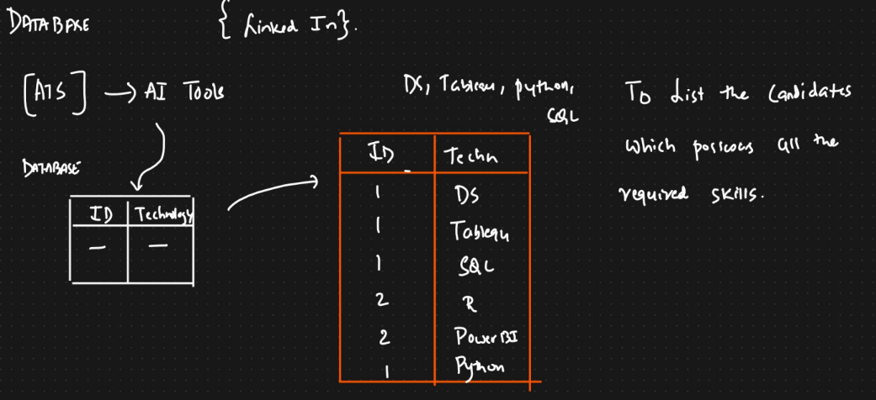

**Answer: -**

create database linkedin;

use linkedin;

create table atstable (id int, technology varchar(25));

insert into atstable values(1, "ds"),

(1,"tablequ"),

(1,"sql"),

(2,"R"),

(2,"Powerbi"),

(1,"python");

select id from atstable where technology = "ds" and id in (select id from atstable where technology = "sql" and id in (select id from atstable where technology = "python" ));

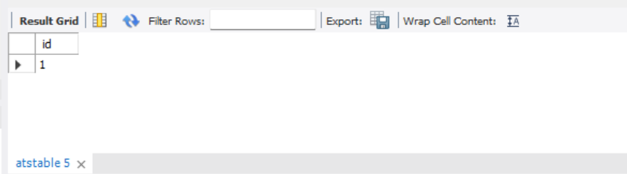

Q2.

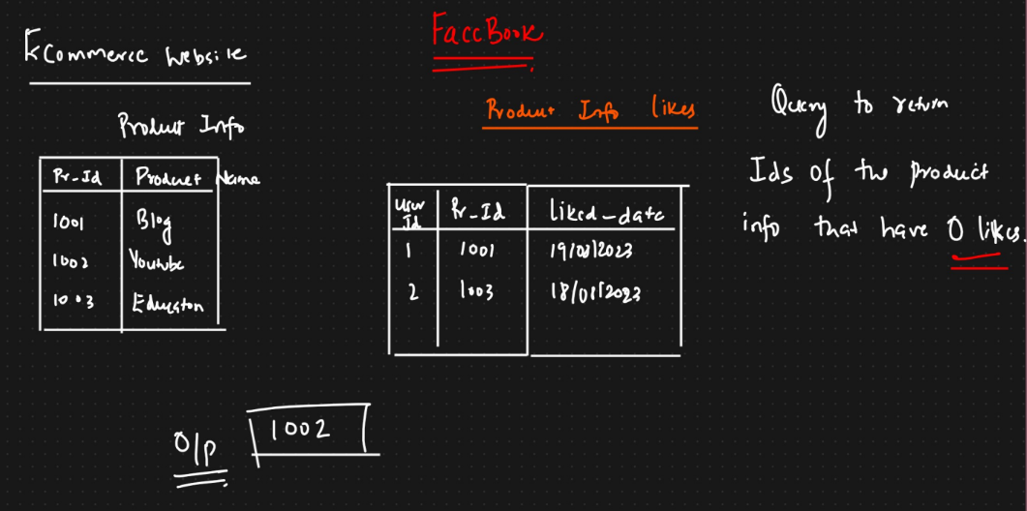

**Answer: -**

insert into product_info values(1001,"blog"),

(1002,"youtube"),

(1003,"education");

insert into like_table value

(1,1001,"19-08-23"),

(2,1003,"08-08-23");

select * from product_info where pr_id NOT IN (select pr_id from like_table);

