SYNTHETIC APPLICATION TEST DATA - NOT A REAL CLAIM
Claim reference: SYN-DEMO-001
Member ID: SYN-MEM-001

Dear customer,
This letter confirms the documents received at our inward desk for the claim above. The desk stamp below records the receipt.
Document | Reference | Status
Itemized hospital bill | SYN-INV-001, version 1 | Received
Final signed discharge summary | - | Not received

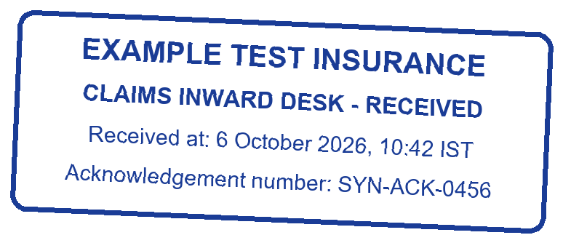

This acknowledgement records receipt only. It is not an approval, rejection, coverage decision or settlement.

