Flask Mongo App Commands Assignment

1. Objective
To build a Flask application that provides an API endpoint to read data from a file and a frontend form to submit data into MongoDB Atlas.

2. Project Structure
flask-mongo-app/
├── app.py
├── data.json
├── templates/
│ ├── form.html
│ └── success.html
Screenshot:
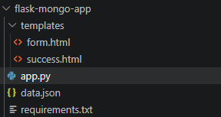

3. API Route (/api)
The /api route reads data from a JSON file and returns it as a JSON response using Flask.
Screenshot:
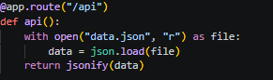

4. Frontend Form
A simple HTML form collects user input and submits data using POST method.
Screenshot:
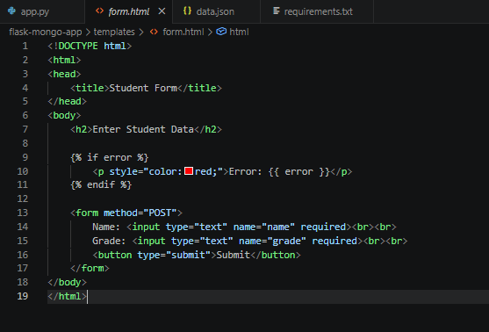
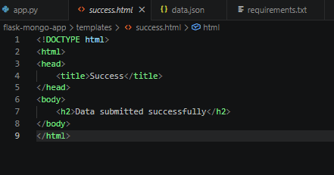

5. MongoDB Atlas Integration
The app connects to MongoDB Atlas using a connection string and inserts data into a collection.
Screenshot:
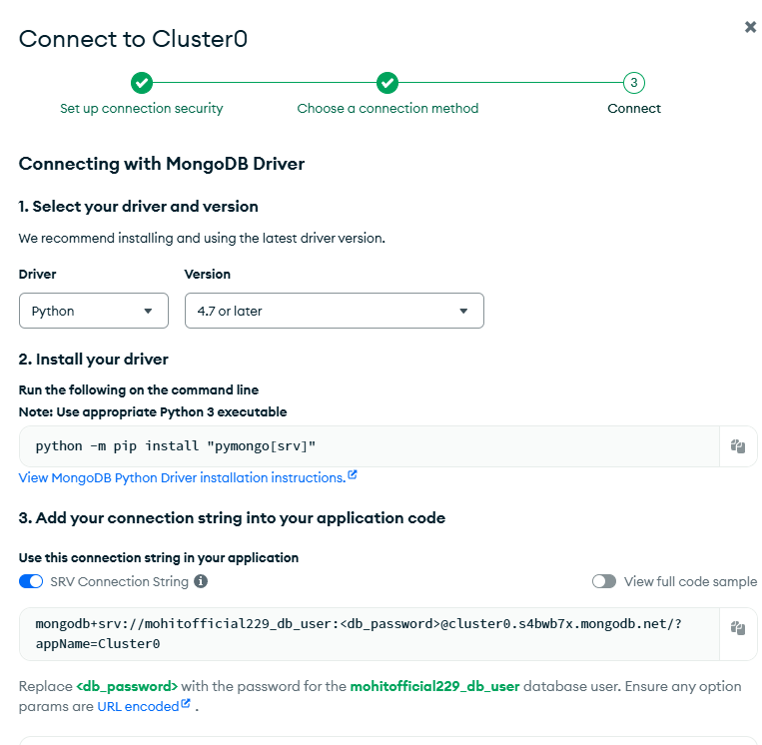

6. Success & Error Handling
On success, user is redirected to success page. On error, message is displayed on same page.
Screenshot:
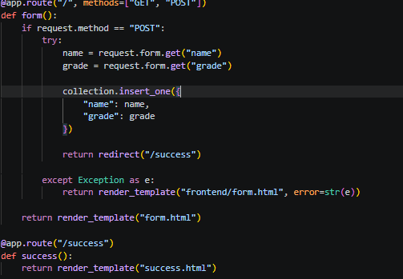

7. Code Explanation
Flask manages routes, templates render UI, pymongo handles DB, JSON handles file data.
Screenshot:

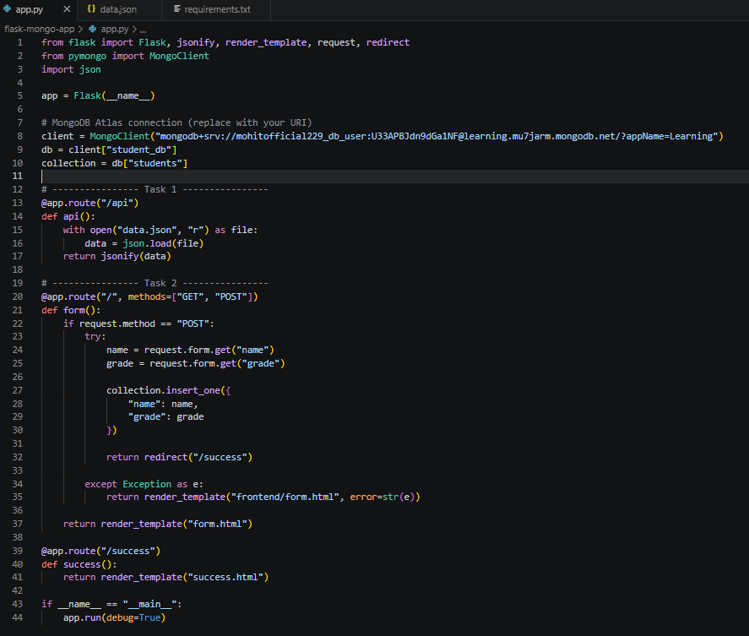

8. Output
Include screenshots of API response, form page, submission, and DB entries.
Screenshot:
