Kubernetes Commands Assignment

1. Objective
To deploy a Flask backend and Node.js frontend application on a local Kubernetes cluster using Minikube.

2. Architecture

User (Browser)
↓
Frontend Service (NodePort :3000)
↓
Frontend Pod (Node.js App)
↓
Backend Service (ClusterIP :5000)
↓
Backend Pod (Flask App)

3. Setup Minikube
Commands used to start Minikube and verify cluster status.
Screenshot:
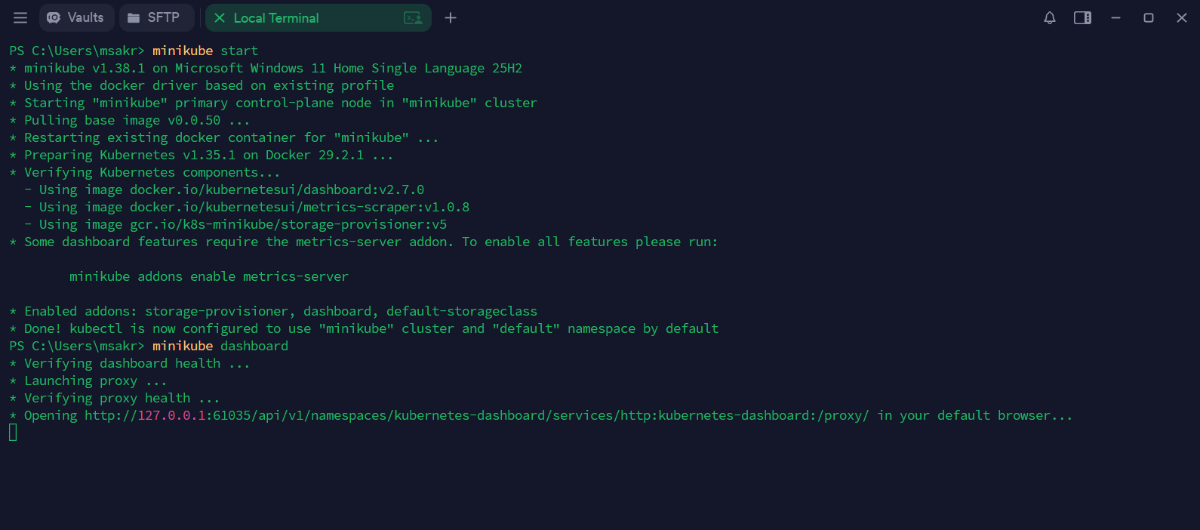
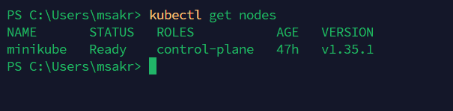
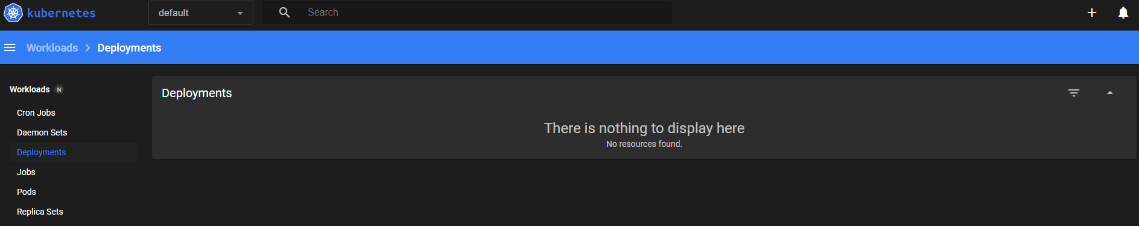

4. Kubernetes Deployment
Created Deployment YAML files (including services) for frontend and backend to manage pods.
Screenshot:
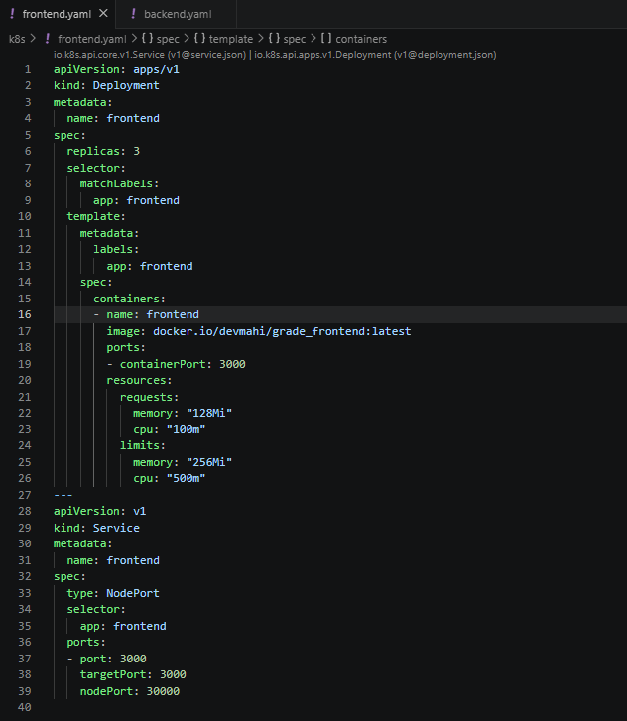
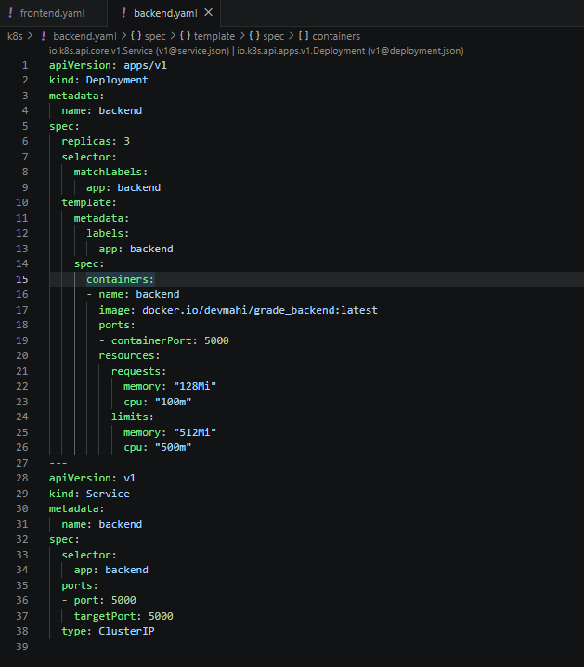
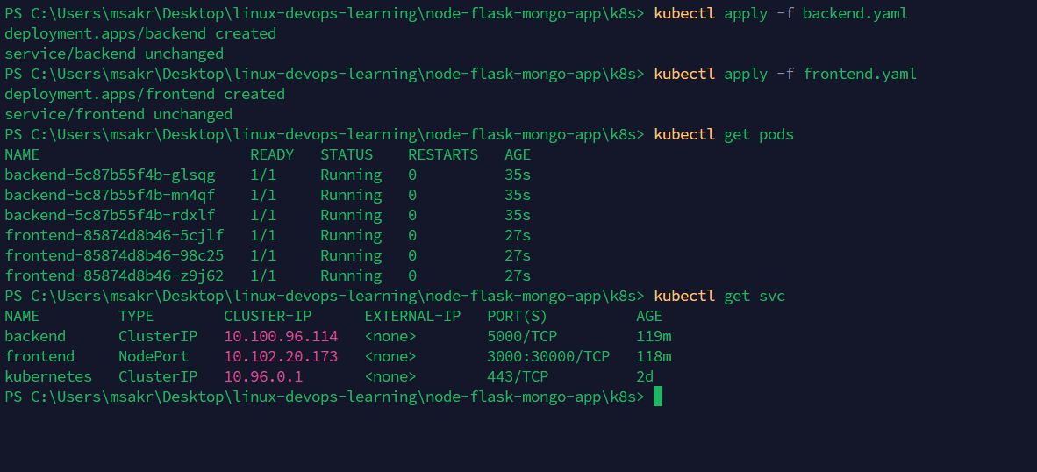
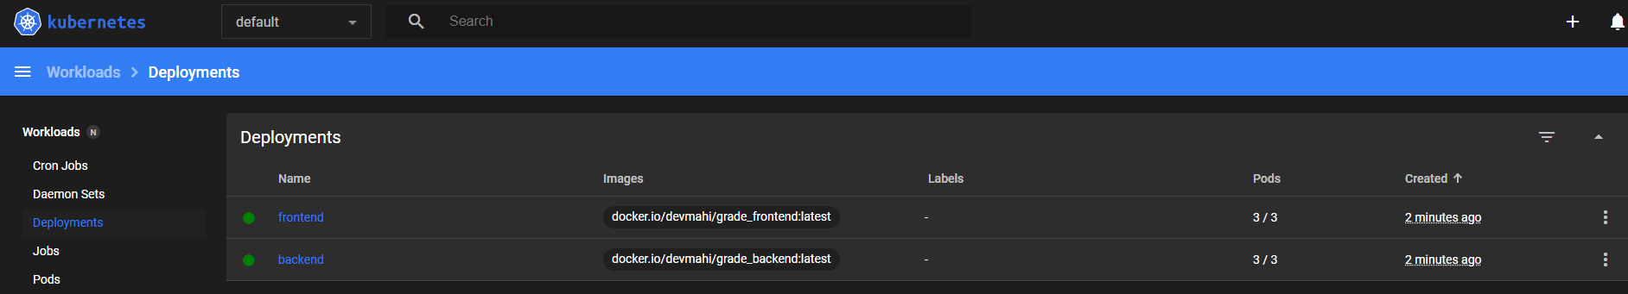
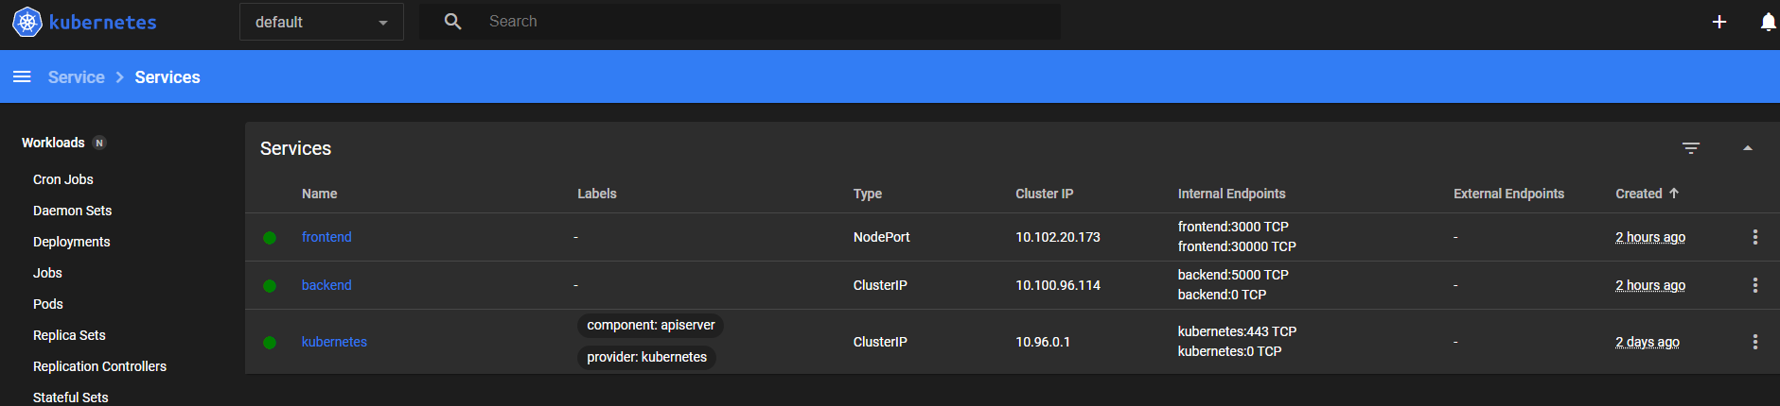

7. Application Access
Used Minikube service command to access the application in browser.
Screenshot:
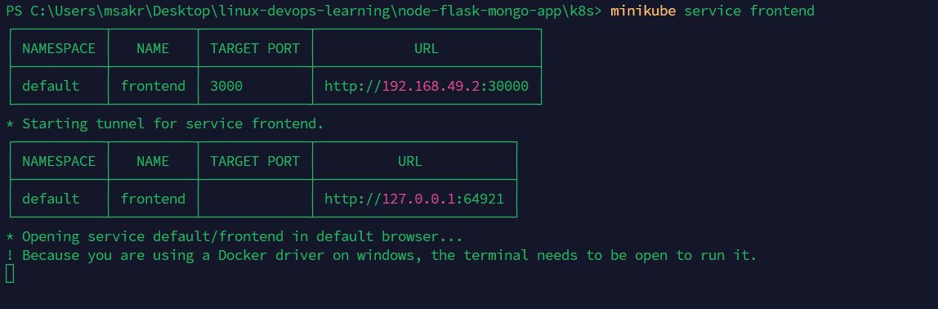

8. Output

Screenshot:
