Git GitHub Commands Assignment

1. Repository Setup and Branching
Commands:
git clone git@github.com:MahiTzy/linux-devops-learning.git
cd linux-devops-learning
git checkout -b mohit
git add .
git commit -m "Added Flask project"
git push origin mohit
git checkout main
git merge mohit
Explanation:
Clone repo using SSH, create branch, add files, commit and merge into main.
Screenshot:
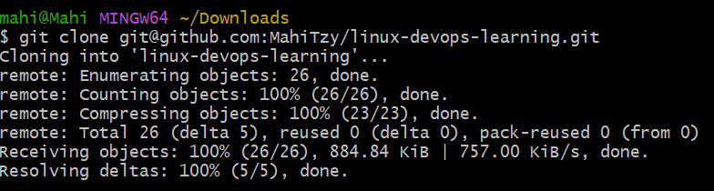
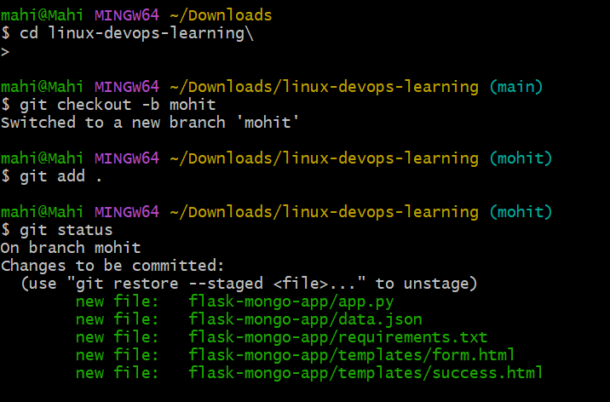
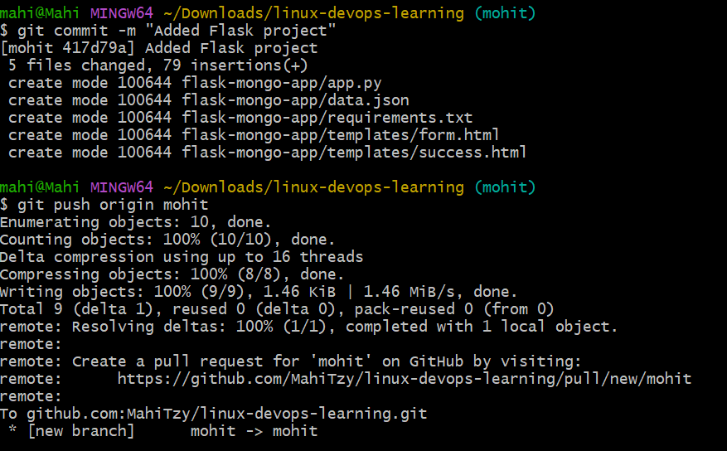
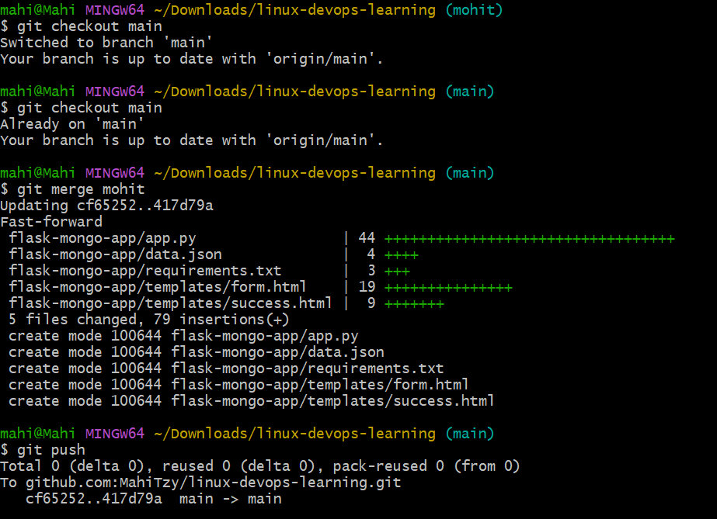
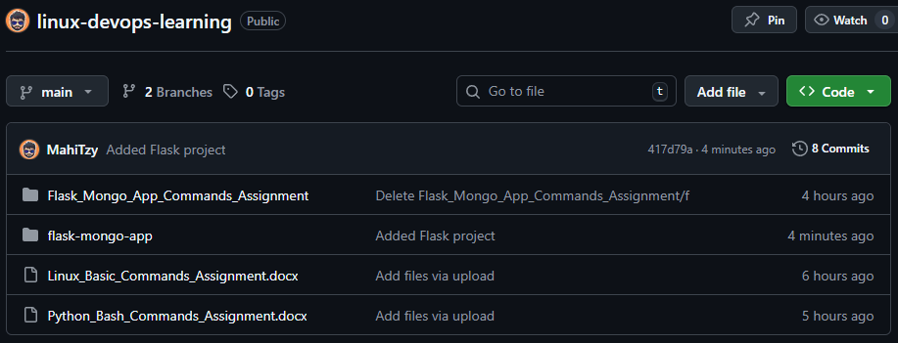
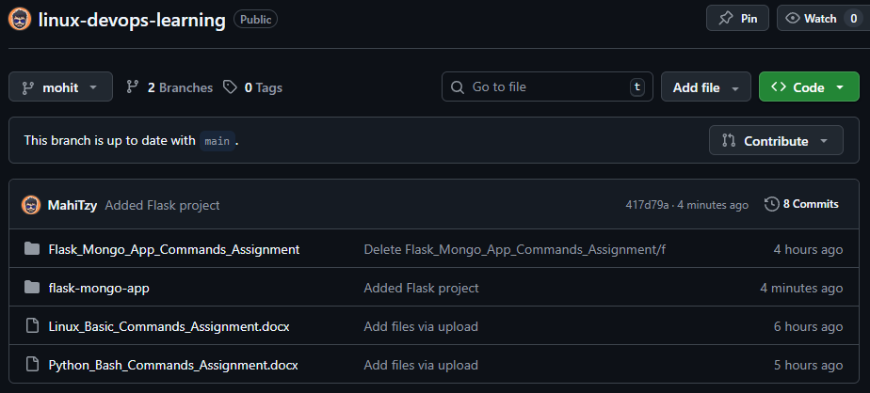

2. New Branch and JSON Update
Commands:
git checkout -b mohit_new
# update data.json
git add data.json
git commit -m "Updated JSON file"
git checkout main
git merge mohit_new
git add .
git commit -m "Resolved conflicts"
git push
Explanation:
Create new branch, update JSON, merge into main and resolve conflicts.
Screenshot:
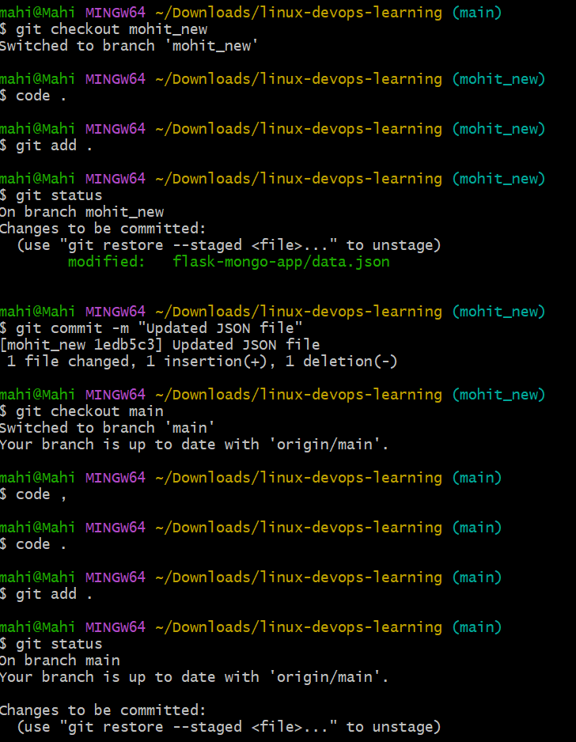
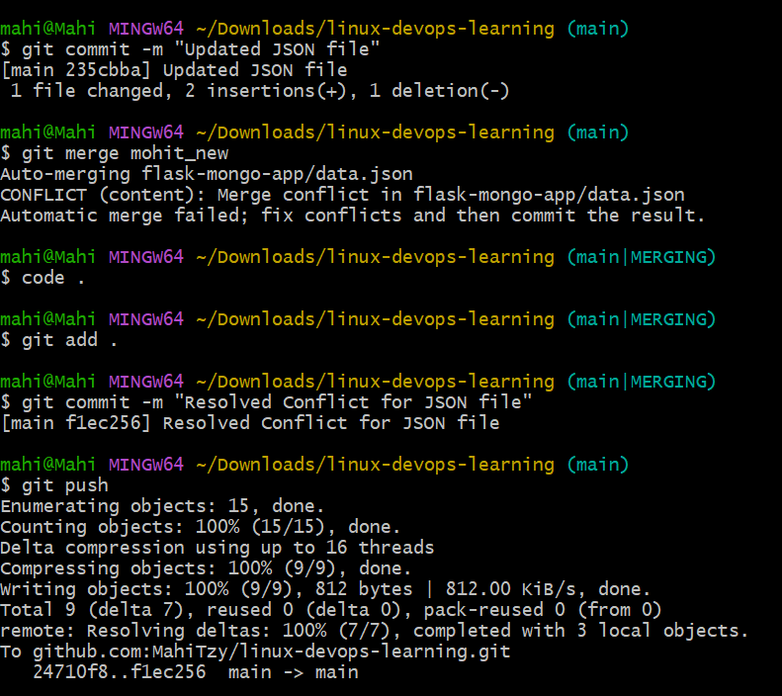
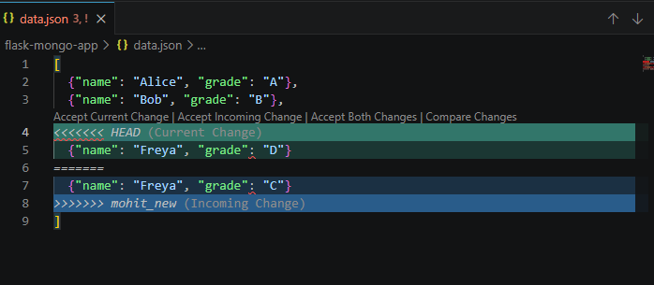

3. Feature Development (Branches)
Commands:
git checkout -b master_1
# frontend todo form
git checkout -b master_2
# backend API
git checkout main
git merge master_1
git merge master_2
Explanation:
Develop frontend and backend in separate branches and merge.
Screenshot:
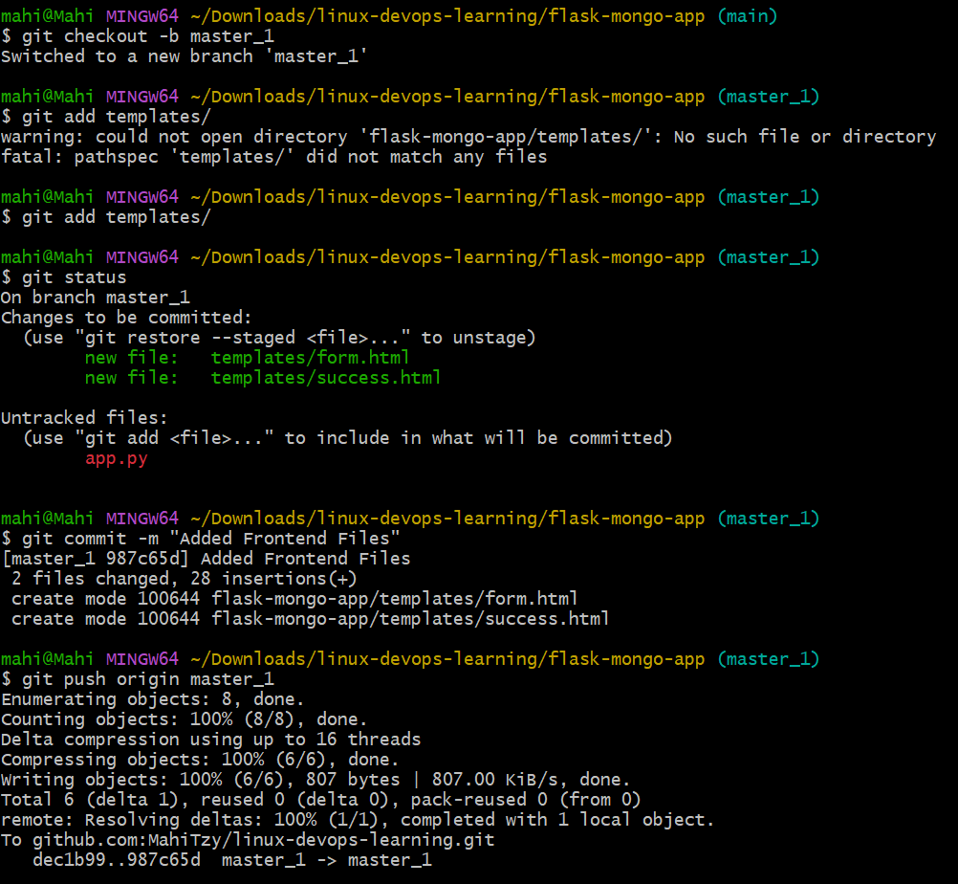
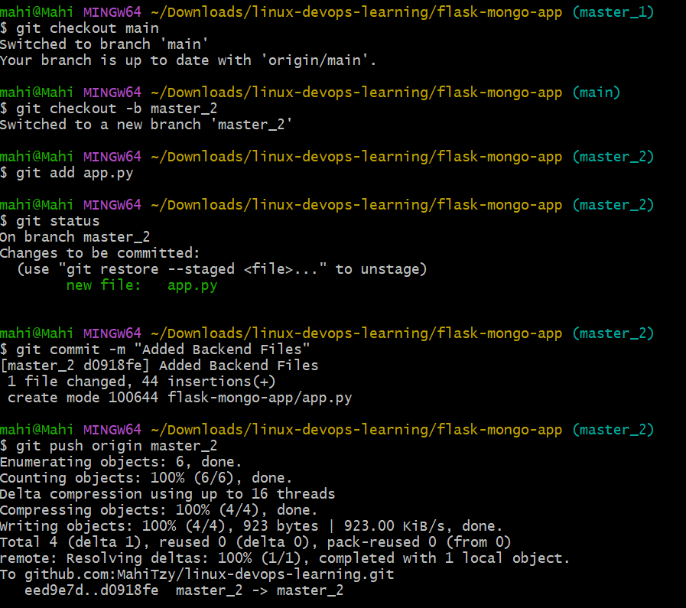
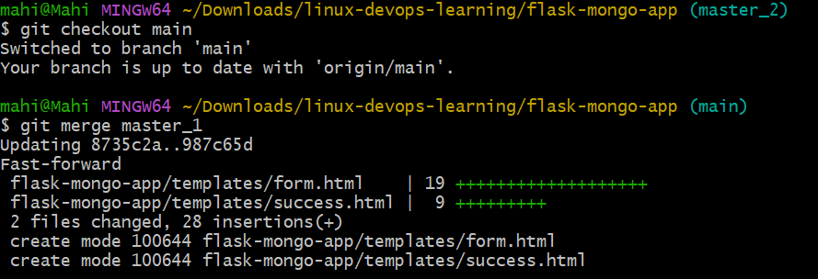
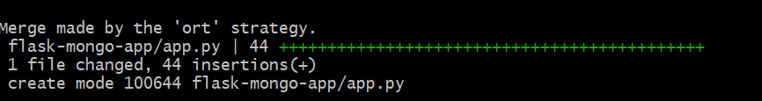
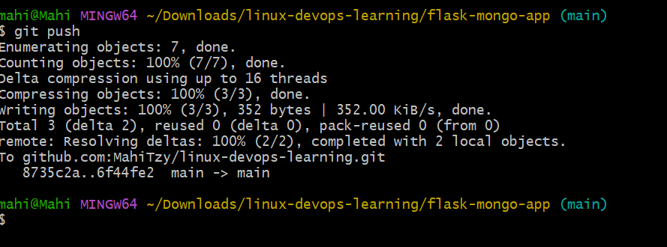
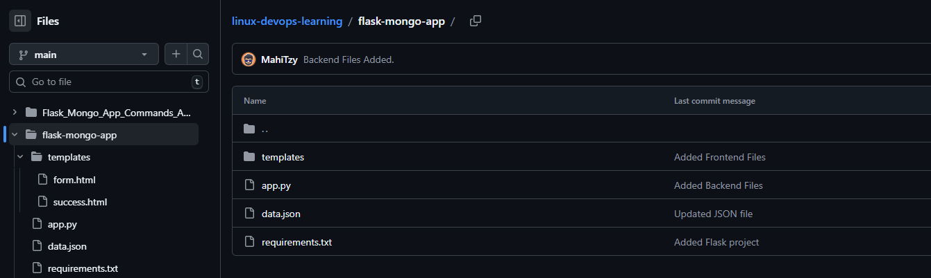

4. Enhancing Form and Git Reset/Rebase
Commands:
git checkout master_1
# commit ID
git commit -m "Added Item ID"
# commit UUID
git commit -m "Added Item UUID"
# commit Hash
git commit -m "Added Item Hash"
git checkout main
git merge master_1
git reset --soft HEAD~2
git commit -m "Rollback to Item ID"
git checkout master_1
git rebase main
Explanation:
Add fields step-by-step, reset commits, and rebase while preserving history.
Screenshot:
