Linux Basic Commands Assignment

1. Creating and Renaming Files/Directories
Command Used:
mkdir test_dir
cd test_dir
touch example.txt
mv example.txt renamed_example.txt
Explanation:
mkdir creates a directory, touch creates a file, and mv renames the file.
Screenshot:
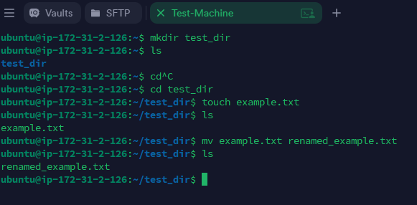

2. Viewing File Contents
Command Used:
cat /etc/passwd
head -n 5 /etc/passwd
tail -n 5 /etc/passwd
Explanation:
cat displays full file, head shows first lines, tail shows last lines.
Screenshot:
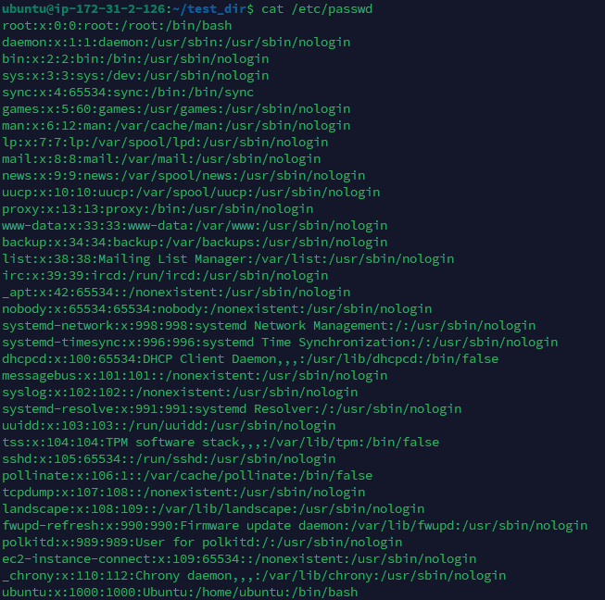
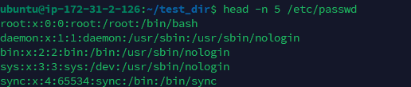


3. Searching for Patterns
Command Used:
grep "root" /etc/passwd
Explanation:
grep searches for lines containing the word "root".
Screenshot:
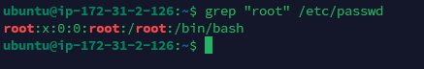

4. Zipping and Unzipping
Command Used:
zip -r test_dir.zip test_dir
mkdir unzipped_dir
unzip test_dir.zip -d unzipped_dir
Explanation:
zip compresses the directory, unzip extracts it into a folder.
Screenshot:
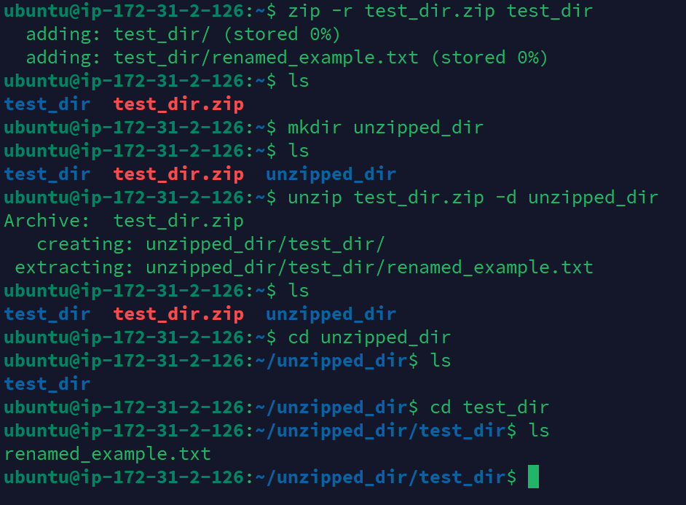

5. Downloading Files
Command Used:
wget https://example.com/sample.txt
Explanation:
wget downloads a file from a given URL.
Screenshot:
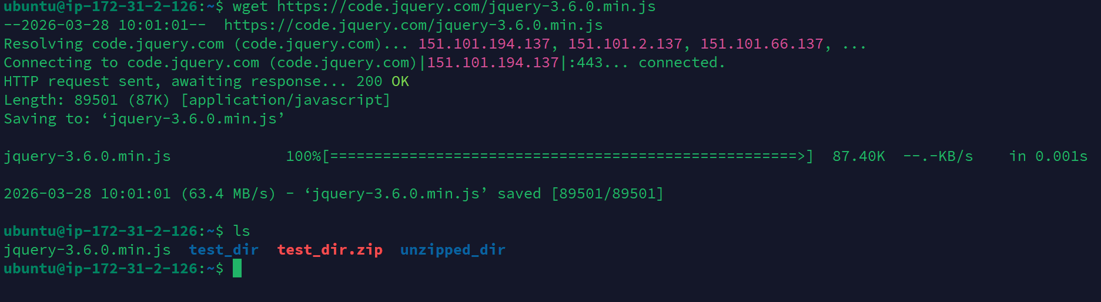

6. Changing Permissions
Command Used:
touch secure.txt
chmod 444 secure.txt
Explanation:
chmod 444 sets the file to read-only for all users.
Screenshot:
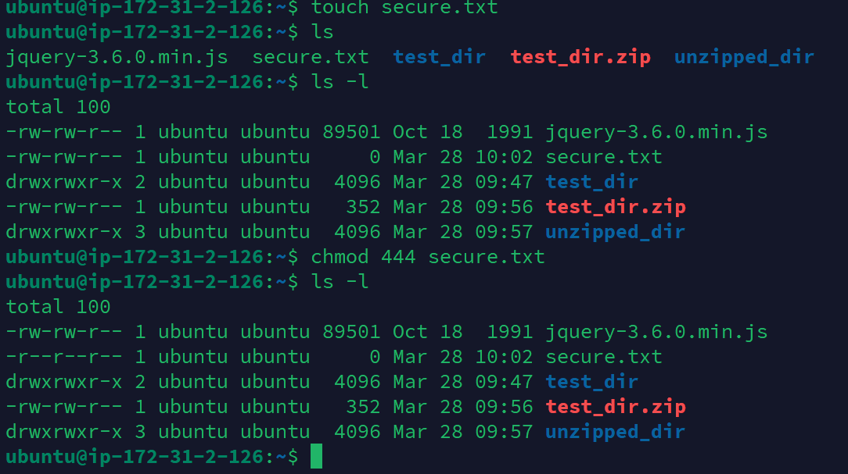

7. Working with Environment Variables
Command Used:
export MY_VAR="Hello, Linux!"
echo $MY_VAR
Explanation:
export creates an environment variable and echo displays it.
Screenshot:
