Docker Commands Assignment

1. Objective
To build a multi-container application using Node.js (frontend) and Flask (backend), containerized using Docker and orchestrated using Docker Compose.

2. Project Structure
Node-flask-mongo-app/
├── frontend/
├── backend/
├── docker-compose.yml
├── .gitignore
Screenshot:
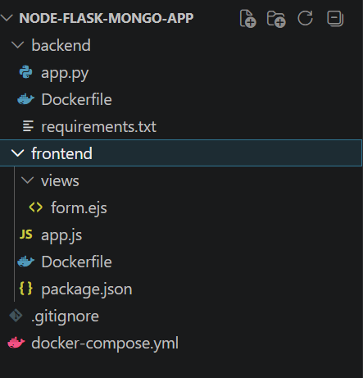

3. Frontend (Node.js)
The frontend is built using Express and renders a form. It sends POST requests to the Flask backend using Axios.
Screenshot:
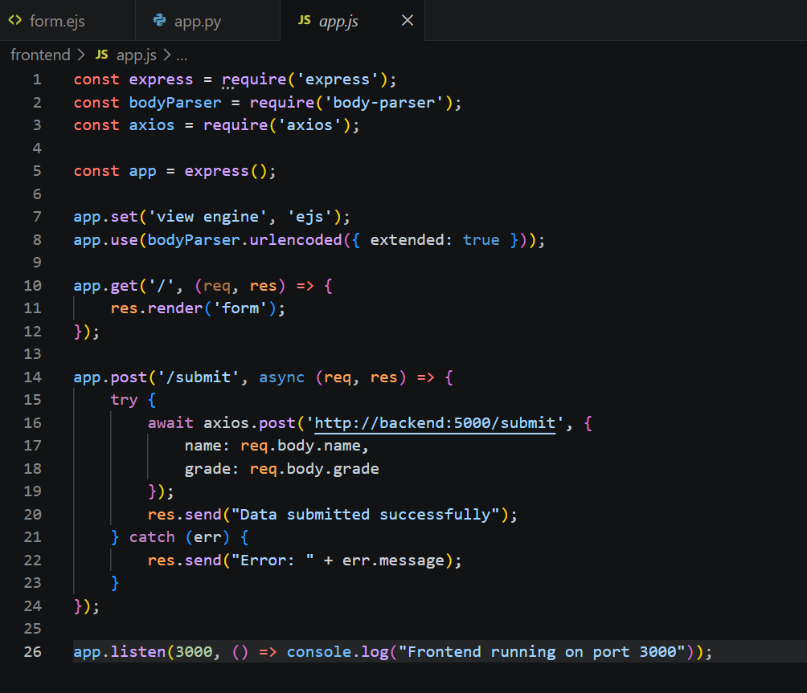

4. Backend (Flask)
The Flask backend handles incoming POST requests from the frontend and processes the data.
Screenshot:

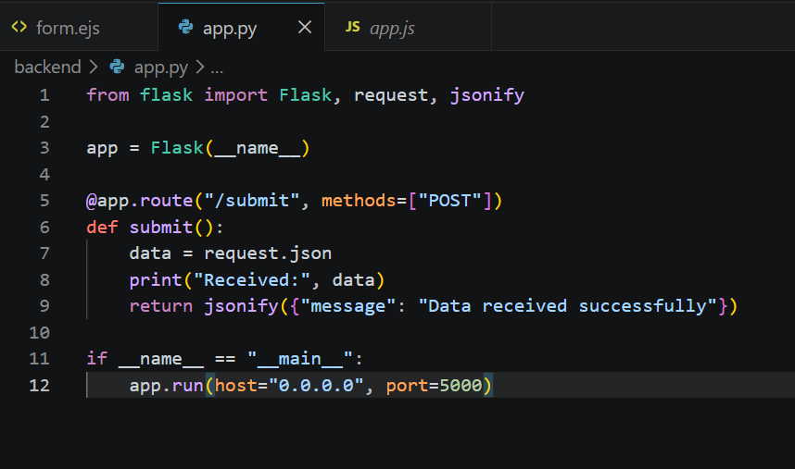

5. Docker Configuration
Separate Dockerfiles are created for frontend and backend. Docker Compose is used to run both services in the same network.
Screenshot:
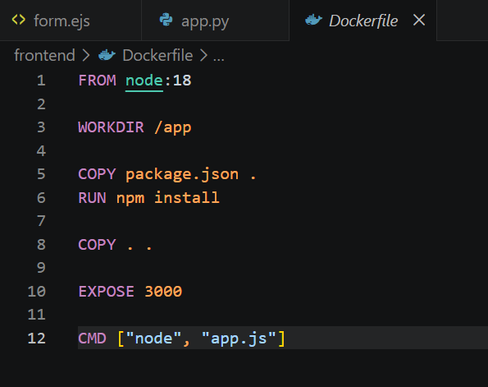
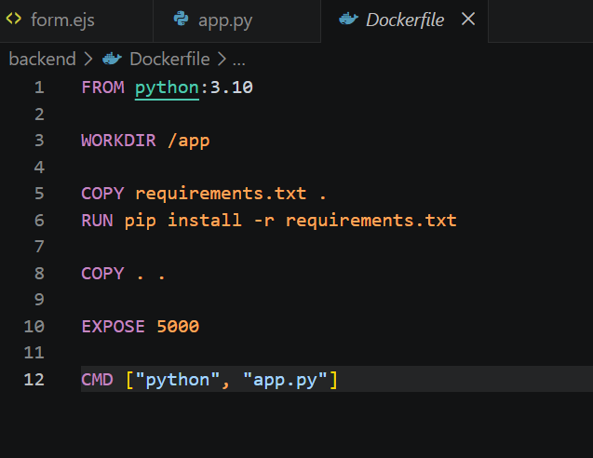

6. Docker Compose
Defines services for frontend and backend, connects them, and exposes ports.
Screenshot:
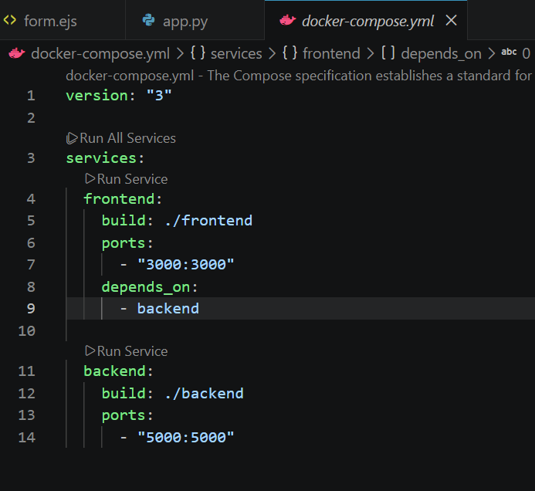

7. Docker Hub
Images are built and pushed to Docker Hub for both frontend and backend.
Screenshot:
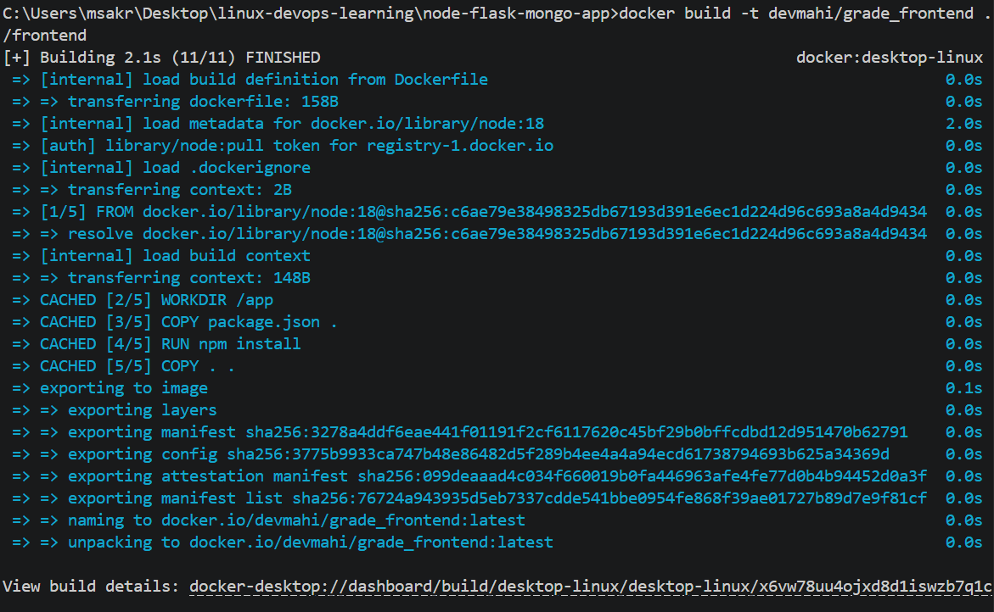
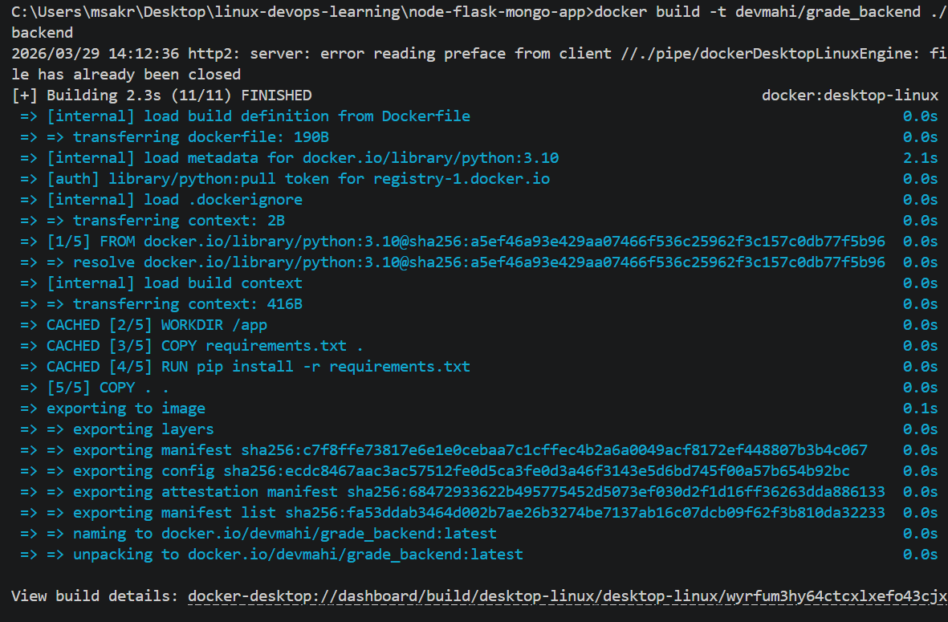
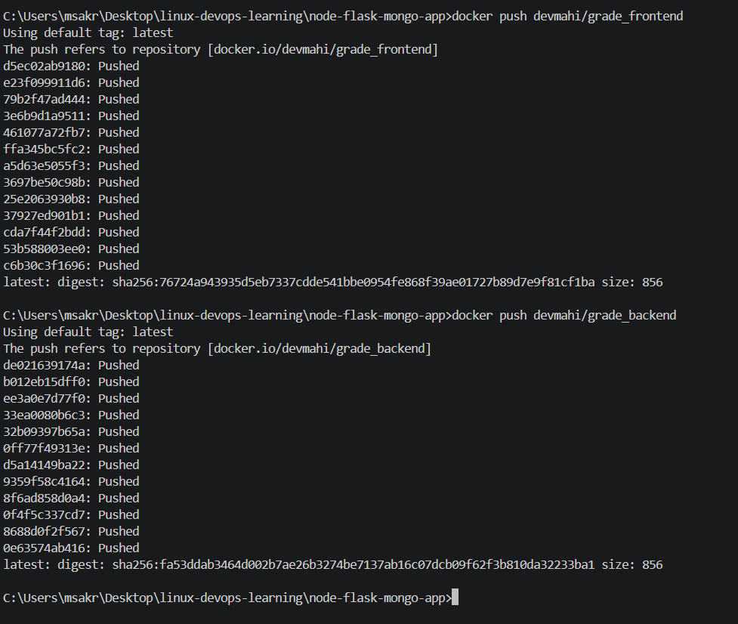

8. Output
Include screenshots of running containers, browser output, and Docker Hub images.
Screenshot:
