Python Bash Commands Assignment

1. Grade Checker
Code:
score = int(input("Enter your score: "))
if score >= 90:
print("Grade: A")
elif score >= 80:
print("Grade: B")
elif score >= 70:
print("Grade: C")
elif score >= 60:
print("Grade: D")
else:
print("Grade: F")
Explanation:
Uses if-elif-else conditions to determine grade.
Screenshot:
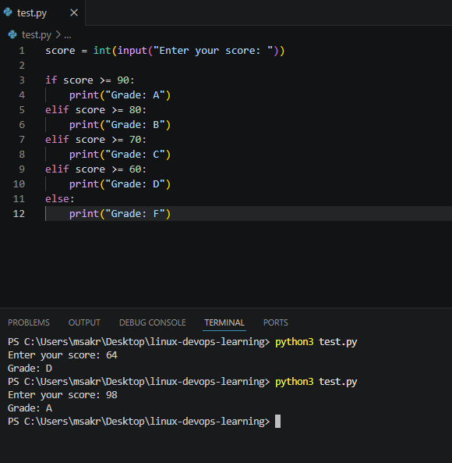

2. Student Grades Dictionary
Code:
students = {}
while True:
print("\n1. Add Student\n2. Update Student\n3. View All\n4. Exit")
choice = input("Enter choice: ")
if choice == "1":
name = input("Enter student name: ")
grade = input("Enter grade: ")
students[name] = grade
elif choice == "2":
name = input("Enter student name to update: ")
if name in students:
grade = input("Enter new grade: ")
students[name] = grade
else:
print("Student not found")
elif choice == "3":
for name, grade in students.items():
print(name, ":", grade)
elif choice == "4":
break
Explanation:
Uses dictionary to add, update and display student grades.
Screenshot:

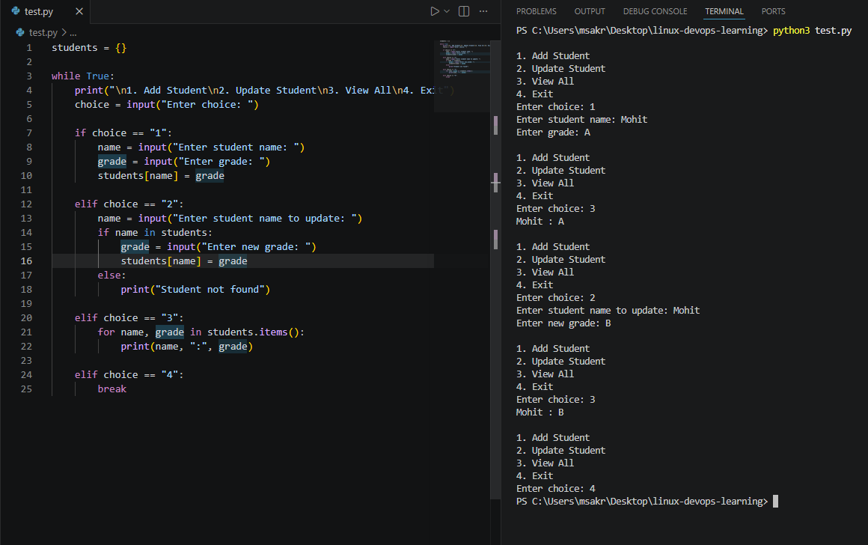

3. Write to a File
Code:
file = open("sample.txt", "w")
file.write("Hello, this is a sample file.\nLearning Python file handling.")
file.close()
Explanation:
Creates and writes data to a file.
Screenshot:
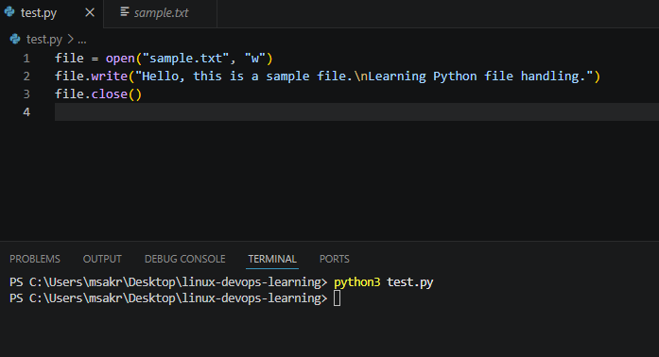
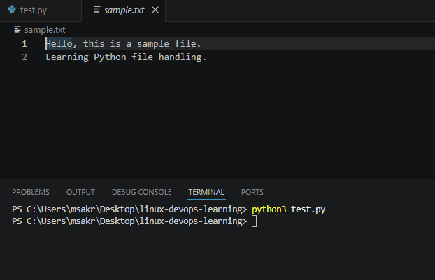

4. Read from a File
Code:
file = open("sample.txt", "r")
content = file.read()
print(content)
file.close()
Explanation:
Reads and displays file content.
Screenshot:
