CI/CD Deployment Assignment

1. Objective
To deploy a Flask backend and Express frontend on an AWS EC2 instance.
To implement a CI/CD pipeline using Jenkins on a separate EC2 instance for automated deployment.

2. EC2 Setup
2.1 Application Server EC2:
- Launch EC2 instance.
- Configure ports: 22, 3000, 5000.
- Install Python, Node.js, Git, PM2.

2.2 Jenkins Server EC2:
- Launch EC2 instance.
- Configure ports: 22, 8080.
- Install Java and Jenkins.
- Access Jenkins dashboard.
Screenshot:
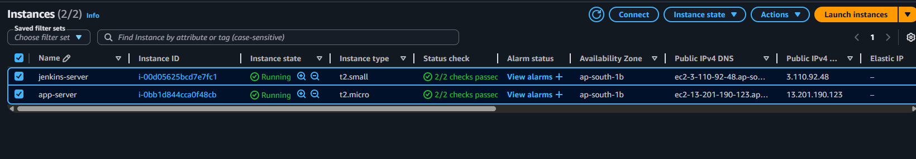
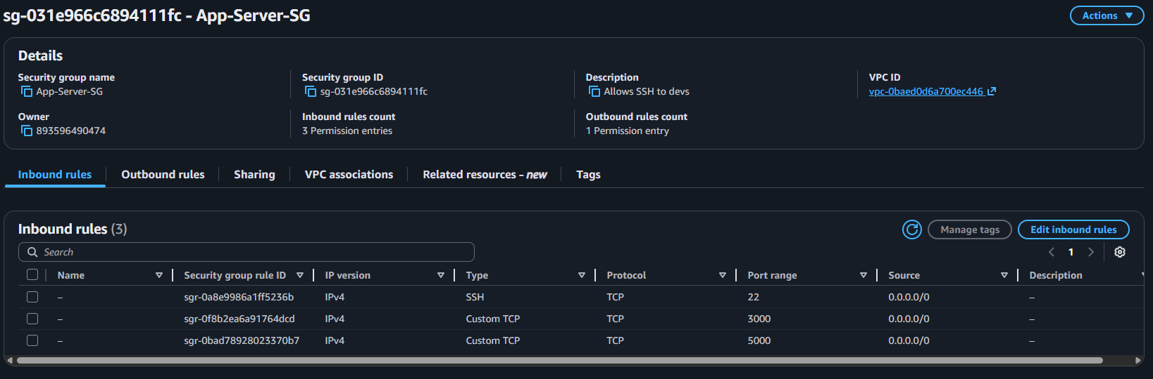
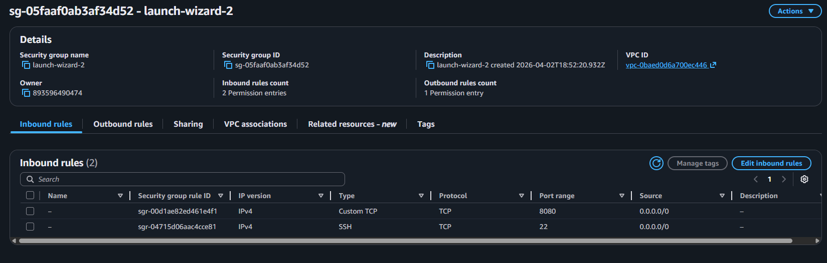
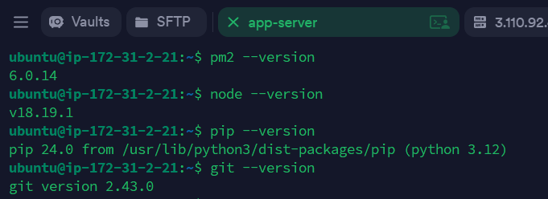
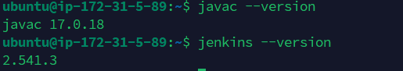

3. Backend (Flask) Setup
Clone Flask repository.
Install dependencies.
Run application on port 5000.
Screenshot:
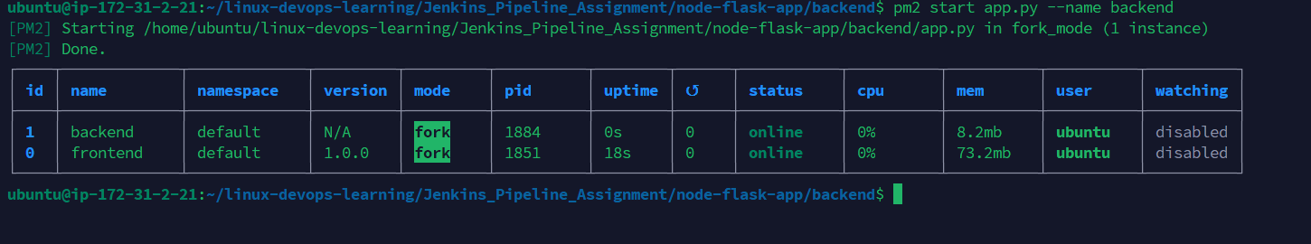
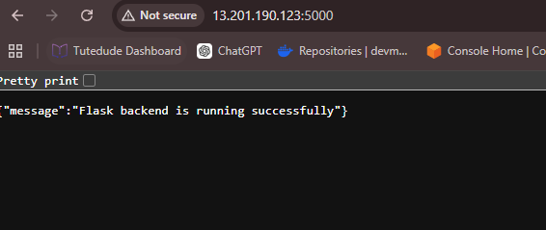

4. Frontend (Express) Setup
Clone Express repository.
Install dependencies.
Run application on port 3000.
Screenshot:
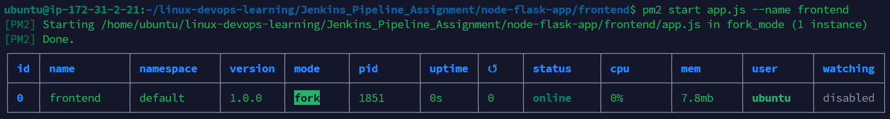
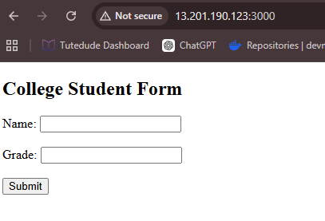

5. Jenkins Setup
Install Jenkins on separate EC2.
Install required plugins (Git, Pipeline, NodeJS).
Configure tools and environment.
Screenshot:
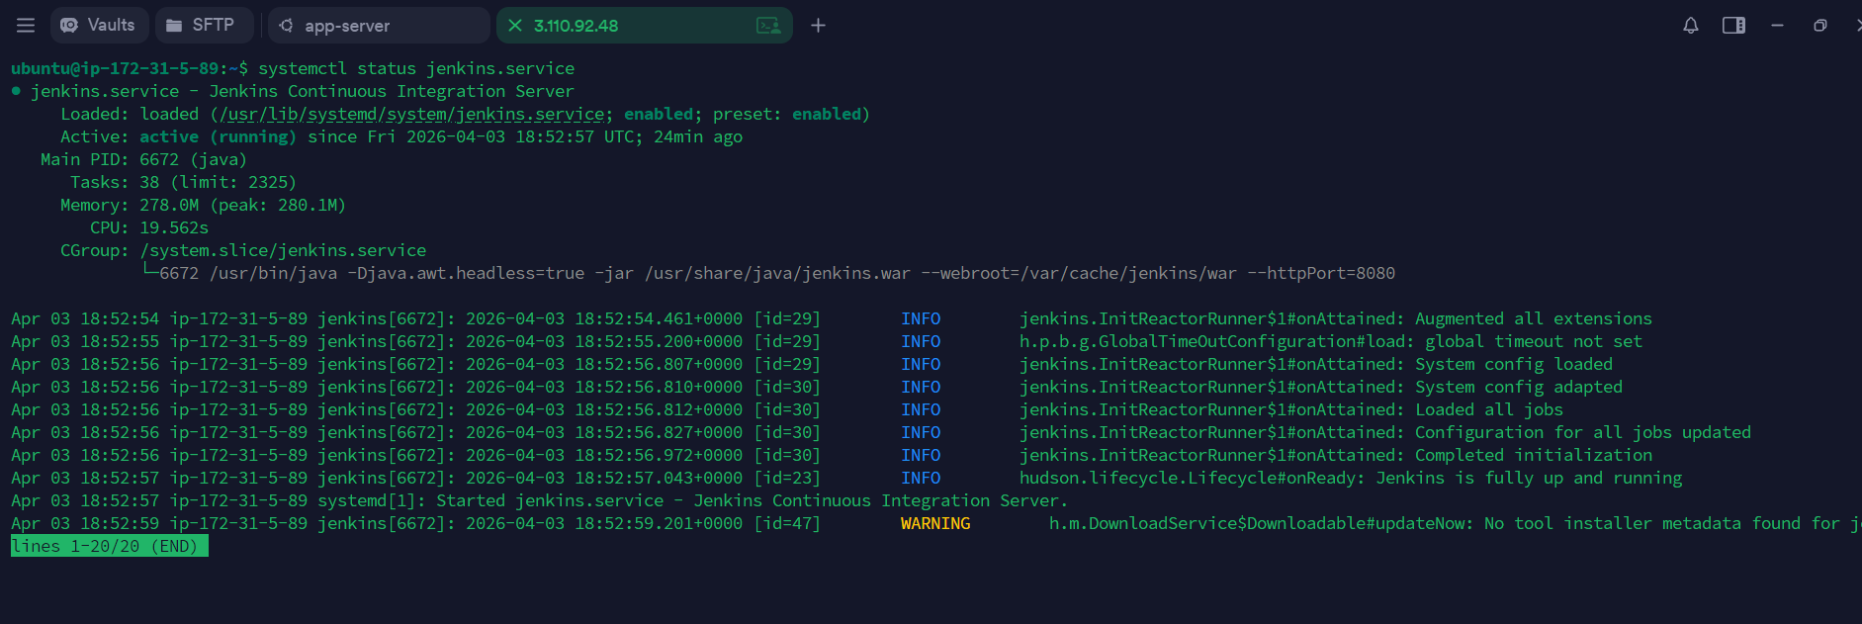
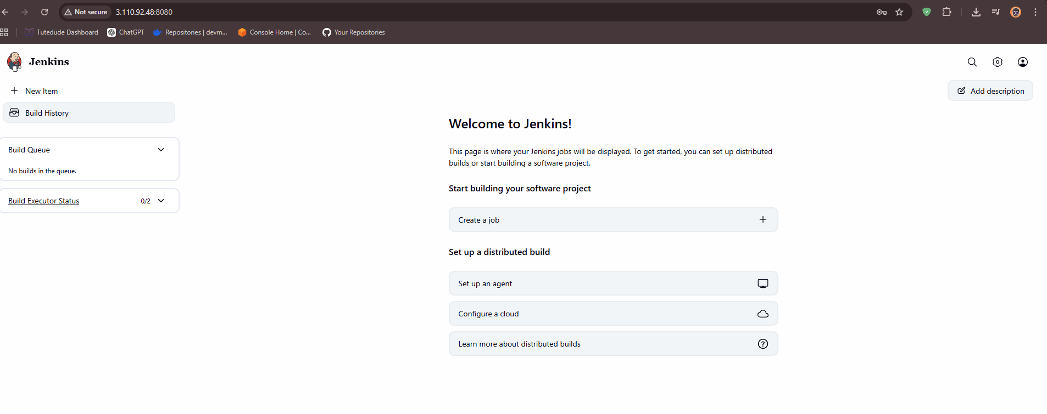

6. CI/CD Pipeline
Create pipelines for Flask and Express.
Pipeline stages include:
- Code checkout from GitHub.
- Install dependencies.
- Deploy application on Application EC2 using SSH.
Jenkins connects remotely to Application EC2.
Screenshot:
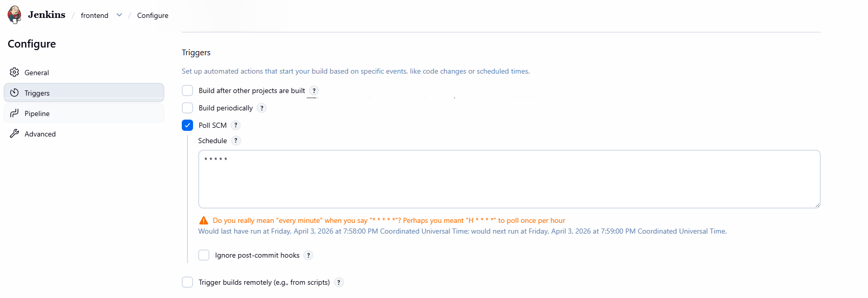
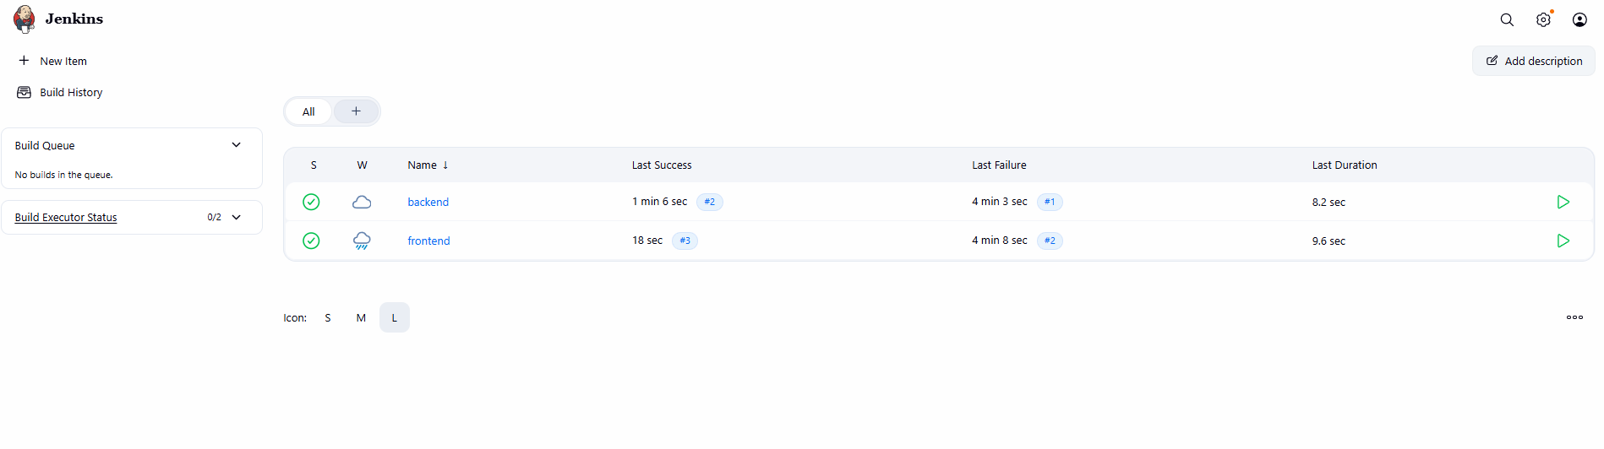
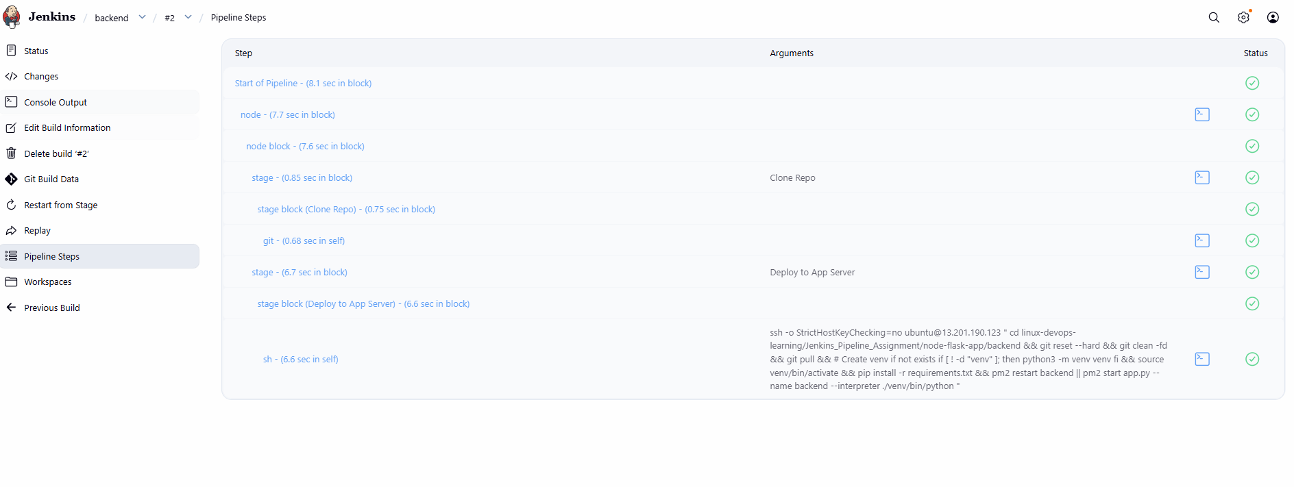
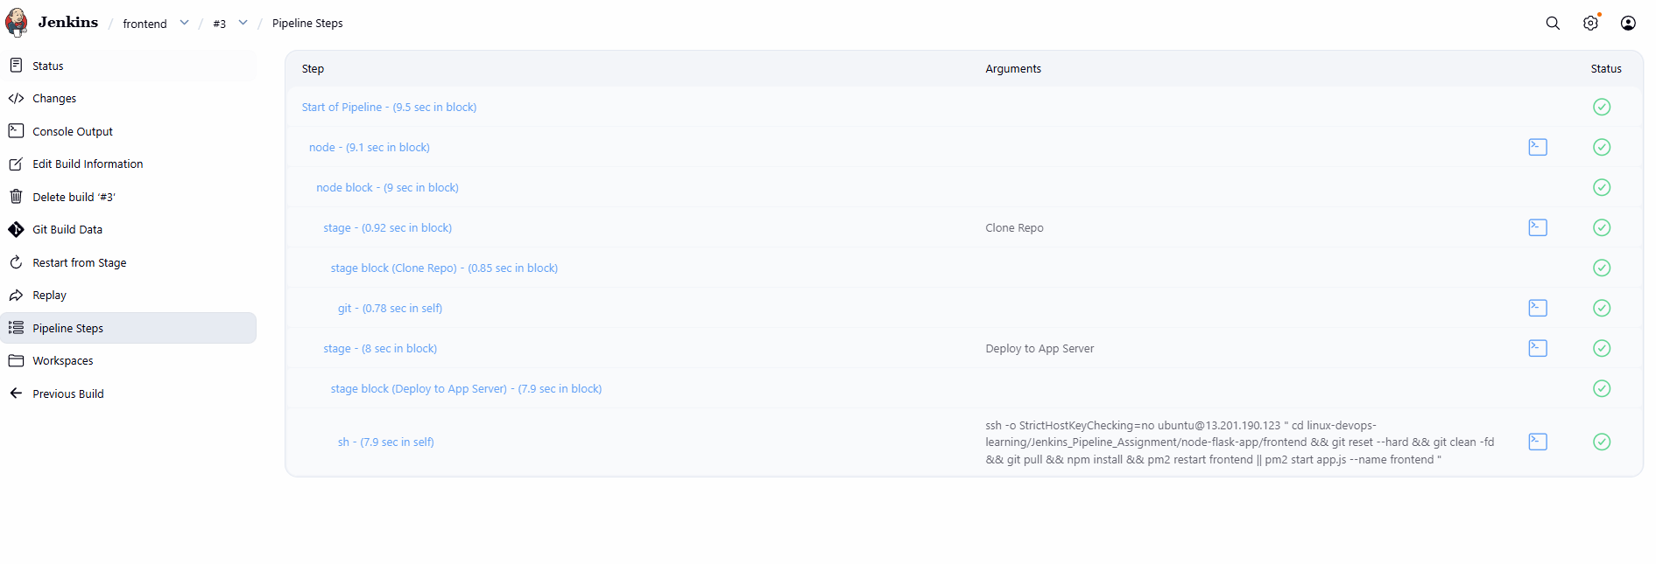

7. CI/CD Pipeline – Flask
Pipeline configured for Flask application.
Includes build and deployment stages.
Screenshot:
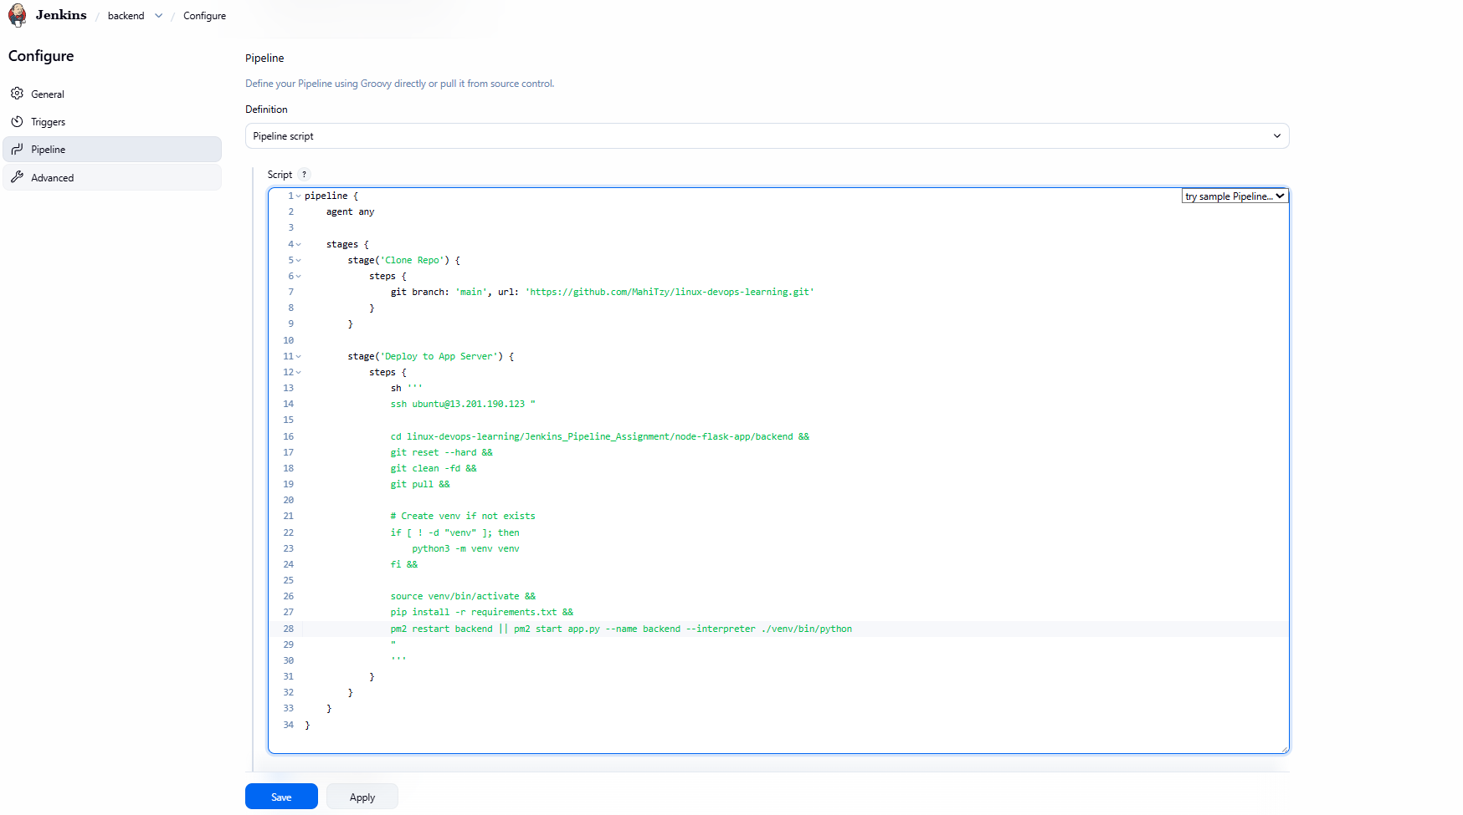

8. CI/CD Pipeline – Express
Pipeline configured for Express application.
Includes build and deployment stages.
Screenshot:
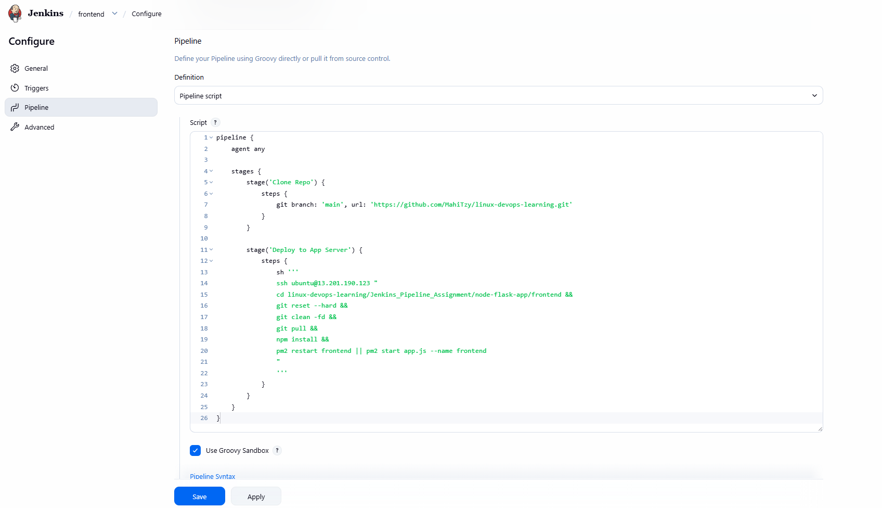

9. GitHub Webhook Integration (Jenkinsfile)
Configure webhook in GitHub repository.
Trigger Jenkins pipeline on every push using Jenkinsfile.
Screenshot:
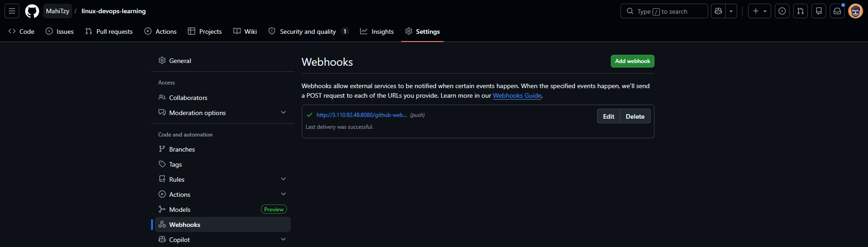
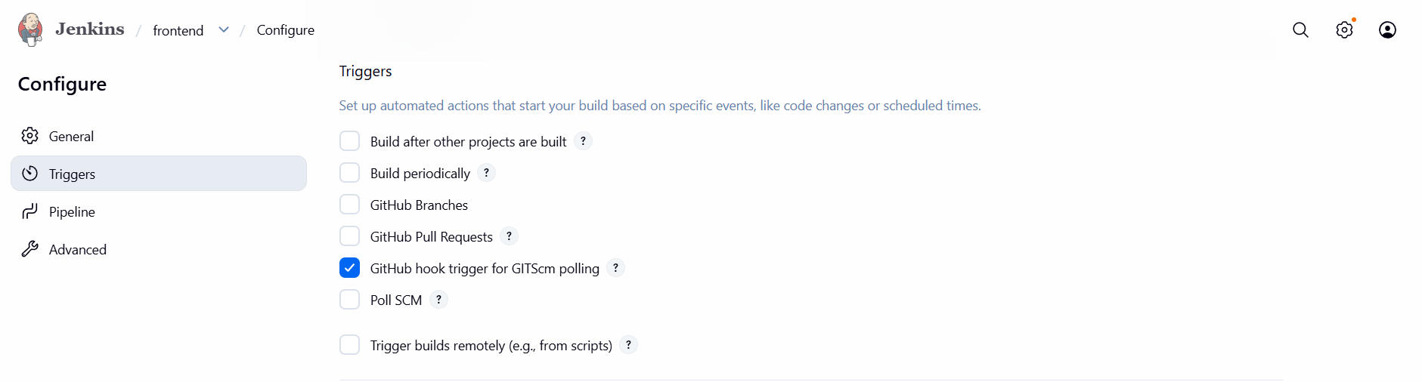
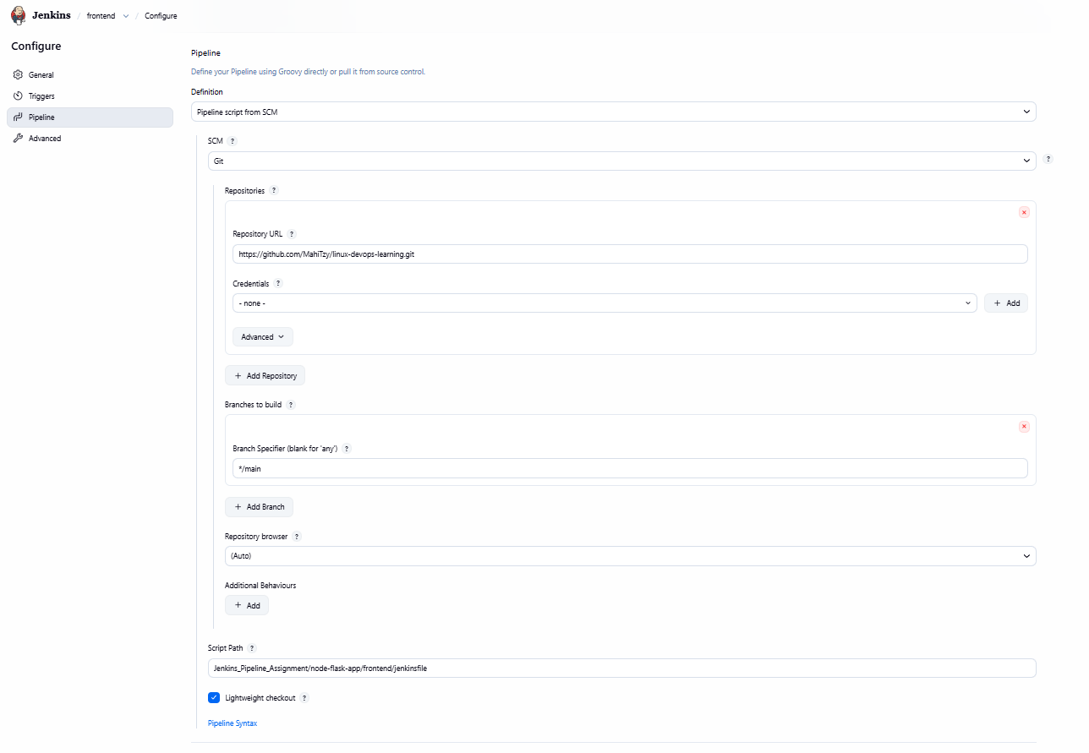
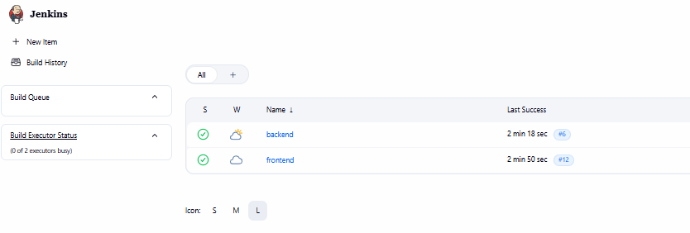
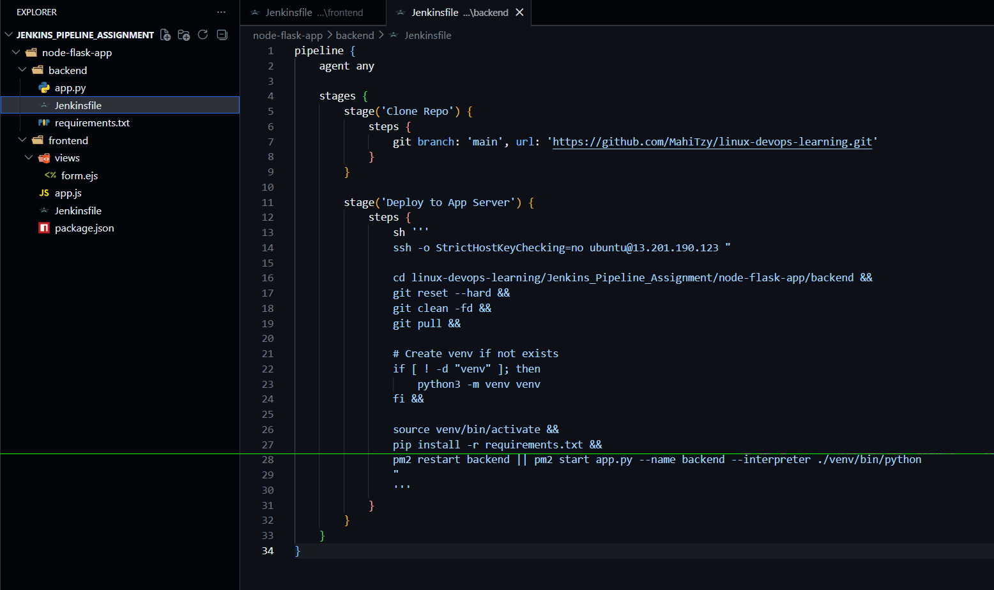
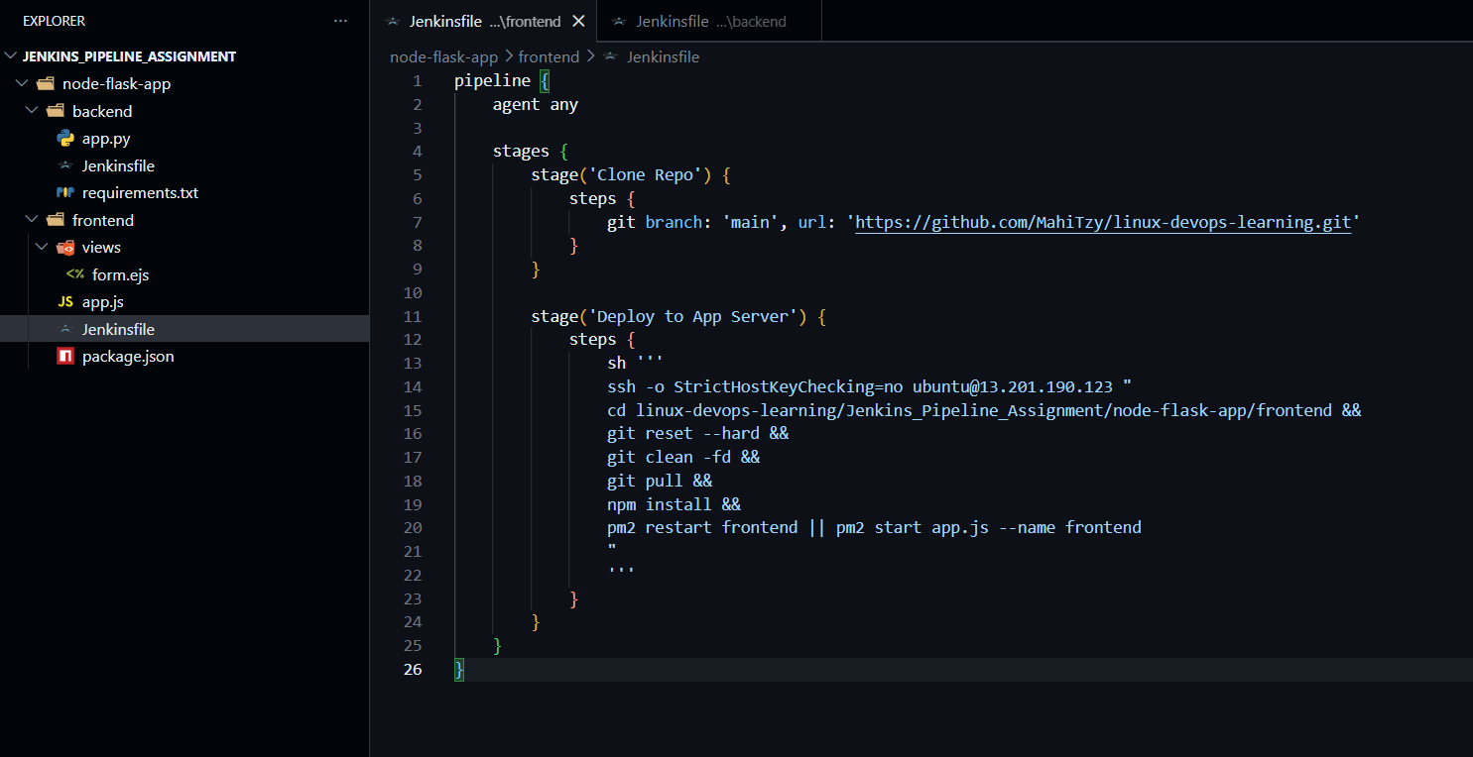
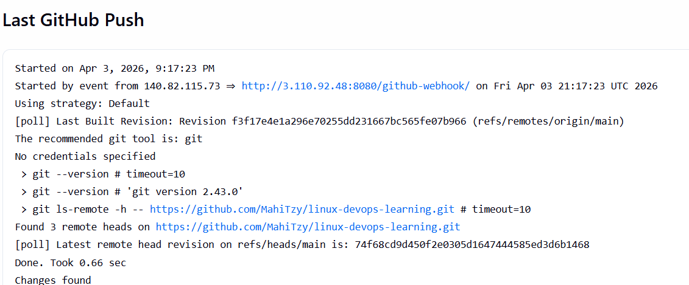

10. Final Output
Flask application accessible via Application EC2.
Express application accessible via Application EC2.
Jenkins accessible via Jenkins EC2.
Automated deployment working successfully.
Screenshot:
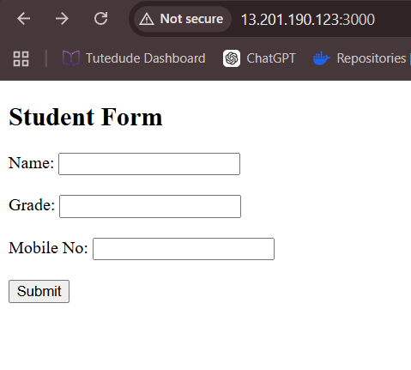
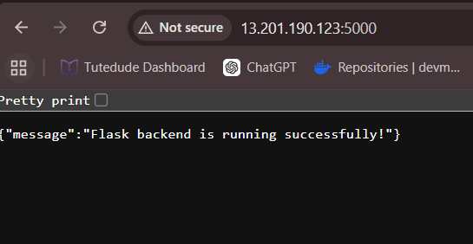
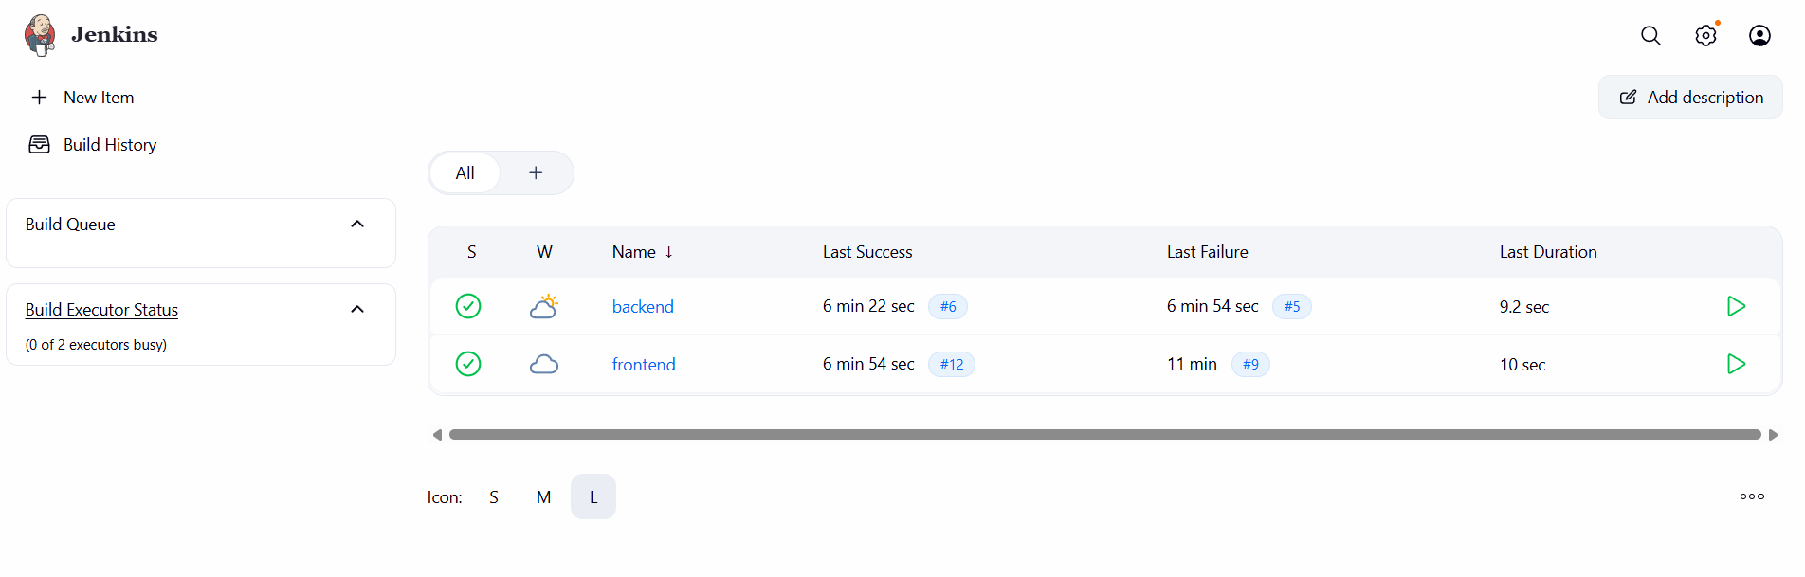

11. Architecture

Developer (You)
↓ git push
GitHub Repository
↓ webhook trigger
Jenkins Server (EC2 - CI/CD)
↓ SSH deploy
Application Server (EC2)
├── Flask Backend (Port 5000)
├── Express Frontend (Port 3000)
└── PM2 (Process Manager)
↓
User (Browser)

