AWS Deployment Commands Assignment

1. Objective
To deploy a Flask backend and Node.js frontend using AWS services including EC2, ECS, ECR, and VPC.

2. Single EC2 Deployment
Frontend and backend are deployed on a single EC2 instance. Dependencies are installed and both services run on different ports.
Screenshot:
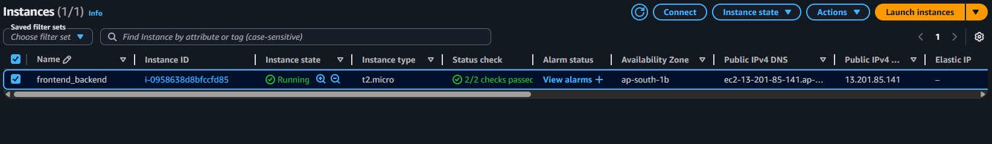
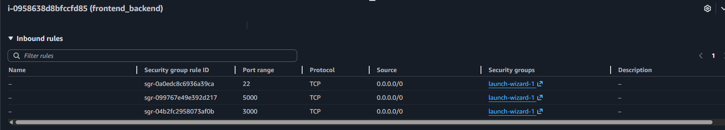
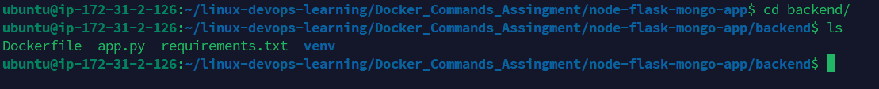
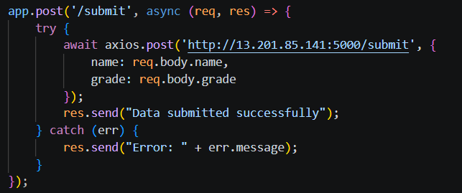
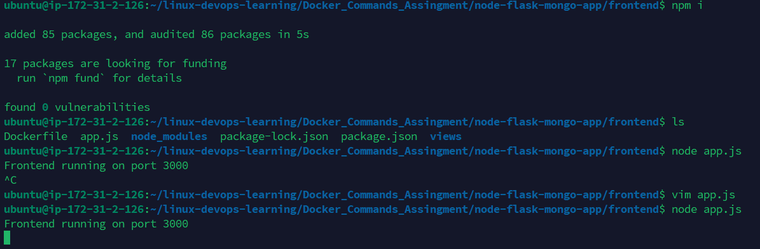
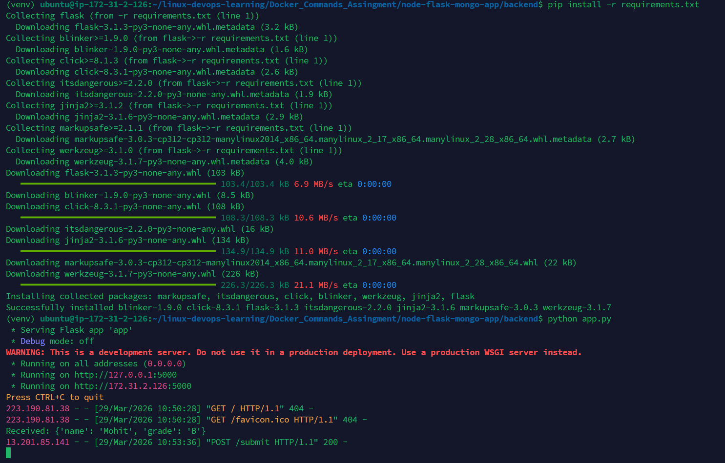
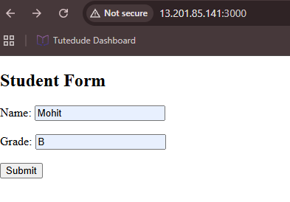
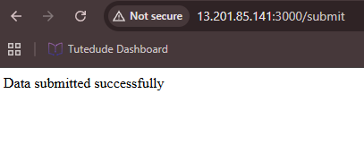
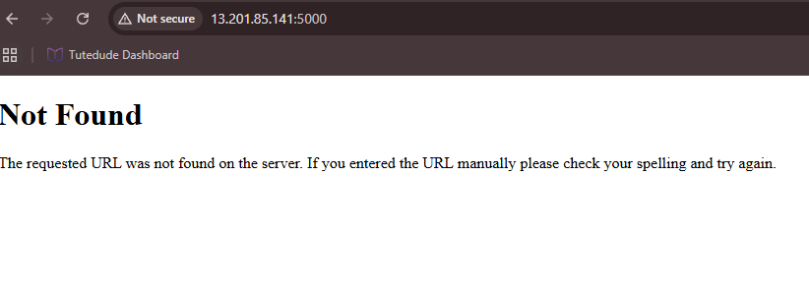

3. Separate EC2 Deployment
Frontend and backend are deployed on separate EC2 instances. Frontend communicates with backend via public IP.
Screenshot:
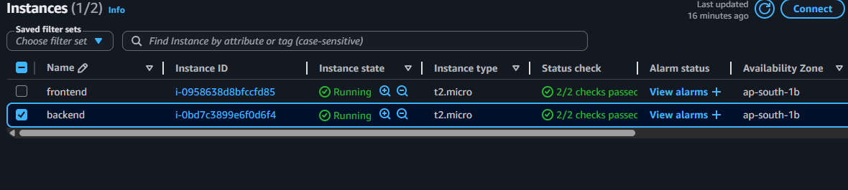
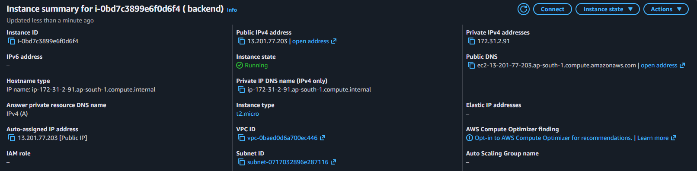
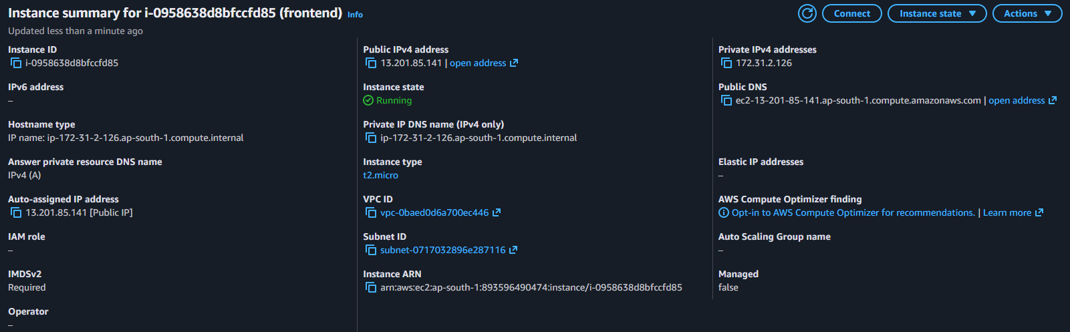

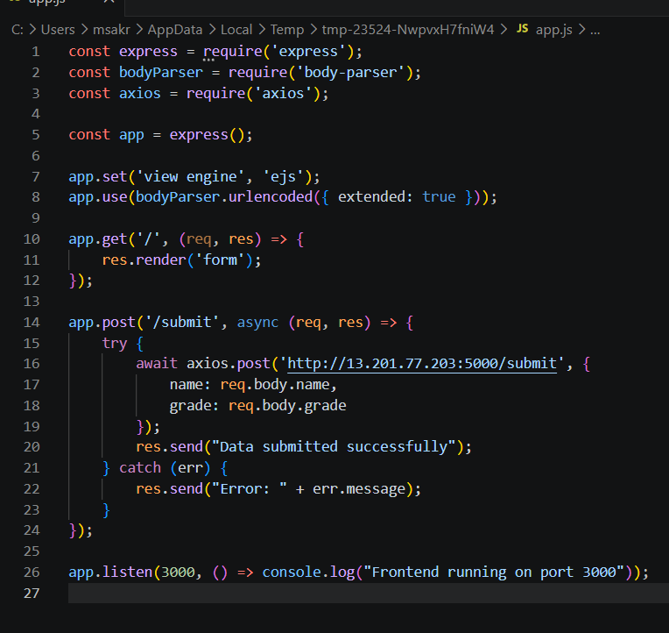
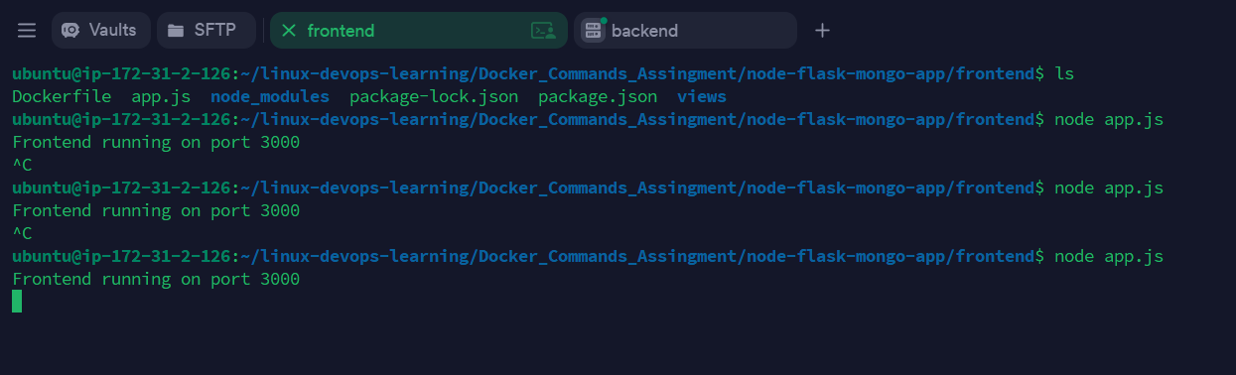
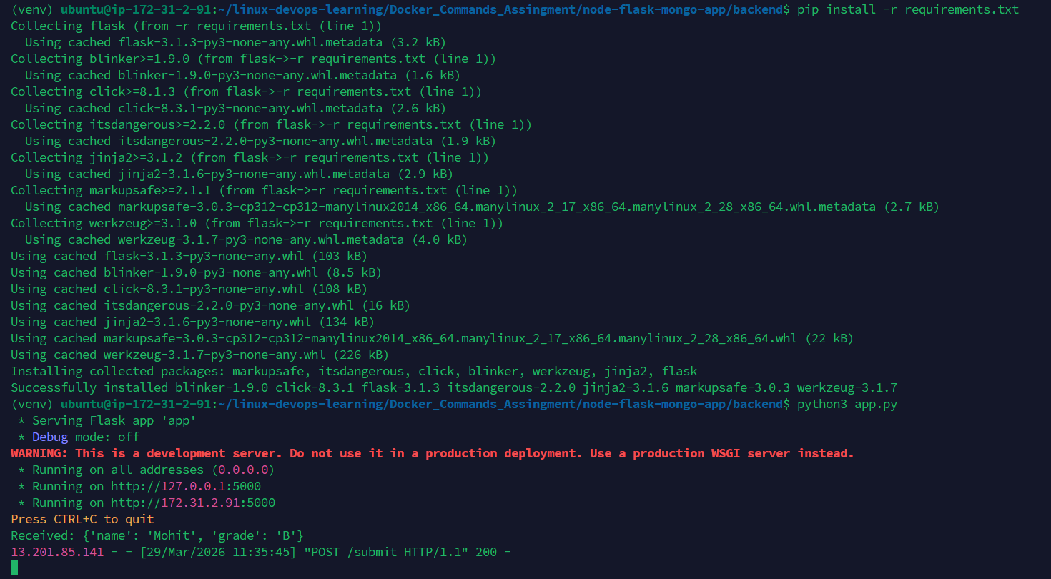
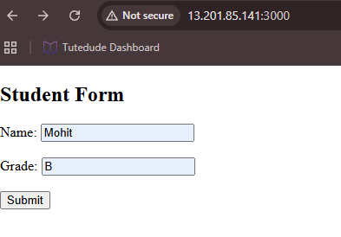
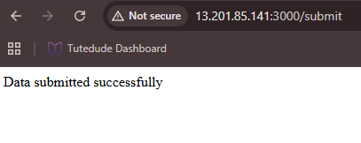

4. ECS + ECR + VPC Deployment
Docker images are pushed to ECR. ECS runs containers and VPC handles networking and security.
Screenshot:
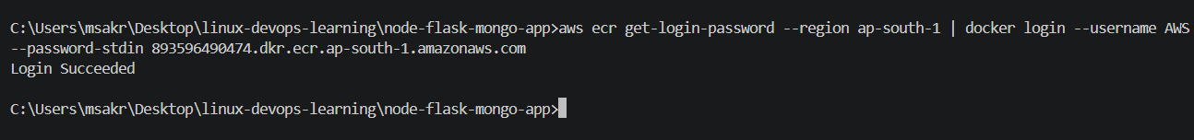
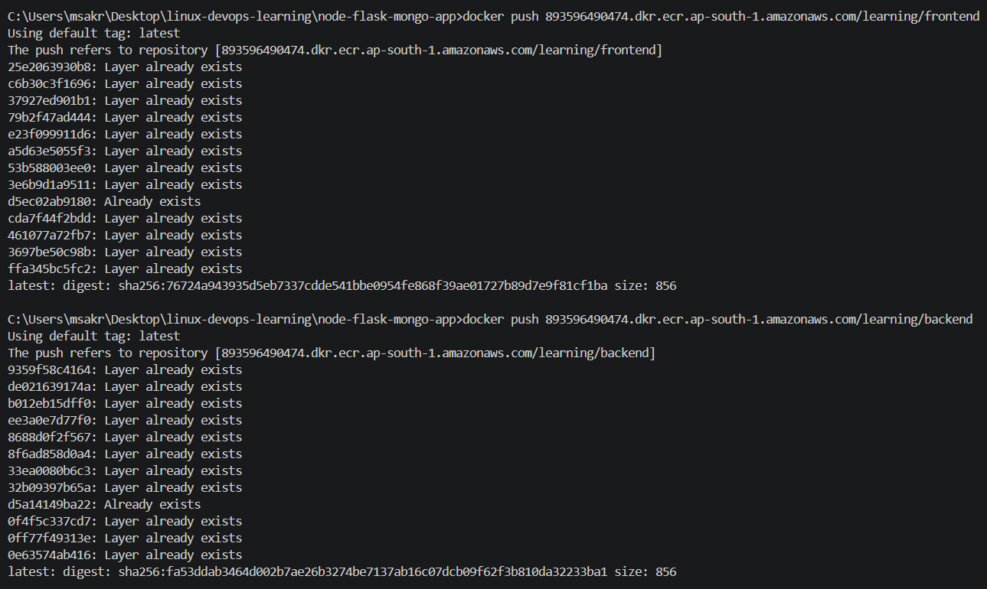
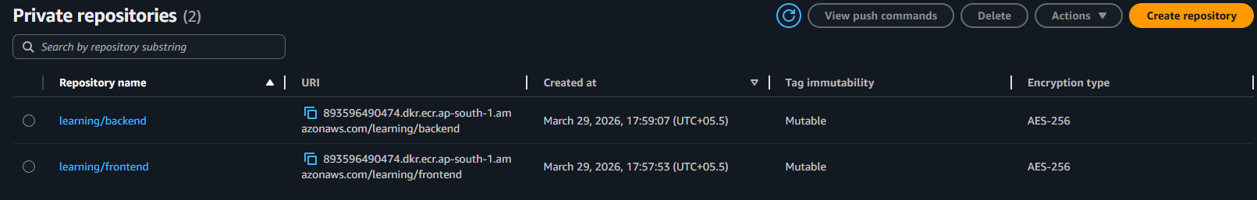
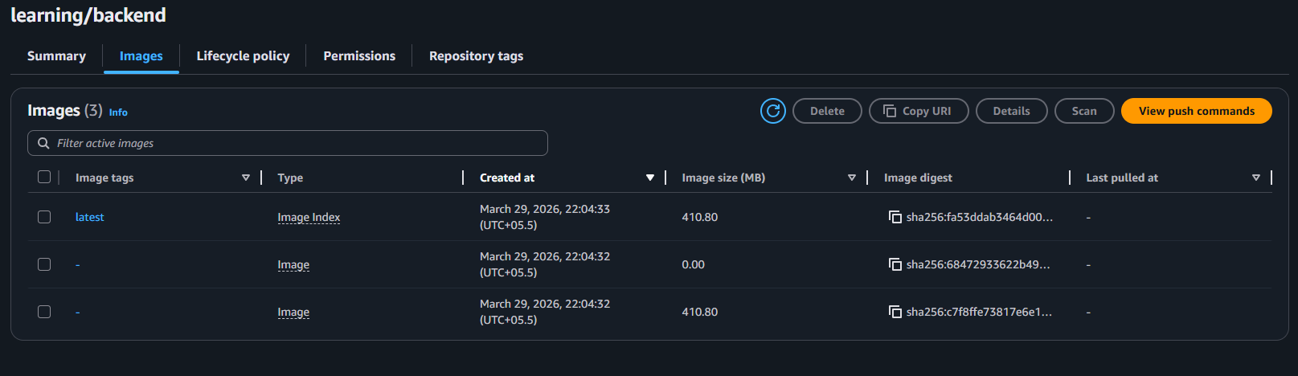
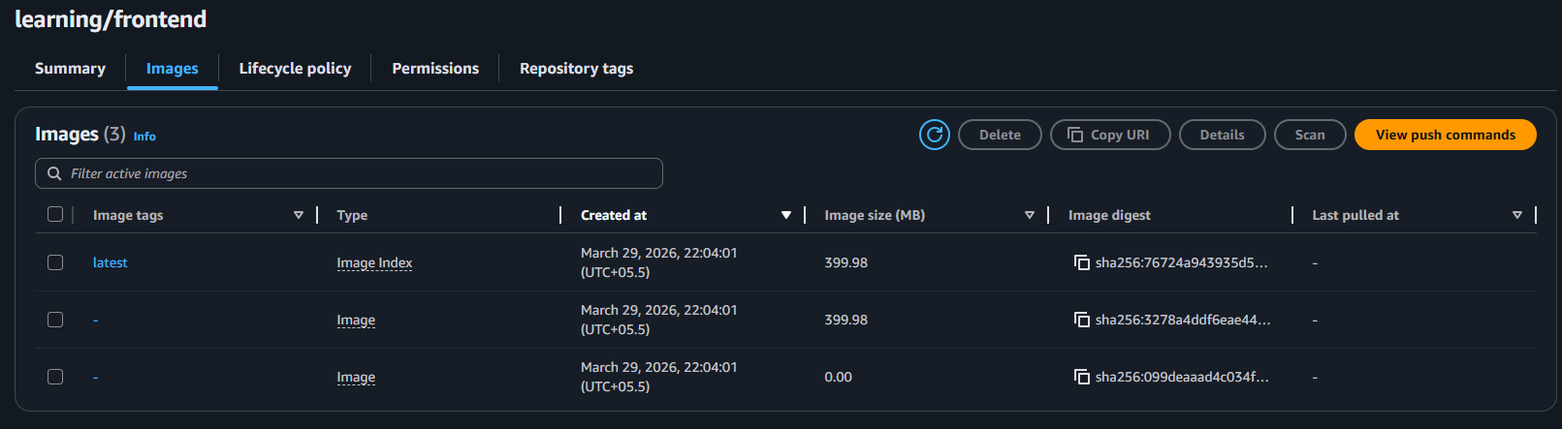
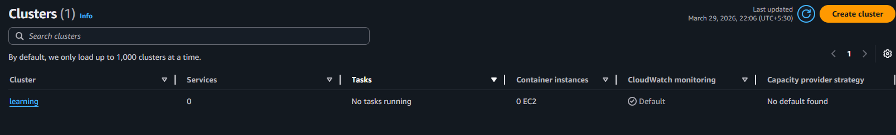
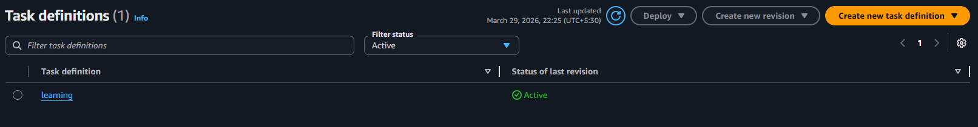
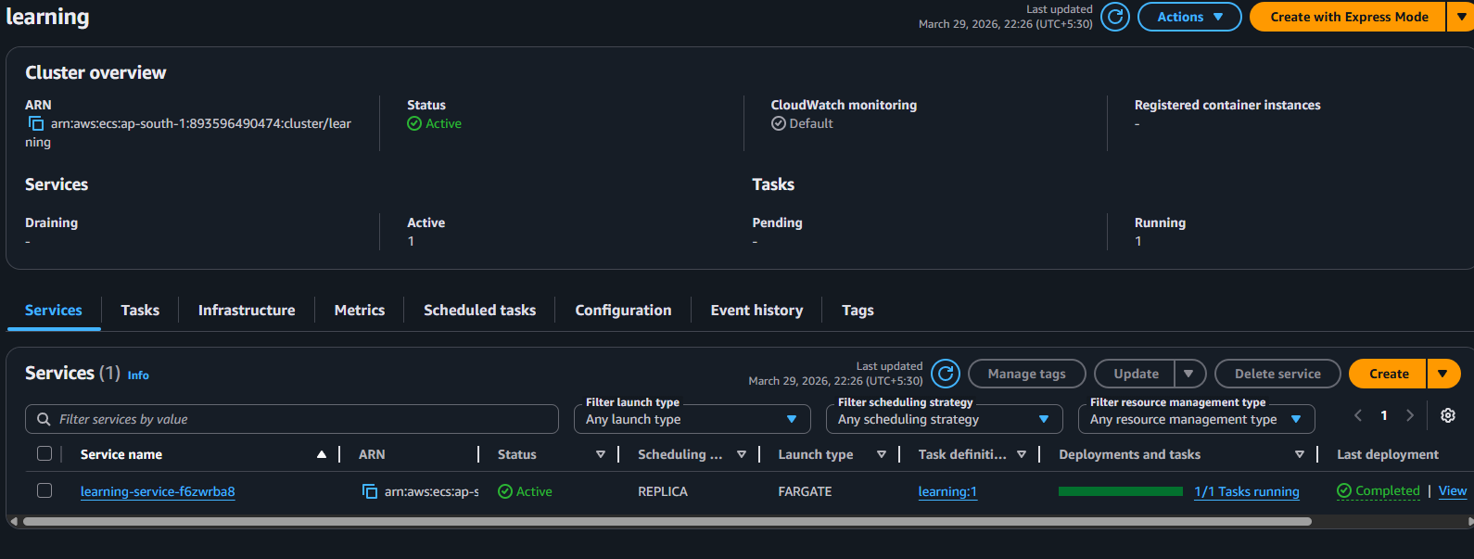
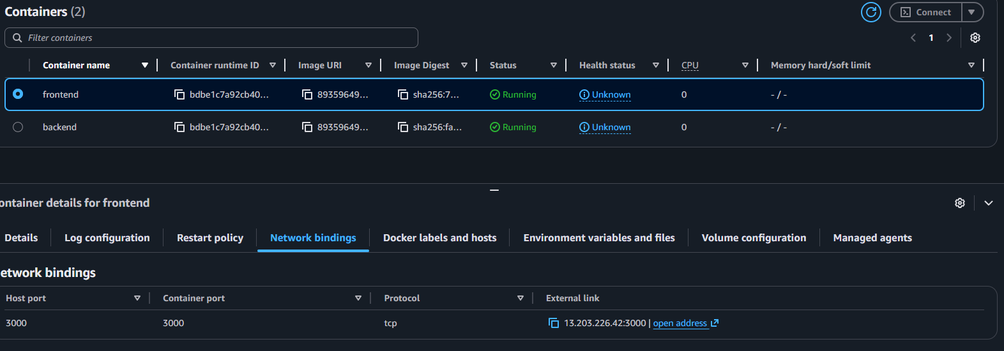
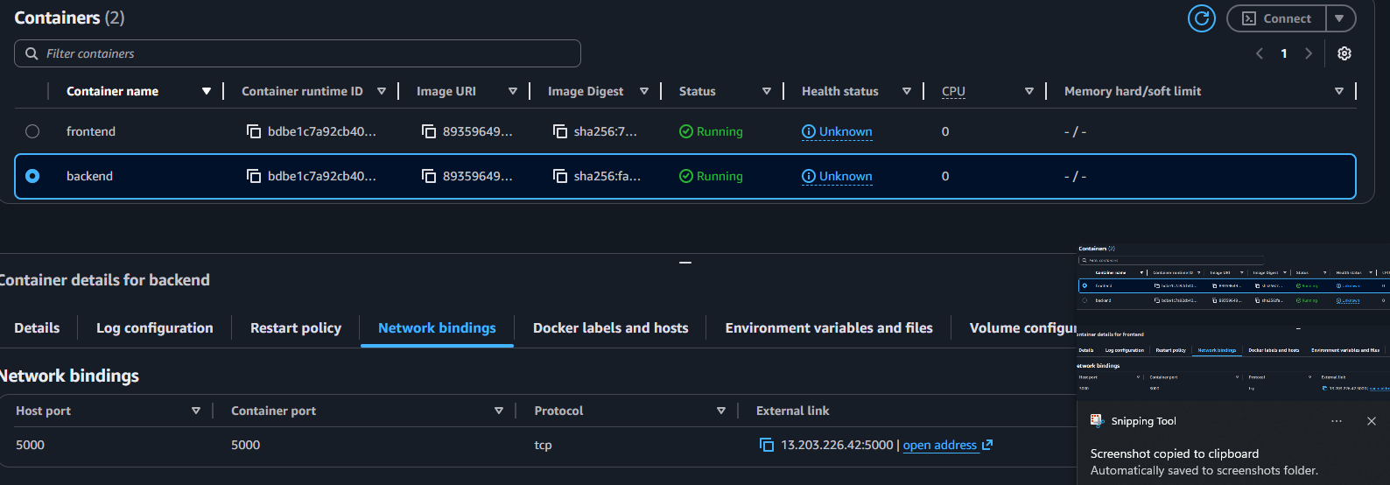
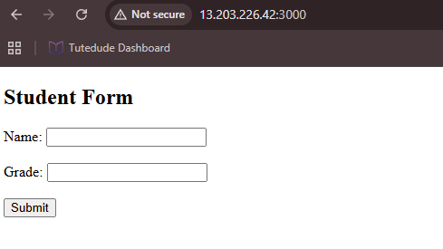



5. Architecture
User → Frontend → Backend. ECS manages containerized deployment using AWS infrastructure.
Single EC2
User → EC2
├── Node (3000)
└── Flask (5000)

🔹 Separate EC2
User → Frontend EC2 → Backend EC2

🔹 ECS
User → Load Balancer → ECS Service
├── Frontend Container
└── Backend Container
↓
Internal Communication

