**Subjective Questions**

1. **Which are the top three variables in your model which contribute most towards**

**the probability of a lead getting converted?**

**Ans.** PCA analysis for features in model are:

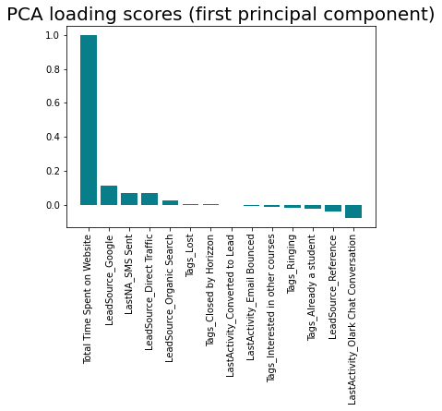

The top 3 variables are:

* Total Time Spent on Website
* Lead Source - Google
* Lead Source - Organic Search

1. **What are the top 3 categorical/dummy variables in the model which should be focused the most on in order to increase the probability of lead conversion?**

**Ans.** Top 3 categorical variables are:

* Lead Source - Google
* Lead Source - Organic Search
* Last Notable Activity – SMS Sent

1. **X Education has a period of 2 months every year during which they hire some interns. The sales team, in particular, has around 10 interns allotted to them. So during this phase, they wish to make the lead conversion more aggressive. So they want almost all of the potential leads (i.e., the customers who have been predicted as 1 by the model) to be converted and hence, want to make phone calls to as much of such people as possible. Suggest a good strategy they should employ at this stage.**

**Ans.** During the time when X Education has extra work force, they should target prospects

* That spend high amount of time on their website
* Whose leads have come from Google or Organic search methods
* That engage in communication exchange like SMS

These are people who are motivated as they are doing some research on their own. So if the right information is shared via regular engagement then such prospects can be converted to customers.

1. **Similarly, at times, the company reaches its target for a quarter before the deadline. During this time, the company wants the sales team to focus on some new work as well. So during this time, the company’s aim is to not make phone calls unless it’s extremely necessary, i.e. they want to minimize the rate of useless phone calls. Suggest a strategy they should employ at this stage.**

**Ans.**

In this time, X Education should focus on non call based communication strategy such as email and SMS. The recipients can still be leads that are relatively less hot but can be engaged for a longer period of time using such communication channels.