PA1

MMR

December 20, 2015

## Loading and preprocessing the data

setwd("~/Desktop/Data_Science_Course/Reproducible Research/PeerAssessment 1")  
unzip("repdata-data-activity.zip", exdir =".", unzip = "internal", setTimes = TRUE)  
myfile <- read.csv("activity.csv")  
library(dplyr)

##   
## Attaching package: 'dplyr'  
##   
## The following objects are masked from 'package:stats':  
##   
## filter, lag  
##   
## The following objects are masked from 'package:base':  
##   
## intersect, setdiff, setequal, union

library(ggplot2)  
mytable <- myfile %>% group_by(date, interval) %>% summarise(steps= sum(steps))  
meanstepspd <- mytable %>% group_by(date) %>% summarise(steps= mean(steps))  
summary(meanstepspd)

## date steps   
## 2012-10-01: 1 Min. : 0.1424   
## 2012-10-02: 1 1st Qu.:30.6979   
## 2012-10-03: 1 Median :37.3785   
## 2012-10-04: 1 Mean :37.3826   
## 2012-10-05: 1 3rd Qu.:46.1597   
## 2012-10-06: 1 Max. :73.5903   
## (Other) :55 NA's :8

The following plot shows the histogram for total number of steps taken per day:

p1 <- ggplot(data = mytable) +   
aes(x = date, y = steps)+  
geom_histogram(stat = "identity", fill = "black")  
p1 + theme(axis.text.x = element_text(angle = 45))

## Warning: Removed 2304 rows containing missing values (position_stack).

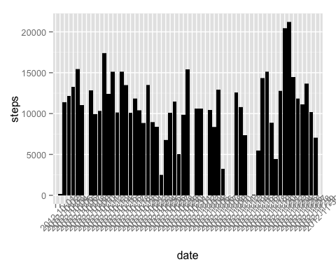

## The mean steps per day is 10766 and median is 10765.

## What is the average daily activity pattern?

## Average steps taken per day mytable2 <- myfile %>% group_by(interval, date) %>% summarise(steps = mean(steps)) plot(mytable2 $interval,mytable2$ steps, xlab = "interval", ylab = "mean steps per day", type = "l") summary(mytable2)

## as in the summary of mytable2, we get the maximum number of steps taken in an interval is 806. It is confirmed by

r mytable2 <- myfile %>% group_by(interval, date) %>% summarise(steps = mean(steps)) max_steps <- max(mytable2$steps, na.rm = TRUE) max_steps

## [1] 806

## The corresponding 5-minute interval is 615, as detected by :

r mytable2$interval[match(806, mytable2$steps)]

## [1] 615 ## Imputing missing values ##For simplicity, the missing values for the steps are replaced with the mean steps/interval as follows

r newtable <- mytable ## makes a copy the original data replacement <- mean(mytable$steps, na.rm = TRUE) ## calculates the mean for steps to be used as replacement newtable$steps[is.na(newtable$steps)] <- replacement ## replaces the missing values with the replacement value miss_val <- sum(is.na(newtable$steps)) ## to confirm there is no missing value miss_val

## [1] 0

r p2 <- ggplot(data = newtable) + ## plotting the histogram aes(x = date, y = steps)+ geom_histogram(stat = "identity", fill = "black") p2 + theme(axis.text.x = element_text(angle = 45))

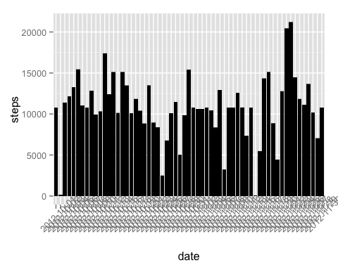 ## The mean and median steps are

r newmeansteps <- mean(newtable$steps) newmediansteps <- median(newtable$steps) print(c(newmeansteps,newmediansteps))

## [1] 37.3826 0.0000

## to compare the mean, median and other features in the two tables

r summary(mytable)

## date interval steps ## 2012-10-01: 288 Min. : 0.0 Min. : 0.00 ## 2012-10-02: 288 1st Qu.: 588.8 1st Qu.: 0.00 ## 2012-10-03: 288 Median :1177.5 Median : 0.00 ## 2012-10-04: 288 Mean :1177.5 Mean : 37.38 ## 2012-10-05: 288 3rd Qu.:1766.2 3rd Qu.: 12.00 ## 2012-10-06: 288 Max. :2355.0 Max. :806.00 ## (Other) :15840 NA's :2304

r summary(newtable)

## date interval steps ## 2012-10-01: 288 Min. : 0.0 Min. : 0.00 ## 2012-10-02: 288 1st Qu.: 588.8 1st Qu.: 0.00 ## 2012-10-03: 288 Median :1177.5 Median : 0.00 ## 2012-10-04: 288 Mean :1177.5 Mean : 37.38 ## 2012-10-05: 288 3rd Qu.:1766.2 3rd Qu.: 37.38 ## 2012-10-06: 288 Max. :2355.0 Max. :806.00 ## (Other) :15840 ## The mean steps per day is 10766 and median is 10766. ## There is no change in the mean. The median changes by 1 step only. ## There is no significant impact for imputing the missing data on the estimates of the total daily number of steps.

## Are there differences in activity patterns between weekdays and weekends?

r datetable <- mutate(newtable, day= as.Date(date)) stepsdate <- select(datetable, interval, steps, day) stepsdateday <- mutate(stepsdate, WEEKDAY = weekdays(day)) stepsdateday$WEEKDAY <- factor(stepsdateday$WEEKDAY) days <- list(weekend = c("Saturday", "Sunday"), weekday= c("Monday", "Tuesday", "Wednesday", "Thursday", "Friday")) levels(stepsdateday$WEEKDAY) <-days weekdayactivity <- stepsdateday %>% group_by(interval, WEEKDAY) %>% summarise(steps = mean(steps)) meanweekdayactivity <- weekdayactivity %>% group_by(WEEKDAY) %>% summarise(steps = mean(steps)) meanweekdayactivity

## Source: local data frame [2 x 2] ## ## WEEKDAY steps ## (fctr) (dbl) ## 1 weekend 42.36640 ## 2 weekday 35.61058 ## Average number of steps taken in weekend is 42.366 and the same on weekday is 35.610. A slightly higher activity in the weekend.

r par(mfrow = c(2, 1)) plot(mytable$interval, mytable$steps, xlab = "interval", ylab = "mean steps per day", type = "l") plot(weekdayactivity$interval, weekdayactivity$steps, xlab = "interval", ylab = "mean steps per day", type = "l")

