HEALTH360
HEALTH RISK & DISEASE ANALYTICS
A Tableau-Based Interactive Healthcare Dashboard

PROJECT REPORT
Submitted By | Academic Details
Name: MAHI JAIN | Course / Program: BCA/CS
Roll No.: EN25CA3020215 | Semester / Year: 3/2
College: MEDICAPS UNIVERSITY | Academic Session: 2026
Project Guide: _______________________ | Submission Date: 2/11/2026

REPORT OVERVIEW
This report documents the planning, requirements, design, implementation and interpretation of HEALTH360 – Health Risk & Disease Analytics. The project presents patient-level health indicators in a consolidated visual dashboard so that patterns related to chronic diseases, age groups, lifestyle factors and health-risk indicators can be explored more easily.
The dashboard was developed in Tableau Public using a dataset containing demographic, clinical and lifestyle-related fields. It combines summary KPI cards with charts that compare health indicators across age groups and categories. A Tableau Story view is also used to guide the viewer through selected observations, including the distribution of fatigue across age groups.

Executive Summary
HEALTH360 is a descriptive analytics project focused on turning a healthcare dataset into an understandable visual summary. The dashboard displays 5,000 total patient records and highlights three major disease indicators: 1,746 diabetes cases, 1,499 heart-disease cases and 1,348 stroke cases. It also includes a health-risk score KPI and visual analyses of blood pressure, BMI category, exercise level, alcohol and smoking patterns, age-group distribution and fatigue.
The project is intended for educational and exploratory use. It can help a viewer notice patterns in the available data and frame questions for further investigation. It is not a diagnostic system, does not predict an individual's medical outcome and should not be used as a substitute for professional medical advice.

Report Contents
- 1. Introduction – Project Overview and Purpose
- 2. Ideation Phase – Problem Statement, Empathy Map and Brainstorming
- 3. Requirement Analysis – User Journey, Requirements, Data Flow and Technology Stack
- 4. Project Design – Problem-Solution Fit, Proposed Solution and Architecture
- 5. Project Planning & Scheduling
- 6. Functional and Performance Testing
- 7. Results – Dashboard, Worksheets and Story
- 8. Advantages & Disadvantages
- 9. Conclusion
- 10. Future Scope
- 11. Appendix – Dataset, Source Code and Demo Details

1. INTRODUCTION

1.1 Project Overview
Healthcare datasets often contain several variables relating to a patient's age, blood pressure, body mass index (BMI), cholesterol, glucose, lifestyle habits and disease status. When these variables are examined separately in rows and columns, it may be difficult for a viewer to identify broader patterns quickly. HEALTH360 addresses this presentation challenge by organising selected indicators into a single interactive Tableau dashboard.
The dashboard is titled “Smart Healthcare and Risk Factor Analytic Dashboard”. It provides an overview of patient and disease counts, followed by visual comparisons. Its main focus areas are:
- Patient and disease overview through KPI cards.
- Average blood pressure comparison across age groups.
- Heart-disease patterns by BMI category and exercise level.
- Heart-disease and diabetes comparison across BMI categories.
- Alcohol and smoking distribution across age groups.
- Patient distribution by age group.
- Age-group distribution by fatigue condition.
- Exercise-level distribution.

1.2 Purpose
The purpose of HEALTH360 is to demonstrate how data visualisation can support the exploration of health-related information. The project aims to:
- Convert a structured healthcare dataset into clear and meaningful visual summaries.
- Provide a quick overview of the number of patient records and selected disease cases.
- Compare health indicators across age groups and BMI categories.
- Explore the relationship of lifestyle-related variables with recorded health conditions.
- Present multiple analyses together in a single dashboard for easier interpretation.
- Build practical skills in data preparation, worksheet creation, dashboard layout and storytelling using Tableau Public.

2. IDEATION PHASE

2.1 Problem Statement
Healthcare information may be spread across many columns and records. A person reviewing the raw dataset may find it time-consuming to compare disease counts, age groups and lifestyle indicators. Without suitable visualisation, important differences and possible patterns can be overlooked.
Problem statement: How might we transform a multi-variable healthcare dataset into a clear, organised and easy-to-understand dashboard that allows users to explore patient distribution, major disease indicators and selected health-risk factors?

2.2 Empathy Map Canvas
The empathy map below represents the needs of a general dashboard viewer, such as a student, analyst or person learning about healthcare data. It is a design assumption for this academic project, not feedback collected from actual patients.
Empathy Area | Viewer Perspective
Says | “I want to understand the main health indicators without reading thousands of rows.”
Thinks | “Which age groups and categories show higher or lower values in this dataset?”
Does | Looks at KPI cards, compares charts, checks categories and explores story points.
Feels | May feel overwhelmed by raw data; prefers a clean dashboard with clear labels and simple visuals.
Needs | Readable charts, meaningful titles, consistent categories, accurate totals and clear limitations.

2.3 Brainstorming
During ideation, the project was organised around two questions: what should the viewer understand first, and what comparisons would provide useful context? The selected ideas were grouped into an overview section, clinical indicator comparisons and lifestyle-related analyses.
- KPI cards were selected to communicate the overall record count and major disease counts immediately.
- Bar charts were selected for comparing average blood pressure and category-level values.
- A pie chart was selected to show patient distribution across age groups.
- Stacked bars were selected to compare alcohol and smoking categories across age groups.
- A matrix-style comparison was used to examine heart disease by BMI category and exercise level.
- A doughnut-style chart was used to display exercise-level distribution.
- A Tableau Story was used to provide a guided explanation of selected age-group and fatigue patterns.

3. REQUIREMENT ANALYSIS

3.1 Customer / User Journey Map
Stage | User Action | Dashboard Support
Discover | Opens the HEALTH360 dashboard. | Clear title and introductory KPI section.
Understand | Checks the total number of records and disease counts. | KPI cards for patients, diabetes, heart disease, stroke and risk score.
Explore | Compares health indicators and lifestyle categories. | Bar charts, stacked bars, pie chart and category comparison views.
Interpret | Looks for differences across age and BMI groups. | Consistent labels, category names and chart titles.
Reflect | Reviews the story view and considers limitations. | Story points and explanatory captions.

3.2 Solution Requirements

Functional Requirements
- The solution should connect to and use the healthcare dataset in Tableau Public.
- It should display the total patient count and selected disease-related KPIs.
- It should provide separate worksheets for the planned health and lifestyle analyses.
- It should combine the worksheets into one dashboard with a readable layout.
- It should provide a story view for guided presentation of selected findings.
- Charts should use meaningful titles, axes, legends and category labels.

Non-Functional Requirements
- Usability: the dashboard should be understandable to a non-technical viewer.
- Readability: labels, headings and legends should remain legible.
- Consistency: colours and formatting should be used consistently.
- Performance: charts should load and respond within a reasonable time for the dataset size.
- Reliability: displayed counts and aggregations should agree with the underlying data.
- Maintainability: worksheets should have clear names so that they can be updated later.

3.3 Data Flow Diagram
The high-level data flow of the project is shown below. The exact file format and data-cleaning operations should be confirmed against the original workbook before final submission.
Step | Process | Output
1. Input | Healthcare dataset containing patient, clinical and lifestyle fields. | Source data.
2. Preparation | Review field names, data types, missing values, categories and duplicate records as applicable. | Analysis-ready data.
3. Analysis | Create measures, dimensions, groups and aggregations in Tableau. | Calculated values and grouped data.
4. Visualisation | Build individual worksheets for KPIs and chart comparisons. | Worksheets.
5. Integration | Arrange worksheets and KPI cards in a dashboard. | HEALTH360 dashboard.
6. Storytelling | Arrange selected views and explanatory text as story points. | Guided Tableau Story.
7. Output | Publish or share the workbook/dashboard for viewing. | Interactive visual report.

3.4 Dataset Description
The project dataset contains 5,000 patient records, as indicated by the dashboard's total-patient KPI. The fields identified during project planning include demographic, clinical, disease and lifestyle variables.
Field / Variable | Description / Analytical Use
Age | Patient age; used to form age groups and compare indicators.
Age Group | Grouped age categories used for patient and health comparisons.
Heart Disease | Indicates the recorded heart-disease status.
HEART DISEASE CATEGORY | Category field used in disease-related comparisons.
Diabetes | Indicates the recorded diabetes status.
Stroke | Indicates the recorded stroke status.
Health Risk Score | A score displayed as an overall health-risk KPI.
Blood Pressure | Used to calculate and compare average blood pressure.
BMI / BMI Category | Body-mass measure and grouped BMI categories for comparison.
Cholesterol | Clinical indicator available for further analysis.
Glucose | Clinical indicator available for further analysis.
Smoking / Alcohol | Lifestyle variables used in age-group comparisons.
Exercise Level | Lifestyle category used in distribution and disease comparisons.
Fatigue Category | Fatigue grouping used in the age-group distribution view.

Note: The exact definitions, units, allowed category values and calculation method for the Health Risk Score must be taken from the original dataset or workbook documentation. They should not be assumed from the dashboard image alone.

3.5 Technology Stack
Component | Technology / Role
Data source | Healthcare dataset (original file and source link to be inserted in Appendix).
Data visualisation | Tableau Public.
Data preparation | Tableau data connection and field-level preparation; any external preparation tool should be listed only if it was actually used.
Analysis | Tableau dimensions, measures, aggregations, groups and calculated fields where applicable.
Dashboard | Tableau Dashboard workspace for combining worksheets and KPI cards.
Storytelling | Tableau Story workspace for arranging story points.
Output | Published Tableau Public dashboard / workbook, subject to the actual sharing settings.

4. PROJECT DESIGN

4.1 Problem-Solution Fit
The central problem is the difficulty of interpreting multiple health-related variables in a large table. The proposed solution is a visual dashboard that places the most important summary indicators at the top and supporting comparisons underneath. This arrangement supports a natural reading order: overview first, detailed comparisons next, and a guided story for interpretation.

4.2 Proposed Solution
The proposed solution is a Tableau-based dashboard titled “Smart Healthcare and Risk Factor Analytic Dashboard”. It combines five headline KPI areas with eight principal analytical views. The dashboard uses a compact, multi-panel layout so that users can compare multiple aspects of the dataset in one place.

4.3 Solution Architecture
Layer | Description
Data Layer | Patient dataset containing demographic, clinical, disease and lifestyle attributes.
Preparation Layer | Field validation, data-type review, category grouping and aggregation in the analysis workflow.
Analysis Layer | KPI calculations and measures such as record counts, disease counts and average blood pressure.
Visualisation Layer | Individual Tableau worksheets, charts, legends and dashboard containers.
Presentation Layer | Combined dashboard and Tableau Story view for guided exploration.

Conceptual flow: Dataset → Data Review & Preparation → Tableau Worksheets → Dashboard Assembly → Story Points → Published / Presented Output.

4.4 Dashboard Layout and Visual Design
The dashboard begins with the project title and KPI cards. The remaining space is divided into chart panels. This layout gives priority to the overall patient and disease summary while keeping detailed comparisons visible below. A consistent title style and clear chart headings help users identify the purpose of each panel.
- Top section: patient overview, diabetes cases, heart-disease cases, stroke cases and health-risk score.
- Middle section: average blood pressure by age group, heart disease by BMI and exercise level, and heart disease versus diabetes by BMI category.
- Lower section: alcohol and smoking by age group, patient distribution by age group, fatigue distribution by age group and exercise-level distribution.

5. PROJECT PLANNING & SCHEDULING

5.1 Project Planning
The work can be organised into the following phases. The sequence reflects the project workflow; dates and actual completion durations can be added according to the student's project log.
Phase | Main Activities | Deliverable
1. Topic Selection | Select healthcare analytics as the project domain and define the dashboard objective. | Project concept.
2. Dataset Review | Identify available fields, understand categories and check data suitability. | Dataset overview.
3. Requirement Analysis | Identify viewer needs, KPIs, chart requirements and expected output. | Requirement list.
4. Worksheet Development | Create individual charts and KPI views in Tableau. | Worksheets.
5. Dashboard Development | Arrange KPI cards and worksheets; format titles, legends and layout. | Integrated dashboard.
6. Story Development | Create story points and add explanatory text for selected views. | Tableau Story.
7. Testing | Check calculations, chart labels, layout and dashboard loading. | Tested workbook.
8. Final Presentation | Publish or present the dashboard and prepare report documentation. | Final project output.

6. FUNCTIONAL AND PERFORMANCE TESTING

6.1 Functional Testing
Functional testing checks whether each dashboard component displays the intended information. The following test cases are recommended for the final workbook review.
Test ID | Test / Check | Expected Result
FT-01 | Check total-patient KPI. | Displays 5,000 records, matching the dataset count.
FT-02 | Check diabetes KPI. | Displays 1,746 cases, matching the dashboard and source calculation.
FT-03 | Check heart-disease KPI. | Displays 1,499 cases, matching the dashboard and source calculation.
FT-04 | Check stroke KPI. | Displays 1,348 cases, matching the dashboard and source calculation.
FT-05 | Check health-risk score KPI. | Displays the score calculated in the workbook; confirm its aggregation and rounding.
FT-06 | Check age-group blood-pressure chart. | Shows average blood pressure for each age group with readable labels.
FT-07 | Check BMI and exercise comparison. | Shows the intended BMI and exercise categories without missing labels.
FT-08 | Check lifestyle charts. | Alcohol and smoking categories are represented correctly.
FT-09 | Check patient distribution chart. | Age-group segments and labels correspond to the underlying records.
FT-10 | Check story view. | Story points open in the intended order and explanatory text is readable.

6.2 Performance and Usability Testing
Performance testing should be carried out on the final published workbook. Since the supplied screenshots do not contain measured load-time or response-time results, no numerical performance claim is made in this report.
- Open the dashboard and confirm that all visualisations render correctly.
- Check whether the dashboard remains readable at the intended presentation screen size.
- Verify that legends, labels and titles do not overlap or become clipped.
- Check that any filters or interactive actions, if enabled, update the relevant views correctly.
- Confirm that the story points load in the expected sequence.
- Recheck the KPI values after any data refresh or workbook modification.

7. RESULTS

7.1 Dashboard Output and KPI Summary
The completed dashboard screenshot shows the following headline values. These are transcribed from the supplied dashboard image and should be cross-checked against the final Tableau workbook before submission.
KPI | Displayed Value | Meaning
Total Patients | 5,000 | Total patient records represented in the dashboard.
Diabetes Cases | 1,746 | Number of records counted as diabetes cases.
Heart Disease Cases | 1,499 | Number of records counted as heart-disease cases.
Stroke Cases | 1,348 | Number of records counted as stroke cases.
Health Risk Score | Approximately 7.2 (image value; verify) | Overall score displayed in the KPI card; confirm exact value and calculation in Tableau.

The disease counts may overlap because one patient record may contain more than one condition. Therefore, the three disease counts should not be added together and interpreted as unique patients unless the dataset confirms that the categories are mutually exclusive.

7.2 Worksheets Developed
Worksheet / View | Chart Purpose and Interpretation
Average Blood Pressure Across Age Group | Compares average blood pressure among age groups. It helps viewers see whether the displayed averages differ between age categories.
Alcohol and Smoking Across Age Group | Compares recorded alcohol and smoking categories across age groups. It provides a view of lifestyle-variable distribution.
Exercise Level Distribution | Shows how records are distributed among exercise-level categories.
Patient Distributed by Age Group | Displays the proportion or count of patients in each age group, helping explain the composition of the dataset.
Heart Disease vs Diabetes by BMI Category | Compares heart-disease and diabetes measures across BMI categories. It supports category-level comparison, not proof of causation.
Heart Disease vs BMI Category and Exercise Level | Examines heart-disease values across BMI categories and exercise levels, allowing multiple dimensions to be compared.
Age Group Distribution by Fatigue Condition | Compares fatigue-condition counts across age groups and supports the related Tableau Story explanation.
Patient Health and Disease Overview / Heart Disease Cases | Provides an overview or disease-focused view that supports the KPI and summary section.

7.3 Dashboard Interpretation
The dashboard makes it possible to examine several dimensions of the same dataset without switching between separate data tables. The patient distribution view provides context for the age composition of the records. The blood-pressure view compares an average clinical measure across age groups. The BMI and exercise views allow disease indicators to be compared across combined categories, while the lifestyle views summarise alcohol, smoking and exercise categories.
These visualisations are descriptive. A difference between categories does not by itself establish that one factor causes a disease. Interpretation should consider sample size, data quality, the meaning of each field and other possible influencing variables.

7.4 Tableau Story
A Tableau Story was also created using the Story workspace. The supplied screenshot shows a story page with the HEALTH360 heading, explanatory text and a list of worksheets available as story content. The visible caption refers to fatigue distribution across five age groups. This story view can be used to guide a presentation: introduce the comparison, show the relevant chart, explain the visible pattern and remind viewers that the result describes the dataset rather than diagnosing an individual.
For the final submission, insert screenshots of each completed story point in this section and add a short caption under each image describing what the viewer should notice.

7.5 Output Screenshots
Insert the following original screenshots in the final formatted report:
- Figure 1: Complete HEALTH360 dashboard showing KPI cards and all chart panels.
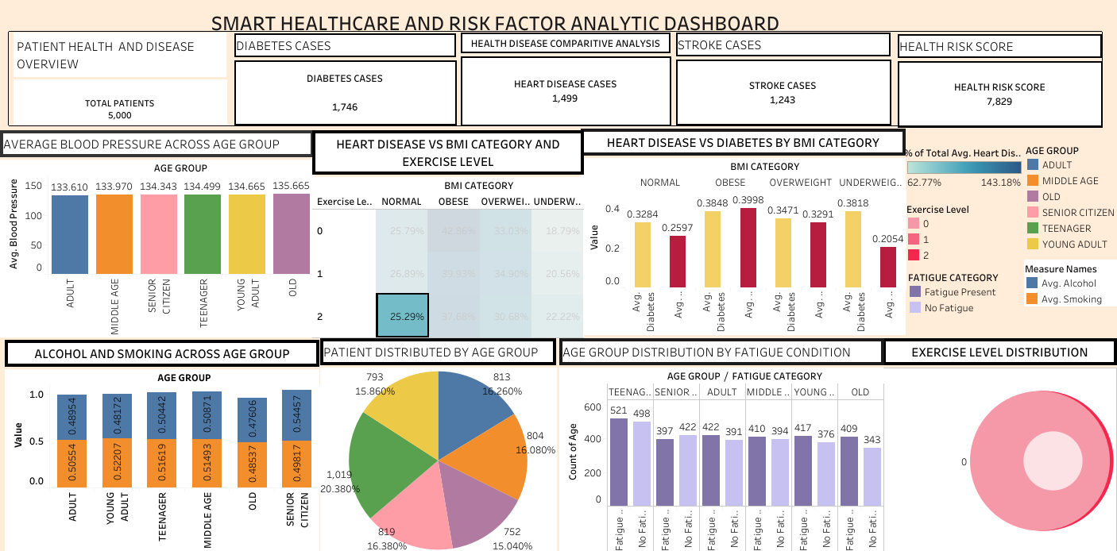

- Figure 2: Tableau Story workspace showing the story title and story point. 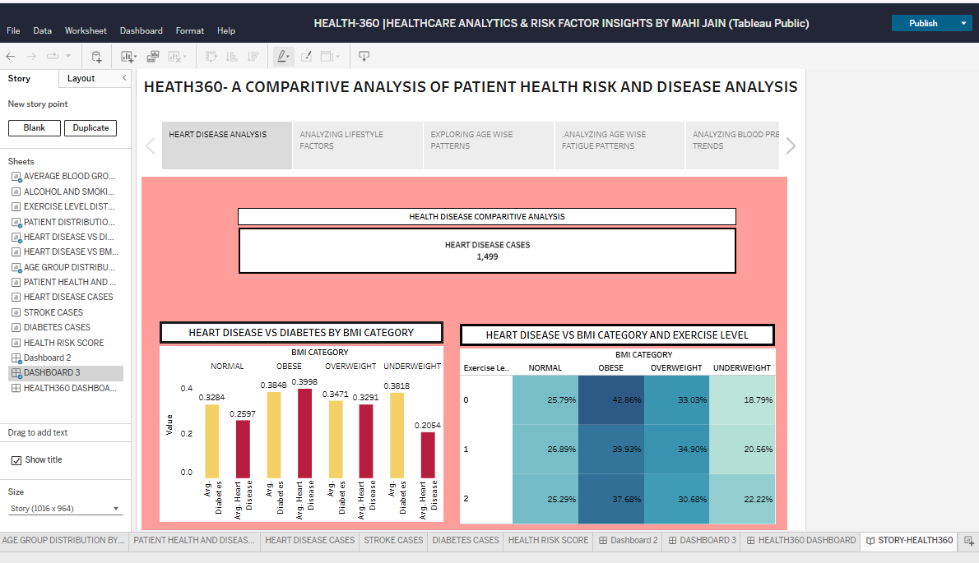

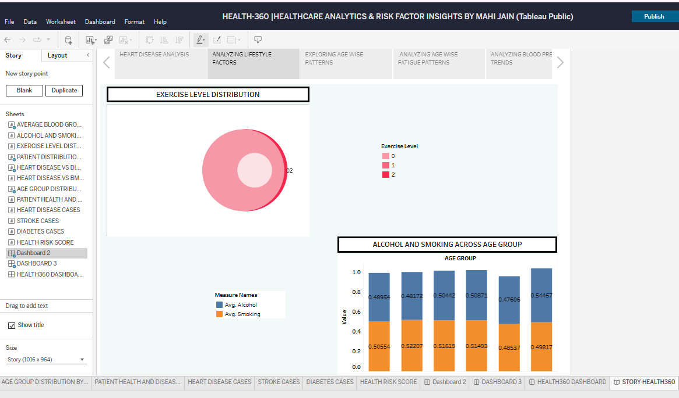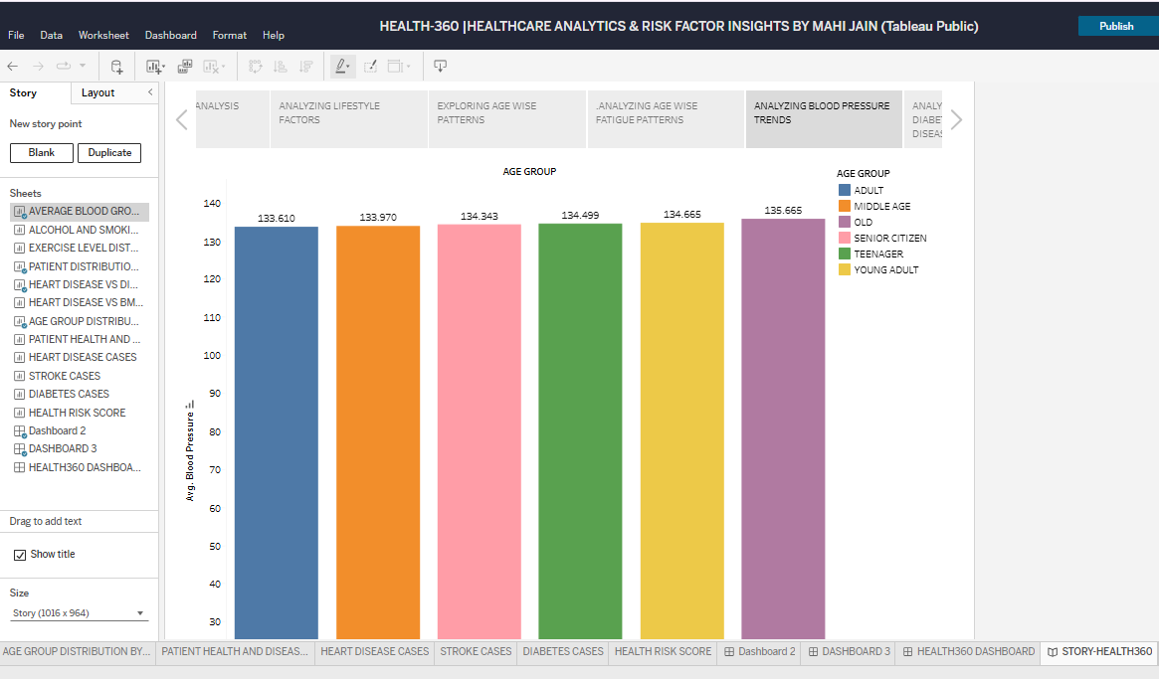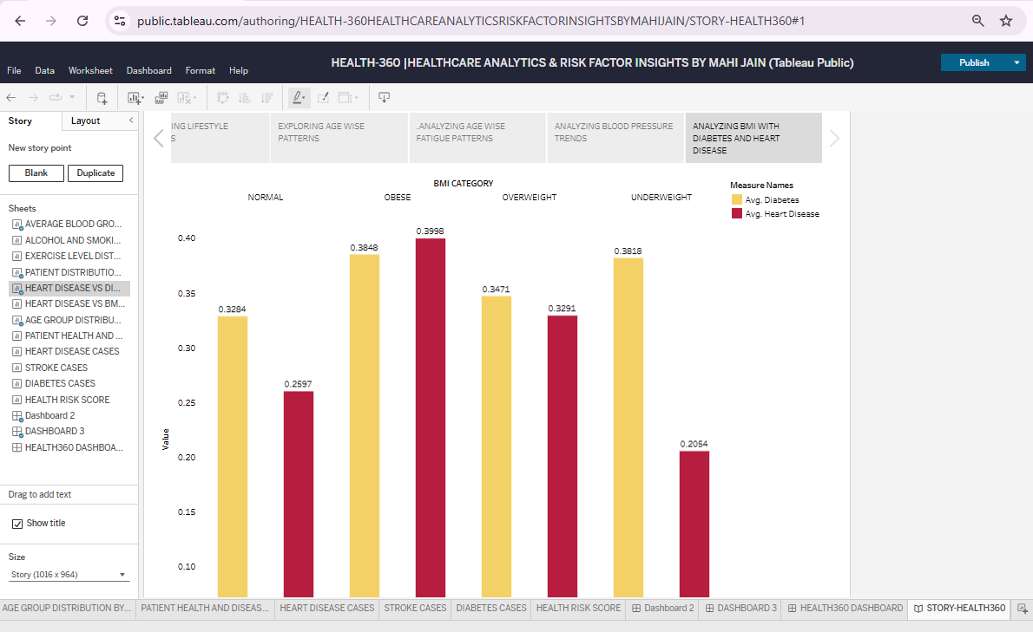

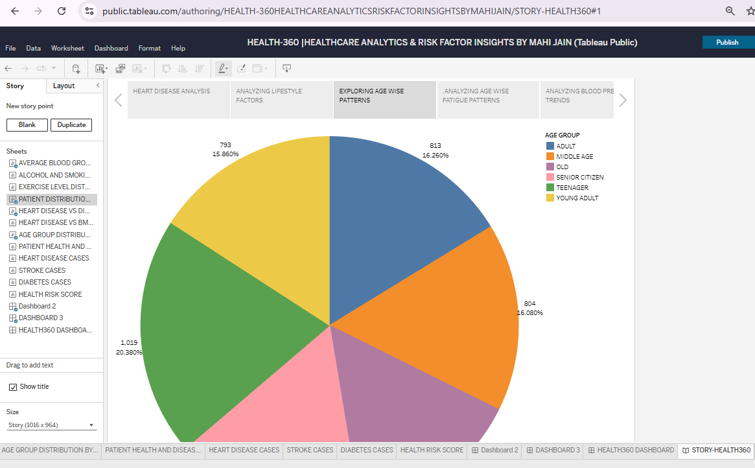
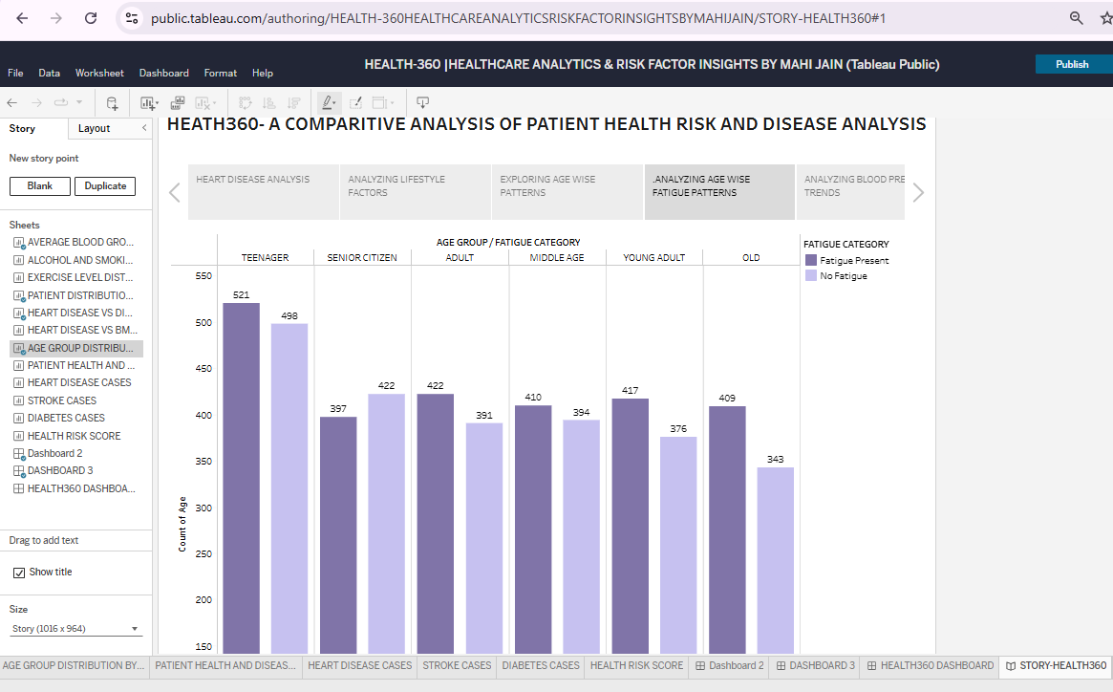

Figure 3: Worksheet list or individual worksheet views demonstrating the analysis components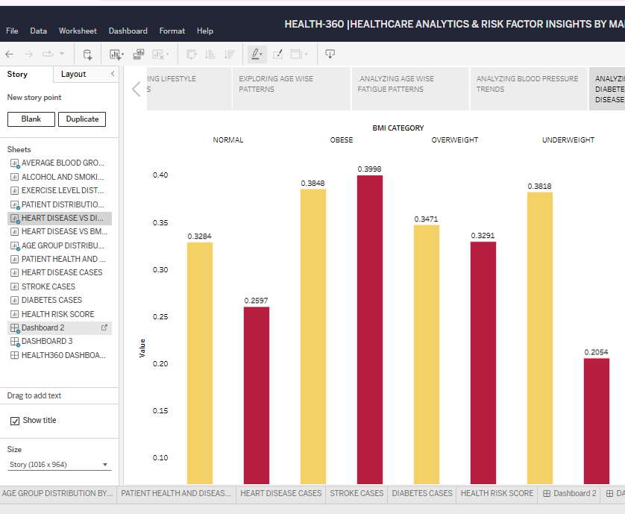

- Figure 4: Published Tableau Public dashboard final project link.

- https://public.tableau.com/views/HEALTH360HEALTHCAREANALYTICSRISKFACTORINSIGHTSBYMAHIJAIN/HEALTH360DASHBOARD?:language=en-US&:sid=&:redirect=auth&:display_count=n&:origin=viz_share_link

8. ADVANTAGES & DISADVANTAGES

8.1 Advantages
- Consolidated view: multiple health indicators are presented in one dashboard.
- Quick overview: KPI cards make key record and disease counts easy to locate.
- Visual comparison: charts make category-level differences easier to inspect than raw tables.
- Multiple dimensions: the project combines age, BMI, exercise, fatigue and lifestyle variables.
- Presentation-friendly: the Tableau Story can guide a viewer through selected analyses.
- Expandable: additional indicators and filters can be incorporated as the project develops.

8.2 Disadvantages and Limitations
- The quality of the analysis depends on the completeness, accuracy and representativeness of the source dataset.
- The dashboard presents descriptive patterns and does not establish medical causation.
- Some chart labels may become difficult to read when the dashboard is viewed on a small screen.
- The meaning of the Health Risk Score depends on its underlying formula and must be documented.
- Aggregated charts can hide variation between individual records and smaller subgroups.
- The dashboard is not a clinical decision-support or diagnostic tool.

9. CONCLUSION
HEALTH360 – Health Risk & Disease Analytics demonstrates the use of Tableau Public to organise and present a multi-variable healthcare dataset through an interactive dashboard. The project brings together patient and disease KPIs with visual comparisons of blood pressure, BMI, exercise, alcohol, smoking, age-group distribution and fatigue.
The project also demonstrates a complete visualisation workflow: understanding the problem, reviewing the dataset, identifying requirements, creating worksheets, assembling a dashboard, developing a story and checking the final output. The result is a presentation-friendly analytical view that can help users explore the data more efficiently. The dashboard should be interpreted as an educational descriptive-analytics tool, not as medical advice or a diagnosis.

10. FUTURE SCOPE
- Add interactive filters for age group, gender, BMI category and other relevant fields, where those fields exist in the dataset.
- Include tooltips with clear definitions, units, record counts and calculation details.
- Document the formula and interpretation scale for the Health Risk Score.
- Add trend analysis if reliable time-based data becomes available.
- Introduce additional comparisons for cholesterol and glucose, after validating their units and data quality.
- Add drill-down views so users can move from an overall KPI to the relevant categories.
- Improve accessibility through readable fonts, colour contrast and descriptive chart captions.
- Validate the dashboard with a larger group of users and incorporate their feedback.
- Use an appropriately validated and ethically governed dataset if the project is extended to predictive modelling.

11. APPENDIX

A. Source Code / Workbook
Platform: Tableau Public. Add the final workbook file name and any repository link here. If no separate source-code repository exists, state that the project was developed in Tableau Public and provide the workbook or public dashboard link.
Workbook / GitHub link:
https://github.com/Mahijain-connect_

B. Dataset Link
Dataset name: HEALTH360-COMPREHENSIVE HEALTH RISK AND DISEASE ANALYSIS_
Dataset source / URL: SKILL WALLET
Dataset access date: _________________________________________

C. Project Demo Link
- Tableau Public dashboard URL: https://public.tableau.com/views/HEALTH-360HEALTHCAREANALYTICSRISKFACTORINSIGHTSBYMAHIJAIN/HEALTH360DASHBOARD?:language=en-US&:sid=&:redirect=auth&:display_count=n&:origin=viz_share_link

- Presentation / demo URL (if any): ______________________________

D. Abbreviations
Term | Meaning
BMI | Body Mass Index.
KPI | Key Performance Indicator.
CSV | Comma-Separated Values file format.
Tableau Public | A platform for creating and sharing data visualisations publicly.
Dashboard | A consolidated view containing multiple visualisations and summary indicators.

E. Final Verification Checklist
- Replace all blank student and institution details on the cover page.
- Verify the exact Health Risk Score and its calculation in Tableau.
- Cross-check all KPI counts with the source data.
- Insert clear screenshots of the dashboard, worksheets and each important story point.
- Add the exact dataset source, workbook link and project demo link.
- Confirm that the final report uses the same worksheet names as the submitted Tableau workbook.

STUDENT DECLARATION
I hereby declare that the project report titled “HEALTH360 – Health Risk & Disease Analytics” has been prepared by me as part of my academic work. The report describes the dashboard, worksheets and story developed using Tableau Public. The information and project outputs included in this report are presented to the best of my understanding and have been prepared for academic purposes.

Student Name: __________________________________________
Signature: ______________________________________________
Date: __________________________________________________

ACKNOWLEDGEMENT
I would like to express my sincere gratitude to my project guide and faculty members for their guidance and support throughout this project. I am also thankful to my institution for providing the opportunity to work on a practical data-analytics project. This project helped me develop a better understanding of healthcare data, visual analysis, dashboard design and storytelling using Tableau Public.

