Week 1 WP Lab

Name: Mahika Wakankar
Registration Number: 220905077
Roll Number: 14
Class: CSE C

Questions:

Q1)Write a simple poem and represent it as a web page. Give a title for the poem.
Make rhyming words in the poem as bold.

Code:
<!DOCTYPE html>
<html lang="en">
<head>
<meta charset="UTF-8">
<meta name="viewport" content="width=device-width, initial-scale=1.0">
<title>Humpty Dumpty</title>
</head>
<body style="font-family: Arial, sans-serif; background-color: #f0f8ff; color: #333; margin: 20px; padding: 20px;">
<h1 style="text-align: center; color: #ff6347; font-size: 36px; ">Humpty Dumpty</h1>
<p style="font-size: 18px; line-height: 1.8; text-align: center;">
Humpty <b style="color: #4682b4; font-style: italic; text-decoration: bold;">Dumpty</b>
<br>
Sat on a <b style="color: #4682b4; font-style: italic; text-decoration: bold;">wall.</b>
<br>
Humpty <b style="color: #4682b4; font-style: italic; text-decoration: bold;">Dumpty</b>
<br>
Had a great <b style="color: #4682b4; font-style: italic; text-decoration: bold;">fall.</b>
<br>
All the king's horses
<br>
And all the king's <b style="color: #4682b4; font-style: italic; text-decoration: bold;">men</b>
<br>
Cannot put Humpty<br>
Dumpty together <b style="color: #4682b4; font-style: italic; text-decoration: bold;">again.</b>
</p>
</body>
</html>

Output:



Q2)Assume you have brought a new car. Write down the list of additional accessories you need for the car as an unordered list in HTML. Also, list the travel plans on the car as an ordered list.

Code:

<!DOCTYPE html>
<html lang="en">
<head>
<meta charset="UTF-8">
<meta name="viewport" content="width=device-width, initial-scale=1.0">
<title>New Car</title>
</head>
<body style="font-family: Arial, sans-serif; background-color: #f9f9f9; color: #333; padding: 20px;">
<h1 style="text-align: center; color: white; font-size: 32px; background-color: #333; padding: 10px;">New Car Plans and Accessories</h1>
<p style="font-size: 18px; color: rgb(255, 187, 0); font-weight: bold;">Car bought: <span style="color: rgb(64, 173, 224); font-weight: bold;">Mercedes-Benz</span></p>
<p style="font-size: 18px; color: rgb(255, 187, 0); font-weight: bold;">Below is the unordered list of accessories for the car.
<ul style="list-style-type: square; padding-left: 40px; font-size: 16px; color: rgb(64, 173, 224);">
<li>GPS</li>
<li>Reverse Camera</li>
<li>Bluetooth</li>
<li>Air freshener</li>
<li>Car charger</li>
</ul>
</p>
<p style="font-size: 18px; color: rgb(255, 187, 0); font-weight: bold;">Below is the ordered list of travel plans.
<ol style="list-style-type: decimal; padding-left: 40px; font-size: 16px; color: rgb(64, 173, 224);">
<li>Bangalore</li>
<li>Goa</li>
<li>Gokarna</li>
<li>Mangalore</li>
</ol>
</p>
</body>
</html>

Output:
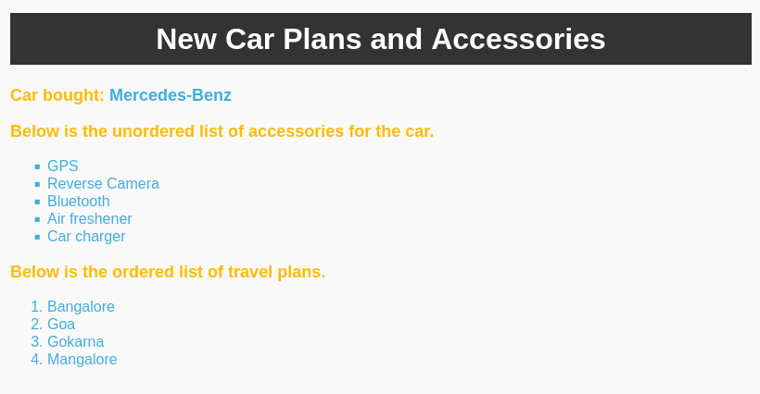

Q3)Complete the following website name “Share your Winter Vacation Videos”. The required video files are located inside compressed folder “Week 1 Assignment Files/Media/”.

Code:

<!DOCTYPE html>
<html lang="en">
<head>
<meta charset="UTF-8">
<meta name="viewport" content="width=device-width, initial-scale=1.0">
<title>Share your Winter Vacation Videos</title>
<style>
body {
background: linear-gradient(to bottom,white , #b591df);
margin: 0;
height: 100vh;
}
</style>
</head>
<body >
<h1 style="text-align: center; margin: 60px; background-color: grey; color: white;">Share your Winter Vacation Videos</h1>
<div style="text-align: center;">
<div style="display: inline-block; margin-right: 20px;">
<video width="200" height="240" controls style="border: 3px solid #000;border-radius: 5px;"> <source src="video1.mp4" type="video/mp4">
Your browser does not support the video tag.
</video>
</div>

<div style="display: inline-block; margin-right: 20px;">
<video width="200" height="240" controls style="border: 3px solid #000;border-radius: 5px;"> <source src="video2.mp4" type="video/mp4">
Your browser does not support the video tag.
</video>
</div>

<div style="display: inline-block;">
<video width="200" height="240" controls style="border: 3px solid #000;border-radius: 5px;"> <source src="video3.mp4" type="video/mp4">
Your browser does not support the video tag.
</video>
</div>
</div>
</body>
</html>

Output:

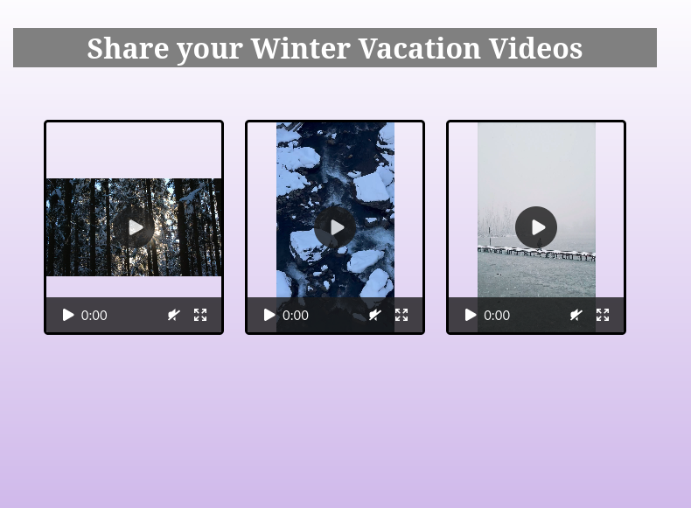
Q4) Create the following output in HTML.

Code:
<!DOCTYPE html>
<html lang="en">
<head>
<meta charset="UTF-8">
<meta name="viewport" content="width=device-width, initial-scale=1.0">
<title>Population Table</title>
<style>
table {
border-collapse: collapse;
width: 50%;
text-align: center;
}
th, td {
border: 1px solid black;
padding: 8px;
}
th {
background-color: red;
color: white;
}
.country {
background-color: yellow;
}
.year {
background-color: lightblue;
}
.population {
background-color: lightgreen;
}
</style>
</head>
<body>
<h1 style="text-align: center; margin: 60px; ">Population of countries</h1>
<table>
<tr>
<th>Country</th>
<th>Population (in Crores)</th>
<th></th>
</tr>
<tr>
<td class="country" rowspan="3">INDIA</td>
<td class="year">1998</td>
<td class="population">85</td>
</tr>
<tr>
<td class="year">1999</td>
<td class="population">90</td>
</tr>
<tr>
<td class="year">2000</td>
<td class="population">100</td>
</tr>
<tr>
<td class="country" rowspan="2">USA</td>
<td class="year">1998</td>
<td class="population">30</td>
</tr>
<tr>
<td class="year">1999</td>
<td class="population">35</td>
</tr>
<tr>
<td class="country" rowspan="3">UK</td>
<td class="year">1998</td>
<td class="population">25</td>
</tr>
<tr>
<td class="year">1999</td>
<td class="population">30</td>
</tr>
<tr>
<td class="year">2000</td>
<td class="population">35</td>
</tr>
</table>
<script src="q5.js"></script>
</body>
</html>

Output:
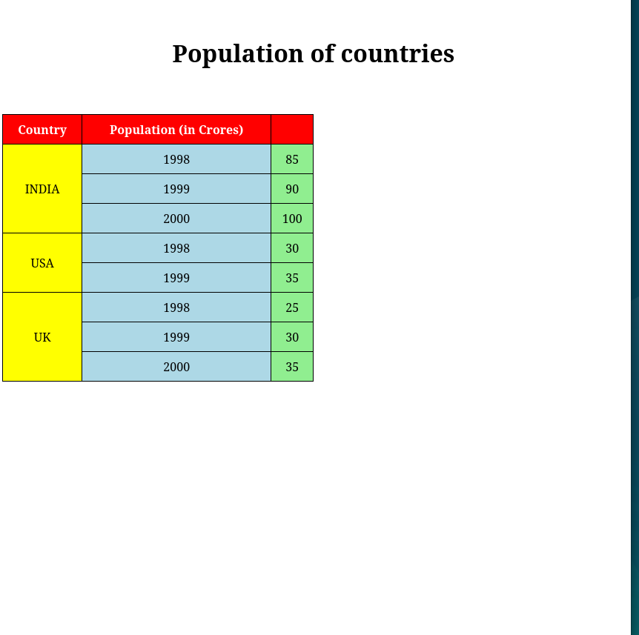

Q5)Create an array of Javascript objects for the data in question 4 and display each row in the table form through a Javascript code.

Code:

const populationData = [
{ country: 'INDIA', year: '1998', population: 85 },
{ country: 'INDIA', year: '1999', population: 90 },
{ country: 'INDIA', year: '2000', population: 100 },
{ country: 'USA', year: '1998', population: 30 },
{ country: 'USA', year: '1999', population: 35 },
{ country: 'UK', year: '1998', population: 25 },
{ country: 'UK', year: '1999', population: 30 },
{ country: 'UK', year: '2000', population: 35 }
];

const generateTable = () => {
const table = document.getElementById('populationTable');

populationData.forEach((data, index) => {
const row = table.insertRow();

const countryCell = row.insertCell(0);
countryCell.textContent = data.country;
if (index > 0 && populationData[index - 1].country === data.country) {
countryCell.remove();
} else {
countryCell.classList.add('country');
if (populationData.filter(item => item.country === data.country).length > 1) {
countryCell.rowSpan = populationData.filter(item => item.country === data.country).length;
}
}

const yearCell = row.insertCell(1);
yearCell.textContent = data.year;
yearCell.classList.add('year');

const populationCell = row.insertCell(2);
populationCell.textContent = data.population;
populationCell.classList.add('population');
});
};

window.onload = generateTable;

Output:

