Week 2 WP Lab

Name: Mahika Wakankar
Registration Number: 220905077
Roll Number: 14
Class: CSE C

Questions:
Q1) Write a web page which contains table with 3 X 3 dimensions (fill some data) and one
image. Style the rows with alternate color. Move the table and image together from
right to left when button is clicked.

Code:
<!DOCTYPE html>
<html lang="en">
<head>
<meta charset="UTF-8">
<meta name="viewport" content="width=device-width, initial-scale=1.0">
<title>Move Table and Image</title>
<style>
body {
margin: 0;
padding: 0;
height: 100vh;
overflow: hidden;
}

#container {
position: absolute;
right: 0;
transition: right 0.5s ease;
}

table {
border-spacing: 0;
width: 100%;
}

th, td {
border: 1px solid black;
padding: 8px;
text-align: left;
}

img {
height: 125px;
margin-top: 10px;
}
</style>
<script type="text/javascript" language="javascript">
// jQuery code written directly here
window.onload = function() {
var moved = false;
document.getElementById("moveButton").onclick = function() {
if (!moved) {
document.getElementById("container").style.right = "80%";
} else {
document.getElementById("container").style.right = "0";
}
moved = !moved;
};
};
</script>
</head>
<body>
<button id="moveButton">Move Left</button>
<div id="container">
<table>
<tr style="background-color: aqua;">
<th>Name</th>
<th>RollNo</th>
<th>Branch</th>
</tr>
<tr style="background-color: purple;">
<td>Mahika</td>
<td>14</td>
<td>CSE</td>
</tr>
<tr style="background-color: aquawhite;">
<td>Ashwin</td>
<td>11</td>
<td>CCE</td>
</tr>
</table>
<img src="image.jpg" alt="DNA structure illustration">
</div>
</body>
</html>

Output:
Before Clicking Button(Move Left)
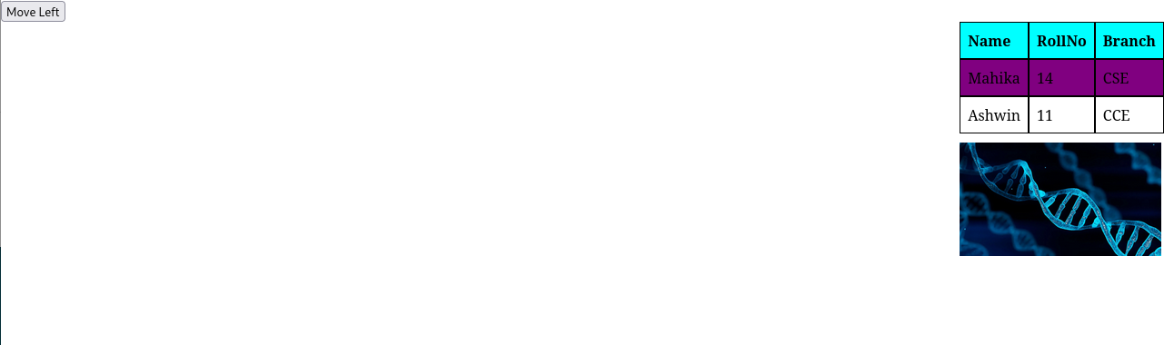

After Clicking Button(Move Left)
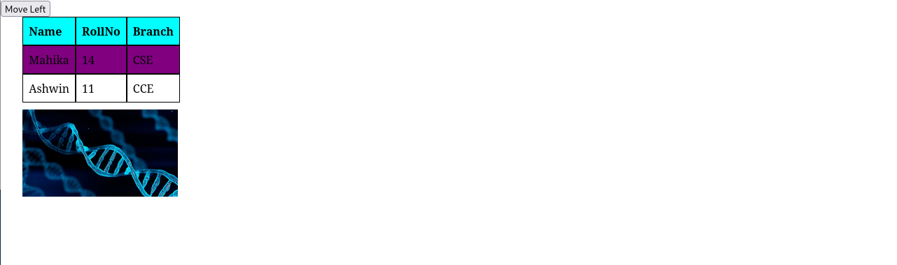
Q2)Design a calculator to perform basic arithmetic operations. Use textboxes and buttons
to design web page.

Code:
<!DOCTYPE html>
<html lang="en">
<head>
<meta charset="UTF-8">
<meta name="viewport" content="width=device-width, initial-scale=1.0">
<title>Calculator</title>
<style>
body {
display: flex;
justify-content: center;
align-items: center;
height: 100vh;
margin: 0;
background-color: #f0f0f0;
}
.calculator {
border-radius: 10px;
padding: 20px;
width: 250px;
background-color: #fff;
border: 2px solid #ccc;
}
.display {
width: 100%;
height: 40px;
margin-bottom: 20px;
font-size: 20px;
text-align: right;
padding: 10px;
border-radius: 5px;
border: 1px solid #ccc;
background-color: #f0f0f0;
}
.buttons {
display: flex;
flex-wrap: wrap;
gap: 10px;
}
.button {
font-size: 20px;
padding: 20px;
border: none;
background-color: #f1f1f1;
cursor: pointer;
border-radius: 5px;
width: 50px;
height: 50px;
transition: background-color 0.2s;
}
.button:active {
background-color: #ccc;
}
.operator {
background-color: #E91E63;
color: white;
}
.equal {
background-color: #4CAF50;
color: white;
width: 110px;
}
.clear {
background-color: #E91E63;
color: white;
width: 110px;
}
</style>
<script type="text/javascript" language="javascript"></script>
<script type="text/javascript" language="javascript">
window.onload = function() {
let currentInput = '';
let previousInput = '';
let operator = '';
let result = '';

$(".button").click(function () {
let buttonValue = $(this).text();

if (buttonValue >= '0' && buttonValue <= '9') {
currentInput += buttonValue;
} else if (buttonValue === '.') {
if (!currentInput.includes('.')) {
currentInput += buttonValue;
}
} else if (buttonValue === 'C') {
currentInput = '';
previousInput = '';
operator = '';
result = '';
} else if (buttonValue === '=') {
if (previousInput && operator && currentInput) {
switch (operator) {
case '+':
result = parseFloat(previousInput) + parseFloat(currentInput);
break;
case '-':
result = parseFloat(previousInput) - parseFloat(currentInput);
break;
case '*':
result = parseFloat(previousInput) * parseFloat(currentInput);
break;
case '/':
if (currentInput === '0') {
result = 'Error';
} else {
result = parseFloat(previousInput) / parseFloat(currentInput);
}
break;
}

currentInput = '';
previousInput = result.toString();
operator = '';
}
} else {
if (currentInput !== '') {
if (previousInput === '') {
previousInput = currentInput;
} else {
switch (operator) {
case '+':
previousInput = (parseFloat(previousInput) + parseFloat(currentInput)).toString();
break;
case '-':
previousInput = (parseFloat(previousInput) - parseFloat(currentInput)).toString();
break;
case '*':
previousInput = (parseFloat(previousInput) * parseFloat(currentInput)).toString();
break;
case '/':
if (currentInput !== '0') {
previousInput = (parseFloat(previousInput) / parseFloat(currentInput)).toString();
} else {
previousInput = 'Error';
}
break;
}
}
operator = buttonValue;
currentInput = '';
}
}

let displayText = previousInput + ' ' + operator + ' ' + currentInput;

if (result !== '') {
displayText = previousInput + ' = ' + result;
}

$('#result').val(displayText.trim() || '0');
});
};
</script>
</head>
<body>
<div class="calculator">
<input type="text" class="display" id="result" readonly>
<div class="buttons">
<button class="button clear" id="clear">C</button>
<button class="button operator" id="divide">/</button>
<button class="button operator" id="multiply">*</button>
<button class="button operator" id="subtract">-</button>
<button class="button" id="7">7</button>
<button class="button" id="8">8</button>
<button class="button" id="9">9</button>
<button class="button operator" id="add">+</button>
<button class="button" id="4">4</button>
<button class="button" id="5">5</button>
<button class="button" id="6">6</button>
<button class="button equal" id="equal">=</button>
<button class="button" id="1">1</button>
<button class="button" id="2">2</button>
<button class="button" id="3">3</button>
<button class="button" id="0">0</button>
<button class="button" id="decimal">.</button>
</div>
</div>
</body>
</html>

Output:

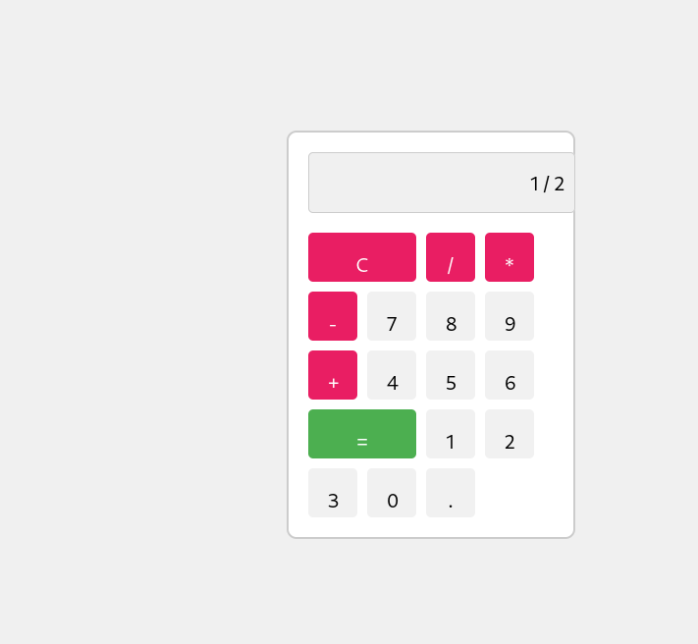
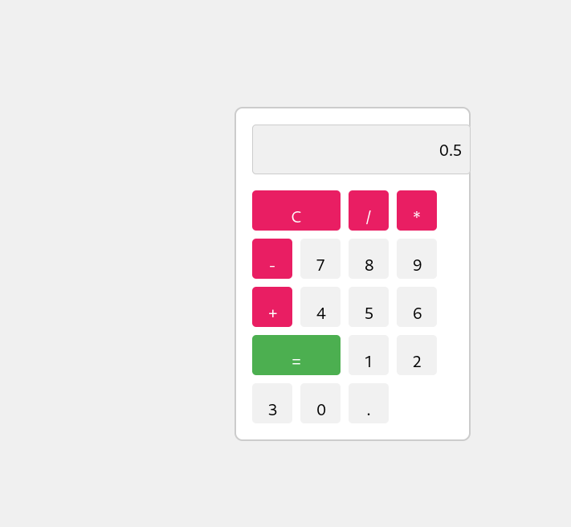

Q3)Create a web page to design a birthday card shown below.

Code:
<!DOCTYPE html>
<html lang="en">
<head>
<meta charset="UTF-8">
<meta name="viewport" content="width=device-width, initial-scale=1.0">
<title>Greeting Card Customization</title>
<style>
body {
font-family: Arial, sans-serif;
background-color: #f9f9f9;
margin: 20px;
}
.container {
background-color: #ffffcc;
padding: 20px;
width: 300px;
border: 1px solid #ccc;
border-radius: 10px;
}
label {
display: block;
margin-bottom: 5px;
font-weight: bold;
}
select, input[type="number"], textarea {
width: 100%;
padding: 5px;
margin-bottom: 15px;
border: 1px solid #ccc;
border-radius: 5px;
}
input[type="radio"] {
margin-right: 5px;
}
.checkbox {
margin-bottom: 15px;
}
button {
background-color: #4CAF50;
color: white;
border: none;
padding: 10px 15px;
border-radius: 5px;
cursor: pointer;
}
button:hover {
background-color: #45a049;
}
.cake-container {
background-color: yellow;
border: 3px solid black;
padding: 10px;
text-align: center;
width: 100%;
border-radius: 10px;
margin-top: 0;
}
.cake-container img {
max-width: 100%;
height: auto;
}
</style>
<script type="text/javascript" language="javascript">
document.addEventListener("DOMContentLoaded", function() {
document.querySelector("#update").addEventListener("click", function() {
var backgroundColor = document.querySelector("#background-color").value;
var fontFamily = document.querySelector("#font").value;
var fontSize = document.querySelector("#font-size").value;
var borderStyle = document.querySelector("input[name='border-style']:checked").value;
var defaultPicture = document.querySelector("#default-picture").checked;
var greetingText = document.querySelector("#greeting-text").value;

var preview = document.createElement("div");
preview.style.backgroundColor = backgroundColor;
preview.style.fontFamily = fontFamily;
preview.style.fontSize = fontSize + "px";
preview.style.border = "2px " + borderStyle + " black";
preview.style.padding = "10px";
preview.style.marginTop = "20px";

var text = document.createElement("p");
text.textContent = greetingText;

if (defaultPicture) {
var img = document.createElement("img");
img.src = "https://via.placeholder.com/150";
img.alt = "Default Picture";
img.style.display = "block";
img.style.marginBottom = "10px";
preview.appendChild(img);
}

preview.appendChild(text);
document.body.appendChild(preview);
});
});
</script>
</head>
<body>
<div class="container">
<label for="background-color">Choose a background color:</label>
<select id="background-color">
<option value="yellow">Yellow</option>
<option value="lightblue">Light Blue</option>
<option value="lightgreen">Light Green</option>
</select>

<label for="font">Choose a font:</label>
<select id="font">
<option value="Verdana">Verdana</option>
<option value="Arial">Arial</option>
<option value="Courier New">Courier New</option>
</select>

<label for="font-size">Specify a numeric font size:</label>
<input type="number" id="font-size" value="25">

<label>Choose a border style:</label>
<input type="radio" name="border-style" value="none" checked> None
<input type="radio" name="border-style" value="double"> Double
<input type="radio" name="border-style" value="solid"> Solid

<div class="checkbox">
<input type="checkbox" id="default-picture"> Add the Default Picture
</div>

<label for="greeting-text">Enter the greeting text below:</label>
<textarea id="greeting-text" rows="4">Happy Birthday, and many more</textarea>

<button id="update">Update</button>

<div class="cake-container">
<img src="cake.jpg" alt="Cake Image">
</div>
</div>
</body>
</html>

Output:
