MailSense: Actionable Email Detection Using NLP
Academic Project Report
Md Ariful Alam Mahim (Roll: 2107023)
Md Jubair Husain (Roll: 2107029)
September 2026

1. Introduction
MailSense is a binary NLP classifier that identifies whether an email-text snippet is Actionable (Yes) or Non-Actionable (No). The project compares a TF-IDF plus Logistic Regression baseline, a BiLSTM initialized with pretrained Word2Vec embeddings, and fine-tuned bert-base-uncased. Because the data are email sentences or snippets rather than complete subject-and-body messages, the scope is actionable email-content classification.

2. Problem Statement and Objectives

2.1 Problem Statement
Given an email-text snippet, predict Yes (Actionable) or No (Non-Actionable). The experiment evaluates the three implemented models on the same held-out test set.

2.2 Objectives
- Prepare a common cleaned dataset split for all models.
- Train and evaluate the three specified classification pipelines.
- Compare held-out-test accuracy, precision, recall, F1-score, ROC-AUC, and confusion matrices.

3. Dataset and Preprocessing

3.1 Dataset Description
The Parakweet Labs Email Intent Dataset file Ask0729-fixed.txt contains 3,657 raw examples: 1,719 Actionable (Yes) and 1,938 Non-Actionable (No). These are source-data counts, not post-processing experimental counts.

3.2 Data Cleaning and Preparation
The implemented pipeline applies Unicode normalization and HTML decoding; replaces URLs, email addresses, and numbers with $LINK, $EMAIL, and $NUM; removes remaining HTML tags; normalizes whitespace; and removes meaningless, conflicting-label, and duplicate cleaned records. Six records were removed, leaving 3,651 examples (1,718 Yes; 1,933 No) for the experiment.

3.3 Train-Validation-Test Split
A stratified 70/15/15 split with seed 42 produced 2,555 training, 548 validation, and 548 test examples. The same split was used for every model. The held-out test set contains 258 Actionable and 290 Non-Actionable examples.

4. Methodology

4.1 TF-IDF + Logistic Regression
Text was represented with TF-IDF unigram and bigram features (min_df=2, max_df=0.9, sublinear term frequency) and classified with balanced Logistic Regression (C=1.0). The vectorizer was fitted on training data only.

4.2 Word2Vec + BiLSTM
This model is a BiLSTM initialized with pretrained Word2Vec embeddings. The embeddings were trainable during training. The implementation uses a maximum length of 64 tokens, a one-layer bidirectional LSTM with hidden dimension 128, dropout of 0.3, and a two-class output layer.

4.3 Pretrained BERT
bert-base-uncased was fine-tuned for two-class sequence classification. Inputs were tokenized and padded or truncated to 64 tokens; all BERT parameters remained trainable.

4.4 Experimental Setup
The BiLSTM configuration used batches of 32, up to 20 epochs, Adam optimization, and validation-F1 checkpoint selection. BERT used batches of 16, up to 4 epochs, AdamW with linear warmup, and validation-F1 checkpoint selection. For all models, Actionable (Yes) was the positive class and a probability threshold of 0.5 produced the final class prediction.

5. Evaluation Metrics
Accuracy, precision, recall, F1-score, and ROC-AUC were computed on the held-out test set. Precision, recall, and F1-score use Actionable (Yes) as the positive class. Confusion matrices report true labels by rows and predicted labels by columns; a false negative is actionable content predicted as non-actionable.

6. Results and Analysis

6.1 Overall Model Performance
Table 1 reports the final held-out-test results recorded in the project files.
Model | Accuracy | Precision | Recall | F1 | ROC-AUC
TF-IDF + Logistic Regression | 77.74% | 76.98% | 75.19% | 76.08% | 86.07%
Word2Vec + BiLSTM | 74.82% | 71.74% | 76.74% | 74.16% | 86.54%
BERT (bert-base-uncased) | 84.85% | 82.05% | 86.82% | 84.37% | 93.16%
Table 1. Final metrics on the common held-out test set (n=548).
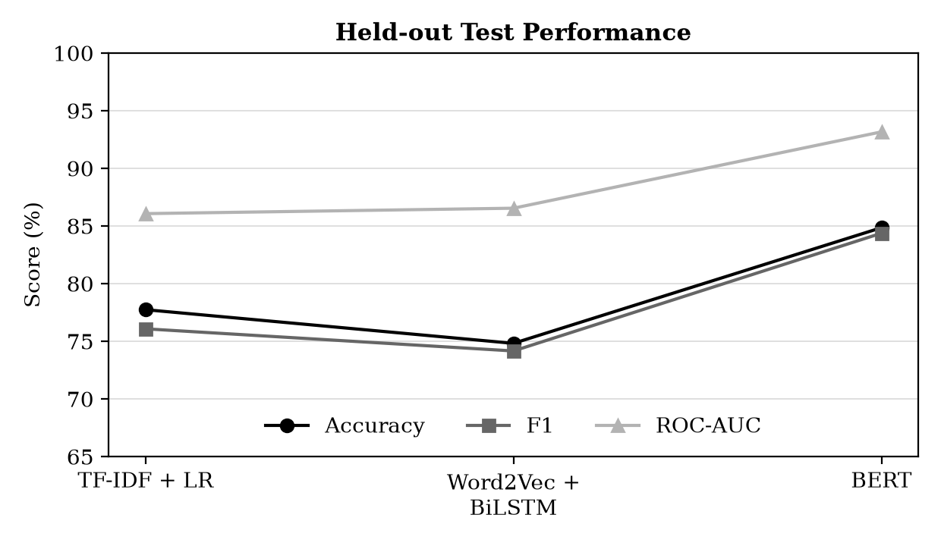
Figure 1. Accuracy, F1, and ROC-AUC across the three models.

6.2 Confusion Matrix Analysis
The recorded confusion matrices show that BERT produced 224 true positives, 241 true negatives, 49 false positives, and 34 false negatives. TF-IDF plus Logistic Regression recorded 194, 232, 58, and 64 respectively; Word2Vec plus BiLSTM recorded 198, 212, 78, and 60 respectively.
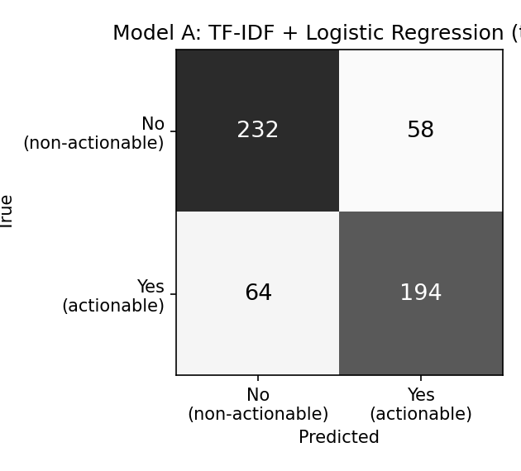
Figure 2. TF-IDF + Logistic Regression test confusion matrix.
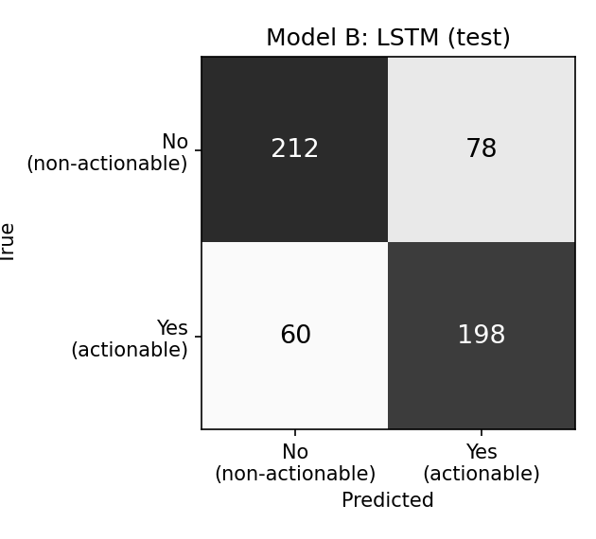
Figure 3. Word2Vec + BiLSTM test confusion matrix.
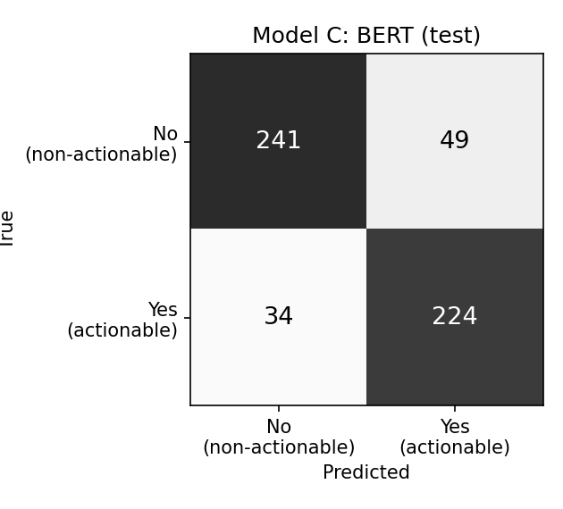
Figure 4. BERT test confusion matrix.

6.3 Training Performance
The following plots reproduce the training and validation loss values from the recorded training-history CSV files; no values were added or estimated.
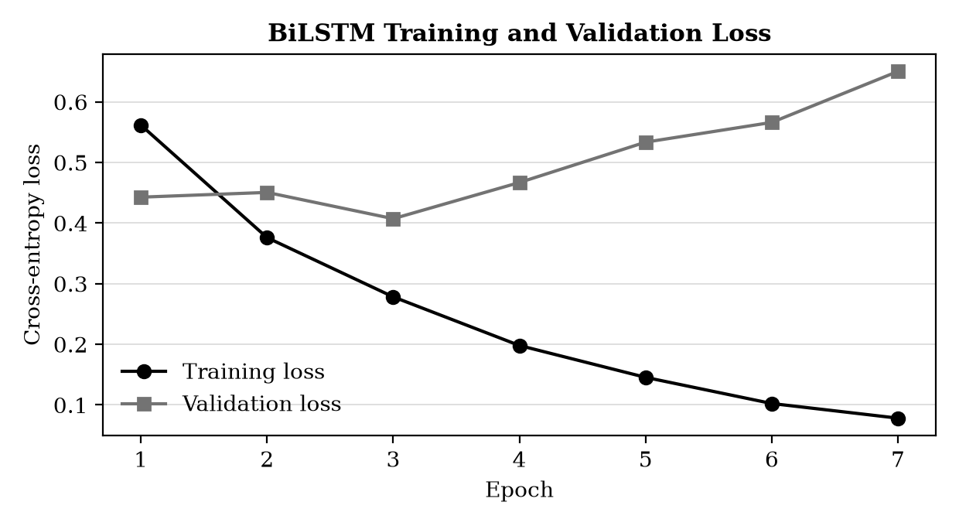
Figure 5. BiLSTM training and validation loss by epoch.
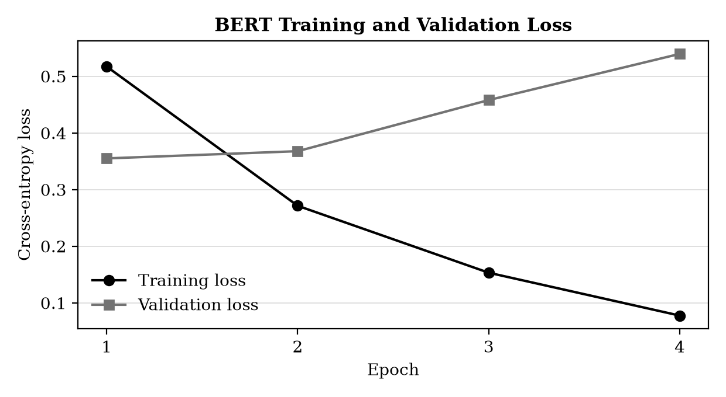
Figure 6. BERT training and validation loss by epoch.

6.4 Discussion
Among the three models in this experiment, BERT achieved the highest measured accuracy (84.85%), precision (82.05%), recall (86.82%), F1-score (84.37%), and ROC-AUC (93.16%). It also had the fewest recorded false negatives (34), whereas the TF-IDF and BiLSTM models had 64 and 60. The TF-IDF baseline achieved 77.74% accuracy and 76.08% F1. The BiLSTM recorded higher recall and ROC-AUC than the TF-IDF baseline, but lower accuracy, precision, and F1 on this test split.

7. Limitations
- The results come from one stratified train/validation/test split and a single experimental run.
- The dataset is limited in size and consists primarily of sentences or snippets rather than complete emails.
- All final class decisions use the fixed 0.5 probability threshold.
- The recorded findings apply to the evaluated dataset and implemented configurations; no additional datasets, searches, or experiments are reported.

8. Conclusion
MailSense compares three NLP pipelines for actionable email-content classification using one common cleaned split. On the held-out test set of 548 examples, fine-tuned BERT achieved the highest measured performance among the three models, with 84.85% accuracy, 84.37% F1-score, and 93.16% ROC-AUC. The results are bounded by the dataset, fixed split, and configurations documented in this project.

References
[1] Parakweet Labs, Email Intent Dataset, Ask0729-fixed.txt. Available: https://raw.githubusercontent.com/ParakweetLabs/EmailIntentDataSet/master/src/resources/Ask0729-fixed.txt.
[2] MailSense project artifacts: README.md; results/data_quality_report.json; results/final_test_comparison.csv; results/*/training_history.csv; configs/*.json; and source preprocessing, training, and evaluation files.

