**DATABASE DESIGN & DEVELOPMENT FOR** [**ET TRANSPORT**](https://www.ettransport.ca/)

**Name:** Mahim Sharma

**Subject:** Data Concepts and Data Design

**Mentor:** Dr Junaid Qazi

**Table of Contents**

Table of Contents .................................................................................................................. 2

Overview ................................................................................................................................3

Principal ..................................................................................................................................3

Purpose .....................................................................................................................................3

Database Structure ...................................................................................................................3,4,5

Entity Relationship Diagram ......................................................................................................6

Relationship Description ...........................................................................................................6

Database Design ........................................................................................................................7

Database development .............................................................................................................8

Conclusion ................................................................................................................................9

Appendix ...................................................................................................................................9

**OVERVIEW**

[ET Transport](https://www.ettransport.ca/) is a Canadian asset-based company founded in 2005, offering dependable transportation and logistics services throughout Canada and the U.S. With operations in Ontario and New Brunswick, we handle more than 25,000 shipments each year. Its fleet consists of 100 trucks and 200 trailers, ensuring the safe and timely delivery of your products.

**PRINCIPAL**

To create a scalable and efficient database system that guarantees data accuracy enhances fleet utilisation and fosters operational excellence for better logistics performance.

**PURPOSE**

* **Reduce Fleet Downtime**: Implement data-driven maintenance schedules to minimize vehicle downtime.
* **Increase Fleet Utilization**: Optimize operations to improve fleet utilisation.
* **Improve On-Time Delivery**: Track performance to increase on-time deliveries.
* **Reduce Operating Costs per Mile**: Improve cost per mile through better route optimization.
* **Enhance Data Accuracy**: Implement validation rules to reduce data errors.
* **Improve Customer Satisfaction Scores**: Analyse feedback to increase satisfaction scores.

**DATABASE STRUCTURE**

In a transport system, many elements need to be managed, from tracking vehicles and drivers to monitoring deliveries and costs. A well-structured database can simplify this process, ensuring that all information is organized and easily accessible.

Entity-Relationship (ER) diagram models various components of a transport system, primarily focused on deliveries, vehicles, routes, drivers, and associated costs:-

1. **Deliveries**:
   * Each delivery is identified by a unique ID and is linked to a specific route, vehicle (through license plate), and driver (via license number).
   * The status of the delivery (whether it's ongoing, completed, or delayed) is also recorded.
2. **Vehicles**:
   * Vehicles are tracked by their license plate and include information about the year, status, and mileage.
   * They are linked to the deliveries they are assigned to and are tracked for maintenance and costs.
3. **Maintenance**:
   * This section keeps track of each vehicle's maintenance history.
   * It records the type of maintenance, its cost, the date, and the downtime (in hours) when the vehicle is unavailable for use.
4. **Costs**:
   * This table records different types of costs associated with each vehicle, such as fuel, maintenance, and toll costs.
   * The total cost is calculated for each vehicle.
5. **Routes**:
   * Each delivery follows a specific route, which has an origin, destination, distance, and estimated time for completion.
   * Routes are monitored for their status (active, completed, or delayed).
6. **GPS Tracking**:
   * GPS tracking is used to monitor vehicles on their routes. It records the location (latitude) and time (timestamp) to estimate the vehicle's arrival time.
   * Each record links the vehicle (via license plate) and the route it's traveling on.
7. **Drivers**:
   * Drivers are assigned deliveries and tracked by their license numbers. Basic details such as their first and last names and phone numbers are recorded.
   * Drivers are linked to the vehicles they operate and the deliveries they manage.
8. **Customer Feedback**:
   * After deliveries are completed, customer feedback is recorded. This includes the customer’s name, their rating of the delivery, and any additional comments.
   * Feedback is linked to specific deliveries, helping assess service quality.

**GPS TRACKING**

|  |  |  |  |  |  |
| --- | --- | --- | --- | --- | --- |
| **License_plate** | **timestamp** | **latitude** | **longitude** | **Route ID (Foreign key)** | **GPS ID (Primary key)** |
| **ABC123** | **2024-09-28 08:00:00** | **40.71277600** | **-74.00597400** | **1** | **1** |
| **PQR678** | **2024-09-28 13:00:00** | **39.73923600** | **-104.9902510** | **2** | **2** |
| **DEF456** | **2024-09-28** | **34.05223500** | **-118.2436830** | **3** | **3** |
| **STU901** | **2024-09-28 14:00:00** | **32.71573600** | **-117.1610870** | **4** | **4** |
| **GHI789** | **2024-09-28 10:00:00** | **41.87811300** | **-87.62979900** | **5** | **5** |
| **VWX234** | **2024-09-28 11:00:00** | **29.76042700** | **-95.36980400** | **1** | **6** |
| **JKL012** | **2024-09-28 15:00:00** | **39.95258300** | **-75.16522200** | **2** | **7** |
| **YZA567** | **2024-09-28 16:00:00** | **47.60620900** | **-122.3332069** | **3** | **8** |
| **MNO345** | **2024-09-28 12:00:00** | **33.44837600** | **-112.0740360** | **4** | **9** |
| **BCD890** | **2024-09-28 17:00:00** | **30.26715300** | **-97.74305700** | **5** | **10** |

**Entity Relationship Diagram**

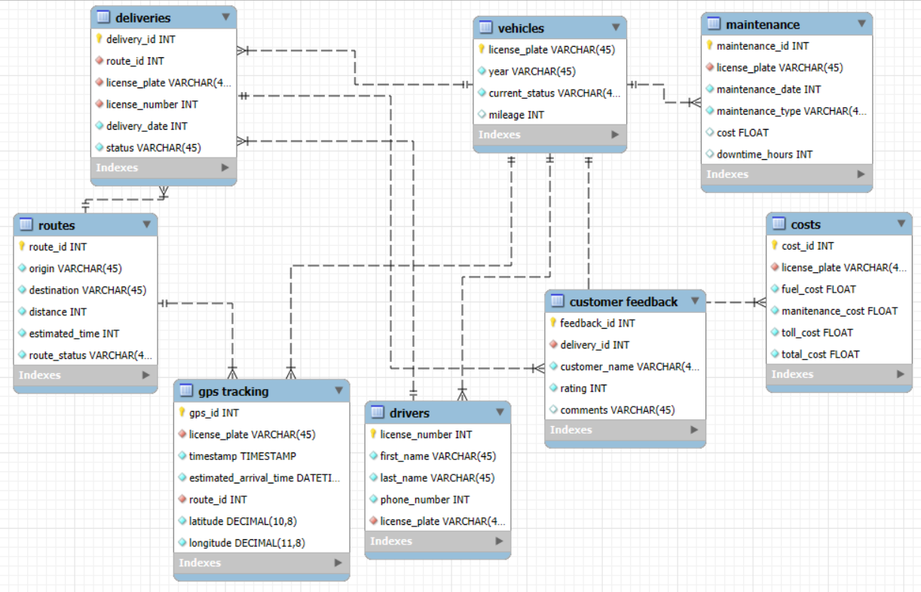

**Relationships**

One vehicle can handle multiple deliveries, but each delivery is assigned to one vehicle.

One route can have many deliveries, but each delivery follows one route.

One driver can manage multiple deliveries, but each delivery has one driver.

One vehicle can have many maintenance records, but each maintenance record belongs to one vehicle.

One vehicle has multiple cost records (fuel, maintenance, tolls), but each cost record is for one vehicle.

Each delivery has one customer feedback entry, and each feedback is related to one delivery.

One vehicle generates multiple GPS tracking records, but each GPS record is for one vehicle.

One route can have multiple GPS tracking records, indicating the vehicle's movement on that route.

**DATABASE DESIGN**

Efficient transport operations are the backbone of any logistics-driven company. At [ET Transport](https://www.ettransport.ca/), we leverage advanced systems to ensure that every delivery reaches its destination on time while keeping track of vehicle health, routes, driver assignments, and costs. This streamlined approach not only improves operational efficiency but also enhances customer satisfaction.

Our system operates using an integrated model, capturing data across several key areas:

1. **Deliveries and Routes**: Every delivery is carefully mapped to a specific route, which is pre-determined based on origin, destination, distance, and expected time. Real-time tracking through GPS ensures that any delays can be immediately addressed, and rerouting can be done if necessary.
2. **Fleet Management**: We continuously monitor our fleet’s performance. From tracking vehicle mileage and maintenance needs to calculating fuel costs and tolls, ET Transport ensures that every vehicle is road ready. Timely maintenance records ensure minimal downtime, while cost tracking helps us stay financially efficient.
3. **Driver Assignments**: Our drivers are an essential part of the operation. By linking them to specific vehicles and deliveries, we can monitor their performance and maintain clear communication, ensuring that every delivery is handled by a skilled and experienced team member.
4. **Customer Feedback**: Post-delivery, we actively seek customer feedback. The data collected helps us continuously improve, ensuring that each delivery meets or exceeds our customers’ expectations.

In essence, our transport management system at [ET Transport](https://www.ettransport.ca/) is a comprehensive solution designed to optimize logistics, cut down costs, and offer a high level of transparency. By leveraging real-time data, we ensure that our operations run smoothly, benefitting both our clients and our team.

**DATABASE DEVELOPMENT**

**CONCLUSION**

This database design simplifies delivery operations by organizing key data—vehicles, drivers, routes, and customer feedback—into a clear, connected system. It enables real-time tracking, better vehicle maintenance, and efficient cost management. The structure helps improve service through customer feedback and provides insights for reducing costs. Overall, it ensures smoother operations and supports business growth

**APPENDIX**

| **Table Name** | **Primary Key** | **Foreign Keys** | **Description** |
| --- | --- | --- | --- |
| **Vehicles** | **License_plate** | **None** | **Stores vehicle information** |
| **Drivers** | **License_number** | **License_plate** | **Stores driver information** |
| **Maintenance** | **Maintenance_ID** | **License_plate** | **Records vehicle maintenance details** |
| **Routes** | **Route_ID** | **None** | **Details about transportation routes** |
| **Deliveries** | **Delivery_ID** | **Route_ID, License_plate, License_number** | **Information on deliveries made** |
| **Customer Feedback** | **Feedback_ID** | **Delivery_ID** | **Captures customer feedback on deliveries** |
| **Costs** | **Cost_ID** | **License_plate** | **Tracks costs associated with trips** |
| **GPS Tracking** | **GPS_ID** | **License_plate, Route_ID** | **Monitors vehicle locations using GPS** |