**SYNOPSIS ON LIBRARY MANAGEMENT SYSTEM**

**INTRODUCTION**

1. **Overview**

Project is related to library management which provides reading services to its members. Any person can become a member of the library by filling a prescribed form. They can get the book issued, so that they cab take home and return them.

The purpose of this application are as follows :

* The software is for automation of library.
* It provides following facilities to

The different areas where we can use this application are :

* Any education institute can make use of it for providing information about author, content of the available books.
* It can be used in offices and modifications can be easily done according to requirements.

It is an application which refers to library systems which are generally small or medium in size. It is used by librarian to manage the library using a computerized system where he/she can record various transactions like issue of books, return of books, addition of new books, addition of new students etc. Books and student maintenance modules are also included in this system which would keep track of the students using the library and also a detailed description about the books a library contains. With this computerized system there will be no loss of book record or member record which generally happens when a non computerized system is used. In addition, report module is also included in Library Management System. If user’s position is admin, the user is able to generate different kinds of reports like lists of students registered, list of books, issue and return reports. All these modules are able to help librarian to manage the library with more convenience and in a more efficient way as compared to library systems which are not computerized.

**1.2 Problem Statement**

Library Management System is an application which refers to library systems which are generally small or medium in size. It is used by librarian to manage the library using a computerized system where he/she can record various transactions like issue of books, return of books, addition of new books, addition of new students etc. Books and student maintenance modules are also included in this system which would keep track of the students using the library and also a detailed description about the books a library contains. With this computerized system there will be no loss of book record or member record which generally happens when a non computerized system is used. In addition, report module is also included in Library Management System. If user’s position is admin, the user is able to generate different kinds of reports like lists of students registered, list of books, issue and return reports. All these modules are able to help librarian to manage the library with more convenience and in a more efficient way as compared to library systems which are not computerized.

**1.3 Project Aims and Objectives**

The project aims and objectives that will be achieved after completion of this project are discussed in this subchapter. The aims and objectives are as follows:

* Book issue
* Request column for librarian for providing new books
* A separate column for digital library
* Student login page where student can find books issued by him/her and date of return.
* A search column to search availability of books
* A teacher login page where teacher can add any events being organized in the college and important suggestions regarding books.

**CHAPTER 2**

**SYSTEM ANALYSIS**

**An Overview to system analysis**

The system analysis phase is considered to be one of the most important phases in the system development life cycle. It is immensely important that the software developer make through study of the existing system. Thorough study of the system is made and need i.e. features that are critical to system success and users wants (i.e. features that would be good but not essential) are brought out. The study will enable the developer to know the intricacies of the existing system.

Requirement analysis is done in order to understand the problem which the S/W system is to solve e.g., the problem could be automating the existing manual system or developing a completely new automated system or a combination of the two. For large systems having a large number of features and the need to perform many different tasks, understanding the requirement of the system is a major task. The emphasis in requirement analysis is on identifying what is needed from the system, and not how the system achieves its goal.

The main objective behind any business organization is to maximize its profit besides maintaining quality and strategic norms. This can be achieved by improving the efficiency of the system by providing more facilities using automation, by adopting faster data access, proper communication.

The most important objective behind automation is to minimize Paper Work. Paper Work/Registers are replaced by a Centralized Data Bank, which is well equipped to store / provide information as and when required. Data Bank also helps speed up the communication between various depts. / outside agencies, as there is no need of making request against different departments for a specific data and to wait for it for a long period. This also improves the efficiency as it saves time and human resources.

By making the manual system computerized, we can ensure complete utilization of our existing resources. Automation helps in generating the reports / information in a consistent way, which saves time and labor if done manually.

**Need of Computerization**

In the area of information technology, it is need of hour to have a fast information processing system capable of providing processed data at right time and to right person which appropriately justified by the following limitation of manual system:

* Delay in information search and retrieval
* Problem in updating of current information and maintaining proper backup of information
* Possible damage of paper carrying the information thereby chance of losing valuable information.
* Much time required in giving correct information
* Less reliability and maintainability of data
* Secrecy of information may not be maintained due to visible facts on paper.

**IMPORTANCE OF COMPUTERIZATION**

After computerization of the system, it will be helpful for giving correct information in a short period of time. This will provide:

* Easy storage and retrieval of data
* Giving correct information with less effort and high accuracy
* Secrecy and less chance of change of loss of data
* Easy data updating facility
* Data integrity and inconsistency

**2.1 Limitation of Existing System**

Some of the problems being faced in manual system are as follows:

1. Existing system does not have any facility of teacher’s login or student login.
2. Existing system does not have any facility to generate student reports as well book issue reports.
3. Existing system does not have any facility for book request.
4. Fast report generation is not possible.
5. Tracing a book is difficult.
6. Information about issue/return of the books are not properly maintained.
7. No central database can be created as information is not available in database.

**2.2 Proposed system with objectives**

Proposed system provides with following solutions :

1. Proposed system will have a facility of student login as well as teacher’s login.
2. Proposed system provides librarian with a tool to generate reports.
3. Proposed system after logging in to their accounts student can request books.
4. It provides "better and efficient" service to members.
5. Reduce the workload of employee.
6. Faster retrieval of information about the desired book.
7. Provide facility for proper monitoring reduces paper work and provide data security.
8. All details will be available on a click.

**2.3 Feasibility Study**

**A feasibility study is carried out to select the best system that meets performance requirements.**

Feasibility is the determination of whether or not a project is worth doing. The process followed in making this determination is called a feasibility study. This type of study determines if a project can and should be taken.

Since the feasibility study may lead to the commitment of large resources, it becomes necessary that it should be conducted competently and that no fundamental errors of judgment are made.

Depending on the results of the initial investigation, the survey is expanded to a more detailed feasibility study. Feasibility study is a test of system proposal according to its workability, impact on the organization, ability to meet user needs, and effective use of resources.

The objective of the feasibility study is not to solve the problem but to acquire a sense of its scope . During the study, the problem definition is crystallized and aspects of the problem to be included in the system are determined. Consequently, costs and benefits are described with greater accuracy at this stage.

It consists of the following:

**1. Statement of the problem:** A carefully worded statement of the problem that led to analysis.

**2.Summary of finding and recommendations**: A list of the major findings and recommendations of the study. It is ideal for the user who requires quick access to the results of the analysis of the system under study. Conclusion are stated , followed by a list of the recommendation and a justification for them .

**3. Details of findings :** An outline of the methods and procedures under-taken by the existing system, followed by coverage of the objectives and procedures of the candidate system. Included are also discussions of output reports, file structures, and costs and benefits of the candidate system.

**4. Recommendations and conclusions:** Specific recommendations regarding the candidate system, including personnel assignments, costs, project schedules, and target dates.

Three key considerations are involved in the feasibility analysis which are:

1. Economic Feasibility
2. Technical Feasibility
3. Operational Feasibility.

**Economic Feasibility**

A system can be developed technically and that will be used if installed must still be a good investment for the organization. In the economic feasibility, the development cost in creating the system is evaluated against the ultimate benefit derived from the new systems. Financial benefits must equal or exceed the costs. The system is economically feasible. It does not require any addition hardware or software. Since the interface for this system is developed using the existing resources and technologies available at NIC, There is nominal expenditure and economic feasibility for certain.

**Technical Feasibility**

The technical issue usually raised during the feasibility stage of the investigation includes the following:

* Does the necessary technology exist to do what is suggested?
* Do the proposed equipment have the technical capacity to hold the data required to use the new system?
* Will the proposed system provide adequate response to inquiries, regardless of the number or location of users?
* Can the system be upgraded if developed?
* Are there technical guarantees of accuracy, reliability, ease of access and data security?

Earlier no system existed to cater to the needs of ‘Secure Infrastructure Implementation System’. The current system developed is technically feasible. It is a web based user interface for audit workflow at NIC-CSD. Thus it provides an easy access to the users. The database’s purpose is to create, establish and maintain a workflow among various entities in order to facilitate all concerned users in their various capacities or roles. Permission to the users would be granted based on the roles specified. Therefore, it provides the technical guarantee of accuracy, reliability and security. The software and hard requirements for the development of this project are not many and are already available as free as open source. The work for the project is done with the current equipment and existing software technology. Necessary bandwidth exists for providing a fast feedback to the users irrespective of the number of users using the system.

**Operational Feasibility**

Proposed projects are beneficial only if they can be turned out into information system. That will meet the organization’s operating requirements. Operational feasibility aspects of the project are to be taken as an important part of the project implementation. Some of the important issues raised are to test the operational feasibility of a project includes the following: -

* Is there sufficient support for the management from the users?
* Will the system be used and work properly if it is being developed and implemented?
* Will there be any resistance from the user that will undermine the possible application benefits?

This system is targeted to be in accordance with the above-mentioned issues. Beforehand, the management issues and user requirements have been taken into consideration. So there is no question of resistance from the users that can undermine the possible application benefits.

The well-planned design would ensure the optimal utilization of the computer resources and would help in the improvement of performance status.

**CHAPTER 3**

**SYSTEM SPECIFICATION**

* 1. **Hardware Requirements**
* Processor minimum Pentium IV.
* RAM 1Gb and Above
* HDD 40 GB Hard Disk Space and Above
  1. **Software Requirements**
* Windows 7 and above.
* Any browser for surfing internet.
* NetBeans IDE
* JDK 1.7.2
* MySQL 5.0 and above

**CHAPTER 4**

**SOFTWARE DESCRIPTION**

**4.1 Front End**

The front end or the client side of the project has been created using the **JAVA** programming language and **Netbeans** as the IDE i.e. the integrated development environment.

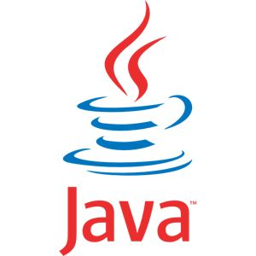

**JAVA Programming Language**

Java is a programming language originally developed by James Gosling at Sun Microsystems (which has since merged into Oracle Corporation) and released in 1995 as a core component of Sun Microsystem’s Java platform. The language derives much of its syntax from C and C++, but it has fewer low-level facilities than either of them. Java applications are typically compiled to bytecode (class file) that can run on any Java virtual machine (JVM) regardless of computer architecture. Java is a general-purpose, concurrent, class-based, object-oriented language that is specifically designed to have as few implementation dependencies as possible. It is intended to let application developers "write once, run anywhere" (WORA), meaning that code that runs on one platform does not need to be recompiled to run on another. Java is as of 2012 one of the most popular programming languages in use, particularly for client-server web applications, with a reported 10 million users.

**Advantages of JAVA**

JAVA offers a number of advantages to developers.

* **Java is simple**: Java was designed to be easy to use and is therefore easy to write, compile, debug, and learn than other programming languages. The reason that why Java is much simpler than C++ is because Java uses automatic memory allocation and garbage collection where else C++ requires the programmer to allocate memory and to collect garbage.
* **Java is object-oriented**: Java is object-oriented because programming in Java is centered on creating objects, manipulating objects, and making objects work together. This allows creation of modular programs and reusable code.
* **Java is platform-independent**: One of the most significant advantages of Java is its ability to move easily from one computer system to another.

The ability to run the same program on many different systems is crucial to World Wide Web software, and Java succeeds at this by being platform-independent at both the source and binary levels.

* **Java is distributed**: Distributed computing involves several computers on a network working together. Java is designed to make distributed computing easy with the networking capability that is inherently integrated into it.
* **Java is interpreted**: An interpreter is needed in order to run Java programs. The programs are compiled into Java Virtual Machine code called bytecode.

The bytecode is machine independent and is able to run on any machine that has a Java interpreter. With Java, the program need only be compiled once, and the bytecode generated by the Java compiler can run on any platform.

* **Java is secure**: Java is one of the first programming languages to consider security as part of its design. The Java language, compiler, interpreter, and runtime environment were each developed with security in mind.
* **Java is robust**: Robust means reliable and no programming language can really assure reliability. Java puts a lot of emphasis on early checking for possible errors, as Java compilers are able to detect many problems that would first show up during execution time in other languages.
* **Java is multithreaded**: Multithreaded is the capability for a program to perform several tasks simultaneously within a program. In Java, multithreaded programming has been smoothly integrated into it, while in other languages, operating system-specific procedures have to be called in order to enable multithreading. Multithreading is a necessity in visual and network programming.



**NETBEANS**

NetBeans refers to both a platform framework for Java desktop applications and an integrated development environment (IDE) for developing with Java, JavaScript, PHP, Python (no longer supported after NetBeans 7), Groovy, C , C++ , Scala , Clojureand others. The NetBeans IDE 7.0 no longer officially supports Ruby and Ruby on Rails, but a third party plug-in allows for development.TheNetBeans IDE is written in Java and can run on Windows, OS X, Linux, Solaris and other platforms supporting a compatible JVM. A pre-existing JVM or a JDK is not required.

Using NetBeans it is easy to make and use the java server pages (JSP) and design a form for user interface. This software is support every language which is used for designing a software or a webpage. NetBeans have its own server which are used locally some example like tomcat, apache, glashfish etc. NetBeans gives its own local environment for running a project.

**4.2 Back End**

**Introduction of SQL SERVER**

SQL (Structured Query Language) is a database sublanguage for querying and modifying relational databases. It was developed by IBM Research in the mid 70's and standardized by ANSI in 1986.

The Relational Model defines two *root* languages for accessing a relational database -- Relational Algebra and Relational Calculus. Relational Algebra is a low-level, operator-oriented language. Creating a query in Relational Algebra involves combining relational operators using algebraic notation. Relational Calculus is a high-level, declarative language. Creating a query in Relational Calculus involves describing what results are desired.

SQL is a version of Relational Calculus. The basic structure in SQL is the *statement*. Semicolons separate multiple SQL statements.

There are 3 basic categories of SQL Statements:

SELECT * is inefficient, particularly when you are only using a few of the columns in the table. This is because it actually makes TWO queries to the database: before it runs your query, it has to query the system tables to determine the name and datatypes of the columns. It is much more efficient to NAME your columns in the SQL query, and this will also help in having your column names right there… so you don’t have to keep flipping back and forth between ASP page and database. In addition, this will prevent ambiguous column names in your resultset (in the case where both or all tables in the JOIN statement have columns with the same name). Further still, your code can break if it relies on ordinal position, and then someone inserts a column at the top of the table (which you can do in Enterprise Manager, or by dropping / re-creating the table). This is also a strong case for always defining columns in the INSERT list.

And finally, here’s another reason to avoid SELECT * : Memo/Text columns, as well as columns containing BLOB data. Microsoft recommends to put BLOB/text columns at the end of the SELECT statement, and if there is more than one, in order of appearance in the table. This is also applicable to VARCHAR columns in SQL Server with a length greater than 255 characters.

**Relational Database Enhancements**

Microsoft® SQL Server™ 2000 introduces several server improvements and new features:

[**Federated Database Servers**](mk:@MSITStore:D:\Program%20Files\Microsoft%20SQL%20Server\80\Tools\Books\whatsnew.chm::/wn_whatnew_6a2b.htm##)

SQL Server 2000 supports enhancements to distributed partitioned views that allow you to partition tables horizontally across multiple servers. This allows you to scale out one database server to a group of database servers that cooperate to provide the same performance levels as a cluster of database servers. This group, or federation, of database servers can support the data storage requirements of the largest Web sites and enterprise data processing systems.

[**User-Defined Functions**](mk:@MSITStore:D:\Program%20Files\Microsoft%20SQL%20Server\80\Tools\Books\whatsnew.chm::/wn_whatnew_6a2b.htm##)

The programmability of Transact-SQL can be extended by creating your own Transact-SQL functions. A user-defined function can return either a scalar value or a table.

[**Indexed Views**](mk:@MSITStore:D:\Program%20Files\Microsoft%20SQL%20Server\80\Tools\Books\whatsnew.chm::/wn_whatnew_6a2b.htm##)

Indexed views can significantly improve the performance of an application where queries frequently perform certain joins or aggregations. An indexed view allows indexes to be created on views, where the result set of the view is stored and indexed in the database. Existing applications do not need to be modified to take advantage of the performance improvements with indexed views.

[**Text in Row Data**](mk:@MSITStore:D:\Program%20Files\Microsoft%20SQL%20Server\80\Tools\Books\whatsnew.chm::/wn_whatnew_6a2b.htm##)

SQL Server 2000 supports a new text in row table option that specifies that small text, ntext, and image values be placed directly in the data row instead of in a separate page. This reduces the amount of space used to store small text, ntext, and image data values, and reduces the amount of disk I/O needed to process these values.

**CHAPTER 5**

**SYSTEM DESIGN**

**5.1 Module Description**

In the home page we have five modules namely:-

* LOGIN
* BOOK
* ISSUE
* USERS
* DASHBOARD (after login)

In all these modules the user can navigate to each individual module through just a single click. According to its selection the user now switch to a module and access the details of colleges and all the informations related to that particular module.

**Module 1: LOGIN**

**What is login all about?**

This sheet keeps a record of student, teacher, librarian, admin credentials. It includes Id and password for the authenticated user.It includes student id, student password, teacher id, teacher password, librarian id, librarian password, admin id, admin password.This is the most important and secure module in this whole project.No one can use any other user details.

**Module 2: BOOK**

**What is Book all about?**

This sheet stores all the relevant information about the books which includes Book ID, Title, Author, Publisher, Category, Year, ISBN, Edition, Date Purchased, Price and Shelf No.

Book ID is automatically generated whenever a new book is entered. It is based on last two digits of year, last two digits of ISBN and the last four digits assign a number starting from 1 based on the order entering the books into system.

**Module 3: ISSUE**

**What is Issue all about?**

This sheet has a record of all the books issued since the system was implemented. It includes Issue Code, Book ID, Student ID, Category, Issue Date, Due Date and Class.

Issue code is VBA generated field which is used to identify which book has been issued by which student at which date. It last two digits of BookID, last two digits of StudentID and excel date code of issue date. Same student may issue one book more than once. This would create a problem in calculating how much fine to charge. To overcome this problem, date code of issue date has been added to issue code to make each issue code unique. This will be used in vlookup to calculate fines when return date exceeds due date. Due date is within two weeks of issue date.

**Module 4: USERS**

**What is users all about?**

The staff table shows brief details of students teachers by the library. It includes name of studentand teacher, ID's, address. The system requires the person receiving books to mention his/her name.

**Module 5: DASHBOARD(After Login)**

**What is dashboard all about?**

When user logged in with their secured credentials after validation of credentials user can see their home page. And after that they can perform many features. Do request for book issue, able to see past history of issued books, return request of issued book, and most important feature is to search book which is available in library.

**5.2 System Flowchart**



**Figure 5.2System Flowchart**

**5.3 E-R Diagrams**

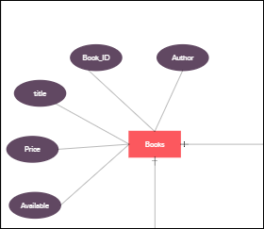

Figure: 5.3.1

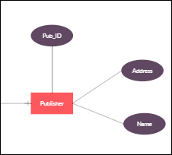

Figure: 5.3.2

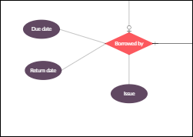

Figure: 5.3.3

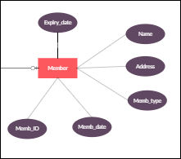

Figure: 5.3.4

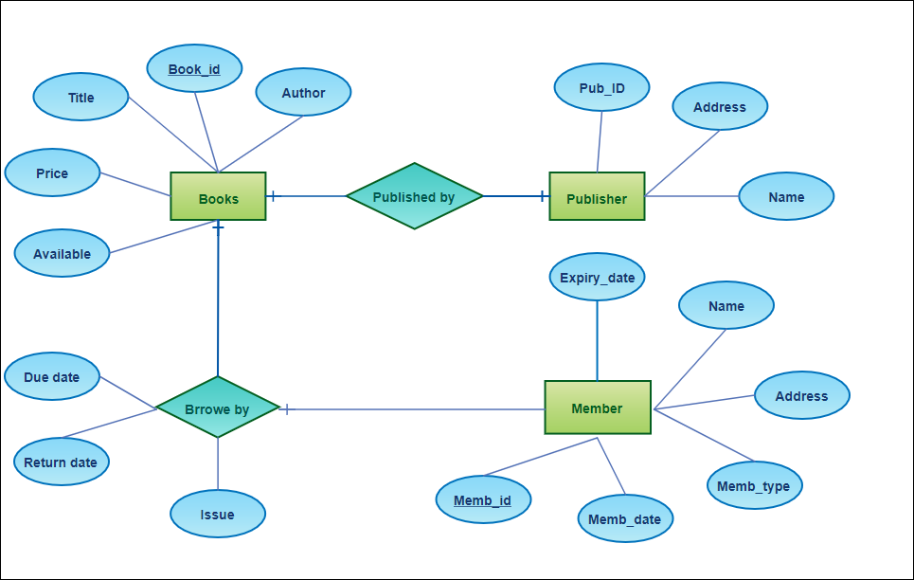

Figure: 5.3.5

**5.4 Data Flow Daigram**

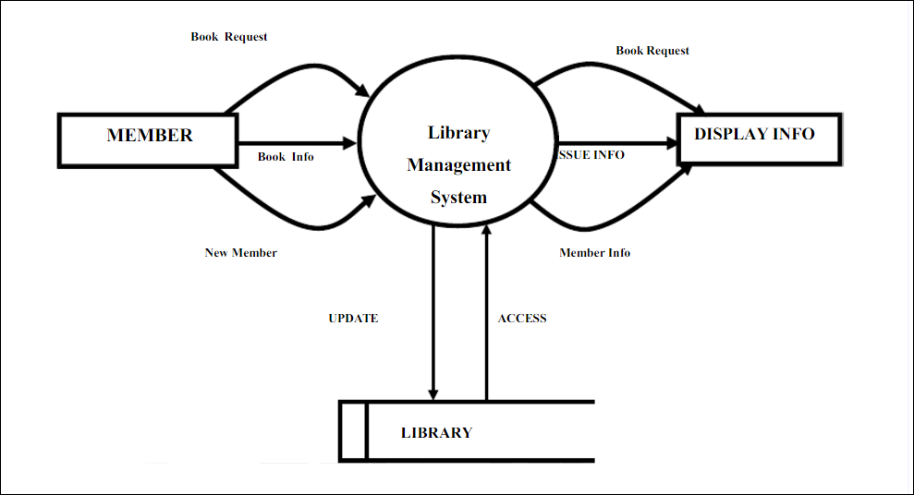

**Figure 1**

**0 Level DFD**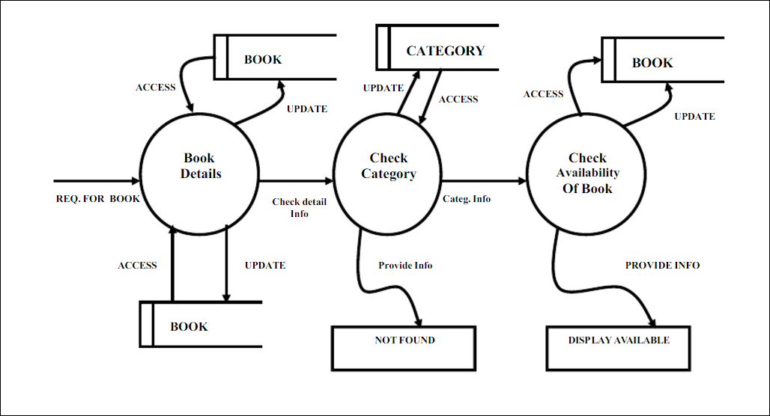

**Figure 2**

**1 Level DFD**

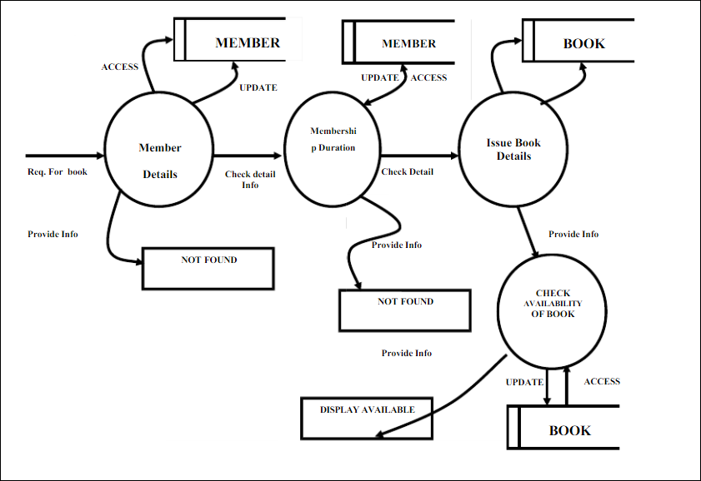

**Figure 3**

**2 Level DFD**

**5.5 Database Design (tabular structure)**

* Book table for keeping track of books

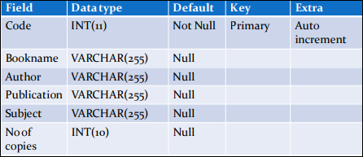

* Student table for student information

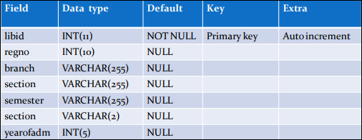

* Teacher table to keep teacher information

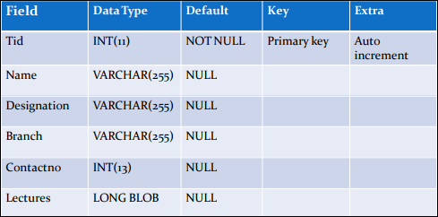

* Issue table to keep track of books issued

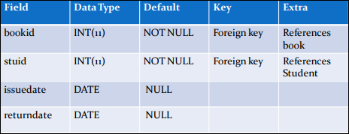

* Student login table

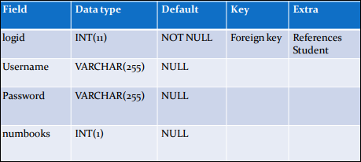

* Teacher login table

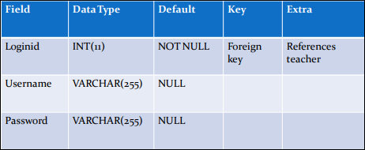

**CHAPTER 6**

**SYSTEM TESTING**

The purpose of testing is to discover errors. Testing is the process of trying to discover every conceivable fault or weakness in a work product. It provides a way to check the functionality of components, sub-assemblies, assemblies and/or a finished product. It is the process of exercising software with the intent of ensuring that the Software system meets its requirements and user expectations and does not fail in an unacceptable manner. There are various types of test. Each test type addresses a specific testing requirement.

**6.1 TYPES OF TESTS**

**Unit testing**

Unit testing involves the design of test cases that validate that the internal program logic is functioning properly, and that program input produce valid outputs. All decision branches and internal code flow should be validated. It is the testing of individual software units of the application .it is done after the completion of an individual unit before integration. This is a structural testing, that relies on knowledge of its construction and is invasive. Unit tests perform basic tests at component level and test a specific business process, application, and/or system configuration. Unit tests ensure that each unique path of a business process performs accurately to the documented specifications and contains clearly defined inputs and expected results.

**Integration testing**

Integration tests are designed to test integrated software components to determine if they actually run as one program. Testing is event driven and is more concerned with the basic outcome of screens or fields. Integration tests demonstrate that although the components were individually satisfaction, as shown by successfully unit testing, the combination of components is correct and consistent. Integration testing is specifically aimed at exposing the problems that arise from the combination of components.

**Functional test**

Functional tests provide a systematic demonstration that functions tested are available as specified by the business and technical requirements, system documentation, and user manuals.

**System Test**

System testing ensures that the entire integrated software system meets requirements. It tests a configuration to ensure known and predictable results. An example of system testing is the configuration oriented system integration test. System testing is based on process descriptions and flows, emphasizing pre-driven process links and integration points.

**White Box Testing**

White Box Testing is a testing in which in which the software tester has knowledge of the inner workings, structure and language of the software, or at least its purpose. It is used to test areas that cannot be reached from a black box level.

**Black Box Testing**

Black Box Testing is testing the software without any knowledge of the inner workings, structure or language of the module being tested. Black box tests, as most other kinds of tests, must be written from a definitive source document, such as specification or requirements document, such as specification or requirements document. It is a testing in which the software under test is treated, as a black box, you cannot “see” into it. The test provides inputs and responds to outputs without considering how the software works.

**6.2 Unit Testing**

Unit testing is usually conducted as part of a combined code and unit test phase of the software lifecycle, although it is not uncommon for coding and unit testing to be conducted as two distinct phases.

**Test objectives**

* All field entries must work properly.
* Pages must be activated from the identified link.
* The entry screen, messages and responses must not be delayed.

**Features to be tested**

* Verify that the entries are of the correct format
* No duplicate entries should be allowed
* All links should take the user to the correct page.

**6.3 Integration Testing**

Software integration testing is the incremental integration testing of two or more integrated software components on a single platform to produce failures caused by interface defects.

The task of the integration test is to check that components or software applications, e.g. components in a software system or – one step up – software applications at the company level – interact without error.

**6.4 Acceptance Testing**

User Acceptance Testing is a critical phase of any project and requires significant participation by the end user. It also ensures that the system meets the functional requirements.

All the above testing are applied on project”Education Hub” and has no error found runs perfectly.

**CHAPTER 7**

**SYSTEM SECURITY**

Security risks are greater with advanced websites.Gone are the days when websites consisted of simple pages. People now expect a dynamic and interactive online experience but all this comes with a number of potential security issues. So we need to check, control and encrypt our data over online to protect from malware, viruses and threats.

**Handle errors gracefully.**

When a web developer builds a website, they often need to view detailed error messages to work out why things aren’t working as planned.

This is fine on your private development server, but allowing these detailed messages to be displayed on your live website can be a huge security risk. They could give away important information that an attacker could use to break in to your web server.

We make sure tidy up all error messages before launch our site. Any errors that may appear should mean something to the people using our website, without giving away any sensitive information. So we maintain these tidy things gracefully.

**Use a Secure Connection for Transfering Data**

Most people know that when a ‘golden padlock’ appears in their web browser, it indicates that the connection is secure. The secure padlock is generated by a secure sockets layer (SSL) certificate, which you have to install on the server hosting your website. It ensures all traffic sent between your web server and a user’s computer is encrypted to prevent malicious eavesdroppers from reading any sensitive information.

Failure to use SSL could leave us vulnerable to attack and could mean us to lose customers due to a lack of trust. People visiting our website over a free wireless network connection are a particular problem - it could be possible for the information being sent across our network to be read. So for security aspect we use a secure connection over web.

**No Injection**

Most websites (except very basic ones) have a database at their core containing information about the site, such as its content or details of registered users.

‘SQL injection’ is a method used by attackers to add extra code to a database query. This can allow the attacker to access parts of the database you never intended them to see, and thereby compromise our website. SQL injection can happen when the server hosting our website doesn’t properly check information that is passed to it from the outside world.

Guard against this is done in our project is by using ‘prepared statements’, to separate the data users enter from the actual structure of our database query.

On that note, we don’t give attackers an easy ride if they do manage to view other fields in our database. For example, we never store user passwords in plain text – instead, make sure they are stored as a one way ‘salted hash’.

**Login Page Security**

To protect data entery by the third person whether it is user or hacker instead from deelopers, we create a login form. The user needs to fill the login and password field to get the access of our website. So without these two filed the user cannot do anything over our website. This security gateway also protects our databae from unwanted access over the server.

**Conclusions**

The aim of this project i.e. Library Management System provides a computerized version of library management system which will benefit the students as well as the staff of the library. It makes entire process system where student can search books, staff can generate reports and do book transactions. It also has a facility for student login where student can login and can see status of books issued as well request for book or give some suggestions. It has a facility of teacher’s login where teachers can give request to issue book and see status of issued book. Librarian can accept student or teacher book issue request as per their wish. Admin can add or delete student, teacher, and librarian anytime. Admin have all access to get anyone details anytime but no other member can access all details of anyone because of high security. Student and teacher can just request for book only. Librarian accepts their request and issue book for them.

**Future Scope**

This application can be easily implemented under various situations. We can add new features as and when we require. Reusability is possible as and when require in this application. There is flexibility in all the modules.

**SOFTWARE SCOPE**:

* **Extensibility**: This software is extendable in ways that its original developers may not expect. The following principle enhances extensibility like hide data structure, avoid traversing multiple links or methods, avoid case statements on object type and distinguish public and private operations.
* **Reusability**: Reusability is possible as and when require in this application. We can update it next version. Reusable software reduces design, coding and testing cost by amortizing effort over several designs. Reducing the amount of code also simplifies understanding, which increases the likelihood that the code is correct.We follow up both types of reusability: Sharing of newly written code within a project and reuse of previously written code on new projects. Online Library Management System 23
* **Understandability**: A method is understandable if someone other than the creator of the method can understand the code (as well as the creator after a time lapse). We use the method, which small and coherent helps to accomplish this.
* **Cost-effectiveness**: Its cost is under the budget and make within given time period. It is desirable to aim for a system with a minimum cost subject to the condition that it must satisfy the entire requirement. Scope of this document is to put down the requirements, clearly identifying the information needed by the user, the source of the information and outputs expected from the system.

**Limitations**

The limitation in our web project “Library Management System” are as follows:

* This is not a online website
* The student’s cannot issue their books itself
* The teacher’s cannot issue their books itself
* The website right now dosen’t allow the user to create there account itself beacause of protection.
* The user also canot find a search button through which they can search out any other student or teacher’s book issue status.
* The user can’t search anyone’s details.
* Librarians also have not all rights to add any student or teacher.
* Only admin can add any one in this system.

**BIBLIOGRAPHY**

* Patrick Naughton, Herbert Schildt, “java-2 complete reference 5th edition” 12 April, 150-175.
* Jason Hunter, William Crawford, “Java Servlet Programming 2nd edition”, O’Reilly Media, April 2001.
* Cedric Buest, “Java Server Programming: J2EE 1.3 Edition”, Apress Publication.
* Ivan Bayross, “HTML 4.0 Completes”, BPB Publications, 2000.
* http://www.javatpoint.com/jsp-tutorial
* http://www.servlets.com/jservlet2/examples/ch09/index.html
* http://Publib.boulder.ibm.com/db2luw/v8/index.jsp?topic=/com.ibm.db2.udb.doc
* http://www.oracle.com/technetwork/java/javaee/jsp/index.html
* http://www.tutorialspoint.com/jsp/index.htm
* http://www.w3schools.com/css/css_intro.asp