Top of Form

[**Marketplace**](https://github.com/marketplace)

[**Explore**](https://github.com/explore)

Top of Form

Bottom of Form

**1: Synopsis**

The goal of the assignment is to explore the NOAA Storm Database and explore the effects of severe weather events on both population and economy.The database covers the time period between 1950 and November 2011.

The following analysis investigates which types of severe weather events are most harmful on:

1. Health (injuries and fatalities)
2. Property and crops (economic consequences)

Information on the Data: [Documentation](https://d396qusza40orc.cloudfront.net/repdata%2Fpeer2_doc%2Fpd01016005curr.pdf)

**2: Data Processing**

**2.1: Data Loading**

Download the raw data file and extract the data into a dataframe.Then convert to a data.table

library("data.table")

library("ggplot2")

fileUrl <- "https://d396qusza40orc.cloudfront.net/repdata%2Fdata%2FStormData.csv.bz2"

download.file(fileUrl, destfile = paste0("/Users/mgalarny/Desktop", '/repdata%2Fdata%2FStormData.csv.bz2'))

stormDF <- read.csv("/Users/mgalarny/Desktop/repdata%2Fdata%2FStormData.csv.bz2")

# Converting data.frame to data.table

stormDT <- as.data.table(stormDF)

**2.2: Examining Column Names**

colnames(stormDT)

## [1] "STATE__" "BGN_DATE" "BGN_TIME" "TIME_ZONE" "COUNTY"

## [6] "COUNTYNAME" "STATE" "EVTYPE" "BGN_RANGE" "BGN_AZI"

## [11] "BGN_LOCATI" "END_DATE" "END_TIME" "COUNTY_END" "COUNTYENDN"

## [16] "END_RANGE" "END_AZI" "END_LOCATI" "LENGTH" "WIDTH"

## [21] "F" "MAG" "FATALITIES" "INJURIES" "PROPDMG"

## [26] "PROPDMGEXP" "CROPDMG" "CROPDMGEXP" "WFO" "STATEOFFIC"

## [31] "ZONENAMES" "LATITUDE" "LONGITUDE" "LATITUDE_E" "LONGITUDE_"

## [36] "REMARKS" "REFNUM"

**2.3: Data Subsetting**

Subset the dataset on the parameters of interest. Basically, we remove the columns we don't need for clarity.

# Finding columns to remove

cols2Remove <- colnames(stormDT[, !c("EVTYPE"

, "FATALITIES"

, "INJURIES"

, "PROPDMG"

, "PROPDMGEXP"

, "CROPDMG"

, "CROPDMGEXP")])

# Removing columns

stormDT[, c(cols2Remove) := NULL]

# Only use data where fatalities or injuries occurred.

stormDT <- stormDT[(EVTYPE != "?" &

(INJURIES > 0 | FATALITIES > 0 | PROPDMG > 0 | CROPDMG > 0)), c("EVTYPE"

, "FATALITIES"

, "INJURIES"

, "PROPDMG"

, "PROPDMGEXP"

, "CROPDMG"

, "CROPDMGEXP") ]

**2.4: Converting Exponent Columns into Actual Exponents instead of (-,+, H, K, etc)**

Making the PROPDMGEXP and CROPDMGEXP columns cleaner so they can be used to calculate property and crop cost.

# Change all damage exponents to uppercase.

cols <- c("PROPDMGEXP", "CROPDMGEXP")

stormDT[, (cols) := c(lapply(.SD, toupper)), .SDcols = cols]

# Map property damage alphanumeric exponents to numeric values.

propDmgKey <- c("\"\"" = 10^0,

"-" = 10^0,

"+" = 10^0,

"0" = 10^0,

"1" = 10^1,

"2" = 10^2,

"3" = 10^3,

"4" = 10^4,

"5" = 10^5,

"6" = 10^6,

"7" = 10^7,

"8" = 10^8,

"9" = 10^9,

"H" = 10^2,

"K" = 10^3,

"M" = 10^6,

"B" = 10^9)

# Map crop damage alphanumeric exponents to numeric values

cropDmgKey <- c("\"\"" = 10^0,

"?" = 10^0,

"0" = 10^0,

"K" = 10^3,

"M" = 10^6,

"B" = 10^9)

stormDT[, PROPDMGEXP := propDmgKey[as.character(stormDT[,PROPDMGEXP])]]

stormDT[is.na(PROPDMGEXP), PROPDMGEXP := 10^0 ]

stormDT[, CROPDMGEXP := cropDmgKey[as.character(stormDT[,CROPDMGEXP])] ]

stormDT[is.na(CROPDMGEXP), CROPDMGEXP := 10^0 ]

**2.5: Making Economic Cost Columns**

stormDT <- stormDT[, .(EVTYPE, FATALITIES, INJURIES, PROPDMG, PROPDMGEXP, propCost = PROPDMG * PROPDMGEXP, CROPDMG, CROPDMGEXP, cropCost = CROPDMG * CROPDMGEXP)]

**2.6: Calcuating Total Property and Crop Cost**

totalCostDT <- stormDT[, .(propCost = sum(propCost), cropCost = sum(cropCost), Total_Cost = sum(propCost) + sum(cropCost)), by = .(EVTYPE)]

totalCostDT <- totalCostDT[order(-Total_Cost), ]

totalCostDT <- totalCostDT[1:10, ]

head(totalCostDT, 5)

## EVTYPE propCost cropCost Total_Cost

## 1: FLOOD 144657709807 5661968450 150319678257

## 2: HURRICANE/TYPHOON 69305840000 2607872800 71913712800

## 3: TORNADO 56947380676 414953270 57362333946

## 4: STORM SURGE 43323536000 5000 43323541000

## 5: HAIL 15735267513 3025954473 18761221986

**2.7: Calcuating Total Fatalities and Injuries**

totalInjuriesDT <- stormDT[, .(FATALITIES = sum(FATALITIES), INJURIES = sum(INJURIES), totals = sum(FATALITIES) + sum(INJURIES)), by = .(EVTYPE)]

totalInjuriesDT <- totalInjuriesDT[order(-FATALITIES), ]

totalInjuriesDT <- totalInjuriesDT[1:10, ]

head(totalInjuriesDT, 5)

## EVTYPE FATALITIES INJURIES totals

## 1: TORNADO 5633 91346 96979

## 2: EXCESSIVE HEAT 1903 6525 8428

## 3: FLASH FLOOD 978 1777 2755

## 4: HEAT 937 2100 3037

## 5: LIGHTNING 816 5230 6046

**3: Results**

**3.1: Events that are Most Harmful to Population Health**

Melting data.table so that it is easier to put in bar graph format

bad_stuff <- melt(totalInjuriesDT, id.vars="EVTYPE", variable.name = "bad_thing")

head(bad_stuff, 5)

## EVTYPE bad_thing value

## 1: TORNADO FATALITIES 5633

## 2: EXCESSIVE HEAT FATALITIES 1903

## 3: FLASH FLOOD FATALITIES 978

## 4: HEAT FATALITIES 937

## 5: LIGHTNING FATALITIES 816

# Create chart

healthChart <- ggplot(bad_stuff, aes(x=reorder(EVTYPE, -value), y=value))

# Plot data as bar chart

healthChart = healthChart + geom_bar(stat="identity", aes(fill=bad_thing), position="dodge")

# Format y-axis scale and set y-axis label

healthChart = healthChart + ylab("Frequency Count")

# Set x-axis label

healthChart = healthChart + xlab("Event Type")

# Rotate x-axis tick labels

healthChart = healthChart + theme(axis.text.x = element_text(angle=45, hjust=1))

# Set chart title and center it

healthChart = healthChart + ggtitle("Top 10 US Killers") + theme(plot.title = element_text(hjust = 0.5))

healthChart

[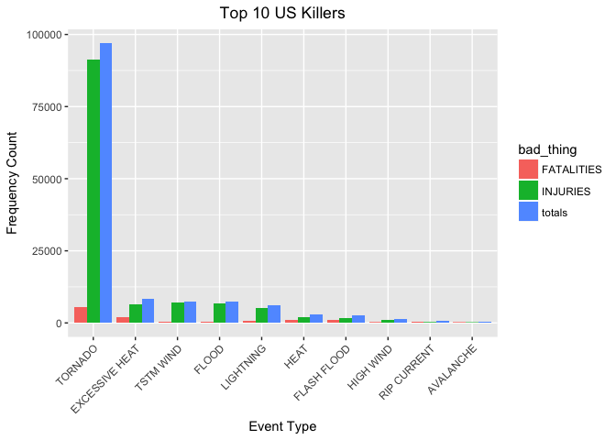](https://github.com/mGalarnyk/datasciencecoursera/blob/master/5_Reproducible_Research/project2/ReproducibleResearchProject2_files/figure-markdown_github/healthChart-1.png)

**3.2: Events that have the Greatest Economic Consequences**

Melting data.table so that it is easier to put in bar graph format

econ_consequences <- melt(totalCostDT, id.vars="EVTYPE", variable.name = "Damage_Type")

head(econ_consequences, 5)

## EVTYPE Damage_Type value

## 1: FLOOD propCost 144657709807

## 2: HURRICANE/TYPHOON propCost 69305840000

## 3: TORNADO propCost 56947380676

## 4: STORM SURGE propCost 43323536000

## 5: HAIL propCost 15735267513

# Create chart

econChart <- ggplot(econ_consequences, aes(x=reorder(EVTYPE, -value), y=value))

# Plot data as bar chart

econChart = econChart + geom_bar(stat="identity", aes(fill=Damage_Type), position="dodge")

# Format y-axis scale and set y-axis label

econChart = econChart + ylab("Cost (dollars)")

# Set x-axis label

econChart = econChart + xlab("Event Type")

# Rotate x-axis tick labels

econChart = econChart + theme(axis.text.x = element_text(angle=45, hjust=1))

# Set chart title and center it

econChart = econChart + ggtitle("Top 10 US Storm Events causing Economic Consequences") + theme(plot.title = element_text(hjust = 0.5))

econChart

[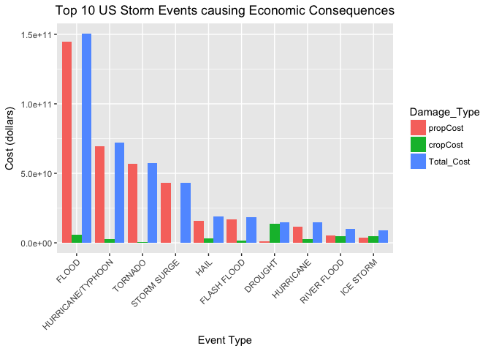](https://github.com/mGalarnyk/datasciencecoursera/blob/master/5_Reproducible_Research/project2/ReproducibleResearchProject2_files/figure-markdown_github/econChart-1.png)

* © 2020 GitHub, Inc.
* [Terms](https://github.com/site/terms)
* [Privacy](https://github.com/site/privacy)
* [Security](https://github.com/security)
* [Status](https://githubstatus.com/)
* [Help](https://help.github.com/)
* [Contact GitHub](https://github.com/contact)
* [Pricing](https://github.com/pricing)
* [API](https://developer.github.com/)
* [Training](https://training.github.com/)
* [Blog](https://github.blog/)
* [About](https://github.com/about)