#ex7 create a basic Django project and run It

Steps:

Step1:

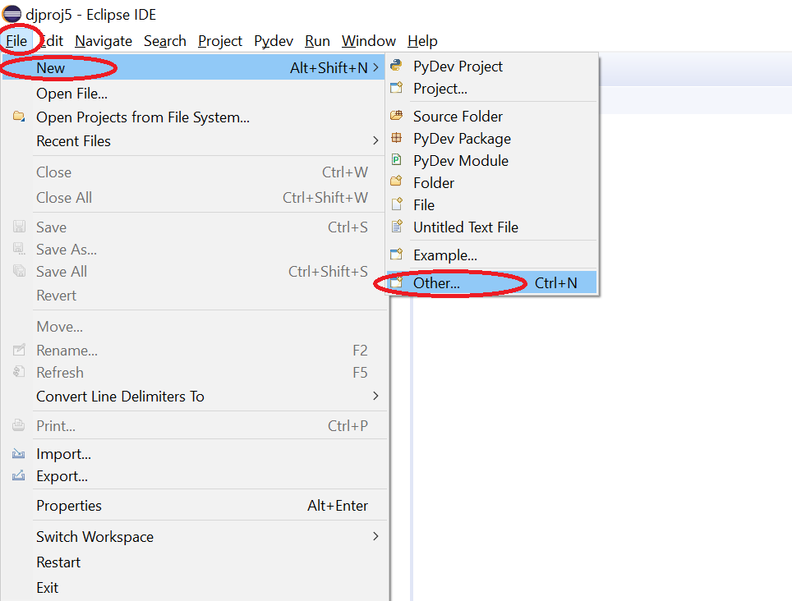

Step 2:

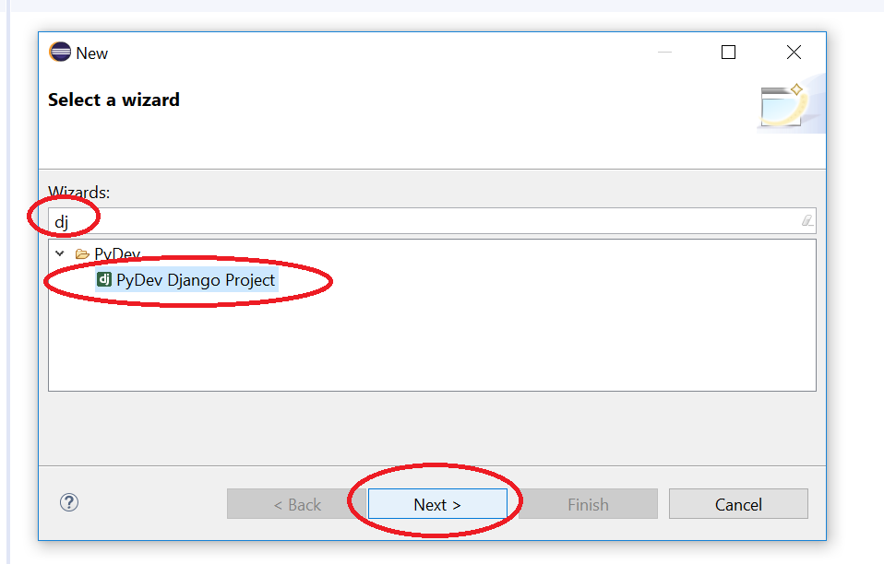

Step 3:

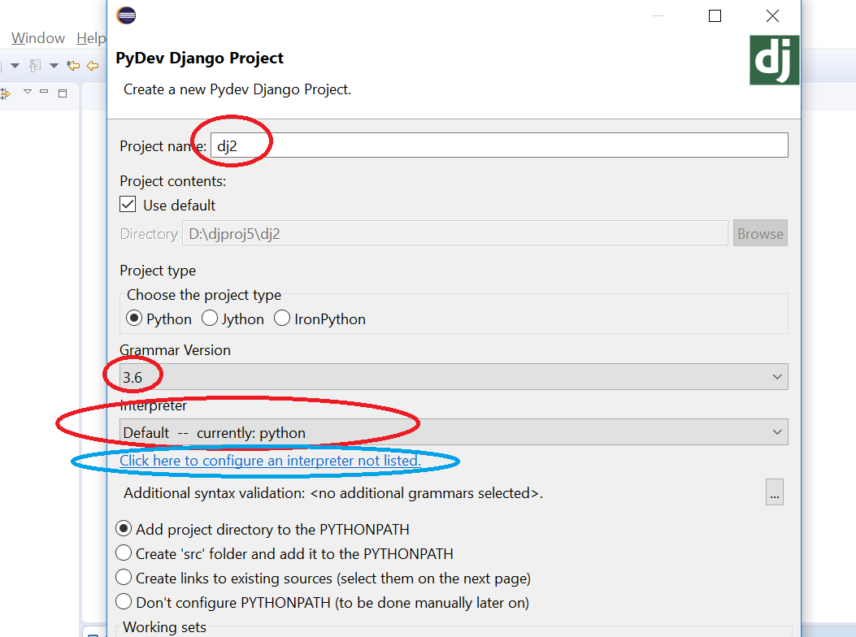

Step 4:

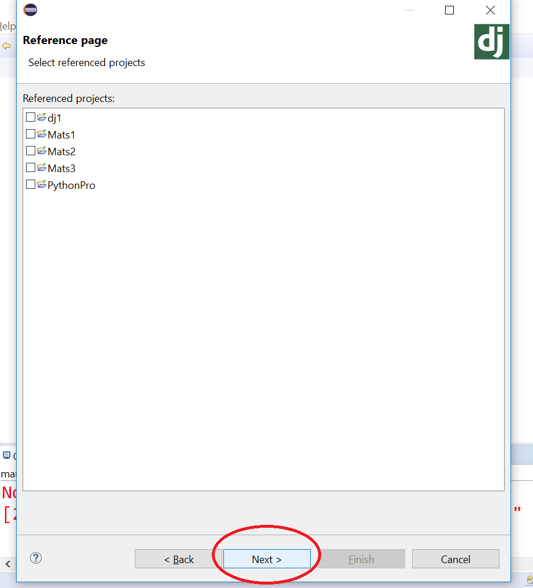

Step 5:

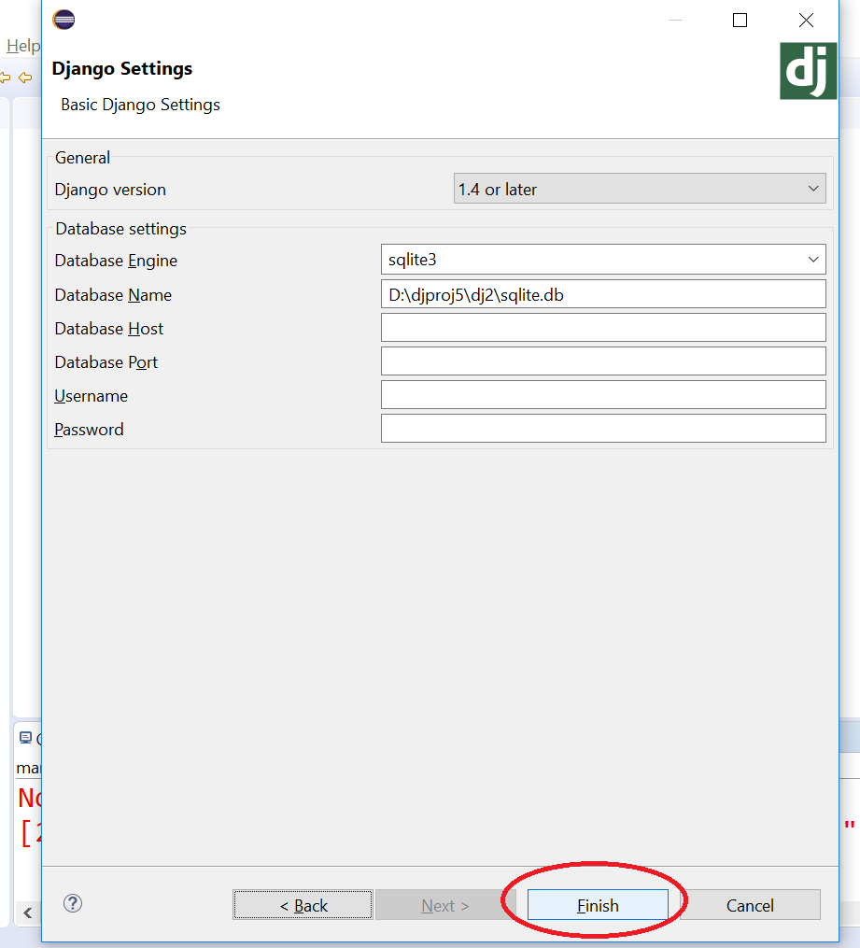

Step 6:

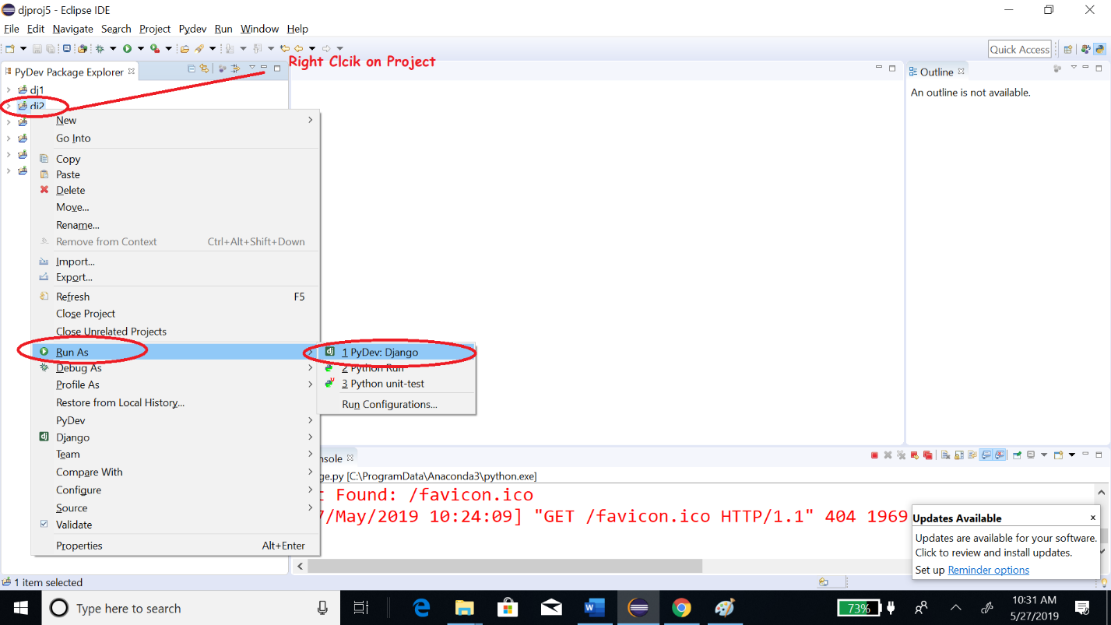

Step 7:

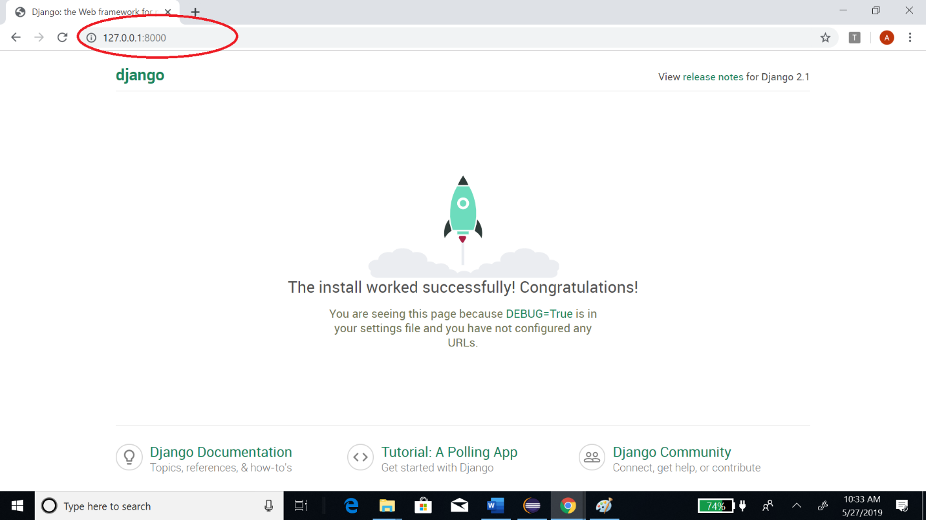

#ex8 create a Django project with a page index.html with its url mapping etc:

Steps as project no 7:

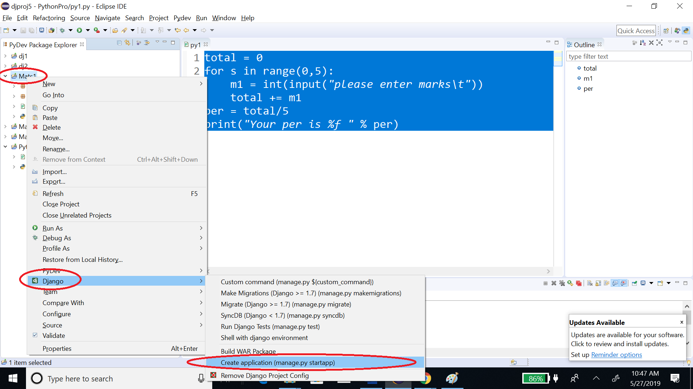

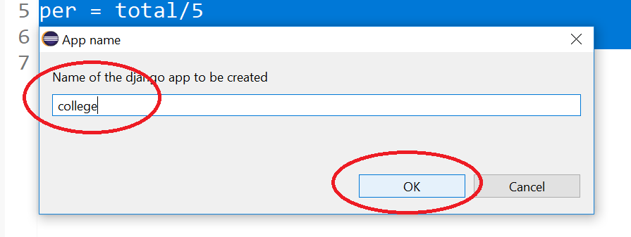

Go to project settings.py add your new module say ‘college’:

INSTALLED_APPS = [

'django.contrib.admin',

'django.contrib.auth',

'django.contrib.contenttypes',

'django.contrib.sessions',

'django.contrib.messages',

'django.contrib.staticfiles',

'college',

]

Go to urls.py in the main folder and write following:

from django.contrib import admin

from django.urls import path

from django.urls.conf import include

urlpatterns = [

path('college/', include('college.urls')),

path('admin/', admin.site.urls),

]

Create a urls.py inside college app (college is your app/module name) and write following:

from django.contrib import admin

from django.urls import path

from college import views

urlpatterns = [

path('home/', views.home),

]

Go to module views.py and add following:

def home(req):

return render(req, "index.html", {"name": "EFFCON"})

Create index.html:

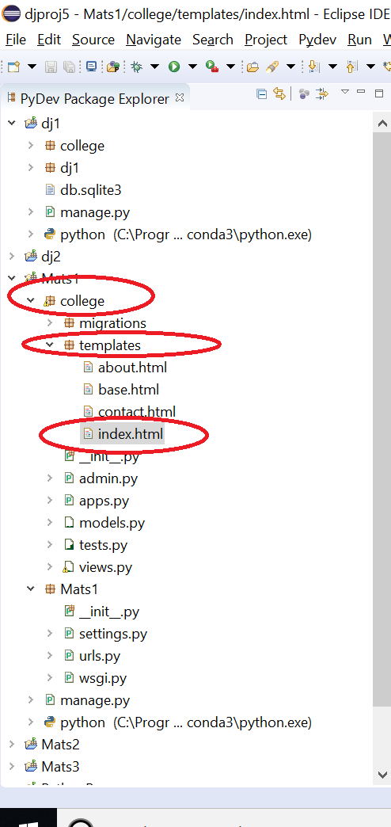

Inside index.html:

<h1>Welcome to {{name}}!!</h1>

