**Task1**

1)Create a folder for this task (cs6314/task1)

2)With the initial web page provided (of the course offering listing), your task is to add javascript program(s) to the web page to do the following:

Initial Web Page provided:

3) design database & table for course (offering) to be used for the following subtasks.

4) to extract all the course information using javascript (task1.html and task1.js)

-coursebook2025.html has been renamed to course.html

- In course.html have added the below code

-The button is added as follows to extract and download the course info in sql format.

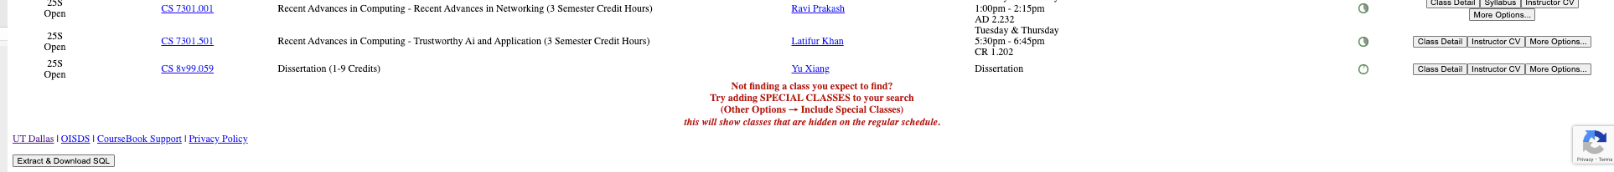

-task1.js contains 2 functions  
 a) extractCourses() : This function handles the extraction of course data from the webpage and initiates the SQL file download:

b) downloadSQLFile(sqlData): This function is responsible for creating and downloading an SQL file

5) to write each course information of (1) in sql format to a file (task1.sql)

-task1.sql file is generated in the downloads folder

Code: task1.js to download the task1.sql file

Downloads folder:

6) with two new fields for each course: time created and time updated, and using this sql table

Code for creating the table course1 with the column headers:

Code for inserting the course info into the sql variable:

7) then to create sql table (course1) via Xampp database with sql statement (task1.sql)

-Create a university_courses database

-go to Import tab inside the university_courses database, choose the task1.sql file and click on Import.

-We can see the course1 table getting generated

8) after the table is done, export the table in various formats (see below)

Save the initial sql statements in a file (task1.sql) and after loading the table, the table will be exported and saved in a file (in cs6314/task1/filename where the filename is specified below):

(a) to save all the course information (SQL document) in a file (task1out.sql)

(b) to save all the course information (XML document) in a file (taskout.xml)

(c) to save all the course information (PHP array) in a file (task1out.php)

(d) to save all the course information (JASON document) in a file (task1out.jason)

-Go to the PhpMyAdmin->university_courses->course1->Export->Custom option

-Under format there are many options available choose SQL, XML, JASON and PHP and save it as task1out.xml, task1out.sql, task1out.php, task1out.json,

9)Final output of file Structure

