**Task 2**

1)For testcase setup, provide a few buttons with a few javascript functions, respectively, to add, to delete, or to update a test case (versus manual add, delete, or update).

-task2.php : Buttons to add, update and delete courses into the database

-task2.php :

-Manually add, update and delete course on the web page:

-Task2.php : Buttons to execute the testcases

-Task2.js : Contains these functions mentioned below

-Testcase buttons as seen on the web page:

2)Once the program runs, it will show all the courses (from sql table via php).

-task2.php: Code to display the courses on the web page

-Snippet of the web page on how the course info is displayed

3)Save this initial web page (source) in a file (task2out.html).

5)Testcase Execution:

-After each test case, save the resulting web pages (in cs6314/task2/filename where the filename is specified below):

a. to save each web page in a file after each test case (test1out.html for test1, test2out.html for test2, …)

Testcases:  
1) Add testcase 1

Adding a new course CS6314:



2)Add testcase 2:

Adding a new course with ID CS6363



3)Add testcase 3:

Adding a new course with ID CS6360

4)Update Testcase 1:

Update the course title to 'Web Programming Language' from 'Web Programming'

Before:

After:



5)Update Testcase 2:

Update the course title to 'Design and Analysis of Algorithms' from 'Algorithms'

Before:

After:

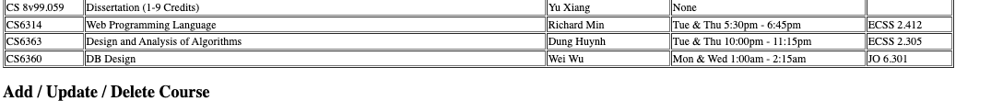

6)Update Testcase 3:

Update the location to 2.416 from 2.412

Before:

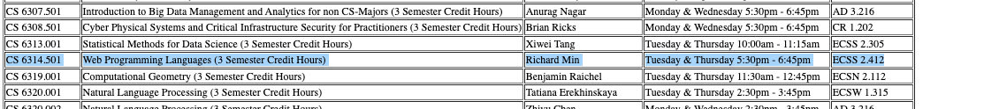

After:

7)Delete test case1:

Deleting the course CS6314:

Before:

After:



8)Delete test case2:

Deleting the course CS6314:

Before:



After:



9)Delete test case3:

Deleting the course id CS6360

Before:



After:



6) Task2 folder snippet

