ASSIGNMENT-1

Submitted by:

Mahima Chopra

15B00320

Q1----------------------------------------------------------------------------------------------------------------------------

#include<graphics.h>

#include<conio.h>

main()

{

int gd = DETECT,gm;

initgraph(&gd,&gm," ");

int x = 100,y=100,y1;

y1 = y;

int i=0;

for(i=0;i<10;i++)

{

setcolor(RED);

circle(x, y1,50);

y1 = y1+20 ;

}

int y2 =y,x1 = x+100 ;

for(i=0;i<30;i++)

{

setcolor(GREEN);

circle(x1,y2,50);

y2 = y2+20;

}

int y3 = y ,x2 = x+200;

for(i=0;i<10;i++)

{

setcolor(YELLOW);

circle(x2,y3,50);

y3 = y3+20;

}

getch();

closegraph();

return 0;

}

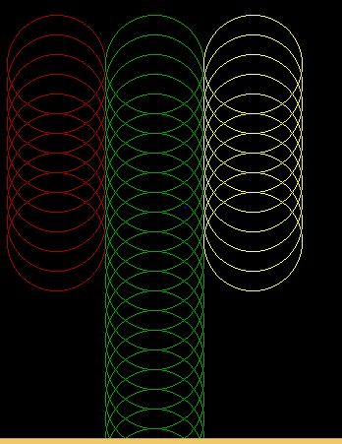

Q2. --------------------------------------------------------------------------------------------------------------------------------

#include<graphics.h>

#include<conio.h>

main()

{

int gd=DETECT, gm;

initgraph(&gd,&gm,"C:\\TURBOC3\\BGI");

setfillstyle(SOLID_FILL,RED);

bar(50,0,80,350);

setfillstyle(HATCH_FILL,RED);

bar(100,0,130,350);

setfillstyle(LTSLASH_FILL,RED);

bar(150,0,180,350);

setfillstyle(SLASH_FILL,RED);

bar(200,0,230,350);

setfillstyle(BKSLASH_FILL,RED);

bar(250,0,280,350);

setfillstyle(LTBKSLASH_FILL,RED);

bar(300,0,330,350);

setfillstyle(INTERLEAVE_FILL,RED);

bar(350,0,380,350);

setfillstyle(WIDE_DOT_FILL,RED);

bar(400,0,430,350);

getch();

closegraph();

return 0;

}

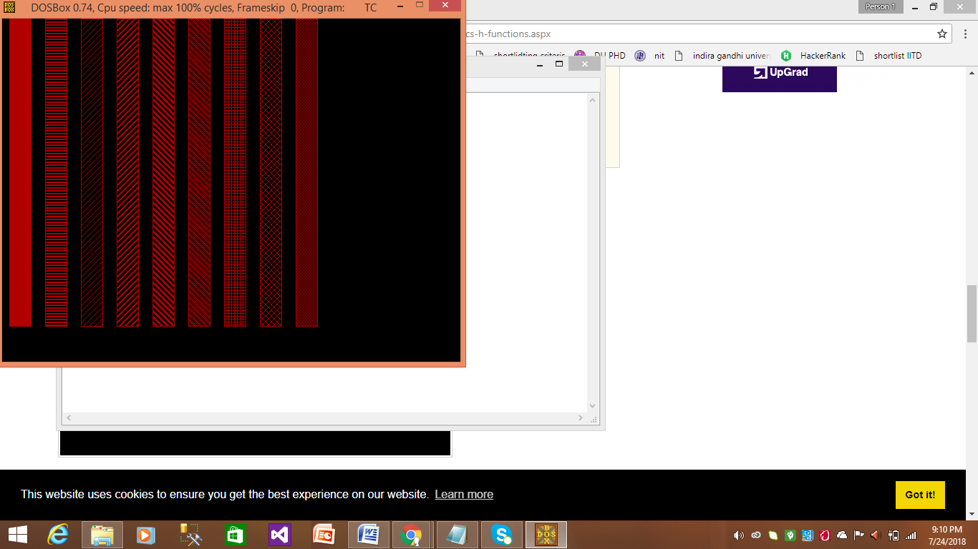

3

#include<graphics.h>

#include<conio.h>

main()

{

int gd=DETECT,gm;

initgraph(&gd,&gm,"C:\\TURBOC3\\BGI");

int left = 100,top=100,right = 130,bottom = 130;

int i,j;

setcolor(MAGENTA);

rectangle(90,90,420,380);

int left1 = left , right1 = right,top1 = top,bottom1 = bottom;

for(i=0;i<7;i++)

{

for(j=0;j<8;j++)

{

setfillstyle(SOLID_FILL,MAGENTA);

bar(left1,top1,right1,bottom1);

left1 = left1+40,right1= right1+40;

}

top1 = top1+40,bottom1 = bottom1+40,left1 = left,right1 = right;

}

getch();

closegraph();

return 0;

}

