**Project Title :**

**Online Voting system In College**

Participants: Mahima Gajjar

**Project Features And Abstract:-**

* This system is designed for the students who are studying in clg.
* It provides the features to choose the clubs in which they are interested there are no limitation for choosing they can choose as many as they are capable of.
* Here they get chance to choose the leader of the club on the basis of voting.
* They can even view the result and also the members of the particular club.

**Activity Diagram**

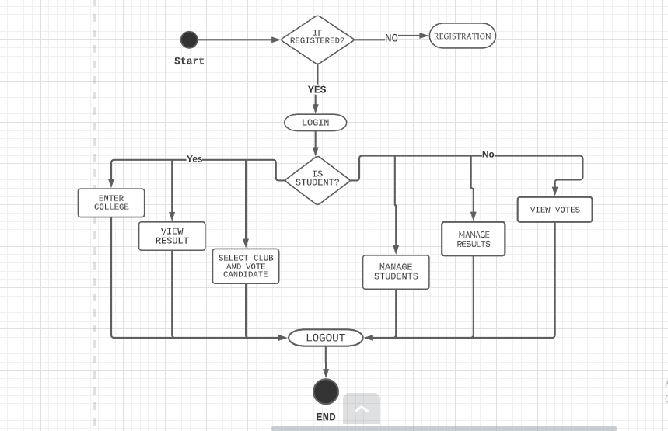

**E-R-Diagram**

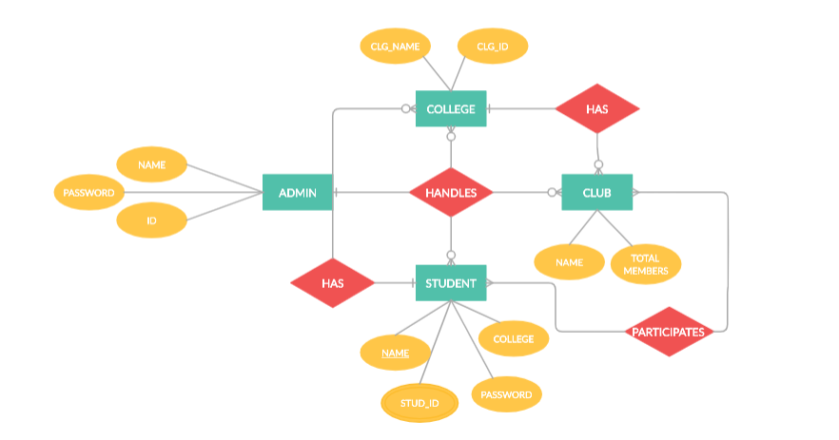

**Database**

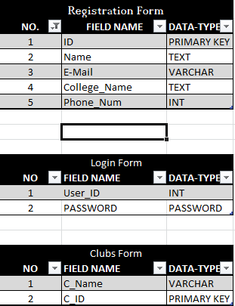

**UseCase :**

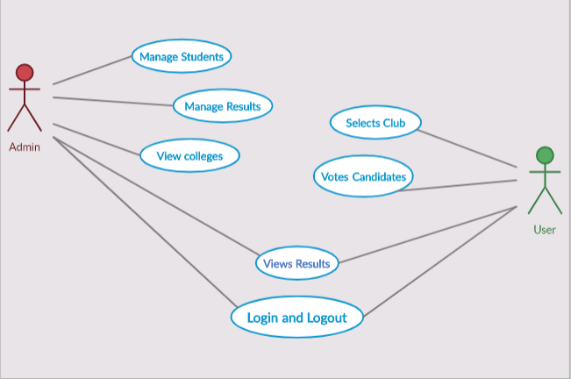

**Thankyou!!**

**Name: Mahima Gajjar**

**Enroll no: 180802032**

**Class: Bsc.IT_ F1**

**Roll no: 29**