|  |
| --- |
| Voting made easy |
| VS Virtual |
| Mahima Gajjar  B.Sc.IT  180802032  Final Year Project |

|  |
| --- |
| 05-May-21 |

Table of Content

1. Project Brief
2. Project Profile
3. Technology Brief
4. System Study

* Existing System
* Proposed System
* Project Aspects

1. Scope of proposed system
2. Project working chronology
3. Aim and Objective of proposed system
4. System Analysis

* System Modules
* System Use case Diagram

1. Future Enhancements
2. References

## Project Brief…

* This project is all about the voting. It is solely based on people voting and counting votes.
* It enables you to make vote and also show the result of the winner.
* I have made voting system at college level.
* Where it provides the brief of choosing the clubs as per users choice and then selecting the candidate whom they think that can be the leader of the club.
* Admin side is also provided and many facilities like adding the colleges and club and also elect the candidates whom the user will be voting.

# Technology Brief…

* Here technologies used in this project are:

1. HTML
2. CSS
3. Java Script [ JQuery, AJEX ]
4. PHP
5. Xampp Server [ for database]

# System Study…

* Unlike other projects here you will be provided to add more and more features to customize your project.
* Keeping in mind the user’s need this project is designed in such a manner.
* It will help the user in various ways and also the admins too.

# Scope of proposed system…

* Along with this it is also used in other different ways in colleges i.e. here all the students can add their projects and all other different students can look their colleague’s project and can vote the best project among them.
* This project is not only used in colleges but also can be used at school level.
* The school students can select their class leader and many more things can be added as per the client requests.

# Project Working Chronology…

* This projects starts with admin adding the colleges then after that it will be adding the multiple clubs to these colleges.
* There may be the same clubs in 2 different colleges but there won’t be any error in that.
* Then the user will then register by adding the email their college name, username, password, etc.
* The user after registering will have to login to the same email_id and password.
* After that they will have to add the clubs in which they are interested and then after that they can select the clubs leaders which are elected by the admins.
* And at last they can also view the result when everyone has voted.
* The admin can remove the misallinious user that they think is fake so that there is no spam voting

# Aim and Objective of the proposed system…

* The main and most effective object could be that the user now won’t have to go personally to register to enter that club.
* Now all these things will be done via just one click.
* To provide all the facilities via online bases.
* Make the work of department easy.

# System Analysis…

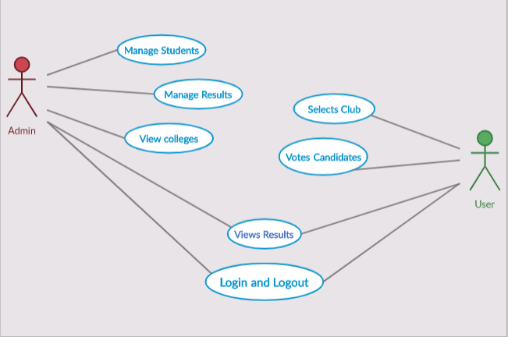

# Future Enhancements…

* Looking at the current situation one can use this project at many places where people are unable to have contact so their work can be done online and is in easy way.
* And talking for future this project can be used at multiple places and on can also modify it in order to make their work more easily.

# References…

* YouTube
* Google
* JavaScript [Udemy]

Thank You…