|  |
| --- |
| **Name: MAHIMA MANOJ**  **Roll No: 15**  **Batch: RMCA B**  **Date: 01-09-2022** |

**DATA SCIENCE LAB**

**Experiment No.: 3**

**Aim**

Pandas Series

**Procedure**

1. How to create Series with nd array

import pandas as pd

import numpy as np

arr=np.array([10,15,18,22])

s = pd.Series(arr)

print(s)

**OUTPUT**

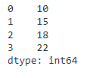

1. How to create Series with Mutable index

import pandas as pd

import numpy as np

arr=np.array(['a','b','c','d'])

s=pd.Series(arr,

index=['first','second','third','fourth'])

print(s)

**OUTPUT**

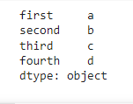

1. Creating a series from a Dictionary

import pandas as pd

d={'Name':'Hardik','Iplteam':'MI','Runs':1500 }

s=pd.Series(d)

print(s)

**OUTPUT**

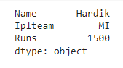

1. Print all the values of the Series by multiplying them by 2.

import pandas as pd

s=pd.Series([1,2,3,4,5])

print('To multiply all values in a series by 2')

print('------------------------------------------')

print(s*2)

**OUTPUT**

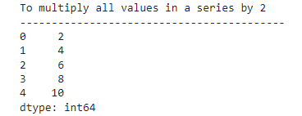

1. Print Square of all the values of the series.

import pandas as pd

s=pd.Series([1,2,3,4,5])

print('To find the square of all the values in a series')

print('------------------------------------------')

print(s**2)

**OUTPUT**

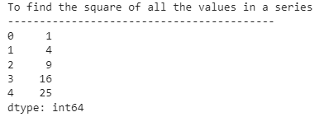

1. Print all the values of the Series that are greater than2

import pandas as pd

s=pd.Series([1,2,3,4,5])

print('To print all the values in a series that are greater 2')

print('------------------------------------------')

print(s[s>2])

**OUTPUT**

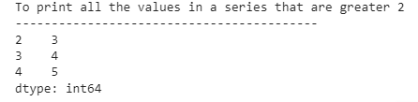

1. Addition of two series

import pandas as pd

s1=pd.Series([1,2,3,4,5],index=['a','b','c','d','e'])

s2=pd.Series([10,20,30,40,50],index=['a','b','c','d','e'])

s3=pd.Series([5,14,23,32],index=['a','b','c','d'])

print('To add series1 and series2')

print('------------------------------------------')

print(s1+s2)

print('To add series2 and series 3')

print('------------------------------------------')

print(s2+s3)

print('To add series2 and series 3 and filled non matching index with 0')

print('------------------------------------------')

print(s2.add(s3,fill_value=0))

**OUTPUT**

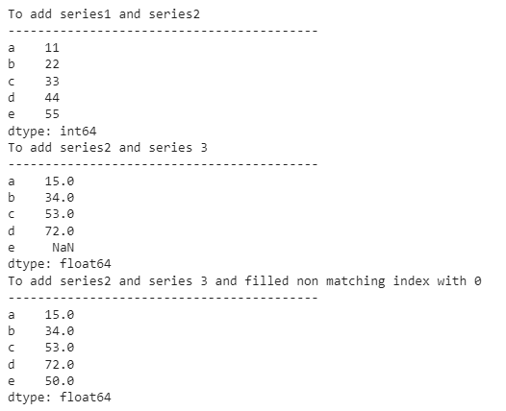

1. Print the first and last 5 elements of a series

import pandas as pd

import numpy as np

arr=np.array([10,15,18,22,55,77,42,48,97])

s=pd.Series(arr)

print(s.head(5))

print(s.tail(5))

**OUTPUT**

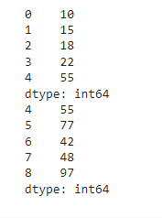

1. Print the values from index 0 to 5

import pandas as pd

import numpy as np

arr=np.array([10,15,18,22,55,77])

s=pd.Series(arr)

print(s)

print(s.loc[:6])

**OUTPUT**

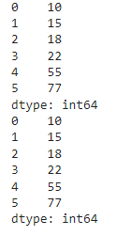

1. Selection Using loc, iloc index label

import pandas as pd

import numpy as np

arr=np.array([10,15,18,22,55,77])

s=pd.Series(arr)

print(s)

print(s.loc[:2])

print(s.loc[3:4])

s.loc[2:3]

s.iloc[2:3]

**OUTPUT**

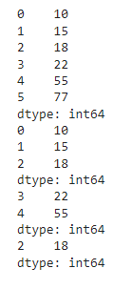

1. Retrieve subsets of data using slicing

import pandas as pd

import numpy as np

arr=np.array([10,15,18,22,55,77])

s=pd.Series(arr,index=['A','B','C','D','E','F'])

print(s)

print(s[1:5:2])

print(s[0:6:2])

**OUTPUT**

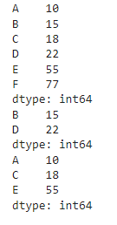

**Q2 Dataframe**

1. create Dataframe From Series

import pandas as pd

s = pd.Series(['a','b','c','d'])

df=pd.DataFrame(s)

print(df)



1. DataFrame from List of Dictionaries

import pandas as pd

l=[{'Name':'Sachin','SirName':'Bhardwaj'},

   {'Name':'Vinod','SirName':'Verma'},

   {'Name':'Rajesh','SirName':'Mishra'}]

df1=pd.DataFrame(l)

print(df1)

**OUTPUT**

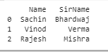

1. Display the first 5 rows of data frame

import pandas as pd

l=[{'Name':'Sachin','SirName':'Bhardwaj'},

   {'Name':'Vinod','SirName':'Verma'},

   {'Name':'Virat','SirName':'Kohli'},

   {'Name':'Hardik','SirName':'Pandya'},

   {'Name':'Rohit','SirName':'Sharma'},

   {'Name':'KL','SirName':'Rahul'}

   ]

df1=pd.DataFrame(l)

print(df1)

for(row_index,row_value)in df1.iterrows():

  print('\nRow index is::',row_index)

  print('\nRow values is::')

  print(row_value)

**OUTPUT**

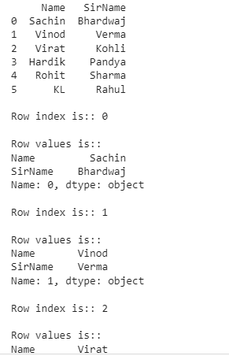

1. Select the last two columns of the data frame

import pandas as pd

import pandas as pd

l=[{'Name':'Sachin','SirName':'Bhardwaj'},

   {'Name':'Vinod','SirName':'Verma'},

   {'Name':'Virat','SirName':'Kohli'},

   {'Name':'Hardik','SirName':'Pandya'},

   {'Name':'Rohit','SirName':'Sharma'},

   {'Name':'KL','SirName':'Rahul'}

   ]

df1=pd.DataFrame(l)

print(df1)

for(col_name,col_value)in df1.iteritems():

  print('\n')

  print('\nColumn index is::',col_name)

  print('\nColumn values is::')

  print(col_value)

**OUTPUT**

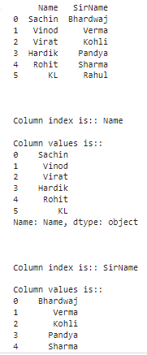

1. Add two data frames

import pandas as pd

s = pd.Series([10,15,18,22])

df=pd.DataFrame(s)

df.columns=['List1']

df['List2']=20

df['List3']=df['List1']+df['List2']

print(df)

**OUTPUT**

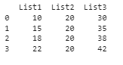

1. Demonstrate deletion, and renaming of columns

import pandas as pd

s= pd.Series([10,20,30,40])

df=pd.DataFrame(s)

df.columns=['List1']

df['List2']=40

df1=df.drop('List2',axis=1)

df2=df.drop(index=[2,3],axis=0)

print(df)

print(" After deletion::")

print(df1)

print("After row deletion:")

print(df2)

**OUTPUT**

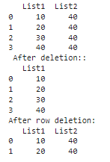

1. Demonstrate concat, Merge operations in data frame

import pandas as pd

dic1={

    'id':['1','2','3','4','5'],'value1':['A','C','E','G','I'],

    'value2':['B','D','F','H','J']

}

dic2={

    'id':['2','3','6','7','8',],'value1':['K','M','O','Q','S'],

    'value2':['L','N','P','R','T']

}

dic3={

    'id':['1','2','3','4','5','7','8','9','10','11'],

    'value3':[12,13,14,15,16,17,15,12,13,23]

}

df1=pd.DataFrame(dic1)

df2=pd.DataFrame(dic2)

df3=pd.concat([df1,df2])

df4=pd.DataFrame(dic3)

df5=pd.merge(df3,df4,on='id')

print(df5)

**OUTPUT**

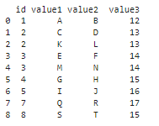

1. Write a Pandas program to join the two given dataframes along rows and assign all data

**Test Data:**

student_data1:

student_id name marks

0 S1 Danniella Fenton 200

1 S2 Ryder Storey 210

2 S3 Bryce Jensen 190

3 S4 Ed Bernal 222

4 S5 Kwame Morin 199

student_data2:

student_id name marks

0 S4 Scarlette Fisher 201

1 S5 Carla Williamson 200

2 S6 Dante Morse 198

3 S7 Kaiser William 219

4 S8 Madeeha Preston 201

import pandas as pd

student_data1={

    'id':['s1','s2','s3','s4','s5'],'name':['Danniella Fenton','Ryder Storey','Bryce Jenson','Ed Bernal','Kwame Morin'],

    'marks':['200','210','190','222','199']

}

student_data2={

    'id':['s4','s5','s6','s7','s8',],'name':['Scarlette Fisher','Carla Williamson','Dante Morse','Kaiser William','Madeeha Preston'],

    'marks':['201','200','198','219','201']

}

df1=pd.DataFrame(student_data1)

df1=pd.DataFrame(student_data2)

df3=pd.merge(df1,df2,on='id',how='outer')

print(df3)

**OUTPUT**

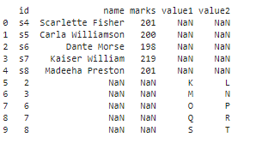

import pandas as pd

student_data1={

    'id':['s1','s2','s3','s4','s5'],'name':['Danniella Fenton','Ryder Storey','Bryce Jenson','Ed Bernal','Kwame Morin'],

    'marks':['200','210','190','222','199']

}

student_data2={

    'id':['s4','s5','s6','s7','s8',],'name':['Scarlette Fisher','Carla Williamson','Dante Morse','Kaiser William','Madeeha Preston'],

    'marks':['201','200','198','219','201']

}

df1=pd.DataFrame(student_data1)

df1=pd.DataFrame(student_data2)

df3=pd.merge(df1,df2,on='id',how='inner')

print(df3)

**OUTPUT**



import pandas as pd

student_data1={

    'id':['s1','s2','s3','s4','s5'],'name':['Danniella Fenton','Ryder Storey','Bryce Jenson','Ed Bernal','Kwame Morin'],

    'marks':['200','210','190','222','199']

}

student_data2={

    'id':['s4','s5','s6','s7','s8',],'name':['Scarlette Fisher','Carla Williamson','Dante Morse','Kaiser William','Madeeha Preston'],

    'marks':['201','200','198','219','201']

}

df1=pd.DataFrame(student_data1)

df1=pd.DataFrame(student_data2)

df3=pd.merge(df1,df2,on='id',how='right')

print(df3)

**OUTPUT**

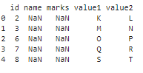

import pandas as pd

student_data1={

    'id':['s1','s2','s3','s4','s5'],'name':['Danniella Fenton','Ryder Storey','Bryce Jenson','Ed Bernal','Kwame Morin'],

    'marks':['200','210','190','222','199']

}

student_data2={

    'id':['s4','s5','s6','s7','s8',],'name':['Scarlette Fisher','Carla Williamson','Dante Morse','Kaiser William','Madeeha Preston'],

    'marks':['201','200','198','219','201']

}

df1=pd.DataFrame(student_data1)

df1=pd.DataFrame(student_data2)

df3=pd.merge(df1,df2,on='id',how='left')

print(df3)

**OUTPUT**

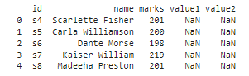

import pandas as pd

student_data1={

    'id':['s1','s2','s3','s4','s5'],'name':['Danniella Fenton','Ryder Storey','Bryce Jenson','Ed Bernal','Kwame Morin'],

    'marks':['200','210','190','222','199']

}

student_data2={

    'id':['s4','s5','s6','s7','s8',],'name':['Scarlette Fisher','Carla Williamson','Dante Morse','Kaiser William','Madeeha Preston'],

    'marks':['201','200','198','219','201']

}

df1=pd.DataFrame(student_data1)

df1=pd.DataFrame(student_data2)

df3=pd.merge(df1,df2,right_index=True,left_index=True)

print(df3)

**OUTPUT**

