|  |
| --- |
| **Name: MAHIMA MANOJ**  **Roll No: 15**  **Batch: RMCA B**  **Date: 27-09-2022** |

**MOBILE APPLICATION DEVELEPOMENT LAB**

Android lab cycle: 3

**Experiment No.:** 1

**Aim**

Design a page with intent

**Procedure**

**activity_main.xml**

<?xml version="1.0" encoding="utf-8"?>

<androidx.constraintlayout.widget.ConstraintLayout xmlns:android="http://schemas.android.com/apk/res/android"

xmlns:app="http://schemas.android.com/apk/res-auto"

xmlns:tools="http://schemas.android.com/tools"

android:layout_width="match_parent"

android:layout_height="match_parent"

tools:context=".MainActivity">

<TextView

android:layout_width="wrap_content"

android:layout_height="wrap_content"

android:text="Main Activity"

app:layout_constraintBottom_toBottomOf="parent"

app:layout_constraintEnd_toEndOf="parent"

app:layout_constraintHorizontal_bias="0.498"

app:layout_constraintStart_toStartOf="parent"

app:layout_constraintTop_toTopOf="parent"

app:layout_constraintVertical_bias="0.449" />

<Button

android:id="@+id/button1"

android:layout_width="166dp"

android:layout_height="61dp"

android:text="Go to second Activity"

tools:layout_editor_absoluteX="132dp"

tools:layout_editor_absoluteY="441dp" />

</androidx.constraintlayout.widget.ConstraintLayout>

**activity_secondactivity.xml**

<?xml version="1.0" encoding="utf-8"?>  
<androidx.constraintlayout.widget.ConstraintLayout xmlns:android="http://schemas.android.com/apk/res/android"  
 xmlns:app="http://schemas.android.com/apk/res-auto"  
 xmlns:tools="http://schemas.android.com/tools"  
 android:layout_width="match_parent"  
 android:layout_height="match_parent"  
 tools:context=".secondactivity">  
  
 <TextView  
 android:id="@+id/textView"  
 android:layout_width="wrap_content"  
 android:layout_height="wrap_content"  
 android:text="Second Activity"  
 tools:layout_editor_absoluteX="173dp"  
 tools:layout_editor_absoluteY="319dp" />  
</androidx.constraintlayout.widget.ConstraintLayout>

**Main_Activity.java**

package com.example.intend;  
  
import androidx.appcompat.app.AppCompatActivity;  
  
import android.content.Intent;  
import android.os.Bundle;  
import android.view.View;  
import android.widget.Button;  
  
public class MainActivity extends AppCompatActivity {  
 Button b1obj;  
  
 @Override  
 protected void onCreate(Bundle savedInstanceState) {  
 super.onCreate(savedInstanceState);  
 setContentView(R.layout.*activity_main*);  
 b1obj=findViewById(R.id.*button1*);  
 b1obj.setOnClickListener(new View.OnClickListener() {  
 @Override  
 public void onClick(View v) {  
 Intent i= new Intent(MainActivity.this, secondactivity.class);  
 startActivity(i);  
 }  
 });  
 }  
}

OUTPUT

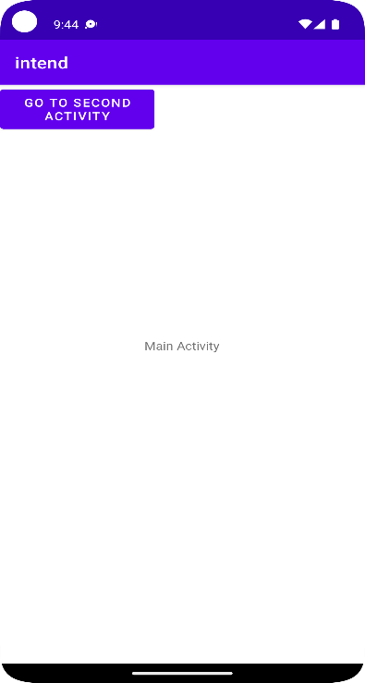

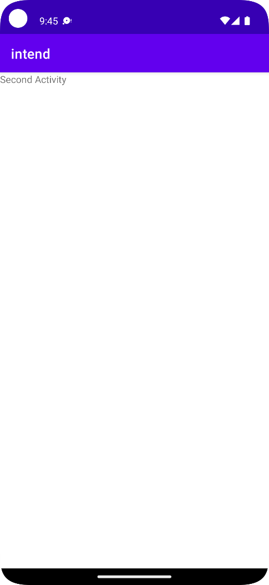

|  |
| --- |
| **Name: MAHIMA MANOJ**  **Roll No: 15**  **Batch: RMCA B**  **Date: 25-10-2022** |

**MOBILE APPLICATION DEVELEPOMENT LAB**

Android lab cycle:3

**Experiment No.:** 2

**Aim**

Design a page using drawable

**Procedure**

**activity_main.xml**

<?xml version="1.0" encoding="utf-8"?>

<androidx.constraintlayout.widget.ConstraintLayout xmlns:android="http://schemas.android.com/apk/res/android"

xmlns:app="http://schemas.android.com/apk/res-auto"

xmlns:tools="http://schemas.android.com/tools"

android:layout_width="match_parent"

android:layout_height="match_parent"

tools:context=".MainActivity">

<ImageButton

android:scaleType="fitCenter"

android:layout_width="233dp"

android:layout_height="243dp"

android:background="@drawable/custom_button_background"

tools:layout_editor_absoluteX="76dp"

tools:layout_editor_absoluteY="227dp">

</ImageButton>

</androidx.constraintlayout.widget.ConstraintLayout>

**custom_button_background**

<?xml version="1.0" encoding="utf-8"?>

<selector xmlns:android="http://schemas.android.com/apk/res/android">

<item>

<shape

android:shape="rectangle">

<solid android:color="#fcba03"></solid>

<stroke android:color="#8c8c87"

android:width="10dp"

></stroke>

<corners android:bottomLeftRadius="50dp"

android:topRightRadius="45dp"></corners>

<size android:width="150dp"

android:height="200dp"></size>

<gradient android:startColor="#e0f037"

android:endColor="#fa400c"

android:angle="360"

android:centerColor="#c3ed58"

android:type="linear"></gradient>

</shape>

</item>

</selector>

**OUTPUT**

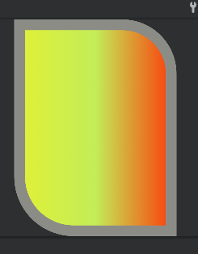

|  |
| --- |
| **Name: MAHIMA MANOJ**  **Roll No: 15**  **Batch: RMCA B**  **Date: 25-10-2022** |

**MOBILE APPLICATION DEVELEPOMENT LAB**

Android lab cycle:2

**Experiment No.:** 3

**Aim**

**Procedure**

**activity_main.xml**

<?xml version="1.0" encoding="utf-8"?>

<androidx.constraintlayout.widget.ConstraintLayout

xmlns:android="http://schemas.android.com/apk/res/android"

xmlns:app="http://schemas.android.com/apk/res-auto"

xmlns:tools="http://schemas.android.com/tools"

android:layout_width="match_parent"

android:layout_height="match_parent"

tools:context=".MainActivity"

>

<ImageButton

android:layout_width="233dp"

android:layout_height="243dp"

android:background="@drawable/circledraw"

android:centerColor="#ffaf7b"

app:layout_constraintBottom_toBottomOf="parent"

app:layout_constraintLeft_toLeftOf="parent"

app:layout_constraintRight_toRightOf="parent"

app:layout_constraintTop_toTopOf="parent">

</ImageButton>

</androidx.constraintlayout.widget.ConstraintLayout>

**circledraw.xml**

<?xml version="1.0" encoding="utf-8"?>

<selector xmlns:android="http://schemas.android.com/apk/res/android">

<item>

<shape

android:shape="oval">

<solid

android:color="#FFFFFF">

</solid>

<stroke

android:color="#9C27"

android:width="30dp">

</stroke>

<gradient

android:startColor="#880E4F"

android:endColor="#E04"

android:angle="360"

android:centerColor="#ffaf7b"

android:gradientRadius="100dp">

</gradient>

</shape>

</item>

</selector>

OUTPUT

|  |
| --- |
| **Name: MALAVIKA A**  **Roll No: 16**  **Batch: RMCA B**  **Date: 20-09-2022** |

**MOBILE APPLICATION DEVELEPOMENT LAB**

Android lab cycle:2

**Experiment No.:** 2

**Aim**

**Procedure**

**activity_main.xml**

**OUTPUT**

|  |
| --- |
| **Name: MALAVIKA A**  **Roll No: 16**  **Batch: RMCA B**  **Date: 20-09-2022** |

**MOBILE APPLICATION DEVELEPOMENT LAB**

Android lab cycle:2

**Experiment No.:** 2

**Aim**

**Procedure**

**activity_main.xml**

**Main_Activity.java**

**OUTPUT**