**Module 4) CSS and CSS 3**

**Q.1 What are the benefits of using CSS?**

**A.1** CSS handles the look and feel part of a web page.

Using CSS, we can control the color of the text, the style of fonts, the spacing between paragraphs, how columns are sized and laid out, etc.

**Benefits of using CSS:-**

1. **Separation of content and style :-** One of the most significant advantages of CSS is its ability to separate content from presentation. This separation enhances the maintainability of web pages as changes to the styling can be made without altering the underlying HTML structure. This also promotes a cleaner, more organized codebase.
2. **Consistency** :- CSS enables consistent styling across an entire website or multiple pages. This is one of the many advantages of using CSS. By creating a single external CSS file and linking it to multiple web pages, we ensure a uniform look and feel. This reduces redundancy and makes it easier to update styling elements globally.
3. **Faster Loading Times :-** External CSS files can be cached by web browsers, allowing them to load faster on subsequent visits. This results in a better user experience, especially for returning visitors.
4. **Responsive Design :-** With CSS, we can create responsive web designs that adapt to different screen sizes and devices. This is another main one among advantages of cascading style sheets.
5. **Ease to Maintenance :-** We can quickly make changes to fonts, colors, and layouts by updating a few lines of code in the CSS file, rather than manually editing each HTML element.
6. **Accessibility :-** CSS allows developers to improve web accessibility by controlling the presentation of content.
7. **Print-Friendly Pages :-** CSS can be used to create printer-friendly versions of web pages. This is particularly useful for e-commerce websites, blogs, or any content-heavy sites where users might want to print articles or product information.
8. **Global Styling :-** External CSS files can be linked to multiple web pages, making it easy to apply consistent styling across an entire website. This saves time and ensures a cohesive design.
9. **Efficient Updates :-** When we need to update the styling of a website, we can make changes in one central CSS file. This means that updates are applied universally, reducing the risk of inconsistencies.
10. **Animations and Effects :-** CSS allows for animations and transitions, enhancing the user experience. We can create interactive elements without relying on JavaScript or other scripting languages.

**Q.2 What are the disadvantages of CSS?**

**A.2** The disadvantages of CSS.

1. **Browsers Compatibility :-** CSS may render differently in various web browsers, leading to inconsistencies in the visual presentation. Developers often need to write browser-specific CSS code or use vendor prefixes to ensure compatibility.
2. **Lack of security :**- CSS itself does not offer security features, and it can be vulnerable to attacks like Cross-Site Scripting (XSS) when used inappropriately. Developers must be cautious when implementing CSS to prevent security risks.
3. **Limited Layout Control :-** CSS has limitations when it comes to controlling complex layouts. Achieving specific layouts, such as equal-height columns, can be challenging without resorting to workarounds or additional technologies like Flexbox or Grid.
4. **Performance Impact :-** Extensive  or poorly optimized CSS files can slow down page load times. It's essential to minimize and optimize CSS to maintain optimal website performance.
5. **Overriding Styles :-** The "cascading" nature of CSS can sometimes lead to unexpected styling conflicts.
6. **Maintenance Challenges :-** As websites grow and evolve, maintaining and refactoring CSS can become complex and time-consuming. It's crucial to follow best practices and use naming conventions to keep styles manageable.

**Q.3 What is the difference between CSS2 and CSS3?**

**A.3** CSS2 and CSS3 are both stylesheet languages used to control the presentation of web pages.Here are some of the key differences between CSS2 and CSS3:

**New features:**CSS3 adds a number of new features to CSS2, including:

**Flexbox:** Flexbox is a layout module that makes it easier to create responsive layouts.

**Grid:**Grid is a layout module that provides more control over the layout of elements on a web page.

**Animations:** CSS3 adds support for animations, which can be used to create more dynamic web pages.

**Transitions:** CSS3 adds support for transitions, which can be used to create smooth transitions between states of an element.

**Custom properties:** CSS3 adds support for custom properties, which can be used to create reusable styles.

**Improved support for media queries:** CSS3 improves the support for media queries, which can be used to adjust the layout of a web page for different screen sizes.

**Better performance:** CSS3 code is typically more efficient than CSS2 code, which can lead to faster page load times.

Overall, CSS3 is a more powerful and versatile stylesheet language than CSS2. It offers a number of new features that make it easier to create responsive, dynamic, and visually appealing web pages.

**Q.4 Name a few CSS style components.**

**A.4** A CSS style consists of several components that define how an HTML element should be visually presented on a web page. These components work together to create the desired appearance of web content. The main components of a CSS style include:

**1. **Selectors:\*\*** Selectors are used to target specific HTML elements to which the style will be applied. CSS selectors can target elements by their HTML tag name (element selectors), class names (class selectors), IDs (ID selectors), attributes, and more.

Example selectors:

- Element selector: `p { ... }`

- Class selector: `.my-class { ... }`

- ID selector: `#my-id { ... }`

**2. **Properties:\*\*** Properties are the individual style attributes that we want to set for the selected elements. Each property corresponds to a specific aspect of an element's appearance, such as color, font size, margin, padding, or border.

Example properties:

- `color`: Sets the text color.

- `font-size`: Defines the font size.

- `margin`: Specifies the margin around an element.

- `padding`: Sets the padding inside an element.

- `border`: Controls the border of an element.

**3. **Values:\*\*** Values are the settings or values we assign to CSS properties. Values can be specific (e.g., `12px`, `red`), relative (e.g., `em`, `%`), or keyword-based (e.g., `bold`, `left`).

Example values:

- `12px`: A specific pixel size.

- `red`: A specific color.

- `1em`: Relative size based on the element's font size.

- `left`: A keyword value indicating alignment.

**4. **Declaration Block:\*\*** A declaration block is a set of one or more property-value pairs enclosed within curly braces `{}`. Each property-value pair is separated by a semicolon `;`.

Example declaration block:

```css

p {

color: blue;

font-size: 16px;

}

```

**5. **Rule Set:\*\*** A rule set is a complete CSS rule that consists of a selector and its associated declaration block. It defines which HTML elements should be styled and how they should be styled.

Example rule set:

```css

p {

color: blue;

font-size: 16px;

}

```

**6. **Stylesheet:\*\*** A stylesheet is a collection of CSS rule sets. Stylesheets can be included in an HTML document using the `<link>` element (external stylesheet) or within a `<style>` element in the HTML `<head>` section (internal stylesheet).

Example external stylesheet link:

```html

<link rel="stylesheet" type="text/css" href="styles.css">

```

Example internal stylesheet:

```html

<style>

p {

color: blue;

font-size: 16px;

}

</style>

```

* By combining these components, we can create sophisticated and customized styles to control the visual presentation of HTML elements on our web page.

**Q.5 What do you understand by CSS opacity?**

**A.5** The opacity property sets the opacity level for an element.

The opacity-level describes the transparency-level, where 1 is not transparent at all, 0.5 is 50% see-through, and 0 is completely transparent.

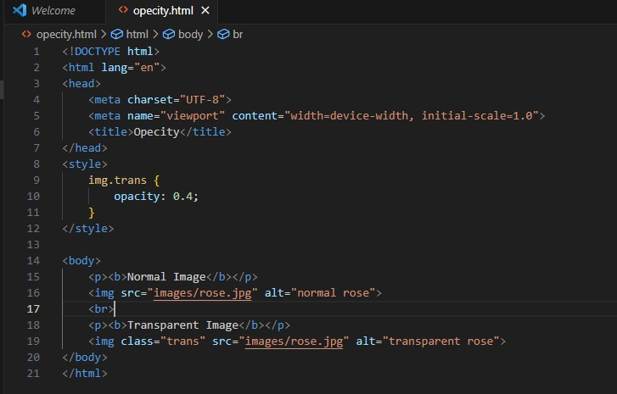

**Output:-**

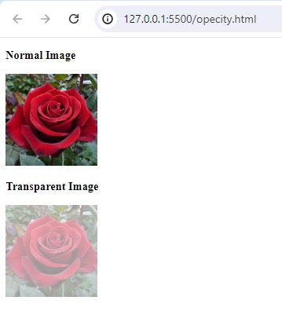

**Q.6 How can the background color of an element be changed?**

**A.6** The background-color property of CSS is used to set the background of an element.

**Syntax:-** background-color: color_name;

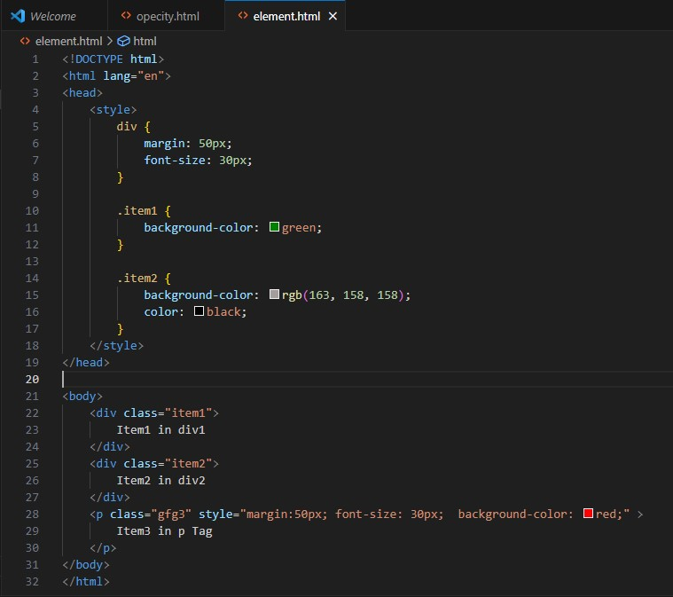

**Output:-**

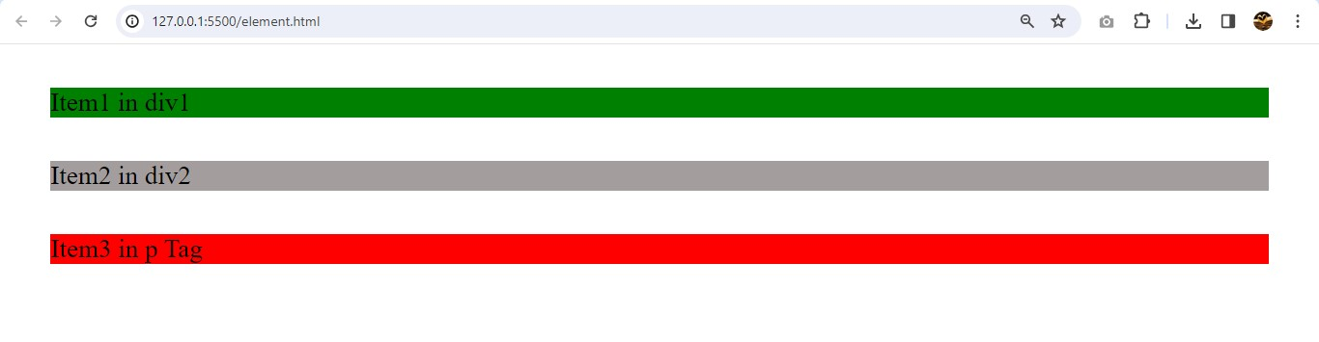

**Q.7 How can image repetition of the backup be controlled?**

**A.7** To control the repetition of an image in the background, use the background-repeat property. We can use no-repeat value for the background-repeat property if we do not want to repeat an image, in this case, the image will display only once.

background-repeat: repeat|repeat-x|repeat-y|no-repeat|initial|inherit;

First we show the example of repeat image

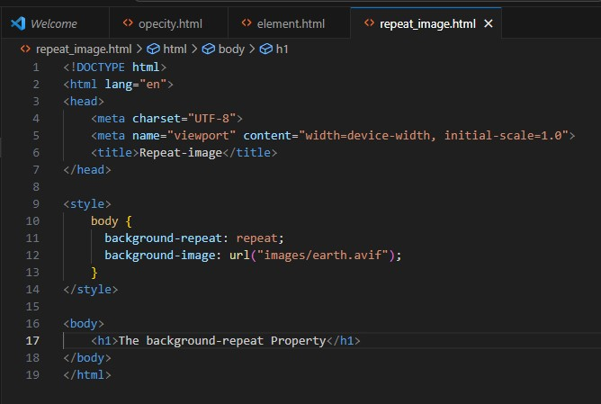

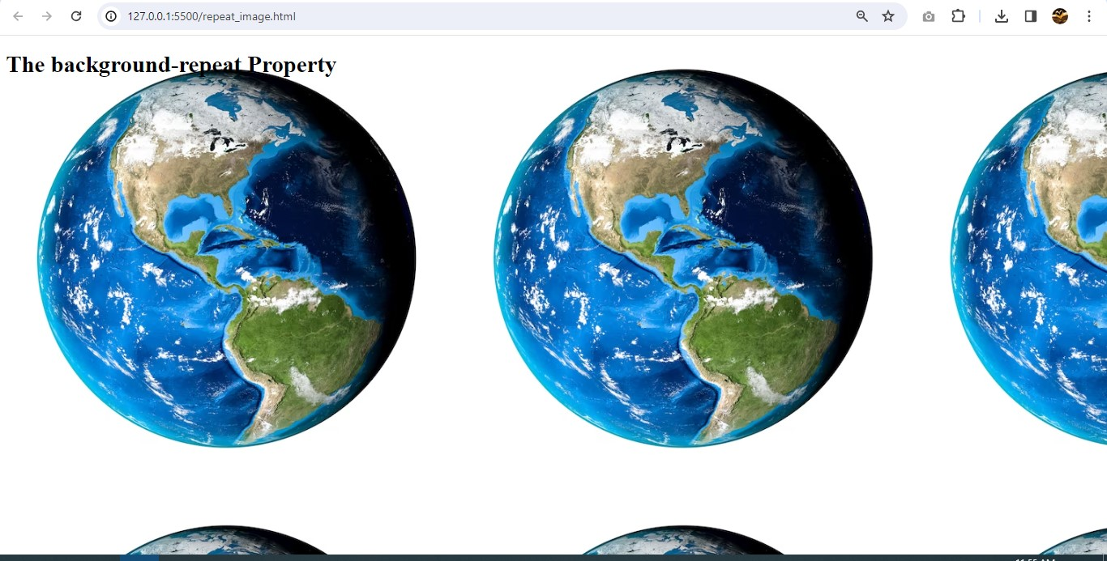

Now,we show how to controlling repetition images to using no-repeat

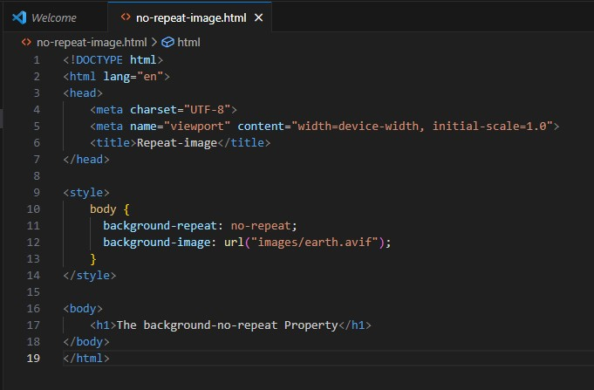

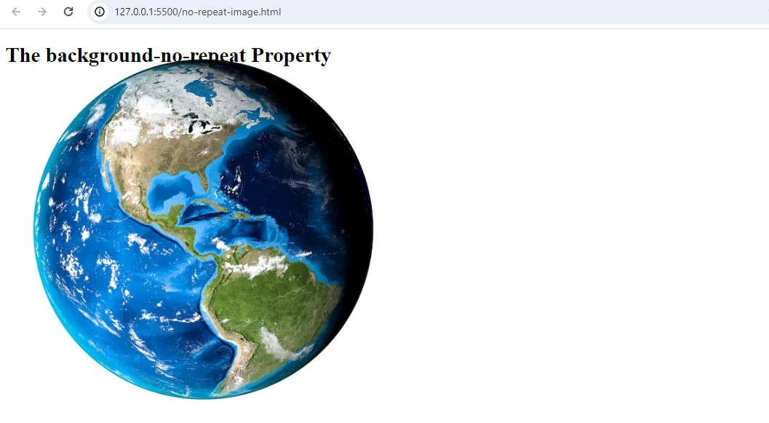

**Q.8 What is the use of the background-position property?**

**A.8** The background-position property sets the starting position of a background image.

By default, a [background-image](https://www.w3schools.com/cssref/pr_background-image.php) is placed at the top-left corner of an element, and repeated both vertically and horizontally.

Now,we show How to position a background-image

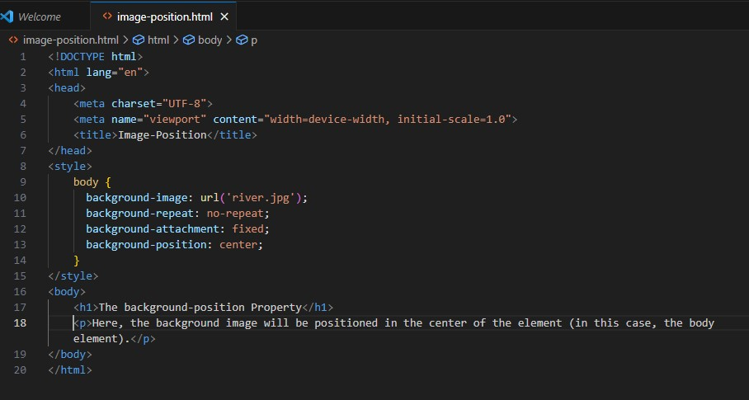

**Output :-**

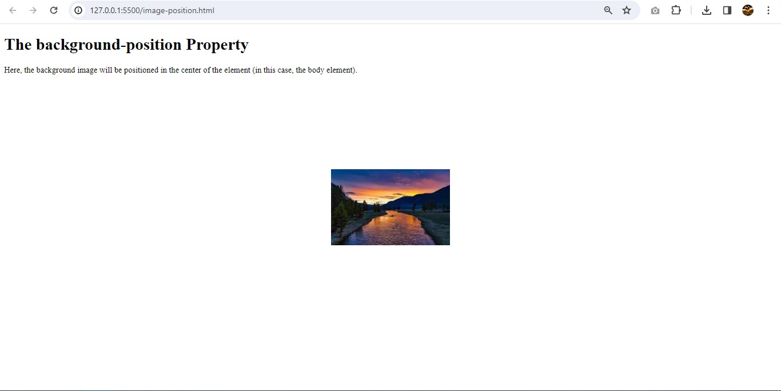

**Q.9 Which property controls the image scroll in the background?**

**A.9** The background-attachment property sets whether a background image scrolls with the rest of the page, or is fixed.

Therte are some background-attachment : scroll , fixed , local , initial , inherit.

A background-image that will scroll with the page (scroll).

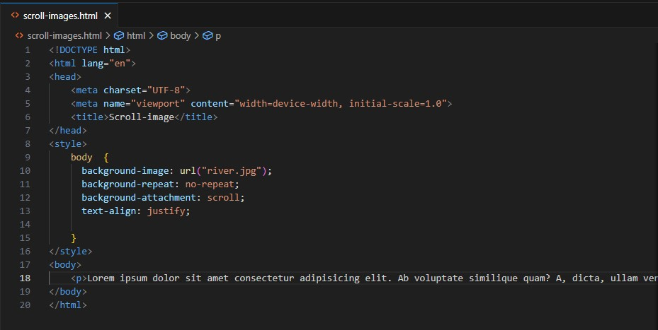

**Output:-**

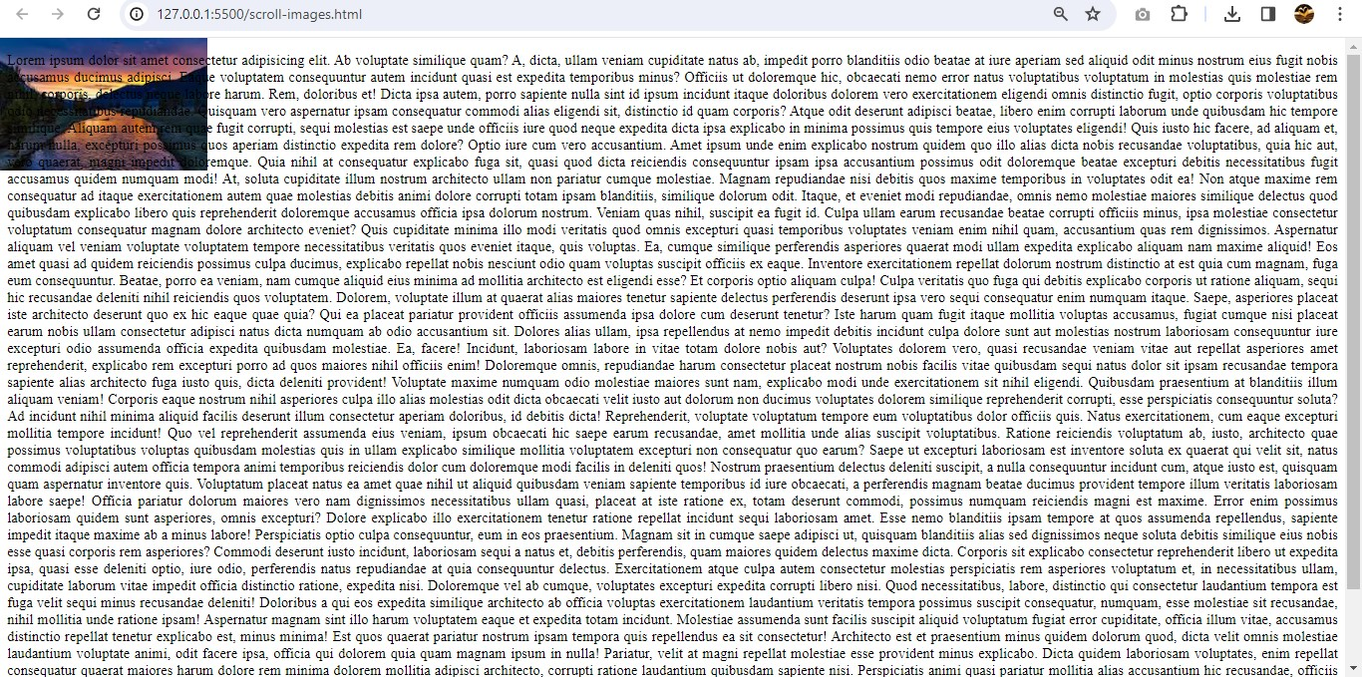

**Q.10 Why should background and color be used as separate properties?**

**A.10** Background and color be used as separate properties because

* Background:- It is a shorthand property that allows to set all the background properties (including the background-color) in one line.
* Syntax:- background: bg-color bg-image position/bg-size bg-repeat bg-origin bg-clip bg-attachment initial|inherit;
* Color:- using the color property we can change the text color.

**Q.11 How to center block elements using CSS1?**

**A.11** Center block elements using margin property:We need to specify the margin from left and right such that it looks centered. We do not need to do this manually, we have one property value “auto” which will automatically set the margin such that our block element is placed in the center. Use the below CSS property to center your block element.

margin: auto

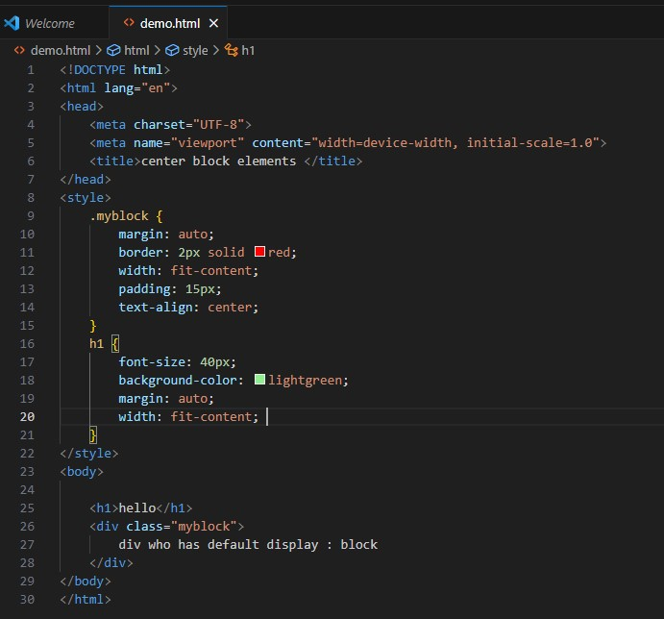

**Output:-**

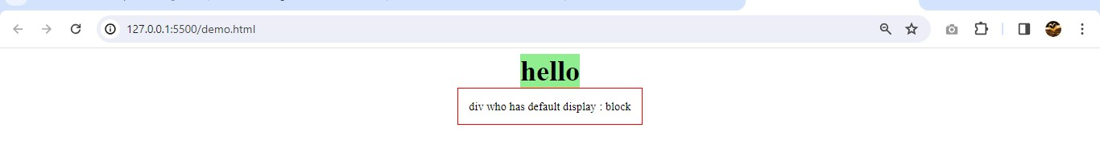

**Q.12 How to maintain the CSS specifications?**

**A.12** The Specification defines how CSS properties should be implemented by browser with detailed algorithms, code samples and information.

The Specification also include:

* The syntax and data types of the language
* Detailed explanation on CSS Selectors
* How you can assign values to properties
* How inheritance works
* The Box Model e.t.c.

The Specification also specify how stylesheets can be included in your web document.

**Q.13 What are the ways to integrate CSS as a web page?**

**A.13** There are three ways to integrate css as a web pages

1. **Inline** :- by using the style attribute inside HTML elements.

<h1 style="color:blue;">A Blue Heading</h1>  
  
<p style="color:red;">A red paragraph.</p>

1. **Internal** :- by using a <style> element in the <head> section

<!DOCTYPE html>  
<html>  
<head>  
<style>  
body {background-color: powderblue;}  
h1   {color: blue;}  
p    {color: red;}  
</style>  
</head>  
<body>  
<h1>This is a heading</h1>  
<p>This is a paragraph.</p>  
</body>  
</html>

1. **External CSS:-**

* An external style sheet is used to define the style for many HTML pages.
* To use an external style sheet, add a link to it in the <head> section of each HTML page:

<!DOCTYPE html>  
<html>  
<head>  
  <link rel="stylesheet" href="styles.css">  
</head>  
<body>  
  
<h1>This is a heading</h1>  
<p>This is a paragraph.</p>  
  
</body>  
</html>

**Q.14 What is embedded style sheets?**

**A.14** Embedded style sheets refer to when we embed style sheet information into an HTML document using the [<style>](https://www.quackit.com/html/tags/html_style_tag.cfm) element. we do this by embedding the style sheet information within [<style></style>](https://www.quackit.com/html/tags/html_style_tag.cfm) tags in the head of our document.

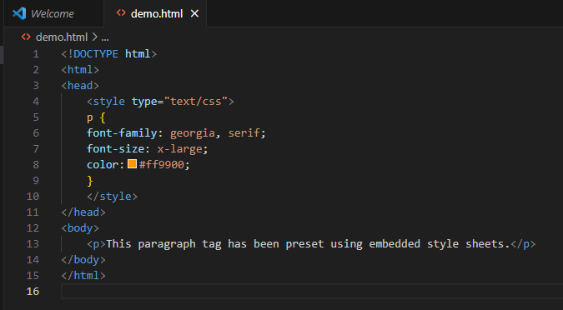

**Output:-**

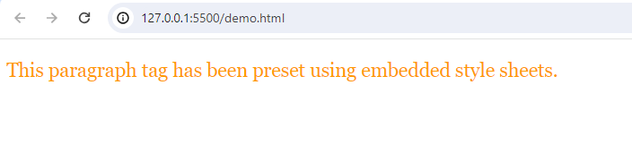

**Q.15 What are the external style sheets?**

**A.15** External CSS is used to style multiple HTML pages with a single style sheet. External CSS contains a separate CSS file with a **.css**extension.

To link a CSS file to an HTML file, use the**<link>**element within the HTML file’s **<head> section** with the **rel** attribute set to “**stylesheet**” and the **href** attribute specifying the CSS file’s path.

Html file:-

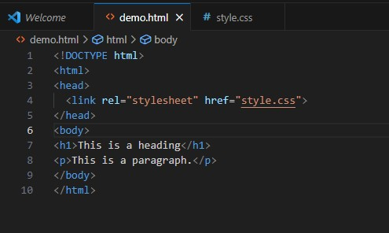

Css file:-

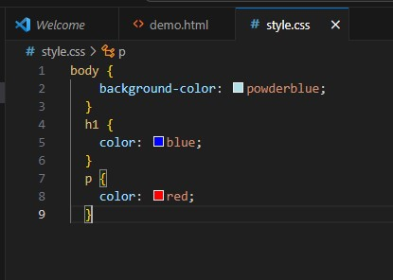

**Output:-**

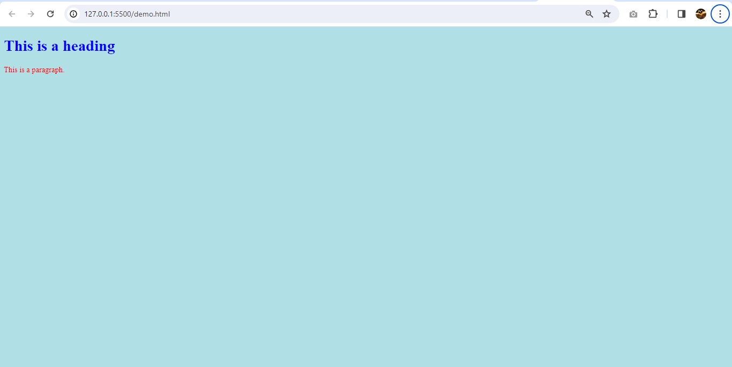

**Q.16 What are the advantages and disadvantages of using external style sheets?**

## **A.16** Using external style sheets,

## **Advantages of External CSS**

* Improved maintainability and code organization.
* Enhanced reusability across multiple HTML files.
* Efficient caching and faster page load times.

## **Disadvantages of External CSS**

* Pages may not render correctly until the external CSS is loaded.
* Uploading or linking to multiple CSS files may increase your site’s download time, affecting its overall performance.
* Large-scale projects may face versioning and caching challenges when using external CSS.

**Q.17 What is the meaning of the CSS selector?**

## **A.17 CSS Selectors:-** CSS selectors are used to "find" (or select) the HTML elements you want to style.

We can divide CSS selectors into five categories:

* Simple selectors (select elements based on name, id, class)
* [Combinator selectors](https://www.w3schools.com/css/css_combinators.asp) (select elements based on a specific relationship between them)
* [Pseudo-class selectors](https://www.w3schools.com/css/css_pseudo_classes.asp) (select elements based on a certain state)
* [Pseudo-elements selectors](https://www.w3schools.com/css/css_pseudo_elements.asp) (select and style a part of an element)
* [Attribute selectors](https://www.w3schools.com/css/css_attribute_selectors.asp) (select elements based on an attribute or attribute value)

**Q.18 What are the media types allowed by CSS?**

**A.18** CSS media types allow you to format your documents to be presented correctly on various types of media such as

* All:- Used for all media type devices.
* Aural:- Used for speech and sound synthesizers.
* Braille:- Used for braille tactile feedback devices.
* Embossed:- Used for paged braille printers.
* Handheld:- Used for small or handheld devices — usually small screen devices such as mobile phones or PDAs.
* Print:- Used for printers.
* Projection:- Used for projected presentations, for example projectors.
* Screen:- Used primarily for color computer screens.
* Tty:- Used for media using a fixed-pitch character grid — such as teletypes, terminals, or portable devices with limited display capabilities.
* Tv:- Used for television-type devices — low resolution, color, limited-scrollability screens, sound available.

**Q.19 What is the rule set?**

**A.19** A **CSS ruleset** consists of an element selector and a properties declaration [block](https://codesweetly.com/code-block).eg,

