**Frontend Assignment**

**Module 1) Foundation**

**web-site:-**

A collection of web pages and media over the internet is called a website. The website can be published on at least one web server and can be identified by a common domain name, for example - javatpoint.com, google.com, youtube.com.

**http**:-

Hypertext Transfer Protocol (HTTP) is the foundation of the World Wide Web.  is the set of rules for transferring files -- such as text, images, sound, video and other multimedia files - over the web. As soon as a user opens their web browser, they are indirectly using http.

[**URL:-**](URL:-)

URL stands for Uniform Resource Locator. It's the web address of a particular webpage on the internet.

**Module 2) Fundamentals of IT**

**Domain:-**

A domain is a [network](https://www.webopedia.com/definitions/network/) of [computers](https://www.webopedia.com/definitions/computer/) and [devices](https://www.webopedia.com/definitions/device/) that are controlled by one set authority and have specific guidelines. More specifically, a domain is controlled by one particular company that has its own internet presence and [IP address](https://www.webopedia.com/definitions/ip-address/).

The domain is labeled by its [domain name](https://www.webopedia.com/definitions/domain-name/), such as Webopedia or [www.webopedia.com](http://www.webopedia.com).

**Hosting:-**

A web hosting service is a type of Internet hosting service that hosts websites for clients, i.e. it offers the facilities required for them to create and maintain a site and makes it accessible on the World Wide Web. Companies providing web hosting services are sometimes called web hosts.

**SEO:-**

**SEO or Search Engine Optimization**is defined as the**process of improving (optimising) the visibility of a website/webpage on Search Engines**, such as Google, Bing, etc.

**Assignment**

**Module 3)** **HTML**

**Q.1 Are the HTML tags and elements the same thing?**

**A.1** HTML tags and elements are not the same thing.

* **Tags**:-
  + The <html> tags are building blocks of html page.
  + The <html> tag represents the root of an HTML document.
  + Ex:-<p></p>,<div></div>,etc.
* **Elements**:-
* The HTML element is everything from the start tag to the end tag:
* HTML element explains the content of the webpage.
* Ex:- <p>This is Paragraph tag</p>
* <p> :- This is html tag(opening/start tag)
* </p>:-This is html tag(closing/end tag)
* This is Paragraph tag:- this is an element.

**Q.2 What are tags and attributes in HTML?**

**A.2 Tags** :-

* + The <html> tags are building blocks of html page.
  + The <html> tag represents the root of an HTML document.
  + Ex:-<p></p>,<div></div>,etc.
* **Attributes** :-
  + HTML attributes provide additional information or properties to HTML elements.
  + Attributes define characteristics such as the source of an image, the link destination of an anchor, or the styling of an element. For example:-
    - <a href="Example Domain">Visit Example</a>
    - <img src="image.jpg" alt="Image">

**Q.3 What are void elements in HTML? With Example.**

**A.3** A void element cannot have any content but may have attributes.

void elements are self-closing, so they must not have a closing tag.

Ex:- area , base , br , col, embed , hr , img , link, meta.

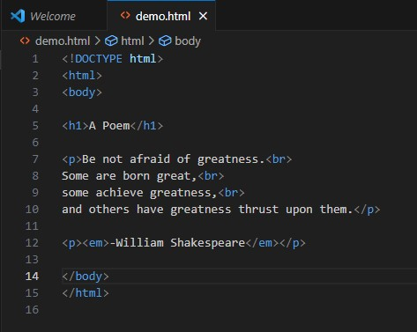

**Output:-**

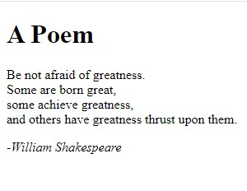

**Q.4 What are HTML Entities? With Example.**

**A.4** HTML entities are the reserved characters that are used in the HTML document.

They are not present in your standard keyboard.

They provide a wide range of characters, allowing you to add icons, geometric shapes, mathematical operators, and so on.

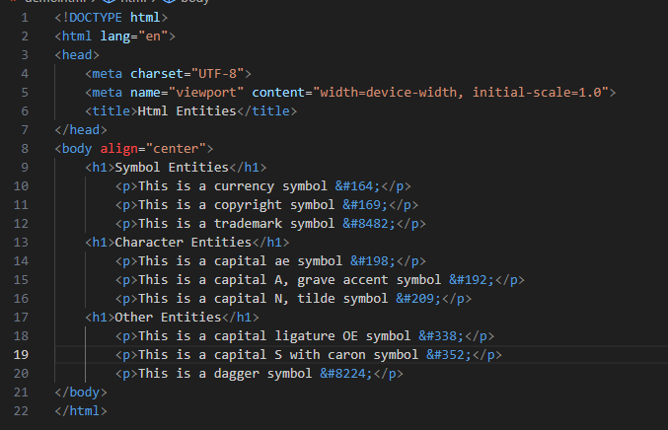

**Output:-**

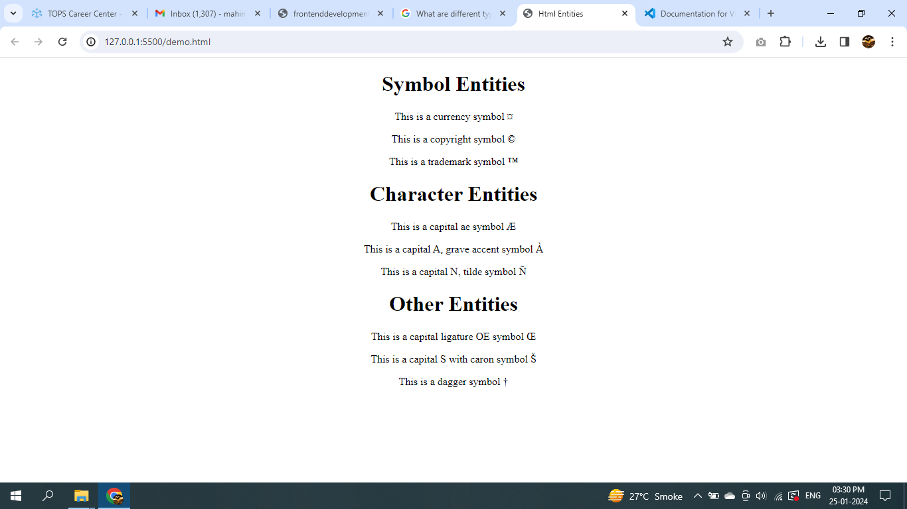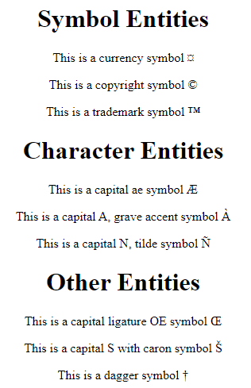

**Q.5 What are different types of lists in HTML? With Example.**

**A.5 Lists** are used to store data or information in web pages in ordered or unordered form.

* There are three different types of HTML lists:
  1. Ordered List or Numbered List (ol)
  2. Unordered List or Bulleted List (ul)
  3. Description List or Definition List (dl)

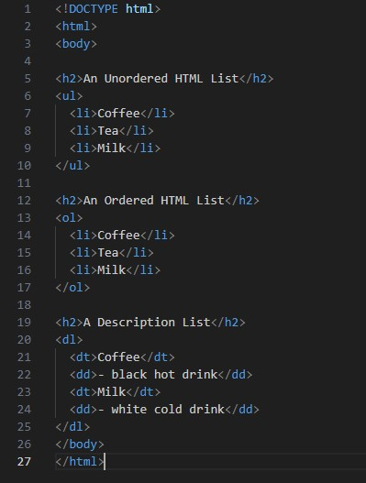

**Output:-**

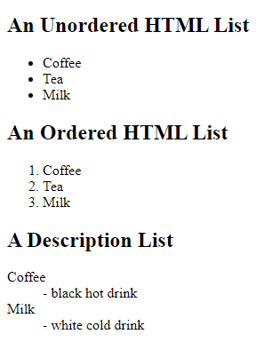

**Q.6 What is the ‘class’ attribute in HTML? With Example.**

**A.6** The "class" attribute is one of the most common and powerful attributes in HTML. It allows you to assign a name or a group of names to an HTML element, which can then be used as a selector in CSS.

* For example, <p class="intro">This is an introduction.</p> is an HTML element with a class attribute that has the value "intro".

/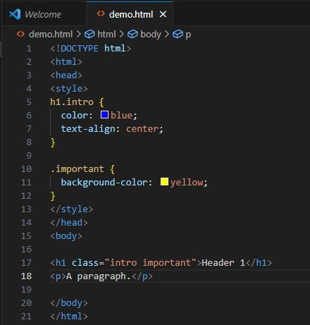

**Output:-**

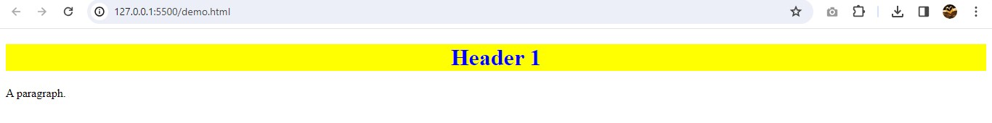

**Q.7 What is the difference between the ‘id’ attribute and the ‘class’ attribute of HTML elements? With Example.**

**A.7** The main difference between Class and ID :- A Class name can be used by multiple HTML elements, while an ID name must only be used by one HTML element within the page.

**ID’s are unique**

* Each element can have only one ID.
* Each ID can have an unlimited amount of Styles applied to it.
* Each page can have only one element with that ID.
* IDs use “#” in the CSS which can also be used as an identifier for HTML “Jump Links” (hyperlinks). This allows you to jump from one place to another on the same web page and can also be used in creating a well-designed Table of Contents.

**Classes are not unique**

* You can use the same Class on multiple elements.
* Class naming is case sensitive.
* Classes use a “.” in front of the name in the CSS as seen in the illustration below.
* Each Class can have an unlimited amount of Styles applied to it.
* You can use multiple classes on the same element.

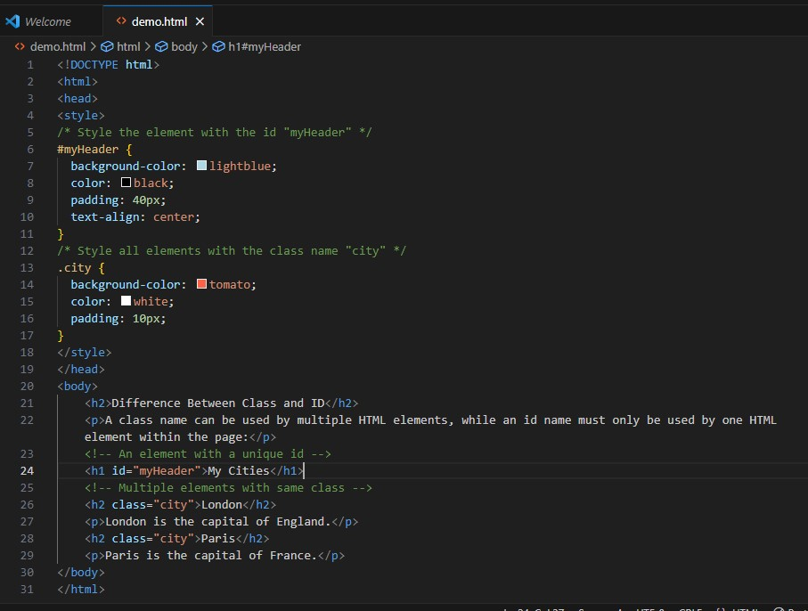

**Output:-**

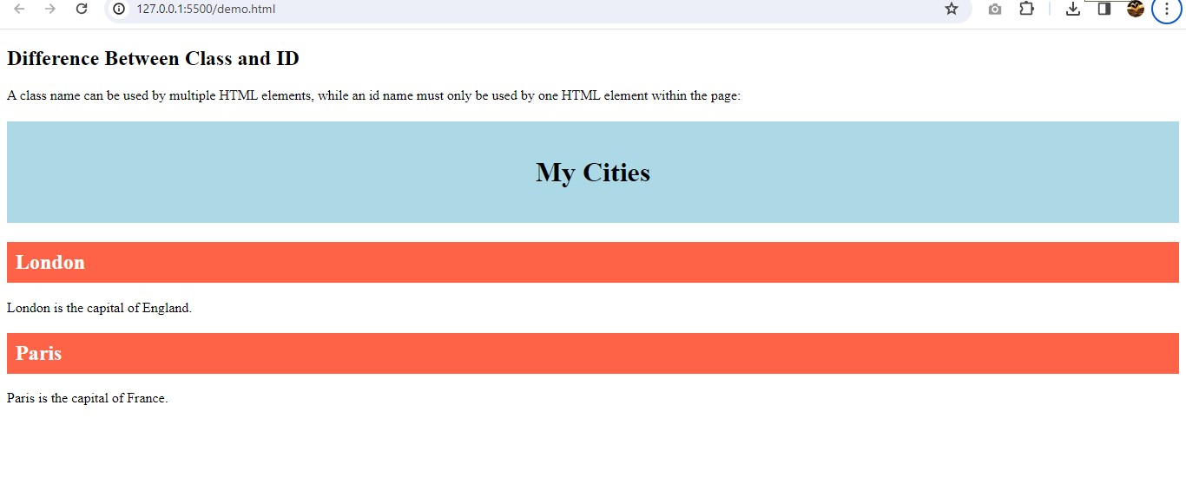

**Q.8 What are the various formatting tags in HTML?**

**A.8** Formatting elements were designed to display special types of text:

* <b> - Bold text
* <strong> - Important text
* <i> - Italic text
* <em> - Emphasized text
* <mark> - Marked text
* <small> - Smaller text
* <del> - Deleted text
* <ins> - Inserted text
* <sub> - Subscript text
* <sup> - Superscript text

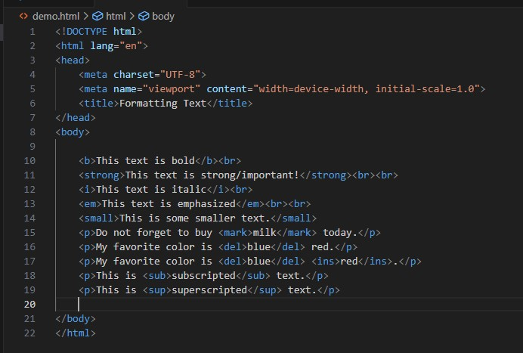

**Output:-**

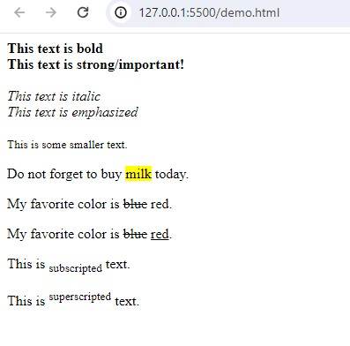

**Q.9 How is Cell Padding different from Cell Spacing? With Example.**

**A.9** The difference between cell padding and cell spacing:-

**Cell Padding :-**  Cell Padding is the distance between a table cell’s border and contents.

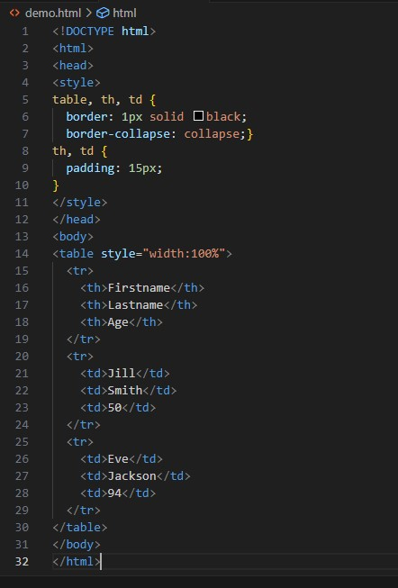

**Output:-**

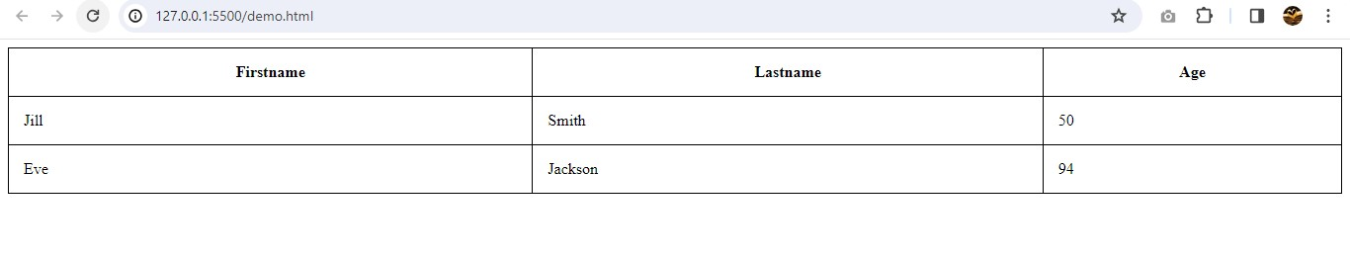

**Cell Specing :-** Cell Spacing is the distance between each individual cell in the table.

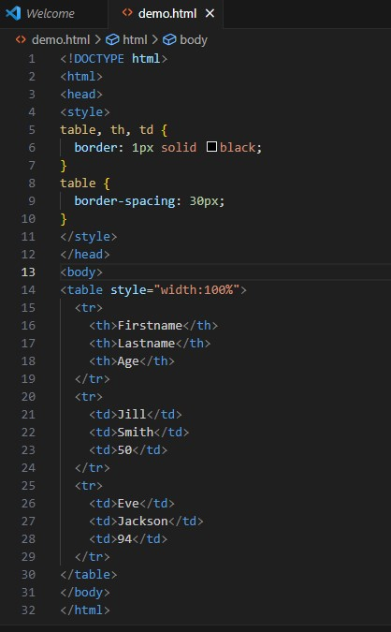

**Output:-**

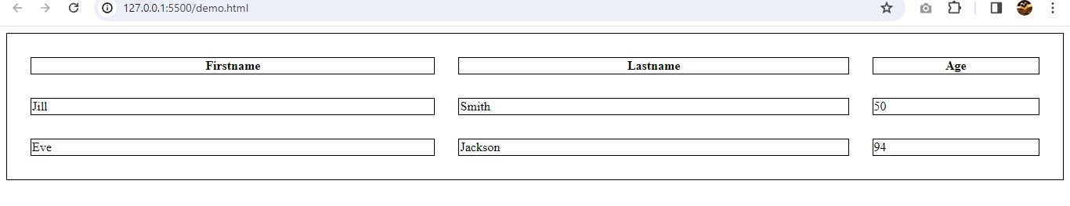

**Q.10 How can we club two or more rows or columns into a single row or column in an HTML table? With Example.**

**A.10** We can merge two or more [table](https://www.computerhope.com/jargon/t/table.htm) cells in a [column](https://www.computerhope.com/jargon/c/column.htm) using the colspan [attribute](https://www.computerhope.com/jargon/a/attribut.htm) in a [<td> HTML tag](https://www.computerhope.com/jargon/h/html-td-tag.htm) (table data). To merge two or more [row](https://www.computerhope.com/jargon/r/row.htm) cells, use the rowspan attribute.

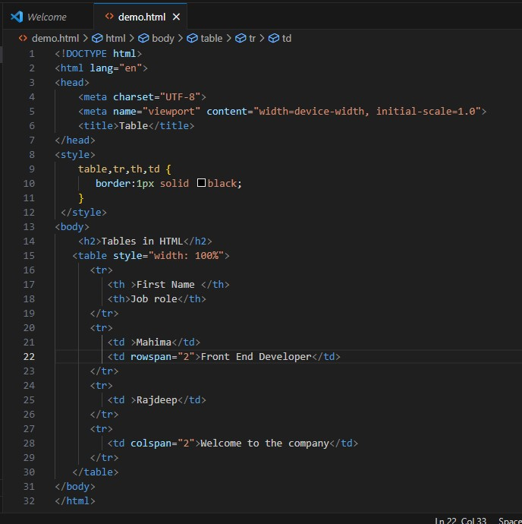

**Output:-**

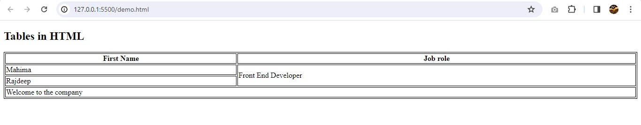

**Q.11 What is the difference between a block-level element and an inline element?**

**A.11**

**Block-level Elements:-**

* A block-level element always starts on a new line, and the browsers automatically add some space (a margin) before and after the element.
* A block-level element always takes up the full width available (stretches out to the left and right as far as it can).
* Two commonly used block elements are: <p> and <div>.

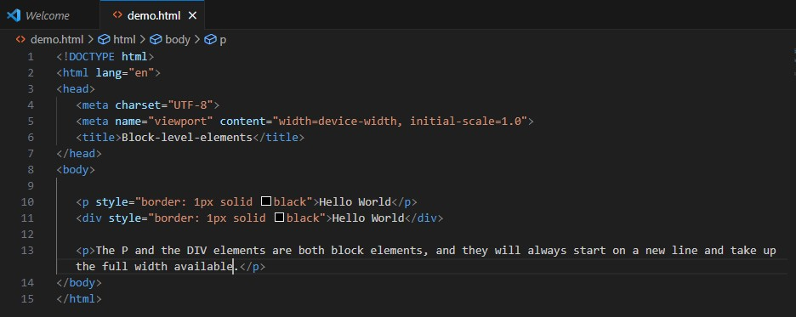

**Output:-**

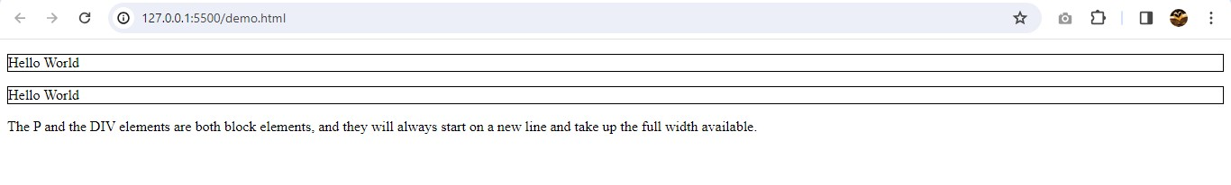

## **Inline Elements:-**

* An inline element does not start on a new line.
* An inline element only takes up as much width as necessary.

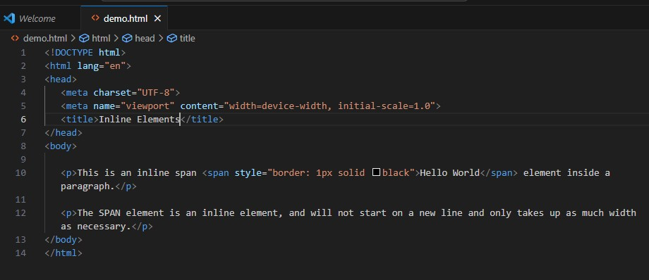

**Output:-**

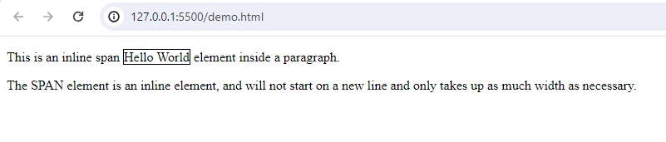**Q.12 How to create a Hyperlink in HTML? With Example.**

**A.12** A basic link is created by wrapping the text or other content inside an [<a>](https://developer.mozilla.org/en-US/docs/Web/HTML/Element/a) element and using the [href](https://developer.mozilla.org/en-US/docs/Web/HTML/Element/a" \l "href) attribute, also known as a**Hypertext Reference**, or **target**, that contains the web address.

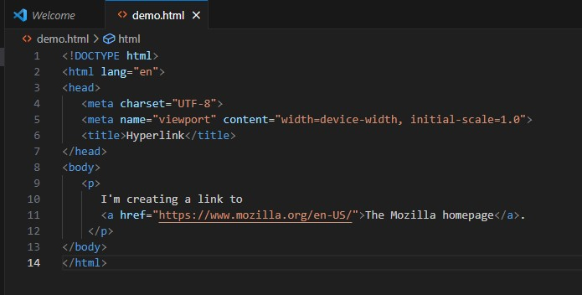

**Output:-**

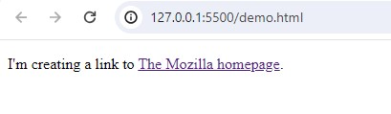

**Q.13 What is the use of an iframe tag? With Example.**

**A.13** The iframe tag in HTML stands for **Inline Frame and**is used to embed another HTML document within the current document.

It supports various attributes for specifying dimensions, borders, scrolling, and more to customize the appearance and behavior of the embedded content.

It requires an **src** attribute specifying the URL of the document to be embedded. Also enables the inclusion of videos, maps, or entire web pages from other sources.

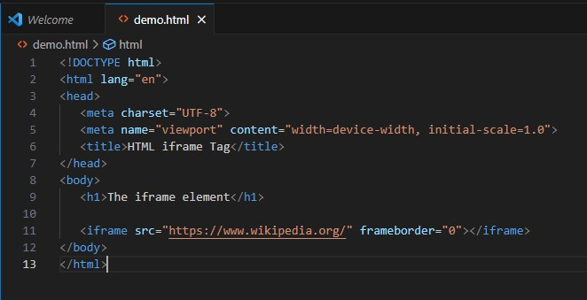

**Output:-**

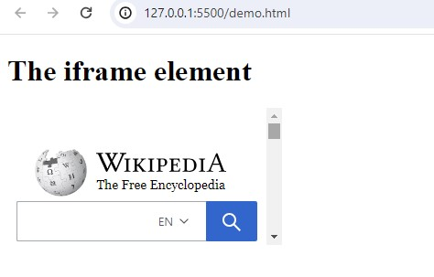

**Q.14 What is the use of a span tag? Explain with example?**

**A.14** The <span> tag is an inline container used to mark up a part of a text, or a part of a document.

The <span> tag is easily styled by CSS or manipulated with JavaScript using the class or id attribute.

The <span> tag is much like the [<div>](https://www.w3schools.com/tags/tag_div.asp) element, but <div> is a block-level element and <span> is an inline element.

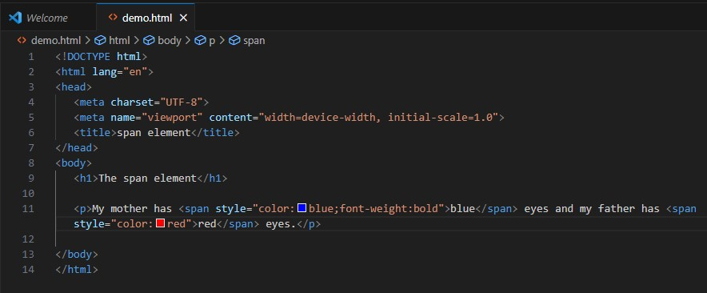

**Output:-**

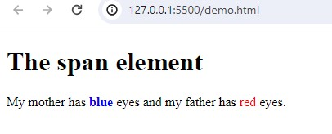

**Q.15 How to insert a picture into a background image of a web page? With Example.**

**A.15** We can use the [background attribute](https://www.tutorialspoint.com/html/html_backgrounds.htm) in the [body tag](https://www.tutorialspoint.com/html/html_body_tag.htm) to set an image as the background of the webpage.

We will need to specify the URL or the location of the image which we want to set to the background attribute of the body tag.

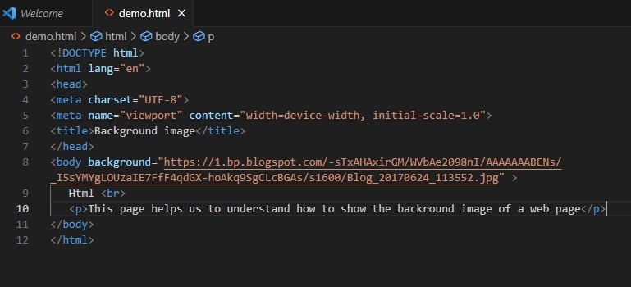

**Output:-**

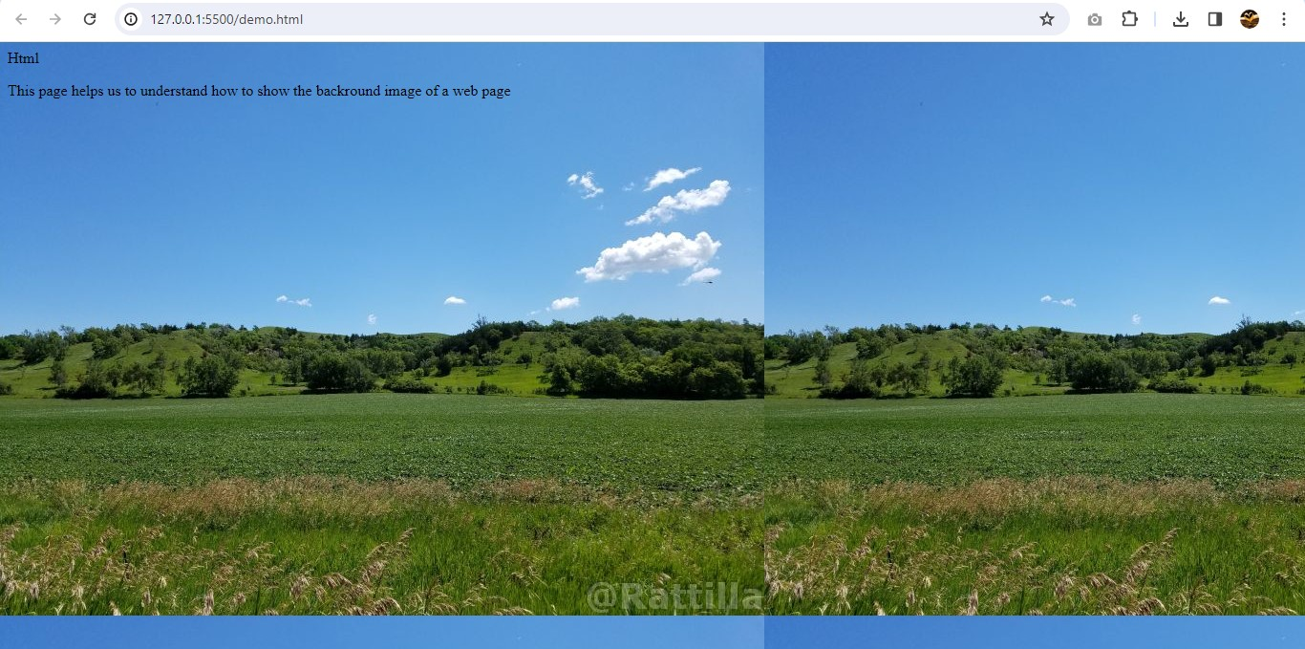

**Q.16 How are active links different from normal links?**

**A.16**

**Active links :-** The active link is those links which appear in the blue text, and when you click on them, they take you to a different page from which they linked.

When the cursor points a link which shows some underlined manner for that link is called active link.

By default active links are displayedin red color.

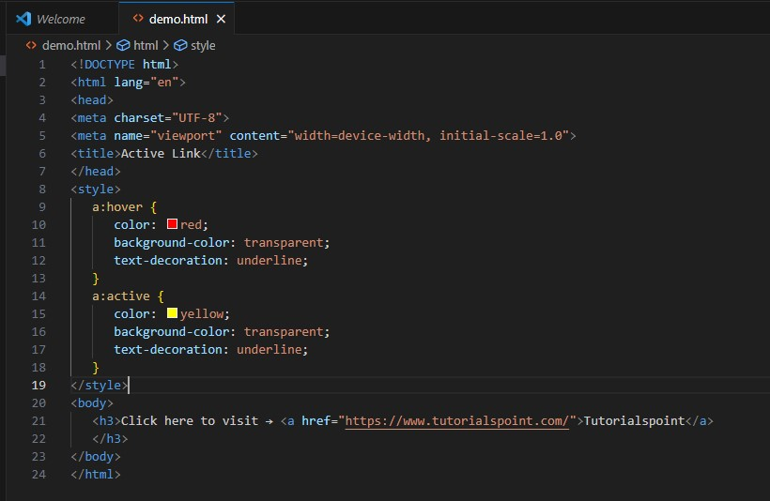

**Output:-**

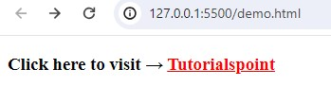

**Normal links :-** There is no focus on the particular link when the cursor over that link is called normal link.

By default normal links are displayed in blue color.

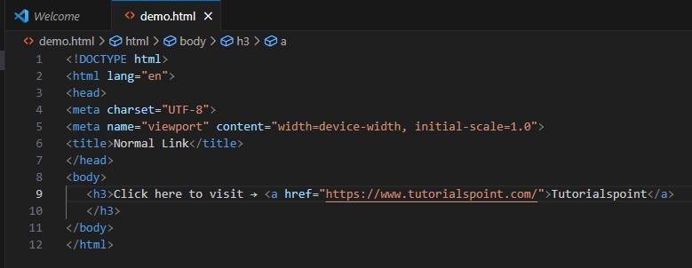

**Output:-**

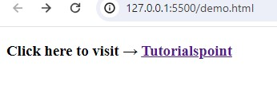

**Q.17 What are the different tags to separate sections of text?**

**A.17** We separate a section of texts in HTML using the below tags:

* <br> tag – It is used to separate the line of text. It breaks the current line and shifts the flow of the text to a new line.
* <p> tag–This tag is used to write a paragraph of text.
* <blockquote> tag–This tag is used to define large quoted sections.

**Q.18 What is SVG?**

**A.18** SVG stands for Scalable Vector Graphics.

* SVG defines vector-based graphics in XML format.
* SVG graphics are scalable, and do not lose any quality if they are zoomed or resized.
* SVG is supported by all major browsers.

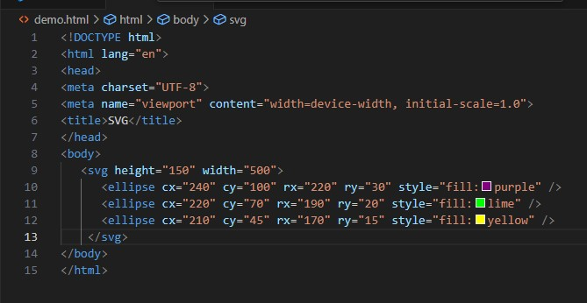

**Output:-**

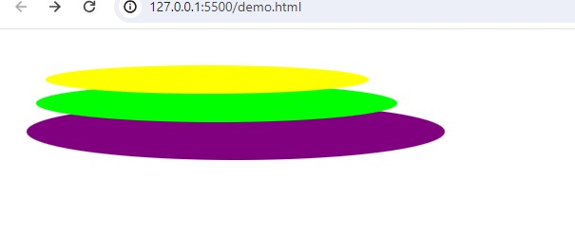

**Q.19 What is difference between HTML and XHTML?**

**A.19** HTML and XHTML are two of the most popular markup languages used for developing web pages and applications.

* HTML is the standard markup language for creating web pages, while XHTML is a stricter and more standardized version of HTML.
* **XHTML**is an older version of**HTML** that follows XML rules. HTML5 is the latest and more flexible version, bringing in new features for better multimedia and web applications.

| **HTML** | **XHTML** |
| --- | --- |
| HTML stands for Hypertext Markup Language. | XHTML stands for Extensible Hypertext Markup Language. |
| It is extended from SGML. | It is extended from XML and HTML. |
| The format is a document file format. | The format is a markup language. |
| All tags and attributes are not necessarily to be in lower or upper case. | In this, every tag and attribute should be in lower case. |
| Doctype is not necessary to write at the top. | Doctype is very necessary to write at the top of the file. |
| While using the attributes it is not necessary to mention quotes.  For e.g. <Geeks>. | While using the attributes it is mandatory to mention quotes.  For e.g. <Geeks=”GFG”>. |
| Filename extension used are .html, .htm. | Filename extension are .xhtml, .xht, .xml. |

**Q.20 What are logical and physical tags in HTML?**

**A.20** Physical and Logical tags are used in HTML for better visibility and understanding of the text by the user on the web page.

**Physical tags :** Physical tags are used to tell the browser how to display the text enclosed in the physical tag. Some of the examples of physical tags are <b>, <big>, <i>.

| **Physical Tag** | **Description** |
| --- | --- |
| <b> | Defines **bold**text |
| <big> | Defines big text |
| <i> | Defines *italic*text |
| <small> | Defines small text |
| <sup> | Defines superscriptedtext |
| <sub> | Defines subscriptedtext |
| <tt> | Defines teletype text |
| <u> | Deprecated. Use styles instead |

**Logical tags :** Logical tags are used to tell the meaning of the enclosed text. The example of the logical tag is <strong> </strong> tag. When we enclose the text in the strong tag, it tells the browser that enclosed text is more important than other texts.

| **Logical Tag** | **Description** |
| --- | --- |
| <abbr> | Defines an abbreviation |
| <acronym> | Defines an acronym |
| <address> | Defines an address element |
| <cite> | Defines citation |
| <code> | Defines computer code text |
| <blockquote> | Defines a long quotation |
| <del> | Defines text |
| <dfn> | Defines a definition term |
| <ins> | Defines inserted text |
| <kbd> | Defines keyboard text |
| <pre> | Defines preformatted text |
| <q> | Defines short quotation |
| <samp> | Defines sample computer code |
| <strong> | Defines strong text |
| <var> | Defines a variable |

**Q.21 Create below example using only HTML tags without CSS.**

**A.21**

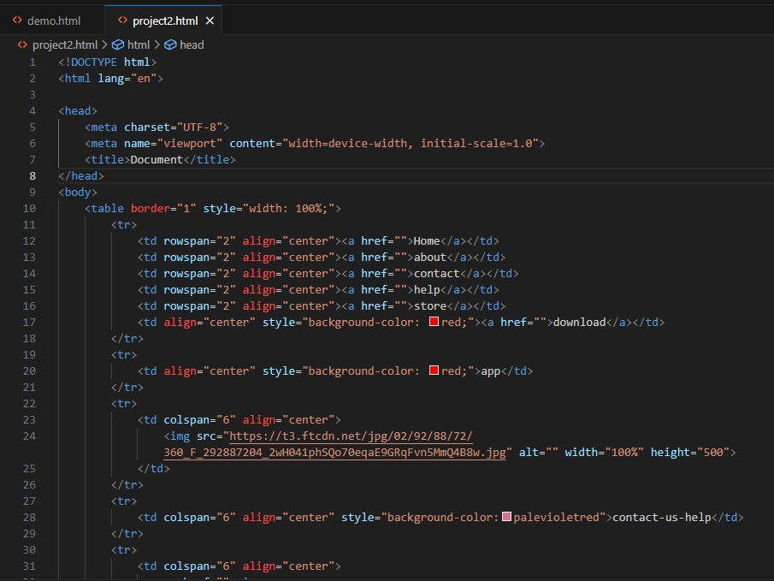

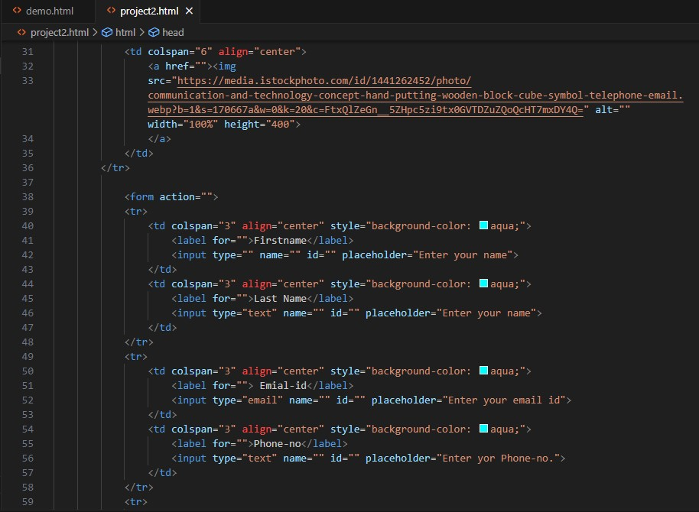

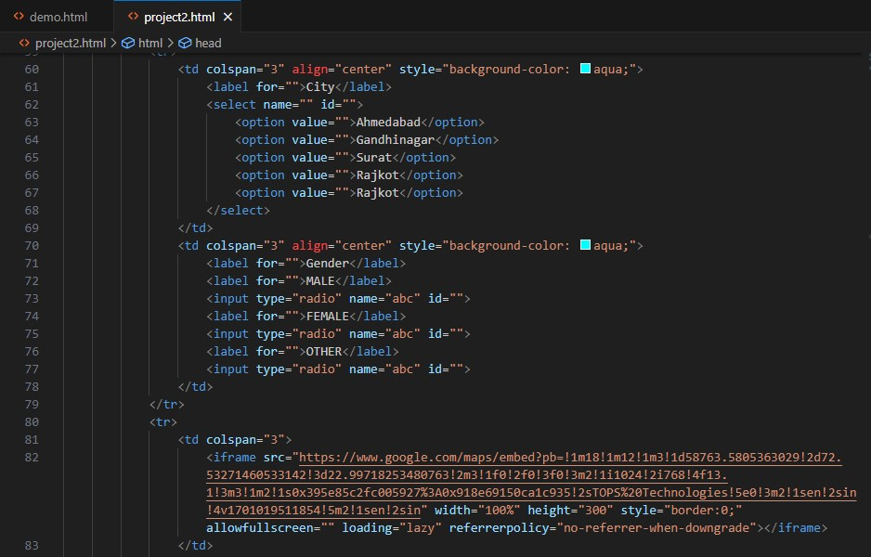

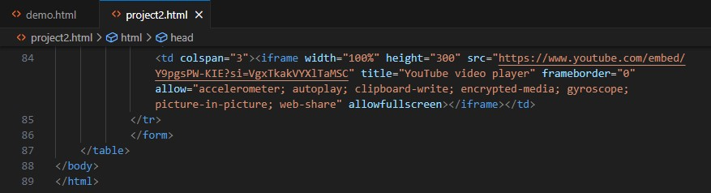

**Output:-**

