**Module 5) HTML5**

**Q.1 What are the new tags added in HTML5?**

**A.1** New tags are added in HTML5 to write easy and fast code to create complex, dynamic, engaging, and effective websites.

|  |  |
| --- | --- |
| **Tags (Elements)** | **Description** |
| <article> | Represents an independent piece of content of a document, such as a blog entry or newspaper article |
| <aside > | Represents a piece of content that is only slightly related to the rest of the page. |
| <audio> | Defines an audio file. |
| <canvas> | This is used for rendering dynamic bitmap graphics on the fly, such as graphs or games. |
| <command> | Represents a command the user can invoke. |
| <datalist> | Together with the a new list attribute for input can be used to make comboboxes |
| <details> | Represents additional information or controls which the user can obtain on demand |
| <embed> | Defines external interactive content or plugin. |
| <figure> | Represents a piece of self-contained flow content, typically referenced as a single unit from the main flow of the document. |
| <footer> | Represents a footer for a section and can contain information about the author, copyright information, et cetera. |
| <header> | Represents a group of introductory or navigational aids. |
| <hgroup> | Represents the header of a section. |
| <keygen> | Represents control for key pair generation. |
| <mark> | Represents a run of text in one document marked or highlighted for reference purposes, due to its relevance in another context. |
| <meter> | Represents a measurement, such as disk usage. |
| <nav> | Represents a section of the document intended for navigation. |
| <output> | Represents some type of output, such as from a calculation done through scripting. |
| <progress> | Represents a completion of a task, such as downloading or when performing a series of expensive operations. |
| <ruby> | Together with <rt> and <rp> allow for marking up ruby annotations. |
| <section> | Represents a generic document or application section |
| <time> | Represents a date and/or time. |
| <video> | Defines a video file. |
| <wbr> | Represents a line break opportunity. |

**Q.2 How to embed audio and video in a webpage?**

**A.2 Audio tag:-** To embed audio in HTML, we use the <audio> tag.

**Syntax:**

<audio>

<source src="file_name" type="audio_file_type">

</audio>

**Attributes of <audio> tag**

| **Attribute** | **Value** | **Description** |
| --- | --- | --- |
| autoplay | autoplay | When the page is loaded. It specifies to play audio as soon as possible. |
| controls | controls | It displays audio control. |
| loop | loop | It will start the audio again when it is finished. |
| muted | muted | When the page is loaded audio will be automatically muted. |
| preload | auto metadata  none | It specifies how the author thinks the audio will be loaded when the page is ready. |
| src | URL | It specifies the URL of the audio file. |

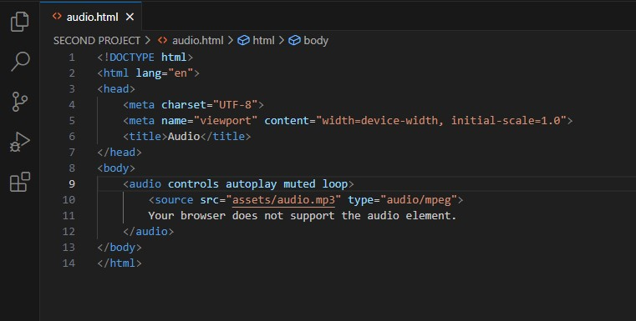

**Output:-**

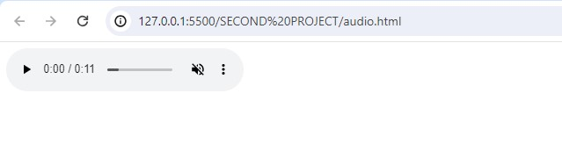

**Video Tag:-** To embed video in HTML, we use the <video> tag. It contains one or more video sources at a time using <source> tag. It supports MP4, WebM, and Ogg in all modern browsers.

* **Syntax**

<video>

<source src="file_name" type="video_file_type">

</video>

**Attributes of <video> tag**

| **Attribute** | **Value** | **Description** |
| --- | --- | --- |
| autoplay | autoplay | When the page is loaded. It specifies to play video as soon as possible. |
| controls | controls | It displays video control such as play, pause, and stop. |
| loop | loop | It will start the video again when it is finished. |
| muted | muted | When the page is loaded video will be automatically muted. |
| poster | URL | It specifies an image will be shown until video play. |
| preload | auto metadata none | It specifies how the author thinks the video will be loaded when the page is ready. |
| src | URL | It specifies the URL of the audio file. |
| width | pixels | It specifies the width of the video area. The default value of width is ‘auto’. |
| height | pixels | It specifies the height of the video area. The default value of height is ‘auto’. |

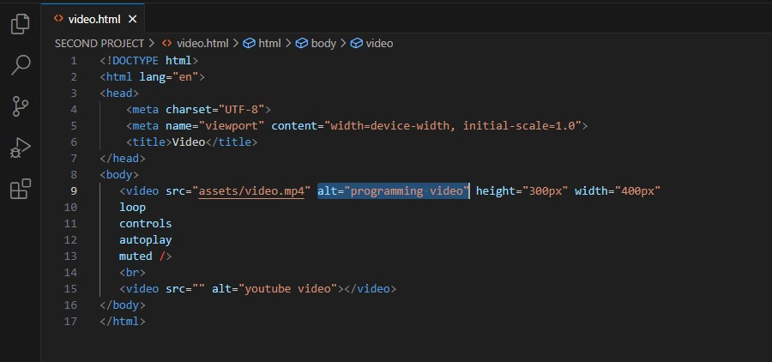

**Output:-**

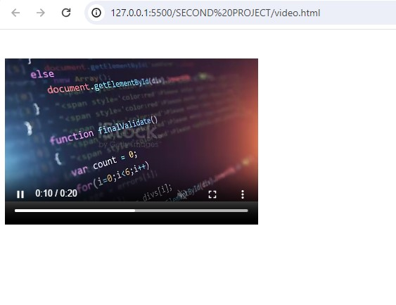

**Q.3 Semantic element in HTML5?**

## **A.3 Semantic Elements in HTML5:-**

* Many web sites contain HTML code like: <div id="nav"> <div class="header"> <div id="footer"> to indicate navigation, header, and footer.
* In HTML there are some semantic elements that can be used to define different parts of a web page:
  + <article>
  + <aside>
  + <details>
  + <figcaption>
  + <figure>
  + <footer>
  + <header>
  + <main>
  + <mark>
  + <nav>
  + <section>
  + <summary>
  + <time>

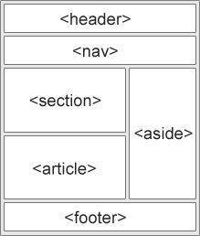

**Q.4 Canvas and SVG tags?**

**A.4 Canvas:-** The HTML <canvas> element is used to draw graphics, on the fly, via JavaScript. Canvas has several methods for drawing paths, boxes, circles, text, and adding images.

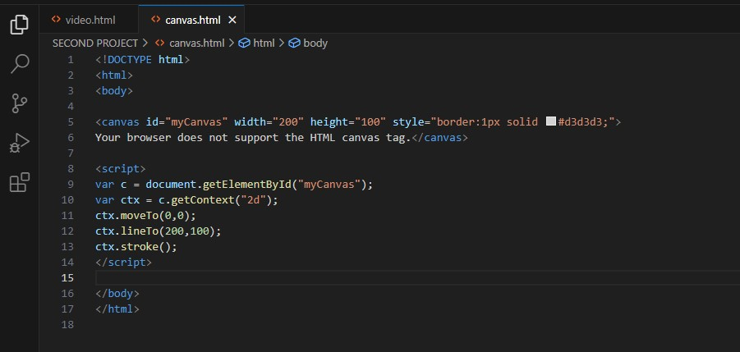

**Output:-**

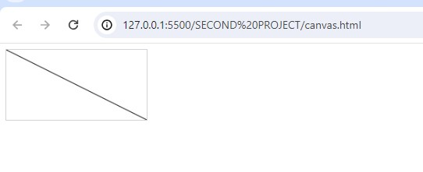

**SVG:-**

* SVG stands for Scalable Vector Graphics
* SVG is used to define vector-based graphics for the Web
* SVG defines graphics in XML format
* Each element and attribute in SVG files can be animated
* SVG is a W3C recommendation
* SVG integrates with other standards, such as CSS, DOM, XSL and JavaScript

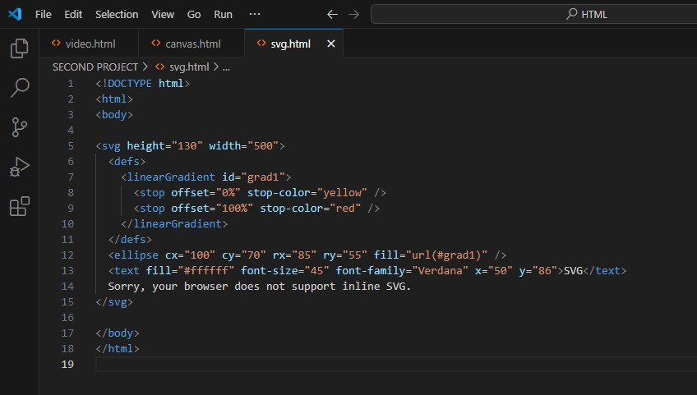

**Output:-**

