# 

MSCI581. Coursework Assignment

### Department of Management Science, Lancaster University

##### COURSE CO-ORDINATORS: Ivan Svetunkov and Alisa Yusupova

A Case Study: DOTA 2

**Submitted by:**

36256915

36342582

36338325

Table of Contents

EXECUTIVE SUMMARY 1

PRELIMINARY DATA ANALYSIS 2

ANALYSIS OF DOTA2 – RESEARCH QUESTIONS 5

QUESTION 1: 5

QUESTION 2: 8

QUESTION 3: 10

QUESTION 4: 11

QUESTION 5: 13

APPENDIX 15

# **EXECUTIVE SUMMARY**

Dota 2 is a MOBA (Multiplayer Online Battle Arena) game developed by Valve Corporation that features an endless number of heroes, abilities, and strong equipment. The game is designed to promote competitive balance, ensuring that all players compete on an equal playing field. Game Analytics want to develop a new commercial game and must analyse player behaviour to forecast the number of people online in the next two weeks in order to decide whether to purchase more servers.

The DOTA 2 game dataset analysis provides crucial insights on the game's performance as well as the effectiveness of twitch views, promotional and pricing initiatives.

**Findings:**

* Twitch viewers and players lag 1 have a positive impact on the players' response variable, however twitch lead 2 and flag lag 2 have a negative effect.
* In terms of pricing strategy, the data indicates that the existing pricing structure may be discouraging new players from entering the game. DOTA 2's average pricing is greater than that of its competitors, which may deter potential gamers from purchasing it.
* The study discovered that the current promotional technique had a short-term influence on player count. The rise in players following each promotion lasts only a fortnight, after which the player count gradually declines over time. The mean of the number of players with and without promotion is minimal, demonstrating that promotional strategies have a minor impact on player growth.
* Finally, the forecasting model ARDL (1,1,2) predicts that the number of participants will rise by 24,259 in the following 14 days. This shows that if the pricing and promotional techniques are altered, the game has the potential to attract new players.

**Recommendations:**

* Increase the frequency of promotions to at least once per week or twice per month, and offer compelling incentives to entice players, such as a free month's subscription or exclusive promos.
* Monitor and analyse the effects of the modified promotional plan over time, and make any necessary adjustments.
* Consider using a tiered pricing plan to appeal to different sorts of players and maybe enhance income while keeping the base price constant.
* Monitor and analyse the impact of the pricing plan on player count and income on a regular basis, and make adjustments as needed.

# 

# **PRELIMINARY DATA ANALYSIS**

We begin with some exploratory data analysis using R language. We discovered that when the flag value was one, there was no player or twitch count data after conducting exploratory data analysis in R. This could be a company promotion technique; thus, we did not replace the missing data with real values and omitted the missing values them from our analysis.

Moving on, from the below graph, we can see the trend of the players counts over the years, we identified a slightly declining tendency in the number of players over the years in our study. However, there were three unexpected outliers or spikes in 2019, early 2020, and early 2023, which could have been caused by the company's promotional strategies. Furthermore, we discovered that the game's maximum popularity or a sudden surge in popularity occurred in the years 2014 to 2016, one year following its release*. (Refer Fig 1)*

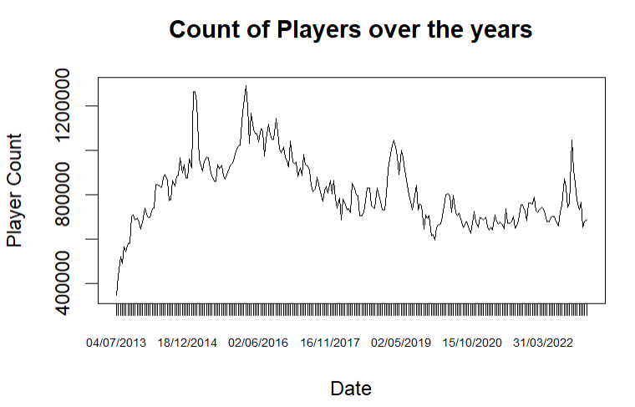

**Fig. 1:** Players counts from 2013 to 2023

Similarly, if we look at the twitch viewer count throughout these years after the release, we can see that there were absolutely no twitch viewers for this game until the end of 2014, but the game started gaming attention majorly from 2015, which almost remains constant year by year and hasn't increased drastically except for a few extreme hikes every year, these are the times near competitions/promotions. *(Refer Fig.2)*

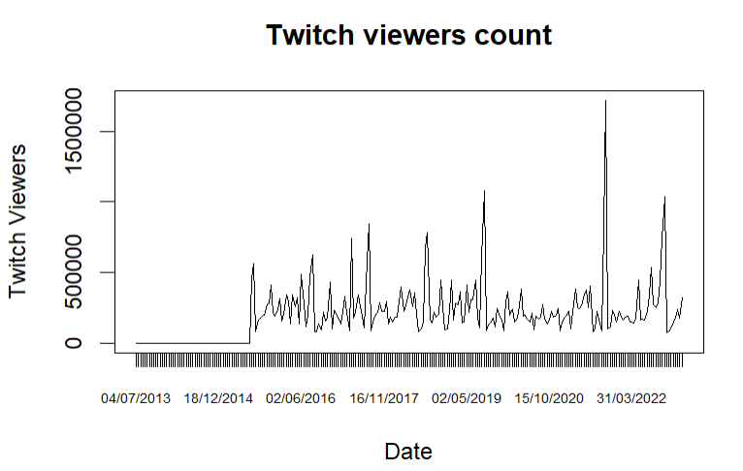

**Fig. 2:** Twitch viewers counts from 2013 to 2023

On comparing further, we see, a large number of players but the game is not as popular on Twitch maybe because it is not very pleasant to watch or lacks a robust esports culture, but the players and twitch viewers share the same peak mostly. As a result, analysing the data and looking for patterns between Twitch viewers and player numbers might be beneficial. *(Refer Fig.3)*

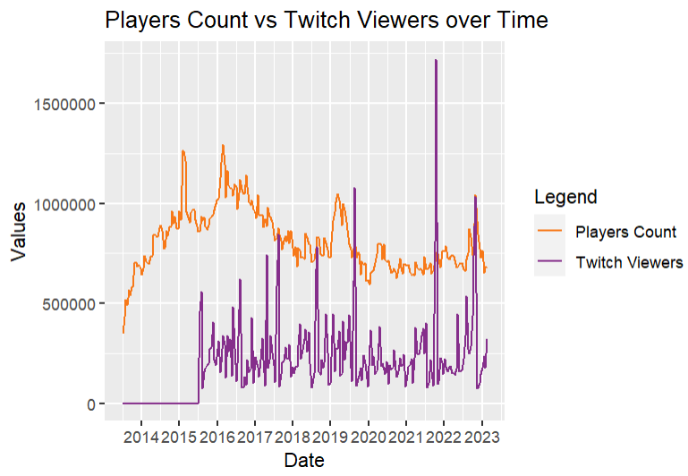

**Fig. 3:** Players count vs Twitch viewers count Graph 1

Further examination of the same comparison, using the graph below, reveals that there is no linear relationship between the Players count & twitch viewers, nor is there any identifiable trend or seasonality*. (Refer Fig, 4)*

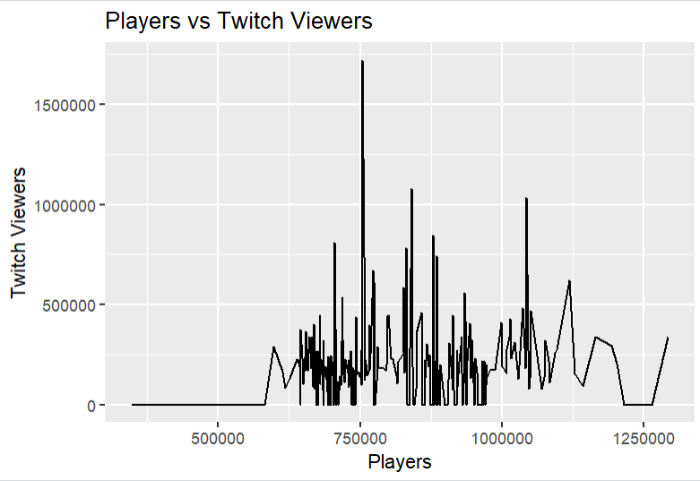

**Fig. 4:** Players count vs Twitch viewers count Graph 2

The correlation graph below also shows that there is no strong evidence that twitch viewers are correlated with player counts which makes sense as twitch viewers may not be necessarily interested in playing the game; however, we can see a slight positive correlation between flags count and player counts *(Refer Fig. 5)*, which could be due to pricing strategies or promotional strategies. We can use model building to figure out why this is happening further in the report.

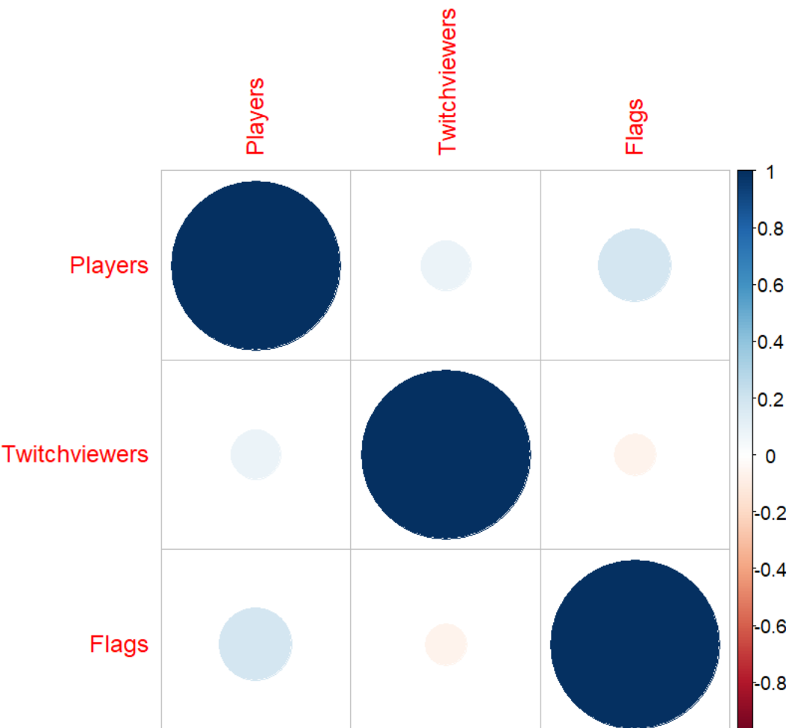

**Fig. 5:** Correlation matrix graph for DOTA 2 dataset

In conclusion, we can see a slight trend in the relationship between date and player count. The player count peaked during the years 2014 to 2016 and has been gradually decreasing since then, with a constant level of popularity in recent years. However, there does not seem to be a significant correlation between Twitch viewers and player count. Also, mean player count remains almost consistent with flags, implying a weak correlation between them. *(Refer Fig. 6)*

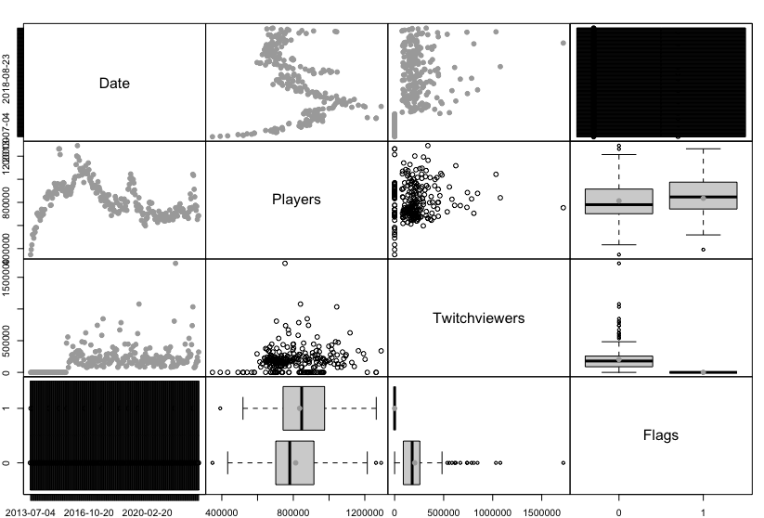

**Fig. 6:** Spread Plot for DOTA 2 dataset

# **ANALYSIS OF DOTA2 – RESEARCH QUESTIONS**

QUESTION 1: Do the Twitch views impact the number of players? If yes, how specifically? Should the company encourage more views on Twitch to attract more customers?

To understand the impact of Twitch views on the number of Players, we will use ARDL (Autoregressive Distributed Lag) model as it can be efficiently used to understand the long-term and short-term relationship, dynamic interactions and impact between the two variables.

To begin with, we started with making sure the data is stationary. We used ADF and KPSS Test for confirming stationarity however, we can see from the below Fig. 1 &2 that ADF test suggests the data is stationary on 5% significance level with p-value=0.04, which is contradictory to the results of KPSS test which is 0.01.

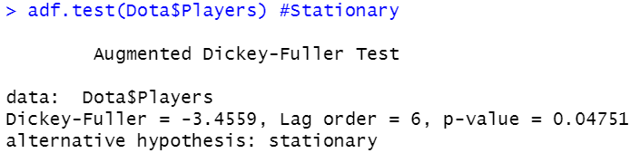

**Fig.1:** ADF test results for DOTA 2

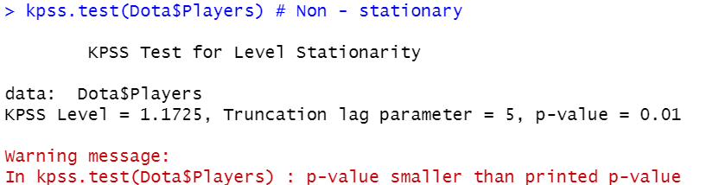

**Fig.2:** KPSS test results for DOTA 2

After doing differencing once for the KPSS test, we can tell from the Fig. 3 that KPSS test’s p-value with 5% significance level is 0.1, which concludes that the data is now stationary.

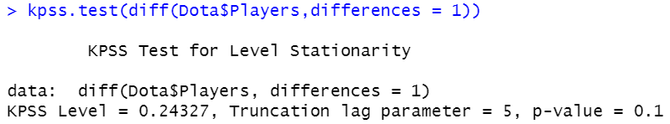

**Fig.3:** KPSS test results for DOTA 2/Differencing=1

We follow the same process discussed about to make the data for twitch viewers stationary as well. Fig. 4 & 5, through ADF test the data is stationary, however KPSS test needs to be differenced so as to confirm if the data is stationary.

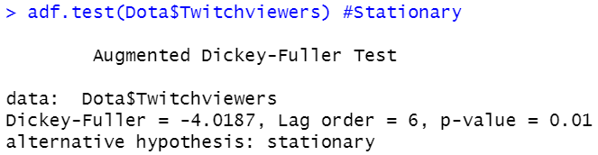

**Fig.4:** ADF test results for DOTA 2/Twitch viewers

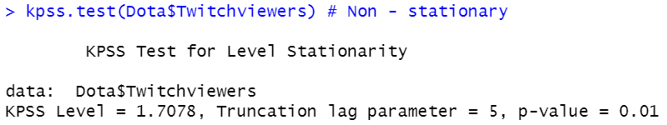

**Fig.5:** KPSS test results for DOTA 2/Twitch viewers

From the Fig.6, we can finally conclude that by 5% significance level, using KPSS test also the data is stationary.

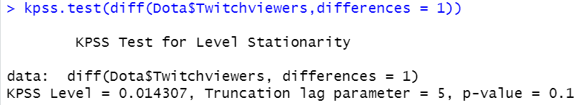

**Fig.6:** KPSS test results for DOTA 2/Twitch viewers

**Cointegration test:**

Subsequently, if we look at the CCF graph *(Refer Fig.8),* we can tell that there are a few significant leads and lags, which illustrates the dynamic effect of twitch viewers on the players count. Fig.7 also indicates the presence of cointegration-relationship as the residuals of the regression between players and twitch are stationary.

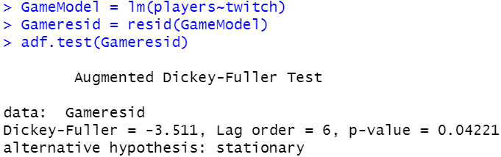

**Fig.7:** ADF test for checking Cointegration using residuals

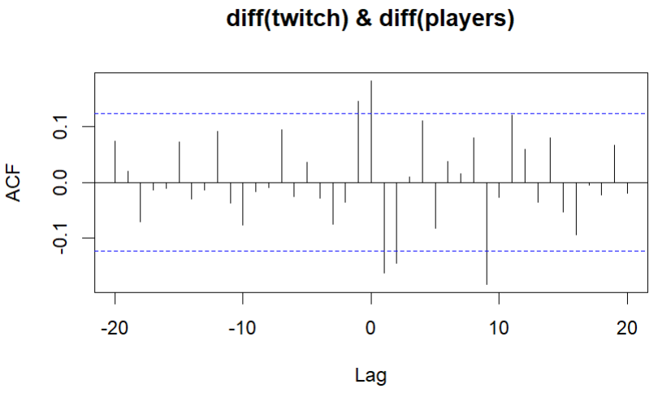

**Fig.8:** CCF of Twitch viewers vs Player’s count

Fig.16 illustrates that in CCF(Cross-correlation-Function) graph Lag-1, Lead-1 and lead-2 are significant and Lead-9 can be ignored because in reality an anticipation of twitch viewers in 9 months would not impact the players count.

Using leading indicator effect in Fig.9 it shows that increasing Twitch views in the current fortnight will increase player count, however the effect will turn negative the next fortnight. The effect will then become somewhat positive over the next two weeks before eventually becoming neutral. Increasing Twitch views may thus initially attract more players.



The sum value=0.0263 also indicates that one unit increase in twitch views will result in cumulative increase of approximatively 0.026 units in the number of players.

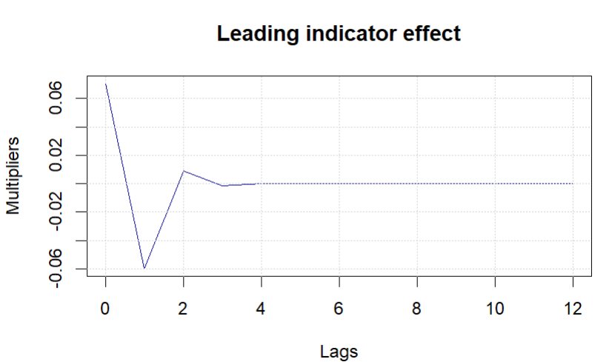

**Fig.9:** Leading indicator effect graphical output

Subsequently, we can also conclude form the Figure 10, Standard residual vs fitted shows heteroskedastic (very few points outside the confidence interval will not be a major concern) which indicates variance of errors is not constant across all fitted values; QQ plot shows normal distribution and absolute residual vs fitted shows the assumption of constant variance and linearity are not violated, which proves the model selected has been appropriate (ARIDL(1,1,q)).

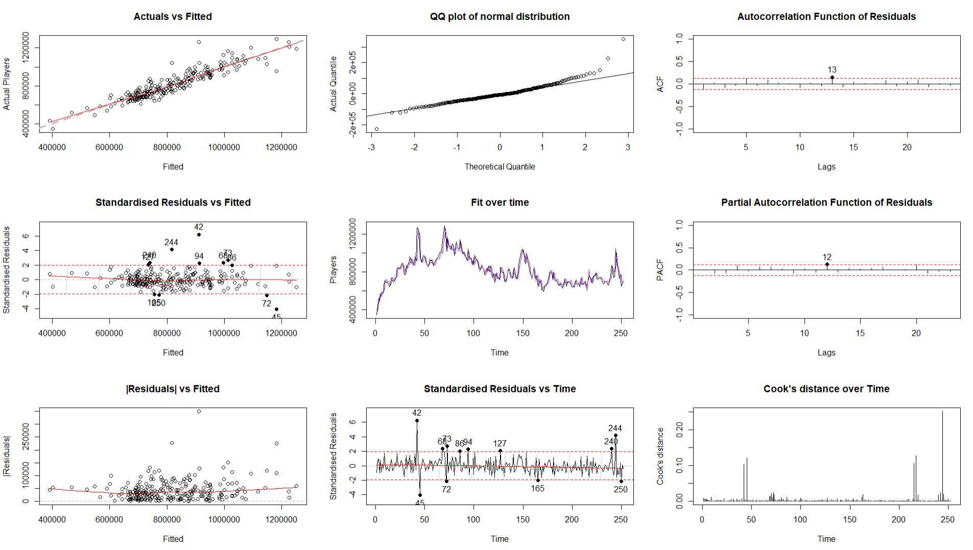

**Fig.10:** Diagnostic plot of the ARIDL (1,1,q)

Furthermore, based on the summary of the ARDL model (ARIDL(1,1,q)) with least AIC value of 6244 from Fig. 11, we can conclude that the Twitch viewers is definitely affecting the number of players, by looking at the significant coefficient “twitch” which indicates that as the number of twitch viewers increases, the players count will increase as well. *(Refer Fig.12)*

* The lag variables "twitchLag2" and "twitchLead2" exhibit statistically significant coefficients, demonstrating that Twitch views have a delayed effect on the number of players.
* A one-unit increase in Twitch views two days ago or two days in the future would result in a 0.038-unit drop in the number of gamers now.

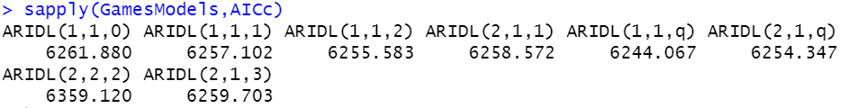

**Fig.11:** ARDL Models AIC Value(Cummulative)

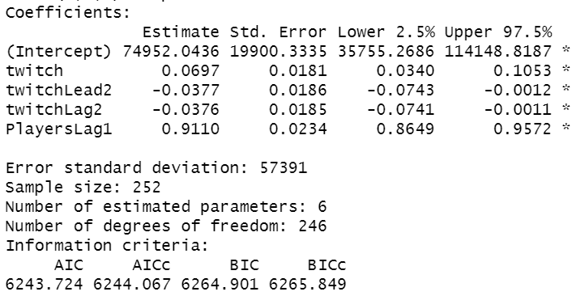

**Fig.12:** Summary of ARDL Model

Hence, the company should encourage more Twitch views to attract more customers, however the corporation should balance its marketing plan because Twitch views have a negative effect after a two-day lag.

QUESTION 2: Approximately, how many innovators and imitators does the game have (overall)?

We are using the Bass Model to analyse the Dota 2 game's player count trend as it is one of the forecasting techniques; used to assess the prospective market size and rate of adoption of new products or services.

The initial step was to create time series for both player count and cumulative player count. As the market potential in this case is limited and rate of adoption has also partially saturated over time, we next used the Bass model, which uses the p and q coefficients to predict potential market size, innovation rate, and imitation rate.

The model also produced fitted values for the number of players as well as the total number of innovators and imitators. Subsequently, the total number of Innovators and Imitators captured by the model in the overall process is 124.7 million and 80.6 million respectively *(Refer Fig.13).*

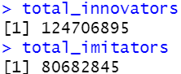

**Fig.13:** Total Innovators and Imitators

We also observed that the innovators represent a steep downward trend, whereas the imitators show an upward trend, which eventually becomes higher than the innovators count after the year 2019.

According to our findings, using the total market size, which is approximately 295.8 million, the coefficient values for p (Innovators) and q (Imitators) are 0.00262 and 0.00576, respectively *(Refer Fig.14).*

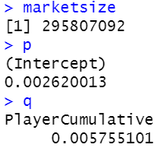

**Fig.14:** Total Market size and Coefficients of innovators and imitators for DOTA 2

Here if p is less than q, it suggests that the trend in player count is being driven primarily by imitators. In this case, our data indicate that imitators have slightly greater influence than innovators as people tend to follow the trend, even though the overall count of innovators are more slightly because of the greater number of innovators in the early 2013 to 2018.

Next up, Using the Bass model we visualized the player count trend and the corresponding fitted values, innovators, and imitators *(Refer Fig. 15).* While the model did not capture all the peaks of the data (especially in the year 2015, 2016, 2019, 2023) accurately due to its deterministic nature, the fitted values capture the overall trend in player count quite well, showing a downward trend with time. Also, the fitted values surpass the overall adoption which is weird at the tail end.

Last point to be noted is that, during the mid-2019, the number of innovators and imitators become equal for the time being, however, the imitators count increases going further and surpasses innovators.

This could signal that the game has matured to the point where growth is primarily driven by the network effect and word-of-mouth, rather than aggressive marketing methods.

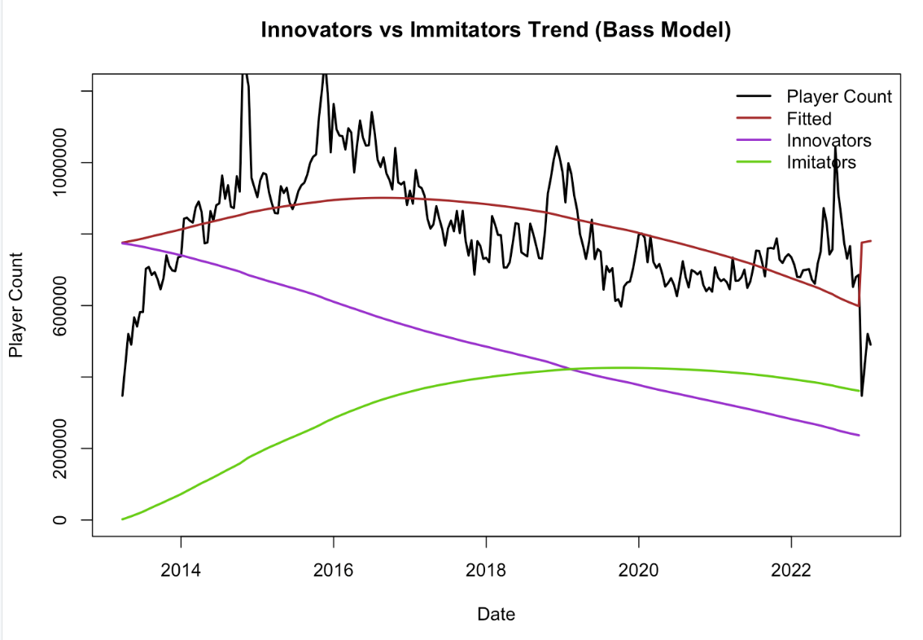

**Fig.15:** The Bass Model graphical analysis for DOTA 2

QUESTION 3: Is the pricing strategy efficient in terms of attracting players to the game?

The DOTA2 game employs two pricing strategies, microtransactions, and the International Event Battle Pass. Microtransactions involve purchasing in-game items with real money, which provide players with virtual currencies, player skins, and cosmetics. The Battle Pass allows players to participate in an international tournament and potentially win cash prizes from the international prize pool. Data has been gathered from various sources *(See appendix for Reference)* for microtransactions and manually calculated for the Battle Pass, where 25% of revenue from the International Prize pool comes from it.

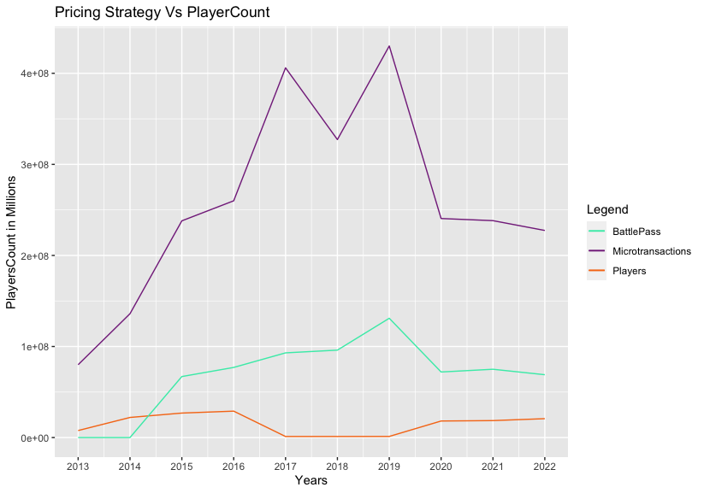  
**Fig.16:** Pricing strategies trend with respect to players

Upon conducting an initial analysis, it was noted from the above figure that during the initial phase, microtransactions had a slight impact on attracting players. However, with the introduction of the battle pass in 2014, there was a slight increase in players until 2016 *(Refer Fig.16)*. After that, the pricing strategies did not seem to have a significant effect on players until 2019. The pandemic caused an increase in players, but might be due to the financial crisis, the pricing strategies did not work well. Based on the figure, it can be concluded that pricing strategies had a limited effect on attracting players initially, but their effectiveness declined over time.

The results of a pricing strategy model *(Refer Fig.17)* showed that for each unit increase in Microtransactions, there was a corresponding decrease of 156,140 units in the player count. On the other hand, for each unit increase in Battle Pass, there was a corresponding increase of 286,079 units in the response variable.

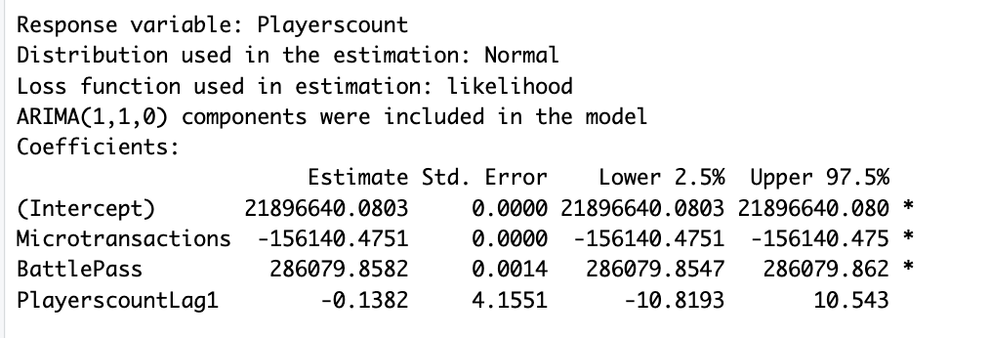

**Fig.17:** Summary through model diagnostics

In conclusion, it can be inferred that the pricing strategies employed by Dota2 have not been successful in attracting new players. Moreover, the data indicates that the current pricing model may be hindering the entry of new players into the game. One possible reason for this is that the average price of Dota2 is higher than that of its competitors, which may be dissuading potential players from purchasing it. Therefore, it is advisable to lower the price to make the game more accessible and appealing to a wider audience.

QUESTION 4:Is the promotional strategy efficient in terms of attracting players? Should it be changed to have more players in the next 14 days? If yes, how specifically?

Figure 18 depicts the rate of promotions over time, and we can see that following each promotion, the number of players rapidly increases. However, this surge is typically only a fortnight long, following which the players count progressively falls over time.

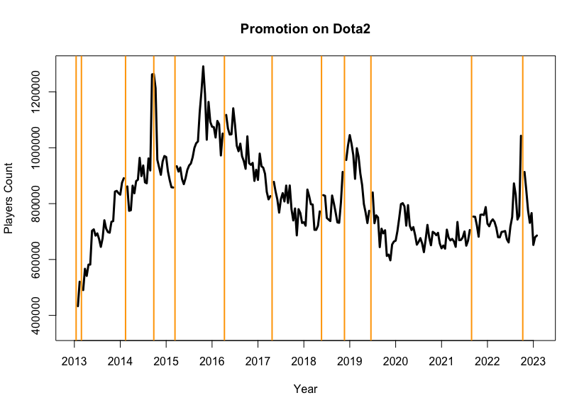

**Fig.18:** Players plot with Flags/Promotions tag

Also, with the help of the spread plot below (*Refer Fig.19*), we can see the mean of the number of players while with promotion (Flag=1) and no promotion (Flag=0) is small, showing that promotional methods have a minor effect on growing the number of players.



**Fig.19:** Spread Plot of DOTA 2

Using leading indicator effect *(Refer Fig.20),* we can conclude that the promotion has the most impact on the number of players in the first fortnight, but the effect gradually decreases over time.

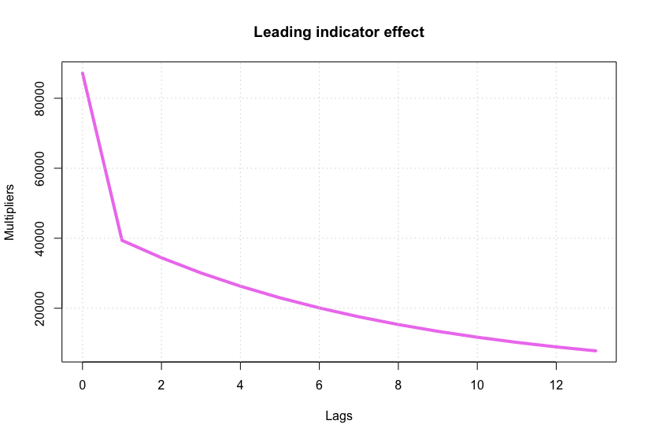

**Fig.20:** Leading-Indicator-Effect for the ARDL model with Players as dependent and Flag as independent variable

Now to check the impact of promotion on the number of players in the next 14 days *(Refer Fig.21)*, we did forecasting using ARDL model, and chose ARDL(1,1,2) as the best fit based on the lowest AIC value. The mean for next 14 days is 687732.

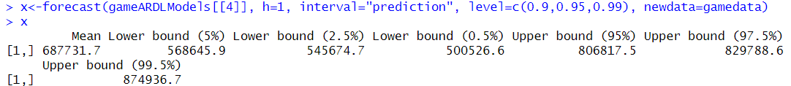

**Fig.21:** Forecast value for the next fortnight(2nd March’23)

According to the ARDL model forecast, wherein using mean value 687731.7, we calculated the per day increase in players count *(Refer Fig.22);* the current promotional strategy appears to be ineffective in attracting players, since the expected growth in player count over the next 14 days is just 1,927, which is relatively low when compared to past data.

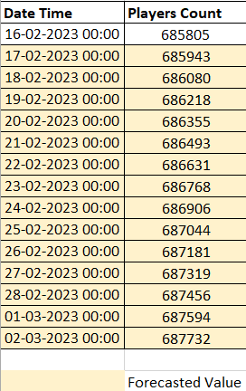

**Fig.22:** Forecast of next-14 days

As a result, it is suggested that the corporation adjust its promotional strategy in order to get better outcomes. One idea is to increase the frequency of promotions to at least once per week or twice per month. Furthermore, the corporation can provide appealing rewards to entice players, such as a free month's subscription, exclusive promotions or giveaways on social networking sites for their fans.

QUESTION 5: What will be the number of players per day in the next 14 days?

The number of players in the game over the course of the following 14 days was predicted using an ARDL model, with players as dependent and the flags and twitch viewers serving as independent variables. To identify the best fit, six alternative models with various order configurations and lags were built, with ARDL(1,1,2) having the lowest AICc value. The number of players is the dependent variable, and the flag and Twitch viewers are the independent factors.

The summary *(Refer Fig.23-24)* below demonstrates that twitch and players lag 1 have a positive effect on the response variable of Players, whereas twitch lead 2 and flag lag 2 have a negative effect. It also reveals that all of the coefficients are statistically significant. ARIDL(1,1,2) model is suitable for predicting player counts in the game for the following 14 days, according to its low AICc value of 6502.049.



**Fig.23:** Best ARDL Models AIC values

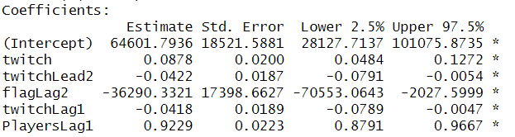

**Fig.24:** Summary output

On plotting the forecasted values along with the historical data we get the below graph, the blue dot like line at the tail end represents the forecasted values. *(Refer Fig.25-26)*

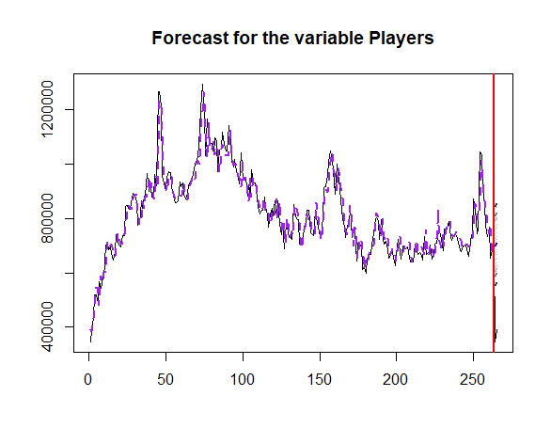

**Fig.25:** Forecasted-values graph

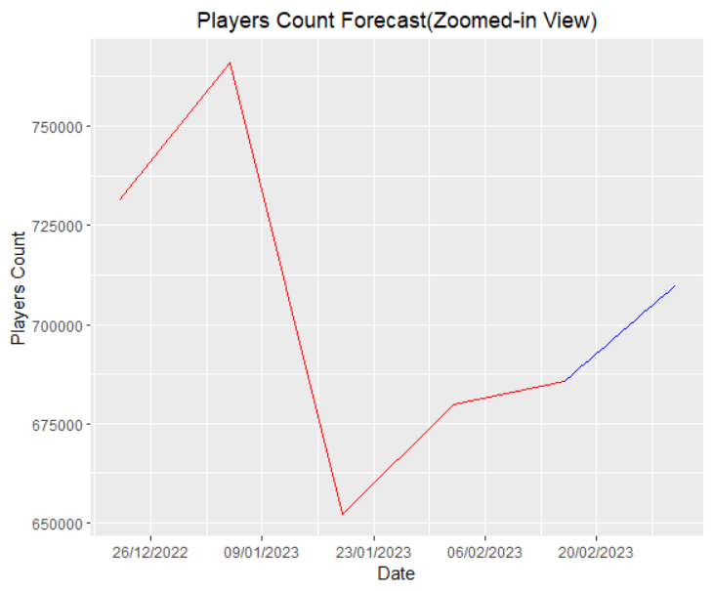

**Fig.26:** Zoomed-in forecasting for next 14 days

The model gives mean prediction value of 710063.9 *(Refer Fig.27)*  for h=1(one iteration), which is for next 14th day, which is then used to calculate the per day players count using the last historical data. Note, players count increases by 24,259 in the next 14 days.

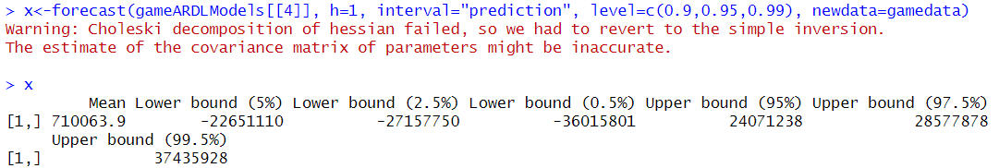

**Fig.27:** Mean forecasted value for the next fortnight iteration

Below *(Refer Fig.28)* are the forecasted values in the table for the next 14 days starting from 17th February’23 till 2nd March’23.

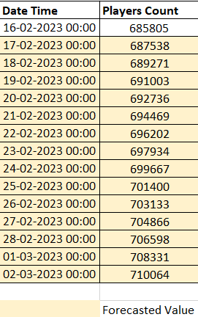

**Fig.28:** Forecasted values for next 14 days starting from 17th Feb,’23

# **APPENDIX**

VentureBeat. (2014). *Hearthstone, Dota 2 can’t compete with League of Legends in terms of player spending*. [online] Available at: https://venturebeat.com/games/the-10-highest-grossing-online-pc-games-in-2014-hearthstone-dota-2-cant-compete-with-league-of-legends/ [Accessed 17 Apr. 2023].

statinvestor.com. (n.d.). Revenue generated by DOTA 2 worldwide. [online] Available at: https://statinvestor.com/data/26932/dota-2-revenue [Accessed 17 Apr. 2023].

Esports.gg. (n.d.). Dota 2 players had over $295 million worth of levels in the 2022 Battle Pass. [online] Available at: https://esports.gg/news/dota-2/dota-2s-2022-battle-pass-reportedly-earned-over-295-million/ [Accessed 17 Apr. 2023].

luzano, kurt (2023). Dota 2’s 2022 Battle Pass made US$290m, but what good did it do for the game? [online] Available at:<https://uk.news.yahoo.com/dota-2-2022-battle-pass-290-million-073408616.html?guccounter=1&guce_referrer=aHR0cHM6Ly93d3cuZ29vZ2xlLmNvLnVrLw&guce_referrer_sig=AQAAAHR5aTrR7B3iyB-XgiI23ihu8OGa8I9Lr0QEJPW0VKOTU3TM533TFYUGdXOavOkG2JzGrYb1mAv81UhZKbC1V6Ab2H87CQQvz4mG5GHfkltfNZjsfDFyxEhHD_rt3WoJ7f2hxPv5ugWxxmjkYuWWc-9rcX7iir9PeLp7hs-NaIzN>.

Andy Chalk published (2014). League of Legends has made almost $1 billion in microtransactions. PC Gamer. [online] 24 Oct. Available at: https://www.pcgamer.com/league-of-legends-has-made-almost-1-billion-in-microtransactions/.