Homework 5

Due: 11:59 PM on Monday, April 12, 2021.

Please answer in your own words. Show your work.

1. (24 points) Consider the following network:

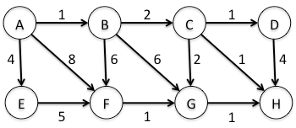

With the indicated *directed* link costs, use Dijkstra’s shortest path algorithm to compute the shortest path from *A* to all network nodes. Show how the algorithm works by computing a table similar to Table 5.1 in the textbook. Be sure to show the resulting graph.

Answer:

|  |  |  |  |  |  |  |  |  |
| --- | --- | --- | --- | --- | --- | --- | --- | --- |
| Step | Node | D(B),P(B) | D(C),P(C) | D(D),P(D) | D(E),P(E) | D(F),P(F) | D(G),P(G) | D(H),P(H) |
| 0 | A | 1, A | ∞ | ∞ | 4,A | 8, A | ∞ | ∞ |
| 1 | AB |  | 3,B | ∞ | 4,A | 7,B | 7,B | ∞ |
| 2 | ABC |  |  | 4,C | 4,A | 7,B | 5,C | 4,C |
| 3 | ABCH |  |  | 4,C | 4,A | 7,B | 5,C |  |
| 4 | ABCHD |  |  |  | 4,A | 7,B | 5,C |  |
| 5 | ABCHDE |  |  |  |  | 7,B | 5,C |  |
| 6 | ABCHDEG |  |  |  |  | 7,B |  |  |
| 7 | ABCHDEGF |  |  |  |  | 7,B |  |  |

1

2

1

4

6

2

1

1. (24 points) Consider the network shown below, and assume that each node initially knows the costs to each of its neighbors:

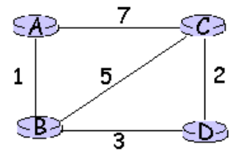

Assume that all nodes receive their neighbors update message at the same time and consider the distance-vector algorithm to update their own distance table at the same time. Show the distance table update procedure for each node similar to Figure 5.6 in the textbook. Note that your answer should show 3 rounds.

Answer:

As we know we the distance vector routing algorithm works as:

“Let dx (y) be the cost of the least-cost path from node x to node y. Then the least costs are related by the celebrated Bellman-Ford equation, namely,

dx (y) = minv{c(x, v) + dv ( y)} {I}

where the minv in the equation is taken over all of x’s neighbors. The Bellman Ford equation is rather intuitive. Indeed, after traveling from x to v, if we then take the least-cost path from v to y, the path cost will be c(x, v) + dv (y). Since we must begin by traveling to some neighbor v, the least cost from x to y is the minimum of c(x, v) + dv (y) taken over all neighbors v”.[1]

where c(x,v) is cost from x node to v directly and dv (y) is distance vector for each neighbor v to x.

Node A table:

|  |  |  |  |  |
| --- | --- | --- | --- | --- |
|  | A | B | C | D |
| A | 0 | 1 | 7 | ∞ |
| B | ∞ | ∞ | ∞ | ∞ |
| C | ∞ | ∞ | ∞ | ∞ |
| D | ∞ | ∞ | ∞ | ∞ |

|  |  |  |  |  |
| --- | --- | --- | --- | --- |
|  | A | B | C | D |
| A | 0 | 1 | 6 | 4 |
| B | 1 | 0 | 5 | 3 |
| C | 7 | 5 | 0 | 2 |
| D | ∞ | 3 | 2 | 0 |

|  |  |  |  |  |
| --- | --- | --- | --- | --- |
|  | A | B | C | D |
| A | 0 | 1 | 7 | ∞ |
| B | 1 | 0 | 5 | 3 |
| C | 7 | 5 | 0 | 2 |
| D | ∞ | 3 | 2 | 0 |

Node B table:

|  |  |  |  |  |
| --- | --- | --- | --- | --- |
|  | A | B | C | D |
| A | ∞ | ∞ | ∞ | ∞ |
| B | 1 | 0 | 5 | 3 |
| C | ∞ | ∞ | ∞ | ∞ |
| D | ∞ | ∞ | ∞ | ∞ |

Node C table:

|  |  |  |  |  |
| --- | --- | --- | --- | --- |
|  | A | B | C | D |
| A | ∞ | ∞ | ∞ | ∞ |
| B | ∞ | ∞ | ∞ | ∞ |
| C | 7 | 5 | 0 | 2 |
| D | ∞ | ∞ | ∞ | ∞ |

|  |  |  |  |  |
| --- | --- | --- | --- | --- |
|  | A | B | C | D |
| A | 0 | 1 | 7 | ∞ |
| B | 1 | 0 | 5 | 3 |
| C | 6 | 5 | 0 | 2 |
| D | ∞ | 3 | 2 | 0 |

Node D table:

|  |  |  |  |  |
| --- | --- | --- | --- | --- |
|  | A | B | C | D |
| A | ∞ | ∞ | ∞ | ∞ |
| B | ∞ | ∞ | ∞ | ∞ |
| C | ∞ | ∞ | ∞ | ∞ |
| D | ∞ | 3 | 2 | 0 |

|  |  |  |  |  |
| --- | --- | --- | --- | --- |
|  | A | B | C | D |
| A | 0 | 1 | 7 | ∞ |
| B | 1 | 0 | 5 | 3 |
| C | 7 | 5 | 0 | 2 |
| D | 4 | 3 | 2 | 0 |

Node A updated neighbor message

Node B updated neighbor message

Node C updated neighbor message

Node D updated neighbor message

Once node A receive value from all neighbors it will recalculate and update their distance value based on the formula I. Below is demonstration for calculating node A value.

Da (a) = 0

Da (b) = min{c(a,b)+ Db(b),c(a,c) +Dc(b), c(a,c)+c(c,d) +Dd(b)}

= min {1+0, 7+5, 7+2+3}

= 1

Da (c) = min{c(a,c) + Dc(c) ,c(a,b) +Db(c) , c(a,b)+c(b,c) +Dd(c)}

= min {7+0, 1+5, 1+3+2} = 6

Da (d) = min{c(a,c) + Dc(d) ,c(a,b) +Db(d) , c(a,b)+c(b,c) +Dc(d), c(a,c)+c(c,b)+ Db(d)}

= min {7+2, 1+3, 1+5+2, 7+5+3}

= 4

Similarly, all other node table update their values.

Next step of table given below:

Here A C D will send their updated values to each node. Node B will not send anything since there is no change in its value.

Node A table

|  |  |  |  |  |
| --- | --- | --- | --- | --- |
|  | A | B | C | D |
| A | 0 | 1 | 6 | 4 |
| B | 1 | 0 | 5 | 3 |
| C | 7 | 5 | 0 | 2 |
| D | ∞ | 3 | 2 | 0 |

|  |  |  |  |  |
| --- | --- | --- | --- | --- |
|  | A | B | C | D |
| A | 0 | 1 | 7 | ∞ |
| B | 1 | 0 | 5 | 3 |
| C | 7 | 5 | 0 | 2 |
| D | ∞ | 3 | 2 | 0 |

|  |  |  |  |  |
| --- | --- | --- | --- | --- |
|  | A | B | C | D |
| A | 0 | 1 | 6 | 4 |
| B | 1 | 0 | 5 | 3 |
| C | 6 | 5 | 0 | 2 |
| D | 4 | 3 | 2 | 0 |

|  |  |  |  |  |
| --- | --- | --- | --- | --- |
|  | A | B | C | D |
| A | 0 | 1 | 6 | 4 |
| B | 1 | 0 | 5 | 3 |
| C | 6 | 5 | 0 | 2 |
| D | 4 | 3 | 2 | 0 |

|  |  |  |  |  |
| --- | --- | --- | --- | --- |
|  | A | B | C | D |
| A | 0 | 1 | 7 | ∞ |
| B | 1 | 0 | 5 | 3 |
| C | 7 | 5 | 0 | 2 |
| D | 4 | 3 | 2 | 0 |

|  |  |  |  |  |
| --- | --- | --- | --- | --- |
|  | A | B | C | D |
| A | 0 | 1 | 7 | ∞ |
| B | 1 | 0 | 5 | 3 |
| C | 6 | 5 | 0 | 2 |
| D | ∞ | 3 | 2 | 0 |

|  |  |  |  |  |
| --- | --- | --- | --- | --- |
|  | A | B | C | D |
| A | 0 | 1 | 6 | 4 |
| B | 1 | 0 | 5 | 3 |
| C | 6 | 5 | 0 | 2 |
| D | 4 | 3 | 2 | 0 |

|  |  |  |  |  |
| --- | --- | --- | --- | --- |
|  | A | B | C | D |
| A | 0 | 1 | 6 | 4 |
| B | 1 | 0 | 5 | 3 |
| C | 6 | 5 | 0 | 2 |
| D | 4 | 3 | 2 | 0 |

Node B table

Node C table

Node D table

1. (20 points) Consider the following network and assume that the routers use RIP with hop count as the routing metric to calculate their forwarding tables:

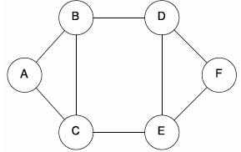

* 1. Fill in the routing table for router *A*, showing "Destination", "Cost", and "Next Hop".

Answer:

|  |  |  |
| --- | --- | --- |
| Destination | Cost | Next hop |
| A | 0 | - |
| B | 1 | B |
| C | 1 | C |
| D | 2 | B |
| E | 2 | C |
| F | 3 | B/C |

* 1. Suppose that router *E* becomes unavailable. Fill in the resulting routing table for router *B*, showing "Destination", "Cost", and "Next Hop" after being updated.

Answer:

|  |  |  |
| --- | --- | --- |
| Destination | Cost | Next hop |
| A | 1 | A |
| B | 0 | - |
| C | 1 | C |
| D | 1 | D |
| E | ∞ | - |
| F | 2 | D |

1. (24 points) Consider the following network:

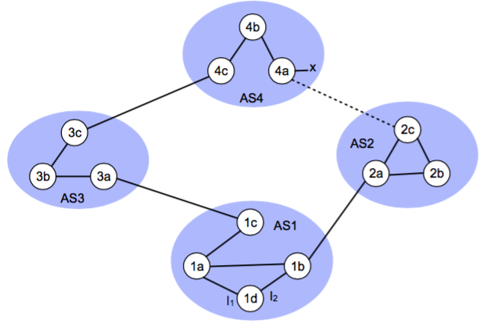

Suppose that *AS2* and *AS3* are running OSPF and that *AS1* and *AS4* are running RIP for their intra-AS routing protocol. Also suppose that eBGP and iBGP are used for the inter-AS routing protocol. Consider that when router *1d* learns about *x*, it will put an entry *(x, I)* in its forwarding table.

* 1. Assume, for this part of the problem, that there is no physical link between *AS2* and *AS4* (i.e., ignore the dotted line). Will the value of *I* be set to *I1* or *I2* for this entry? Briefly justify your answer.

Answer: I value will be set to I1 because interface begins the least cost path from 1d towards the gateway router 1c.

* 1. Now suppose that a physical link exists between AS2 and AS4 (as indicated by the dotted line). If router 1d learns that *x* is accessible via AS2 as well as via AS3, will the value of *I* be set to *I1* or *I2*? Consider AS-PATH and NEXT-HOP as you briefly justify your answer.

Answer: The value of I will be set to I2 Although both have equal AS-PATH but I2 leads to shortest path as it begins the path that has closest NEXT-HOP router 1b.

* 1. Now suppose that another AS called AS5 (not shown) lies on the path between AS2 and AS4. If router 1d learns that x is accessible via AS2-AS5-AS4 as well as via AS3-AS4, will the value of *I* be set to *I1* or *I2*? Consider AS-PATH and NEXT-HOP as you briefly justify your answer.

Answer: In this scenario I value will be set to I1 because I1 begins the path that has shortest AS-PATH.

1. (8 points) Describe in sufficient detail what is hierarchical routing and why it is needed.

Answer:

“Hierarchical routing allows to partition the network into autonomous routing domains. A routing domain is the portion of the network which is handled by the same instance of a routing protocol. Routers belonging to a domain do not know the exact topology of another domain, but they only know the list of destinations included in it with their related costs a good choice to reach them is to take the best exit path toward the target domain across a border router.”[2]

There were two overhead with Link-State and Distance vector algorithm. One is Scaling issue: when the router becomes large, communicating computing and storing the information of such larger network become prohibitive, which is current real-world scenario. Other issue is “Administrative autonomy where the internet is a network of ISPs and organization wants to operate and administered its network as it wishes, while still being able to connect its network to other outside networks.”[1]

To overcome above two overhead Hierarchical routing was introduced which works on the phenomena of autonomous systems. Hierarchical routing allows aggregate the routers into region known as autonomous system (AS). Routers which are in same AS runs same routing protocol unaware of other AS protocol. There is gateway router which are situated at edges of network and help communicate with routers in other AS, these routers have link information of router in other AS.

References:

[1] : Computer Networking: A Top-Down Approach featuring Internet 7th edition, Kurose and Ross, Addison Wesley,

[2]: https://en.wikibooks.org/wiki/Routing_protocols_and_architectures/Hierarchical_routing