**CT-2021-042 Lab Worksheet**

**Q1.**

**Code:**

|  |
| --- |
| ***package Q1;***  ***import javax.swing.*;***  ***public class Q1 {***  ***public static void main(String[] args) {***  ***JFrame frame = new JFrame("q");***  ***frame.setSize(800,600);***  ***frame.setTitle("Welcome To JAVA");***  ***frame.setVisible(true);***  ***frame.setLocation(500,100);***  ***frame.setDefaultCloseOperation(JFrame.EXIT_ON_CLOSE);***  ***}***  ***}*** |

**Output:**

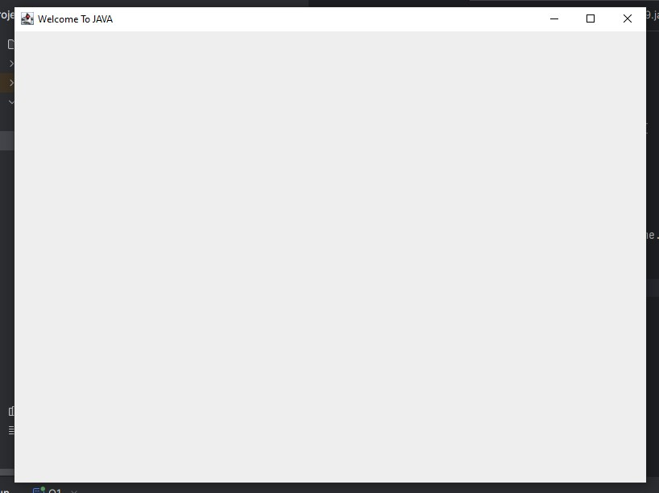

**Q2.**

**Code:**

|  |
| --- |
| ***package Q2;***  ***import javax.swing.*;***  ***import java.util.Scanner;***  ***public class Q2 {***  ***public static void main(String[] args) {***  ***JFrame frame = new JFrame ("Q2" );***  ***frame.setSize(800,600);***  ***frame.setLocation(500,100);***  ***frame.setDefaultCloseOperation(JFrame.EXIT_ON_CLOSE);***  ***frame.setVisible(true);***  ***Scanner scanner = new Scanner(System.in);***  ***System.out.println("Enter First Name :");***  ***String firstname = scanner.nextLine();***  ***System.out.println("Enter Second Name");***  ***String Lastname = scanner.nextLine();***  ***System.out.println(firstname+Lastname);***  ***scanner.close();***  ***}***  ***}*** |

**Output:**

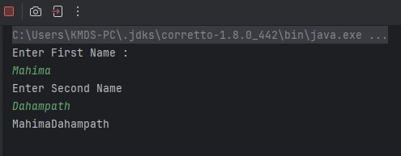

**Q3.**

**Code:**

|  |
| --- |
| ***package Q3;***  ***import java.util.Scanner;***  ***public class Q3 {***  ***public static void main(String[] args) {***  ***Scanner scanner = new Scanner(System.in);***    ***System.out.println("Eneter First Name :");***  ***String firstname = scanner.next();***    ***System.out.println("Enetr Middle Name :");***  ***String Middelname = scanner.next();***    ***System.out.println("Enter Last Name :");***  ***String Lastname = scanner.next();***    ***String initial = Middelname.substring(0,1);***  ***System.out.println(firstname+" "+initial+". "+Lastname);***  ***scanner.close();***  ***}***  ***}*** |

**Output:**

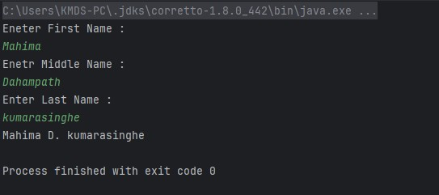

**Q4.**

**Code:**

|  |
| --- |
| ***package Q4;***  ***import java.text.SimpleDateFormat;***  ***import java.util.Date;***  ***public class Q4 {***  ***public static void main(String[] args) {***  ***Date today = new Date();***  ***System.out.println(today);***  ***System.out.println();***  ***SimpleDateFormat sdf = new SimpleDateFormat("dd MMM yyyy");***  ***System.out.println(sdf.format(today));***  ***}***  ***}*** |

**Output:**

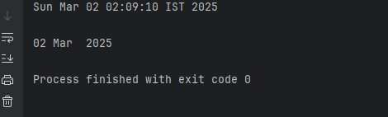

**Q5.**

**Code:**

|  |
| --- |
| ***package Q5;***  ***import java.text.SimpleDateFormat;***  ***import java.util.Date;***  ***public class Q5 {***  ***public static void main(String[] args) {***  ***Date today = new Date();***  ***System.out.println(today);***  ***System.out.println();***  ***SimpleDateFormat D1 = new SimpleDateFormat("EEEE MMMM d yyyy");***  ***System.out.println(D1.format(today));***  ***}***  ***}*** |

**Output:**

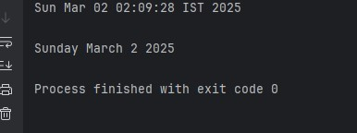

**Q6.**

**Code:**

|  |
| --- |
| ***package Q6;***  ***import javax.swing.*;***  ***import java.util.Scanner;***  ***public class Q6 {***  ***public static void main(String[] args) {***  ***JFrame frame =new JFrame("Q06");***  ***Scanner scanner = new Scanner(System.in);***  ***System.out.print("Enter width of the frame :");***  ***int width = Integer.parseInt(scanner.nextLine());***  ***System.out.print("Enter height of the frame :");***  ***int height = Integer.parseInt(scanner.nextLine());***  ***frame.setSize(width,height);***  ***frame.setDefaultCloseOperation(JFrame.EXIT_ON_CLOSE);***  ***frame.setVisible(true);***  ***}***  ***}*** |

**Output:**

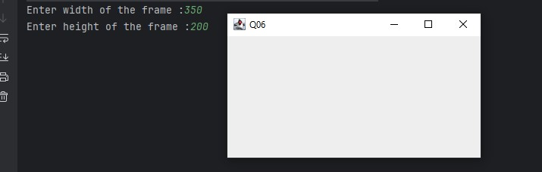

**Q7.**

**Code:**

|  |
| --- |
| ***package Q7;***  ***import javax.swing.*;***  ***import java.text.SimpleDateFormat;***  ***import java.util.Date;***  ***public class Q7 {***  ***public static void main(String[] args) {***  ***JFrame frame = new JFrame();***  ***frame.setSize(400, 200);***  ***frame.setDefaultCloseOperation(JFrame.EXIT_ON_CLOSE);***  ***frame.setVisible(true);***  ***Date today = new Date();***  ***System.out.println(today);***  ***System.out.println();***  ***SimpleDateFormat D1 = new SimpleDateFormat("hh:mm:ss a");***  ***System.out.println(D1.format(today));***  ***frame.setTitle(D1.format(today));***  ***}***  ***}*** |

**Output:**

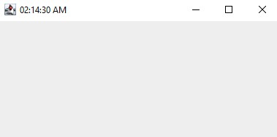

**Q8.**

**Code:**

|  |
| --- |
| ***package Q8;***  ***import java.util.Scanner;***  ***public class Q8 {***  ***public static void main(String[] args) {***  ***Scanner scanner = new Scanner(System.in);***  ***System.out.print("Enter a string containing a single exclamation mark (!):");***  ***String text = scanner.nextLine();***  ***int index = text.indexOf('!');***  ***if (index == -1 || text.indexOf('!', index + 1) != -1) {***  ***System.out.println("Error: The input must contain exactly one exclamation mark.");***  ***return;***  ***}***  ***String before = text.substring(0, index).trim();***  ***String after = text.substring(index + 1).trim();***  ***System.out.println(before);***  ***System.out.println(after);***  ***}***  ***}*** |

**Output:**

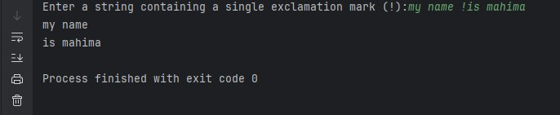

**Q9.**

**Code:**

|  |
| --- |
| ***import java.util.Scanner;***  ***public class Q9 {***  ***public static void main(String[] args) {***  ***Scanner scanner = new Scanner(System.in);***  ***System.out.println("Enter a string: ");***  ***String string = scanner.nextLine();***  ***int length = string.length();***  ***if (length> 0) {***  ***char firstChar = string.charAt(0);***  ***char lastChar = string.charAt(length - 1);***  ***System.out.println(length);***  ***System.out.println(firstChar);***  ***System.out.println(lastChar);***  ***} else {***  ***}***  ***}***  ***}*** |

**Output:**

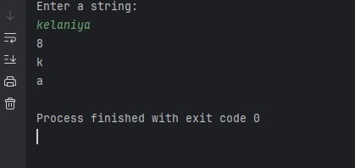

**Q10.**

**Code:**

|  |
| --- |
| ***package Q10;***  ***import java.util.Scanner;***  ***public class Q10 {***  ***public static void main(String[] args) {***  ***Scanner scanner = new Scanner(System.in);***  ***System.out.print("Enter a word :");***  ***String word = scanner.nextLine();***  ***scanner.close();***  ***int length = word.length();***  ***if (length % 2 == 1) {***  ***int middleIndex = length / 2;***  ***char CharM = word.charAt(middleIndex);***  ***System.out.println("Middle character: " + CharM);***  ***} else {***  ***System.out.println("Error: The word has odd number of characters.");***  ***}***  ***}***  ***}*** |

**Output:**

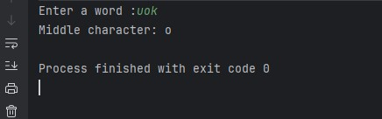

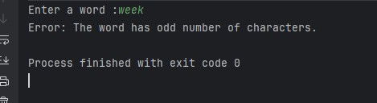

**Q11.**

**Code:**

|  |
| --- |
| ***package Q11;***  ***import java.util.Scanner;***  ***public class Q11 {***  ***public static void main(String[] args) {***  ***Scanner scanner = new Scanner(System.in);***  ***System.out.print("Enter your full name (First Middle Last): ");***  ***String fullName = scanner.nextLine();***  ***scanner.close();***  ***String[] nameParts = fullName.split(" ");***  ***if (nameParts.length == 3) {***  ***String firstName = nameParts[0];***  ***String middleName = nameParts[1];***  ***String lastName = nameParts[2];***  ***String formattedName = lastName + ", " + firstName + " " + middleName.charAt(0) + ".";***  ***System.out.println("Formatted Name: " + formattedName);***  ***} else {***  ***System.out.println("Error: Please enter your full name in the format 'First Middle Last'.");***  ***}***  ***}***  ***}*** |

**Output:**

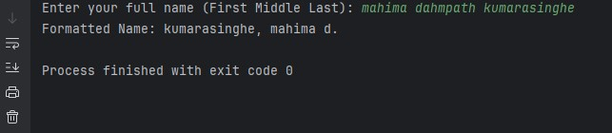

**Q12.**

**Code:**

|  |
| --- |
| ***package Q12;***  ***import javax.swing.*;***  ***public class Q12 {***  ***public static void main(String[] args) {***  ***JFrame frame = new JFrame("My First Frame");***  ***frame.setSize(300, 200);***  ***frame.setLocation(100, 50);***  ***frame.setDefaultCloseOperation(JFrame.EXIT_ON_CLOSE);***  ***frame.setVisible(true);***  ***}***  ***}*** |

**Output:**

